System Design Specification (SDD) DRAFT

for

Assignment 5
Version 1.1 approved
Prepared by Sean Coggeshall
American Military University
October 14, 2024

Contents
1. Introduction 2
2. Purpose 2
2.1 Document Conventions 2
2.2 Intended Audience and Reading Suggestions 2
2.3 Product Scope 2
2.4 References 2
3. System Overview 3
3.1 Goals, Functionality and Architecture 3
3.2 Design Constraints 3
4. System Architecture 4
4.1 Architectural Design 4
4.2 Subsystem Decomposition 4
4.3 Access Control and Security 4
4.4 Design Rationale 4
5. File and Database Design 5
5.1 Database Design 5
5.2 Non-Database Management System Files 5
5.3 Corrections 5
6. Software Design 6
6.1 Structure Chart. 6
6.2 Structure Chart Discussion 6
7. Human Interface Design 7
7.1 Functionality from User Perspective 7
7.2 Sample Mockups of Web Pages for the Case Study. 7
8. Testing 8
8.1 Test Case TC001 Schedule New Valid Appointment 8
8.2 Test Case TC002 Cancel Scheduled Appointment 8
8.3 Test Case TC003 Schedule New Appointment without Data 8
8.4 Test Case TC004 Schedule Appointment with Schedule Conflict 9
8.5 Testing Types 9
Appendix. 10

Revision History
Name | Date | Reason for Changes | Version
Sean Coggeshall | 09 24, 2021 | Creating initial document | 1.0
Sean Coggeshall | 09 30, 2024 | Adding Structure Chart and completing sections 6 and 7. | 1.1
Sean Coggeshall | 10 14, 2024 | Completing section 8 for testing. | 1.2

Introduction
This document provides an overview of the FCS System Design. Highlighting the purpose, system overview, system architecture, and security features.

Purpose
The System Design Document covers the design requirements for the Family Clinic Services (FCS) Appointment Scheduling System.

Document Conventions
We will identify priority levels as follows:

- High – (H)
- Medium – (M)
- Low – (L)

Italics indicate external references.
Bold text will be used for key system components.

Intended Audience and Reading Suggestions
The SDD is intended for developers, project managers, system architects, and testers. Developers should focus on sections 4-7, while project managers should focus on introduction and overview sections.

Product Scope
The FCS Appointment Scheduling System aims to provide an efficient way for patients to book and manage appointments, reducing wait times and improving doctor and service provider schedules.

References
- FCS Case Study
- FCS Vision Document Version 1.0
- FCS Software Requirements Specification Document Version 1.1
- HIPAA Regulations

System Overview

This section provides a high-level overview of the FCS Appointment Scheduling System.

Goals, Functionality and Architecture
The FCS System's primary goal is to automate appointment scheduling. The system will utilize a cloud-based, client-server architecture for scalability and availability purposes.

Design Constraints
- Compliance with HIPAA regulations.
- Ability to handle at least 500 concurrent users.
- Integration with existing database management systems.

System Architecture
This section provides a detailed description of the FCS Appointment Scheduling System's architecture, including its components, subsystems, and security features. It explains the reasoning behind design choices.

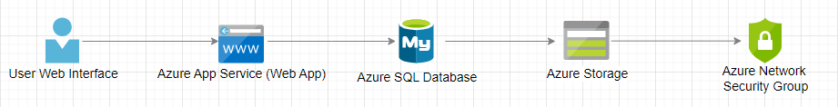
Architectural Design

Subsystem Decomposition
1. Appointment Scheduling Subsystem
  - Responsible for scheduling and managing appointments.
2. User Management Subsystem
  - Handles user authentication and authorization.
3. Database Management Subsystem
  - Manages data storage and retrieval.

Access Control and Security
- User authentication: username/password combination with MFA (Microsoft Authenticator)
- Authorization: role-based access control.
- Data encryption: SSL/TLS protocol.
- Key management: secure key storage.

Design Rationale
The cloud-based, client-server architecture was chosen for its scalability, flexibility, and security features. The system's design prioritizes user-friendliness, data security, and compliance with HIPAA regulations.

File and Database Design
<Provide an overview of contents of this section.

Remove these directions after completing the section.>

Database Design
<Insert a copy of your ERD

Remove these directions after completing the section.>

<Describe the design of the database where all the data used by the system resides. The design should include interoperability between the user portion of the system and the background data and how the database is designed to achieved this. Refer to your ERD showing the database design. Include physical description, access methods, file size of volume, update frequency, and number of transactions.

Remove these directions after completing the section.>

Non-Database Management System Files
<Describe detailed description of all non-DBMS files and include a narrative description of the usage of each file including if the file is used for input, output, or both. Include the file structure, record length, access method, file size, and update frequency. .

Remove these directions after completing the section.>

Corrections
< Make any corrections to your previous SDD and list the corrections.

Remove these directions after completing the section.>

Software Design
The structure chart for the FCS Appointment Scheduling System provides a detailed breakdown of the software’s main processes and how they interact with each other and external systems. This chart represents the hierarchical relationships and data flows between different components of the system, including user interactions, system approvals, notifications, and storage systems like Azure SQL Database and Azure Storage.

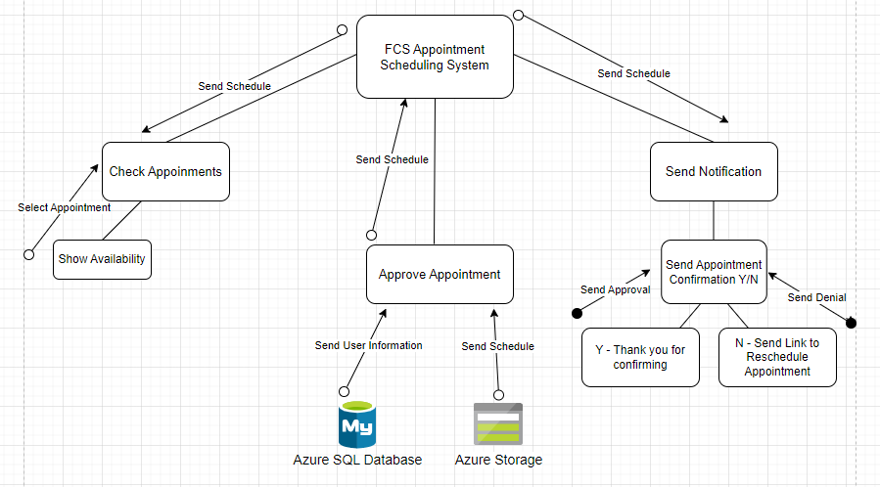
6.1 Structure Chart.

6.2 Structure Chart Discussion
The structure chart shows how the FCS Appointment Scheduling System is organized into modular components, each interacting through data and control flows.

- Components:
  - Main Program: Controls system flow and data exchange.
  - Authentication: Verifies user credentials for secure access.
  - Appointment Scheduling: Handles the scheduling logic.
  - Database Management: Communicates with the Azure SQL Database.
  - Storage Management: Manages data storage through Azure Storage.
- Component Interactions:
  - The Main Program triggers Authentication for user verification.
  - Authentication checks credentials via Database Management.
  - FCS Portal interacts with Appointment Scheduling.
  - Appointment Scheduling updates Database Management with appointment details.
- Design Rationale:
  - Modularity: Each component handles a specific task.
  - Reusability: Components are reusable across the system.
  - Scalability: New components can be added or changed easily.

Human Interface Design
The Human Interface Design section provides an overview of how users will interact with the FCS Appointment Scheduling System. This section outlines the functionality from the user's perspective and provides mockups of web pages for each key interaction point.

7.1 Functionality from User Perspective

Functionality from the user’s perspective is designed to minimize the steps needed for appointment confirmation. By keeping the options to a minimum, we will reduce the time needed for appointment selection. The FCS Appointment Scheduling System allows users to perform the following tasks:

- Users can view available appointment slots and select the most suitable time in a calendar view.

- Once an appointment is selected, the user submits it for approval. If the appointment is still available, it is approved, and the user is notified.

- After approval, users receive confirmation of their appointment, along with additional details. If the appointment is denied, they are sent a link to reschedule.

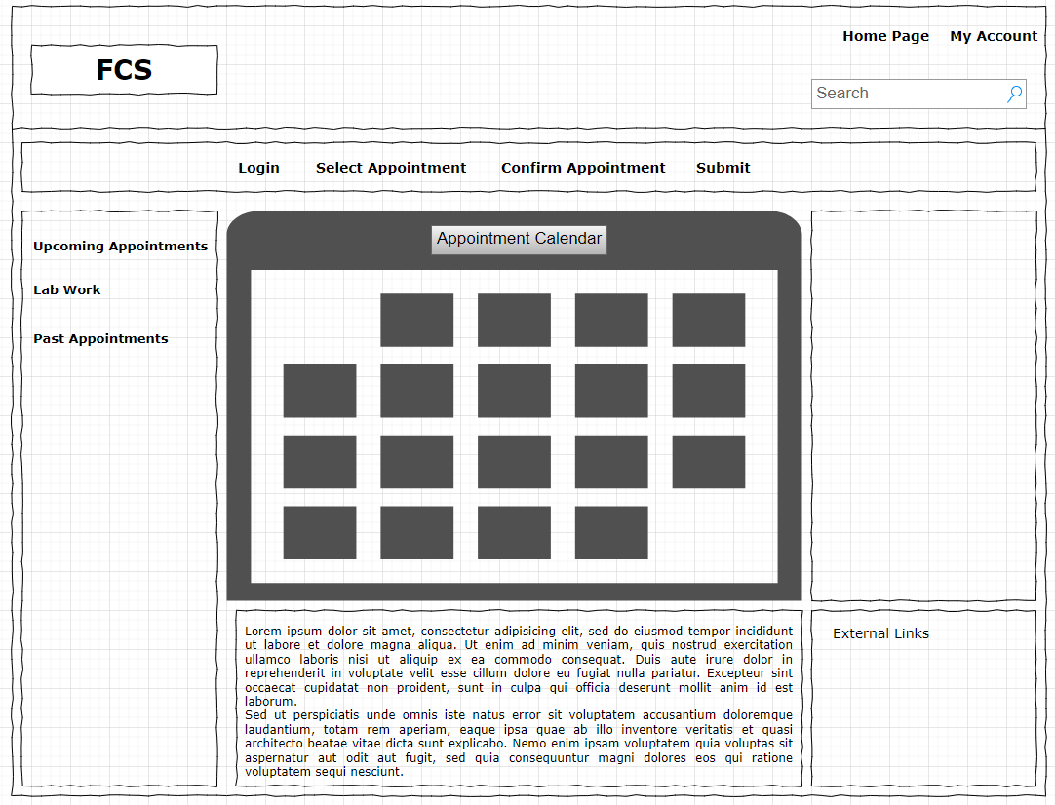
7.2 Sample Mockups of Web Pages for the Case Study.

Testing
This section documents the testing approach to validate system functionality through key use cases, including test cases, discussions, and various testing types.

8.1 Test Case TC001 Schedule New Valid Appointment
Test Case Steps | Description | Test Data | Expected Results | Actual Results | Test Case Status
Step 1 | Select the option to add a new appointment | N/A | The option to add a new appointment appears with the calendar | The option appeared | Pass
Step 2 | Navigate the calendar and click on the day for the appointment | 12/17/2020 (Thursday) | Day appears as selected | Day selected | Pass
Step 3 | Click on the option to choose patient | N/A | Dialog box appears | Dialog box appeared | Pass
Step 4 | Navigate the patient list and choose patient | John Murphy | Patient name appears as selected | Patient name appeared | Pass
Step 5 | Navigate the service provider list and choose available provider | Dr. Bryant | Provider name appears as selected | Provider name appeared | Pass
Step 6 | Choose available room | Room 4 | Room number appears as selected | Room number selected | Pass
Step 7 | Choose appointment start/end time | Start: 9:20 AM, End: 10:00 AM | Start and end time appear as selected | Start and end time selected | Pass
Step 8 | Save the appointment | N/A | Dialog box closes, schedule refreshes with new appointment | Dialog box closed; schedule refreshed | Pass

8.1.1 TC001 Discussion.

Test case validates the ability of the system to successfully create a new appointment using valid data. Each step, from selecting a patient and provider to choosing a room and time slot, was executed without errors. The successful completion of all steps, including saving the appointment and refreshing the schedule, demonstrates that the system functions as expected under normal conditions and is ready for use.

8.2 Test Case TC002 Cancel Scheduled Appointment
Test Case Steps | Description | Test Data | Expected Results | Actual Results | Test Case Status
Step 1 | Select an existing appointment | John Murphy, 12/17/2020 | Appointment details appear | Appointment details appeared | Pass
Step 2 | Click the delete option | N/A | Confirmation prompt appears | Confirmation prompt appeared | Pass
Step 3 | Confirm the deletion | N/A | Appointment is removed from schedule | Appointment was removed | Pass

8.2.1 TC002 Discussion.

This test case verifies effective appointment cancellation, ensuring a confirmation prompt and schedule update. It maintains scheduling accuracy and prevents conflicts.

8.3 Test Case TC003 Schedule New Appointment without Data
Test Case Steps | Description | Test Data | Expected Results | Actual Results | Test Case Status
Step 1 | Select the option to add a new appointment | N/A | The option to add a new appointment appears | Option appeared | Pass
Step 2 | Leave patient field blank and try to save | N/A | Error message appears for missing patient | Error message appeared | Pass
Step 3 | Leave provider field blank and try to save | N/A | Error message appears for missing provider | Error message appeared | Pass
Step 4 | Leave room and time slot fields blank and try to save | N/A | Error message appears for missing fields | Error message appeared | Pass

8.3.1 TC003 Discussion.

This test case focuses on the system’s behavior when mandatory fields are left blank. It verifies that the system identifies missing information and displays appropriate error messages.

8.4 Test Case TC004 Schedule Appointment with Schedule Conflict
Test Case Steps | Description | Test Data | Expected Results | Actual Results | Test Case Status
Step 1 | Select the option to add a new appointment | N/A | The option to add a new appointment appears | Option appeared | Pass
Step 2 | Choose date, patient, provider, room | 12/17/2020, John Murphy, Dr. Bryant, Room 4 | Fields are populated | Fields populated | Pass
Step 3 | Select overlapping start and end time | 9:20 AM to 10:00 AM (already taken) | Error message appears indicating schedule conflict | Error message appeared | Pass

8.4.1 TC004 Discussion.

This test case checks that the system detects and prevents scheduling conflicts. It confirms that when a new appointment conflicts with an existing one, the system displays an error message. This feature is critical for avoiding double bookings and maintaining schedule integrity.

8.5 Testing Types
Different testing types ensure the system's reliability and performance throughout development.

- Unit Testing: Verifies individual components (e.g., time validation, error handling).
- Integration Testing: Examines component interactions (e.g., data exchange, workflow).
- System Testing: Evaluates overall functionality and performance (e.g., functional testing, performance testing).
- Acceptance Testing: Confirms alignment with business and user requirements (e.g., UAT, regression testing).

Appendix.
<Add other relevant sections here.

Remove these directions after completing the section.>

