System Design Specification
Sean F. Coggeshall
American Public University System
INFO498 Information Technology Capstone

System Design Specification
Table of Contents
1. Management Summary 3
a. Requirements and Development to Date 3
b. Current Status and Implementation Schedule Highlights 3
c. Project Costs, Benefits, and Management Issues 4
2. System Components 4
a. System 4
3. System Environment 6
Constraints 6
Hardware Requirements 6
Software Requirements 6
Security 6
4. Implementation Requirements 7
Start-Up and Data Migration 7
Training and Testing 7
5. Time and cost estimates 7
Schedule 7
Costs 8
Staffing 8
6. Additional Material 8
References 8

1. Management Summary

a. Requirements and Development to Date
Club IT requires a comprehensive, integrated technology solution to modernize its outdated inventory and point-of-sale (POS) processes. The new system must deliver real-time, tablet-based order processing, instant inventory updates with low-stock alerts, and seamless integration with Microsoft Access and Power BI for robust reporting and trend analysis. Enhanced security measures, including encrypted cloud data storage (via Square POS and Microsoft Azure), role-based access controls, and reliable backup and recovery protocols, are essential. Initial investigations highlighted critical inefficiencies from current manual inventory methods and aging hardware with only 1GB RAM. A successful pilot deployment using Square POS on two tablets confirmed the new system’s rapid response times, user-friendly interface, and effective data integration with existing Microsoft tools.

b. Current Status and Implementation Schedule Highlights
Infrastructure enhancements, including upgraded business-class Wi-Fi and Azure SQL cloud database setup, are progressing on schedule. Data migration scripts are finalized for transferring historical Excel-based sales and inventory records to the new platform. Training materials, such as quick-reference guides and instructional videos, are in the final stages of preparation for staff distribution.
- Key implementation milestones include:
- Week 1: Complete infrastructure deployment and initial data migration.
- Week 2: Conduct expanded pilot tests during slower operational periods.
- Week 3: Execute comprehensive staff training sessions and full system tests.
- Week 4: Finalize club-wide rollout and provide immediate post-launch support.

c. Project Costs, Benefits, and Management Issues
The total estimated cost for this implementation is approximately $22,500, including hardware and network upgrades ($10,000), software licenses and cloud services ($5,000), and implementation support and staff training ($7,500). Expected benefits are substantial, featuring at least a 15% reduction in inventory stock-outs, 20% less manual reporting effort, enhanced accuracy of sales data, improved customer service through reduced waiting times, and an anticipated 3% increase in overall margins.
Management will need to proactively address the following critical issues to ensure smooth execution:
- Approval of budget reallocation to cover weekend and after-hours system installations.
- Securing a secondary internet connection to guarantee continuous and reliable system performance.
- Effective scheduling and coordination to maximize staff participation in training sessions while minimizing disruption to daily operations.

2. System Components

a. System
The new system at Club IT is designed to replace outdated manual processes with a modern, cloud-based solution. It combines Square POS on the front end with Microsoft Azure on the back end to handle transactions, inventory, data storage, and reporting. Staff will use iPad tablets with the Square app to take orders, enter modifiers, and process payments. Orders will appear instantly on a kitchen display screen, removing the need for paper tickets and helping reduce order errors. Managers will access reports and dashboards through Power BI and Microsoft Access, allowing them to work within tools they already know.
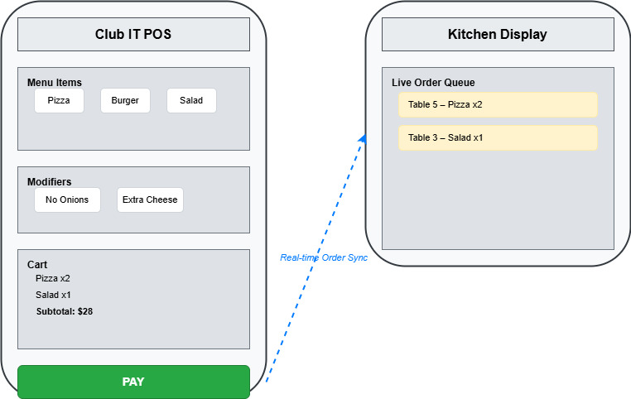
Every time a sale is made, the system updates inventory levels in real time. If a stock item falls below its set threshold, an alert is automatically emailed to management. These alerts, paired with daily sales dashboards, make it easier to stay on top of inventory and avoid running out of key items during peak hours.
Data from all parts of the system is stored in an Azure SQL Managed Instance. Nightly backups are pushed to Azure Blob Storage, and weekly backups are archived to OneDrive to ensure a 30-day recovery window. The system runs on a secure, business-class dual-band Wi-Fi network, supported by an Azure VPN Gateway to encrypt all data between devices and the cloud. A backup internet connection will also be available to keep things running in case of a primary connection failure.
Each morning, startup scripts will check for connectivity and available storage across the tablets and servers. Transaction logs are kept for 90 days, and historical sales and inventory data will be saved for long-term use. The Square POS system syncs with Azure using secure APIs, and both Power BI and Access connect through ODBC to allow easy access to reporting without needing to learn new tools. Visuals like flow diagrams and screen mockups are provided in the appendix to support system setup, training, and documentation.

3. System Environment

Constraints
The system must support peak transaction volumes of up to 120 orders per hour with response times under two seconds. Inventory records may grow to 2,000 unique items, requiring optimized storage and indexing. Daily reports must be generated and made available to management by 10 a.m. System uptime is required seven days a week, with scheduled maintenance limited to early morning hours to avoid interfering with operations.

Hardware Requirements
The environment includes six iPad Air tablets for servers, four bar-station tablets, one 27-inch kitchen display monitor, and a cloud-hosted Azure virtual machine for backend processing. Business-class dual-band Wi-Fi is required to provide uninterrupted connectivity throughout the venue. A secondary internet line will be provisioned to support redundancy and minimize downtime.

Software Requirements
The system will run Square POS on all tablets for order processing. Microsoft Azure SQL Managed Instance will serve as the central database for storing transactions, inventory, and user data. Reporting tools include Power BI for dashboards and Microsoft Access for ad hoc reporting. All system components will communicate securely via the Azure VPN Gateway, and software updates will be applied during low-traffic hours.

Security
Security measures include role-based access control, ensuring that only authorized users can perform sensitive functions such as inventory editing and report generation. All data is encrypted in transit using TLS and at rest with Azure Transparent Data Encryption. Administrative accounts are protected with multi-factor authentication to reduce the risk of unauthorized access.
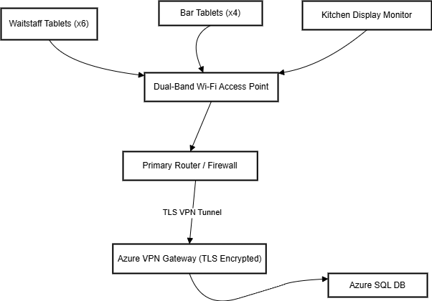

4. Implementation Requirements

Start-Up and Data Migration
Initial setup includes configuring Wi-Fi access points, deploying tablets, setting up Square POS accounts, and establishing a secure VPN connection to Azure. Historical inventory and sales data from Excel will be cleaned and imported into Azure SQL through Access staging tables, followed by validation against the source files.

Training and Testing
Frontline staff will attend two 90-minute training sessions focused on order entry and tablet use. Managers will complete a 60-minute session on reporting and inventory controls. Quick-reference guides and support materials will be distributed. Testing includes unit checks for database triggers, integration tests for POS-to-database sync, and load testing simulating peak transaction volume. A rollback drill will confirm manual operations can resume if needed.

5. Time and cost estimates

Schedule
- Week 1: Infrastructure deployment and data migration
- Week 2: Pilot launch and adjustments
- Week 3: Full staff training and live system testing
- Week 4: Final rollout and post-launch support

Costs
- Hardware and network upgrades: $10,000
- Software licenses and cloud services: $5,000
- Implementation, training, and support: $7,500
- Total Estimated Cost: $22,500
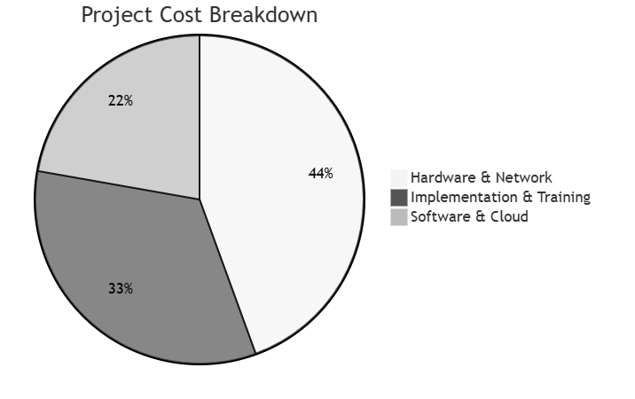

Staffing
- Project Lead: 60 hours
- IT Technicians (2): 40 hours each
- Trainers (3): 10 hours each
- Total Costs-to-Date: $3,200

