INFO498 Final Case Studies Name: Sean Coggeshall

Instructions:
Your essays will be graded on content to include grammar and spelling. Each case should take 1-2 pages including diagrams. The essay answers for both #2 and #3 should be 500 to 700 words each, in order to completely answer the questions. Please submit as one document.
Assignment:
#1. Forest Point Construction (System Planning)
- What is the correct total time?

The correct total time to complete the steel building project is 31 days. This is much shorter than a naive sum of all task durations because several tasks run in parallel.

- Create a Gantt chart that shows WBS.

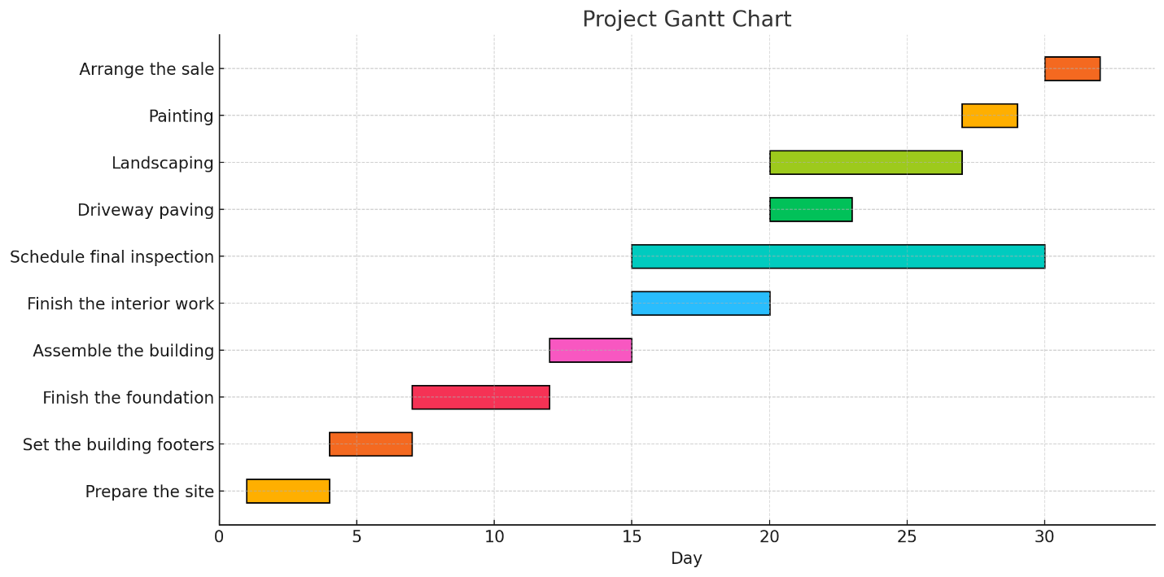

- What is the critical path?

The critical path shows the sequence of activities that sets the shortest possible timeline to finish the project. In this case, it follows the longest chain of tasks that depend on each other without any gaps.

According to the schedule, the critical path includes these steps:
preparing the site, setting the building footers, finishing the foundation, assembling the building, completing the interior work, doing the landscaping, painting, and finally arranging the sale. Any delay in one of these tasks will directly extend the total project duration.

Each of these tasks must be completed one after the other with no delay, and any delay in one would delay the whole project.

#2. Atrium Bio-Medical Supply, Inc. (System Analysis)
- What options does Atrium have for acquiring a new system?

Atrium can build a custom system in-house using its IT team, purchase an off-the-shelf system from a vendor, or outsource development to an external firm. Another option is to adopt a cloud-based SaaS solution, which is maintained by a third-party provider and paid through a subscription. Each approach offers different levels of control, customization, cost, and speed of deployment. Atrium could also consider hybrid strategies, such as buying a commercial package and then customizing it or integrating it with existing tools.

- What are the pros and cons of in-house development versus purchasing a system?

In-house development allows a system to be tailored precisely to Atrium’s workflows, giving full control over design, implementation, and future enhancements. This can result in a strong competitive advantage and seamless integration with current processes and data. However, it requires significant time, budget, and a highly skilled development team, and carries higher risks of delays, technical challenges, and cost overruns. Ongoing maintenance and support also remain Atrium’s responsibility.

Purchasing a system is usually faster to deploy and has lower initial costs. It comes with vendor support, updates, and tested features that are already proven in similar businesses. The trade-off is that it may not fit all of Atrium’s needs perfectly, requiring process adjustments, custom configurations, or additional modules. Long-term dependency on the vendor for updates, support, and licensing can also limit flexibility in the future.

- If the decision is made to purchase a new system, what are three options for customizing the software?

When Atrium chooses to purchase an off-the-shelf system, they have three practical paths for tailoring the software to its business. Vendor customization lets the software maker adjust the product to Atrium’s exact requirements, guaranteeing full support but adding extra cost. A second option is paid enhancement, where Atrium funds new features that the vendor weaves into the standard product line; those features may later benefit other customers as well. The third path is in-house modification, allowing Atrium’s own IT team to extend or tweak the system, assuming the license permits it. This internal work offers flexibility yet can complicate future patches and upgrades from the vendor.

- Based on Part C of the Systems Analyst’s Toolkit, what financial analysis tools should you use to evaluate the software acquisition options for Atrium? Explain how you would apply each of the tools.

Atrium should use payback period, ROI, and NPV to evaluate the software acquisition options. The payback period measures how quickly cumulative benefits, such as cost savings or productivity gains, recover the initial investment. For example, if a system costs $100,000 and generates $50,000 in annual savings, the payback period would be two years. ROI compares net gains to total costs to illustrate profitability over time, using the formula ROI = Net Benefits divided by Total Costs multiplied by 100%. A higher ROI means a more favorable return on investment. NPV discounts future cash flows to their present value using a chosen discount rate, which helps assess which option provides the greatest overall value, accounting for the time value of money. Taking together, these tools allow Atrium to balance short-term affordability with long-term benefits and risks, supporting a well-informed and financially sound decision.

.
#3. Nothing But Net (System Design)
- Should an organization choose a new system based on client/server architecture? Why or why not?

Client/server architecture is generally a smart choice for most organizations because it centralizes data management, improves security, and scales easily as the business grows. With a central server, it is simpler to back up data, enforce access controls, and support many users working together. Client/server design also makes it easier to maintain consistent software versions and apply patches across the system. However, it does introduce dependencies: if the server fails or becomes overloaded, clients may lose access to critical applications and files. Setting up and maintaining the servers requires an upward investment in skilled IT staff and reliable infrastructure. Even with these costs, the benefits of control, centralized management, and flexibility usually outweigh the drawbacks for businesses with multiple users and shared resources.

- Explain the pros and cons of thick or thin client characteristics.

Thick clients handle more processing locally on the user’s machine. This can improve performance, allow offline work, and enable more sophisticated interfaces. Applications like graphic design or data analysis often run best on thick clients because they can use the full power of local hardware. The downside is that each workstation must be updated, secured, and supported individually, which increases complexity and maintenance time. Thin clients, in contrast, rely on the server for most processing and data storage. This makes it much simpler to update applications, enforce security policies, and ensure consistency across users. Thin clients are also easier to deploy on lower-cost hardware. However, they are heavily dependent on network speed and stability. If connectivity is poor or the server is under heavy load, performance suffers, and productivity can stall.

- What is the difference between physical and logical topology? Provide examples.

Physical topology describes how devices are linked together in the real-world using cables, wireless connections, or other infrastructure. For example, a star layout has each device connecting directly to a central switch or hub, while a bus layout involves all devices sharing one main cable. Logical topology shows how data moves across the network and how devices communicate. In many Ethernet networks, the setup looks like a star because each device connects to a switch, but logically it works like a bus since data packets reach all devices and each one checks if the information is addressed to it. Token Ring networks often use cables that looks like a star with a central hub, but the data travels in a logical ring where a token is passed around to control who can send messages. Knowing both physical and logical arrangements is important for designing, securing, and troubleshooting a network effectively.

- Will mobile devices replace desktop system units and traditional laptop computers? How would networks have to change if that were to happen?

Mobile devices have become essential for many tasks, and in some industries, they have already replaced desktops for activities like email, messaging, and point-of-sale. Still, desktops and laptops remain better suited for work that requires large displays, precise input devices, or heavy processing. If mobile devices became the main computing tools across an organization, networks would need much stronger wireless coverage, increased bandwidth, and more capacity to handle hundreds of simultaneous connections. Companies would also need better mobile device management tools, VPN and secure remote access solutions, and stricter policies to protect sensitive data. Supporting a mobile-first environment would require investment in robust Wi-Fi infrastructure (such as Wi-Fi 6 or 6E), segmentation of network traffic, and continuous monitoring to ensure performance and security. While mobile adoption will keep growing, traditional desktops will likely still have a role in scenarios requiring advanced capabilities and ergonomic setups.

