ISSC221 Final Project
Sean F. Coggeshall
American Military University

Table of Contents
ISSC221 Final Project 3
Chapter 1 Motherboard and Memory 3
Chapter 2 Optical Disk and Drive Prep 5
Chapter 3 Computer and Video Interfaces 9
Chapter 5 Workstation Specifics: 11
Chapter 6 Network Topologies and OSI Model: 13
Chapter 7 IP Addressing: 15
Chapter 8 Wireless Networking: 15
Chapter 9 Laptop Video/Hardware: 15
References 17

ISSC221 Final Project

Chapter 1 Motherboard and Memory:
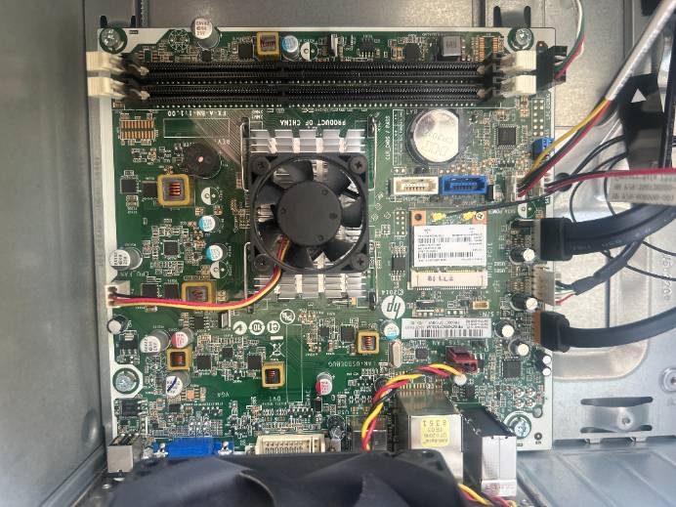
This is an HP Pavilion Desktop - 550-a114 from my parents’ house.
Memory Slots (RAM)
CMOS Battery
CPU and Fan
SATA Interfaces
Main Power (19.5V DC In)

Memory Modules:
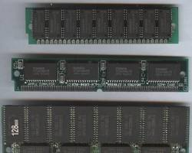
Single In-Line Memory Module (SIMM):

- Older technology, primarily used in late 1980s and 1990s computers.
- 30 or 72 pins.
- Limited capacity, typically up to 64 MB.
- Replaced by DIMMs due to limitations and higher data transfer rates needed.
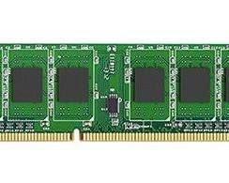
Dual In-Line Memory Module (DIMM):

- Current standard memory module for desktops and some servers.
- 168 pins (standard DDR3 and DDR4) or 240 pins (DDR5)
- Higher capacity compared to SIMMs (up to several Gigabytes).
- Supports higher data transfer speeds for faster computer performance.

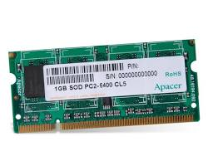
Small Outline Dual In-Line Memory Module (SODIMM):

- Smaller version of the DIMM designed for laptops and other compact devices.
- 200 or 260 pins depending on the generation (DDR3, DDR4).
- Lower capacity compared to standard DIMMs due to size constraints.
- Supports similar data transfer speeds as DIMMs of the same generation.

Rambus In-Line Memory Module (RIMM):
- Less common type, primarily used in high-performance systems in the late 1990s and early 2000s.
- 184 pins.
- Offered higher data transfer rates compared to early DDR SDRAM DIMMs.
- Generally, more expensive than DIMMs.
- Largely replaced by high-performance DDR memory advancements.

Chapter 2 Optical Disk and Drive Prep
Recordable CDs (CDs)
- CD-R: Up to 700MB (stated capacity) and can hold approximately 80 minutes of audio.
- CD-RW: Up to 700MB (stated capacity) and can be rewritten multiple times (typically 1,000 erase/rewrite cycles).
Recordable DVDs (DVDs)
- DVD-R:
  - Single layer: Up to 4.7GB (stated capacity).
- Double-layer: Up to 8.5GB (stated capacity).
DVD+RW:
  - Single layer: Up to 4.7GB (stated capacity), but rewritable capabilities may reduce usable space slightly.
  - Double-layer: Up to 8.5GB (stated capacity), but rewritable capabilities may reduce usable space slightly.
Recordable Blu-ray Discs (BDs)
- BD-R:
  - Single layer: Up to 25GB (stated capacity).
  - Double-layer: Up to 50GB (stated capacity).
  - Triple-layer: Up to 100GB (stated capacity).
BD-XL:
  - Single layer: Up to 128GB (stated capacity).
  - Triple layer: Up to 300GB (stated capacity).
  - Quad-layer: Up to 400GB (stated capacity).
Drive Installation and Preparation:
I used a USB I had laying around. You can see the two partitions with folders within them in the last screenshot (New Folder and New Folder 2).
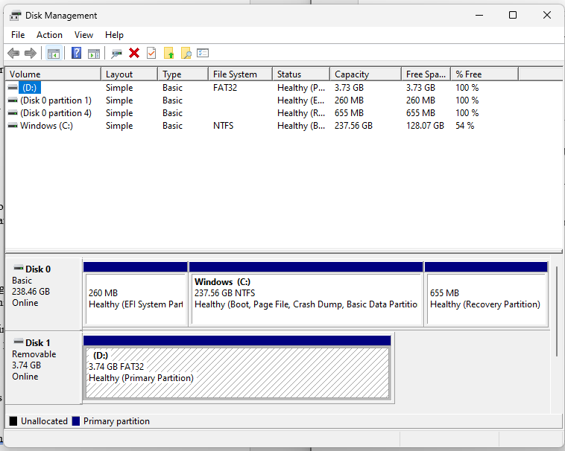

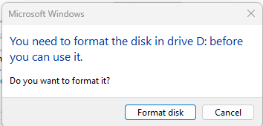
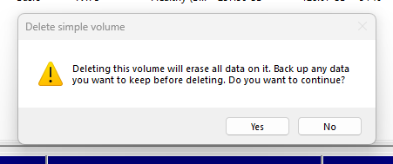

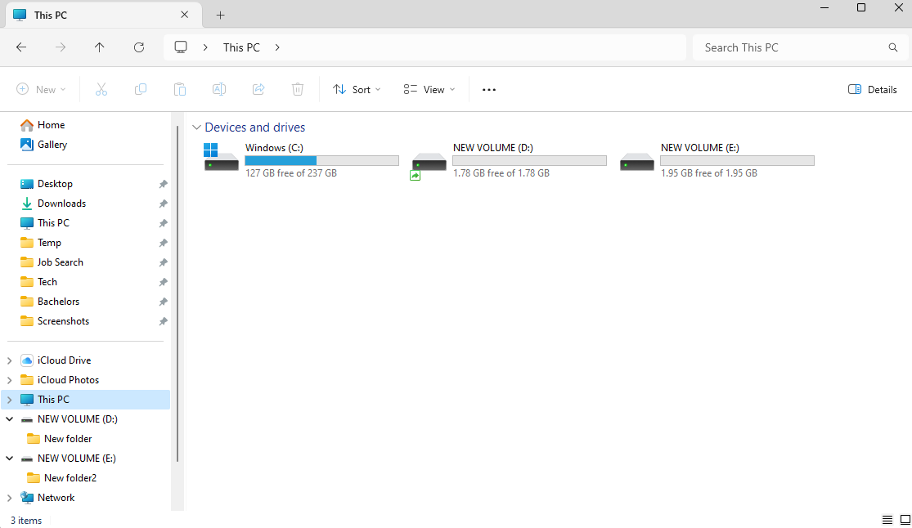

Chapter 3 Computer and Video Interfaces
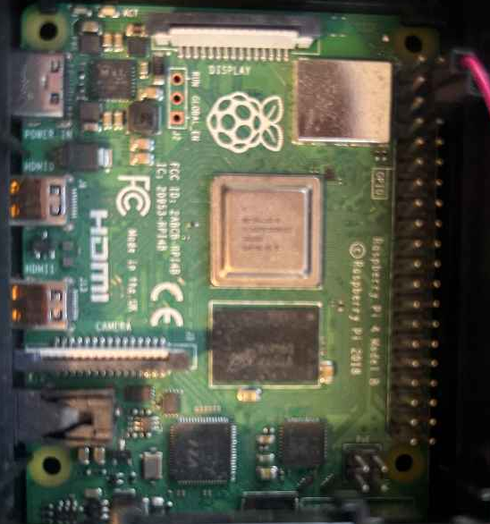
This is a Raspberry Pi 4 I had in my room.
I/O interface for a Raspberry Pi:
- USB-A Ports: These versatile ports are used to connect a wide range of peripherals, such as external hard drives, flash drives, keyboards, mice, printers, scanners, and more.
- HDMI Port: This port can be used to connect a high-definition monitor or projector for video and audio output.
- USB-C Port: A newer, more versatile type of USB port that can support higher data transfer speeds, power delivery, and video output (depending on the implementation). On some laptops, the USB-C port may also be used for charging the laptop.
- Headphone/Microphone Jack (3.5mm): This jack can be used for connecting headphones or speakers for audio output, or a microphone for audio input.
- Power Connector: This port is used to connect the laptop to the power adapter for charging.
- Ethernet Port: For connecting to a wired network.
- MicroSD Card Reader: A slot for inserting and reading MicroSD cards, commonly used in cameras and mobile devices. On the Raspberry Pi, you use it to install the OS.
Video Interfaces:
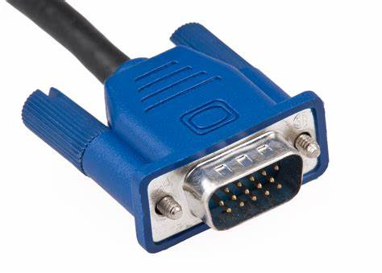
VGA (Video Graphics Array):
A legacy analog video interface commonly found on older monitors and laptops. Offers lower video quality compared to digital interfaces and limited to lower resolutions.
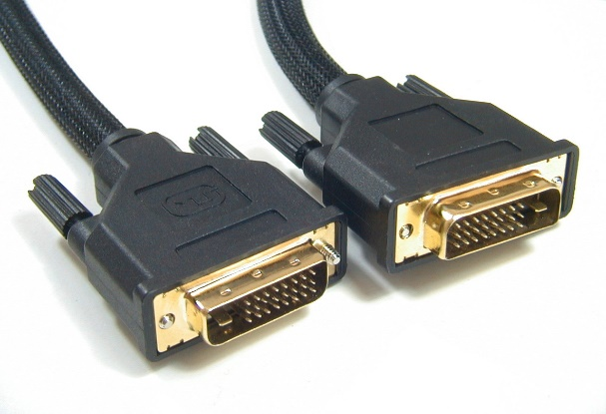
DVI (Digital Visual Interface):
An older digital video interface, primarily found on older monitors and some desktops. Offers digital video transmission but lacks audio capabilities. Available in various subtypes like DVI-D (digital only) and DVI-I (integrated digital and analog).

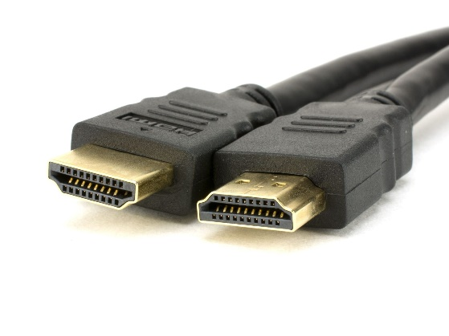
HDMI (High-Definition Multimedia Interface):
The most common digital video interface for modern displays, offering high-resolution video and audio transmission over a single cable. Supports resolutions up to 8K with high refresh rates and features like HDR (High Dynamic Range) for enhanced visuals.
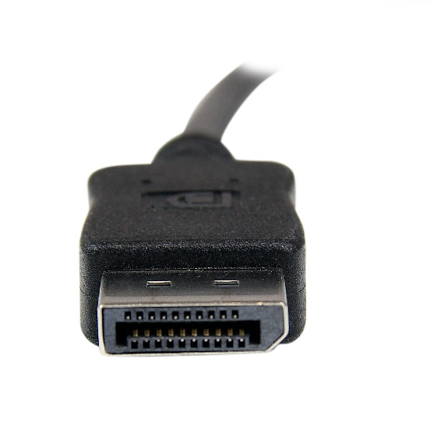
Display Port:

Another digital video interface offering high-resolution video and audio transmission. Often used as an alternative to HDMI, particularly in professional environments. Supports similar resolutions and features as HDMI.

Chapter 5 Workstation Specifics:
List two features that should be enhanced for each of the following: graphic and CAD/CAM workstations, audio/video editing workstations, virtualization workstations, gaming PCs, home theater PCs, and home server PCs.

CAD/CAM Workstations: High-performance graphics cards are used for rendering complex 3D models and detailed graphics. A powerful CPU with multiple cores and high clock speeds is necessary to handle intensive design and calculation tasks.

Audio/Video Editing Workstations: Expanded RAM is needed for smoother editing and processing of large audio and video files. High-speed storage solutions, such as SSDs with fast read/write speeds, allow for quick access to media files and efficient editing.

Virtualization Workstations: Large amounts of RAM are necessary to allocate sufficient memory to each virtual machine. Multiple CPUs or multi-core CPUs provide processing power to multiple virtual environments, making a better overall performance.

Gaming PCs: A high-end GPU creates high frame rates and detailed visuals in the latest games. A fast refresh rate monitor creates smooth gameplay and reduces motion blur, making a better gaming experience.

Home Theater PCs: A quality sound card is important for high audio playback through a home theater system. Support for 4K video allows viewers to enjoy high-definition content on a large screen, providing better visual quality.

Home Server PCs: Redundant storage solutions, such as RAID configurations, protect data against drive failures and ensure data reliability. Enhanced network capabilities, like Gigabit Ethernet or faster network cards, create quick data transfer across the network.

Chapter 6 Network Topologies and OSI Model:
Bus topology is simple to install and configure, requiring less cable compared to star topology. It is easy to expand by adding new devices to the main cable and is cost-effective due to simpler components. However, it has a single point of failure. If the main cable fails, the entire network goes down. Performance can also degrade with more devices due to increased traffic on the shared cable.
Star topologies are scalable and allow an easy addition or removal of devices without affecting others. It is reliable because the failure of one device doesn't impact the rest of the network, and troubleshooting is easier due to dedicated connections. However, star topology has higher costs because it requires more cable and a central hub or switch, which can be a single point of failure and adds complexity to the network.
Ring topology provides deterministic performance with data packets traveling in a specific order. However, it has a single point of failure. If one device in the ring fails, the entire network can go down. Troubleshooting can be complex due to the challenge of isolating problems within the ring.
Mesh topologies are highly scalable and flexible, allowing multiple device connections, which makes expansion and redundancy easier. However, it is costly due to the need for more cable and potentially more complex hardware. Managing a mesh network requires complex configuration and troubleshooting, and it can have higher power consumption due to the increased number of devices.

OSI Model:
Physical Layer (Layer 1): The Physical layer transmits raw bits over a physical medium. This layer includes the layout of pins, voltages, cable specifications, hubs, repeaters, network adapters, and more.
Data Link Layer (Layer 2): The Data Link layer provides node-to-node data transfer, creating a link between two directly connected nodes. It comprises two sublayers, the Logical Link Control (LLC) and Media Access Control (MAC).
Network Layer (Layer 3): The Network layer determines how data is sent from the source network to the receiving devices. It routes packets according to unique network addresses.
Transport Layer (Layer 4): The Transport layer transfers variable-length data sequences from a source to a destination host while maintaining quality of service functions. This layer includes protocols like TCP (Transmission Control Protocol) and UDP (User Datagram Protocol).
Session Layer (Layer 5): The Session layer manages sessions between end-user applications. It establishes, manages, and terminates connections between local and remote applications.
Presentation Layer (Layer 6): The Presentation layer translates data between the application layer and the network format. It ensures data is in a usable format and handles data encryption.
Application Layer (Layer 7): The Application layer serves as the window for users and application processes to access network services. This layer includes all higher-level protocols like SMTP (Simple Mail Transfer Protocol), FTP (File Transfer Protocol), HTTP (Hypertext Transfer Protocol), and more.

Chapter 7 IP Addressing:
IP address (What class is it?) 192.168.1.161(Preferred) Class C private IP range.
Subnet mask (Is it the default subnet mask?) Yes, it is the default - 255.255.255.0
Default gateway fe80::d2fc:d0ff:fefc:2a11%9.
DNS server(s) 2600:1700:62e0:63d0::1 and 192.168.1.254.
DHCP server 192.168.1.254
Do you have an IPv6 address? If so, what is it? 2600:1700:62e0:63d0::36(Preferred)

Chapter 8 Wireless Networking:
Locate the wireless access points and wireless routers on your network.
Do they allow sufficient coverage for everyone who needs access? Not really, I have an ethernet cord run from the router to my computer. It goes into the wall from what was an old phone line, into the attic, across the house, out into my room and into my docking station.
Do they use the same SSID or different SSIDs? We have one SSID.
Do they broadcast their SSIDs? – Yes, we broadcast our SSID.
Is a password required to get on the wireless network? Yes, we have password protection.

Chapter 9 Laptop Video/Hardware:
I checked System Information; I do not use shared video memory.
- Hard drive - 256 GB PCIe® NVMe™ M.2 SSD
- Memory - 8 GB DDR4-2666 SDRAM (1 x 8 GB)
- Processor - Intel® Core™ i5-1035G1 (1.0 GHz base frequency, up to 3.6 GHz with Intel® Turbo Boost Technology, 6 MB cache, 4 cores)
- Expansion slots - 1 multi-format SD media card reader
- Wireless network card - Product Type Realtek RTL8821CE 802.11ac PCIe Adapter802.11ac (1x1) Wi-Fi® and Bluetooth® 4.2 combo
- Video card - Intel® UHD Graphics
- CMOS battery – The newer HP Notebooks do not come with a CMOS battery; the internal battery maintains the clock and BIOS settings.

BIOS Version and beep codes:
BIOS Version/Date: AMI F.32, 11/16/2023. HP does not list diagnostic lights and audible beep codes for all models but offer the following:
The red-light blinks represent a major error category (long blinks).
- The white light blinks represent a minor error category (short blinks).
- A one (1) second pause occurs after the last major blink.
- A two (2) second pause occurs after the last minor blink.
- Blink error code sequences continue until you unplug the computer or press the power button.
- Beep error code sequences occur for the first five (5) iterations of the pattern, and then stop.

References
GeeksforGeeks. (2024, March 12). Introduction of classful IP addressing. GeeksforGeeks. https://www.geeksforgeeks.org/introduction-of-classful-ip-addressing/
IP Chicken - What is my IP address? Free public IP lookup. (n.d.). https://ipchicken.com/
ISO - 35.100 - Open systems interconnection (OSI). (n.d.). https://www.iso.org/ics/35.100/x/
HP Notebook 15-DY1086NR Product Specifications | HP® Support. (n.d.). https://support.hp.com/us-en/document/c06447665
How to use interaction accessibility settings in Windows 11. (n.d.). https://support.hp.com/us-en/product/setup-user-guides/hp-15-dy1000-laptop-pc-series/model/31046525
Getting started - Raspberry Pi Documentation. (n.d.). https://www.raspberrypi.com/documentation/computers/getting-started.html
GeeksforGeeks. (2024, June 3). Types of computer ports. GeeksforGeeks. https://www.geeksforgeeks.org/types-of-computer-ports/
Paul, I. (2020, November 4). What is RAM? Everything you need to know. How-To Geek. https://www.howtogeek.com/697659/what-is-ram-everything-you-need-to-know/
Messer, J. & Messer Studios, LLC. (2018). Professor Messer’s CompTIA 220-1001 Core 1 A+ Course Notes. http://www.ProfessorMesser.com

