Website Vibe
Sean F. Coggeshall
American Military University
Table of Contents
Website Vibe 3
Checkout Process 3
Pros and Cons 4
User Interactions 4
References 5

Website Vibe
I selected to visit Best Buy’s website. Instantly I recognized the brand due to the use of a white, blue, and yellow color scheme that is both visually appealing and functional. These colors not only represent the brand but also create a consistent and professional look that builds trust with the user. The homepage is well-organized, featuring intuitive navigation with a menu bar, search functionality, and cart access prominently displayed at the top of the page. The design ensures that important elements are easy to locate and use, which enhances the overall user experience. The balance between functionality and aesthetics makes it clear why Best Buy is a leader in online retail.
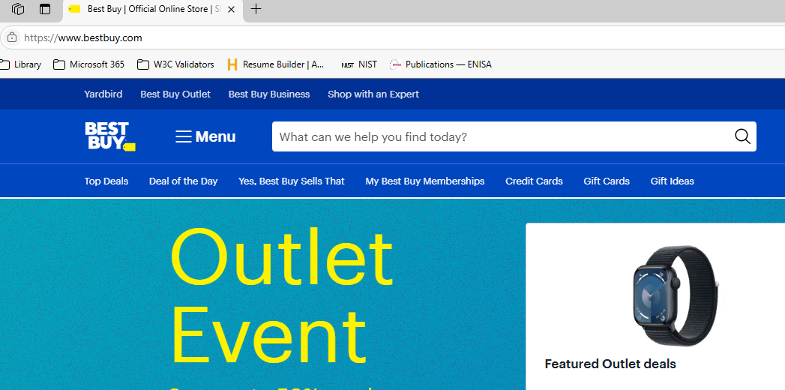

Checkout Process
The website’s navigation is straightforward and logical, with well-structured product categories. Clicking "Add to Cart" triggers a side menu displaying cart details, allowing users to proceed to checkout or continue shopping seamlessly. The cart provides a clear view of selected items, including warranty options, ensuring transparency. The checkout process is flexible, offering the option to log in or continue as a guest, with basic contact information required for order confirmation, which would be used for communication during the shipping process.

Pros and Cons
I didn’t find any broken links while looking on the site, which shows that the site is well-maintained and reliable. The item I tested the checkout process with did get all the way to the end before it told me it was not available in the nearest store. Had I been wanting to buy that, it would have been frustrating, as it wastes time and creates a poor user experience. I did like that I was not prompted to login until I was making a purchase. This approach respects the user's browsing experience and avoids unnecessary interruptions, which I find thoughtful. I never like making an account until I know I want to save something like order history. This flexibility is a welcome feature compared to some sites. Some sites give you a login pop-up right when you get to their page, which can be intrusive and off-putting for potential customers.

User Interactions
Interactive features further enhance engagement. For example, location permissions adjust the default pickup store to the nearest Best Buy, personalizing the shopping experience. This feature is particularly useful for customers who prefer in-store pickups, as it saves them the step of manually selecting a store. Additional options like newsletter signups, social sharing, and detailed product information were options at checkout, these increase user interaction and convenience. These features make it easy for users to stay informed about new products, promotions, and updates while also allowing them to share their interests with others. Together, these features demonstrate Best Buy’s effort to create a seamless and engaging shopping experience for its users.

References
Kaushik, A. (2010). Beginner’s Guide to web Data Analysis: Ten steps to love & Success.
Best Buy | Official Online Store | Shop Now & Save. (n.d.). BestBuy.com. https://www.bestbuy.com/

McGuirk, M. (2023). Performing web analytics with Google Analytics 4: a platform review. Journal of Marketing Analytics, 11(4), 854–868. https://doi.org/10.1057/s41270-023-00244-4

