Lab #1 - Assessment Worksheet
Evaluating Web Server Vulnerabilities

Course Name and Number:
Student Name:
Sean Coggeshall

Instructor Name:
Jon Adams

Lab Due Date:
November 17, 2024

Lab Assessment Questions

- What are some of the greatest risks businesses face when connecting to the web? Why?

Data breaches, malware, and DDoS attacks are some of the greater risks, as they lead to data loss, financial harm, and damage to reputation.

- Why is it critical to perform periodic web-application vulnerability assessments and penetration tests?

These tests detect new vulnerabilities, which can be addressed through updates and patches. Creating a more secure environment.

- Why might connecting your web servers and web applications to the Internet be like opening Pandora’s Box?

Connecting to the internet exposes web servers to a wide range of threats, as they become accessible to potentially malicious actors globally. Like Pandora’s Box, opening to the internet introduces new security risks that require careful management.

- What does the Skipfish application do, and why is it a good security tool for web servers and web application testing?

Skipfish scans for web vulnerabilities like SQL injection and XSS, making it useful for securing web applications.

- What is tcpdump, and why is it a good tool for testing the Ubuntu Linux web server and web application security?

Tcpdump captures network packets, helping identify suspicious activity or vulnerabilities in web traffic.

- What does the Firefox Live HTTP Headers plug-in application do, and why is this a good tool for web server and web application security testing?

It shows HTTP headers, allowing testers to spot data leaks, insecure cookies, and configuration issues.

- What does using the -h switch for tcpdump and skipfish do?

The -h switch displays the help menu, listing available commands and options.

- What information can you determine from the ifconfig -a command?

It shows network interface details, like IP addresses and MAC addresses, useful for network troubleshooting.

Lab Report
Part 1
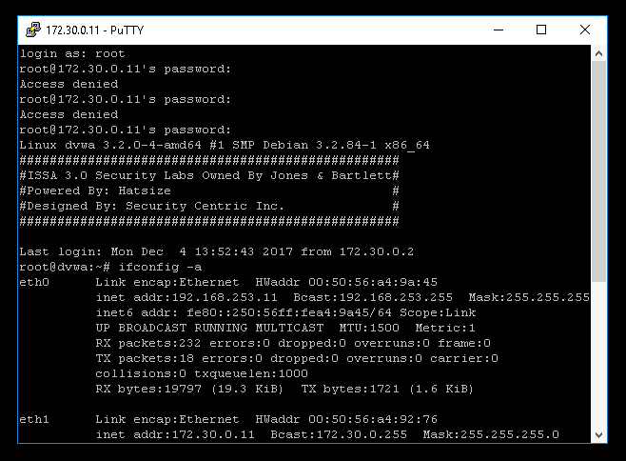

Describe how tcpdump can identify vulnerabilities in web traffic.

Tcpdump captures and analyzes network packets, allowing identification of unusual patterns, open ports, and potentially malicious traffic that could indicate vulnerabilities.

Describe how Skipfish can identify vulnerabilities in web traffic.

Skipfish is a web application scanner that crawls the site and identifies common vulnerabilities like cross-site scripting (XSS) and SQL injection by analyzing server responses to various inputs.

Part 2

Summarize the type of information identified by the Live HTTP Headers add-on.

Live HTTP Headers shows HTTP request and response headers, including information like cookies, user-agent, referrer, and server details.

Describe how Live HTTP Headers add-on can identify vulnerabilities in web traffic.

By inspecting headers, it can reveal missing security headers like Content-Security-Policy and potential data leaks, which help in identifying configuration issues or insecure setups.

Part 3
- Publicly traded retailer: Compromised applications can lead to customer data breaches, affecting trust, revenue, and potentially stock value.
- Small private law firm: Leaked client information could lead to privacy violations, damaging reputation and client trust.
- Real estate appraisal company: Breaches may expose sensitive financial data, affecting credibility with clients and partners.
- Web hosting company: If compromised, it risks exposing multiple clients' data, leading to severe liability and trust issues across its customer base.

