Review of Aspects of UX Psychology

Sean Coggeshall
School of Science, Technology, Engineering & Math, APUS
ENTD120 User Experience I
Instructor Kathryn Williams
September 26, 2024

Table of Contents
Effective UX Design 3
User Psychology Principles 3
Ethical Implications 4
UX Techniques 4
Impact on Business Success 4
References 6

Effective UX Design

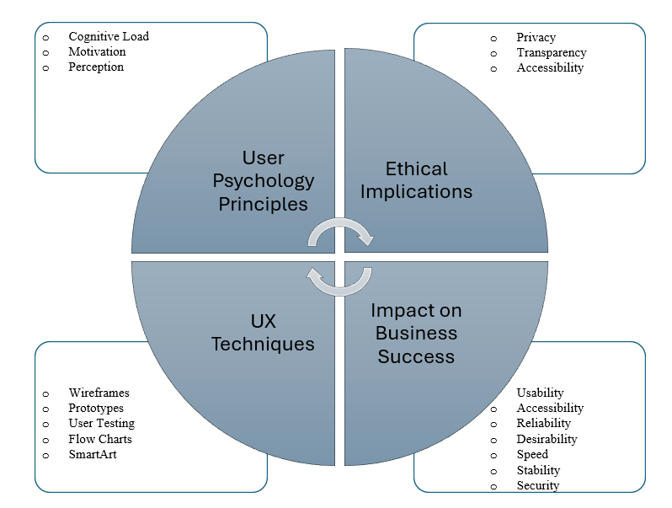

User Psychology Principles
UX and Psychology Principles go hand in hand when it comes to creating a good product. Principles such as cognitive load, motivation, and perception affect how your product is used, liked, and purchased. One way you can look at this is how a product or service is learnt, the more people that learn to use it, the more companies that will buy it. We see this in example with Security Training and products like AWS.
Security Training often comes with a security awareness program for its end users. A way to keep the company safe, although most people do not show up to work hoping to do some mandated training. A new technique called “Gamification” has been developed to make the learning experience a more engaging experience and less tedious for end users (Robb, 2024).
Amazon Web Services uses gamification to teach technicians how to use their products (AWS Skill Builder, n.d.). The more technicians that use AWS, the more companies will use it rather than a competitor like Azure or Google Cloud.

Ethical Implications
UX design can raise ethical concerns. Meta recently created UX design that made it extremely difficult for end users to find how to opt out of data collection for AI (Mauran, 2024). There are multiple links, you need to fill out forms, and then it needs to be reviewed. This is unethical, using UX to make the process difficult for end users in the hopes that they give up.

UX Techniques
Effective UX design leverages various techniques to create seamless experiences:
- User research and testing
- Wireframing and prototyping
- Iterative design and feedback
- Accessibility guidelines and testing
- Analytics and user behavior tracking
These techniques enable designers to craft intuitive, user-centered products that meet real-world needs.

Impact on Business Success
Investing in UX design significantly impacts business success:
- Enhanced user engagement and satisfaction
- Increased conversion rates and revenue
- Improved brand reputation and loyalty
- Competitive edge in the market
- Increased productivity and reduced support costs
By prioritizing UX, businesses can drive growth, innovation, and long-term success.

References
Robb, D. (2024, March 4). How gamification boosts security awareness training effectiveness https://www.infosecinstitute.com/resources/industry-insights/how-gamification-boosts-security-awareness-training-effectiveness/
AWS Skill Builder. (n.d.). https://explore.skillbuilder.aws/learn/signin
Mauran, C. (2024, May 30). Meta is using your posts to train AI. It’s not easy to opt out. Mashable. https://mashable.com/article/meta-using-posts-train-ai-opt-out
Naumets, N. (2022, May 14). The business value of UX - UX Collective. Medium. https://uxdesign.cc/business-value-of-ux-design-35a8039b4817

