The UX Process: The Design Stage. Implementation of Basic Design Principles

Sean Coggeshall
School of Science, Technology, Engineering & Math, APUS
ENTD120 User Experience I
Instructor Kathryn Williams
October 3, 2024

The UX Process
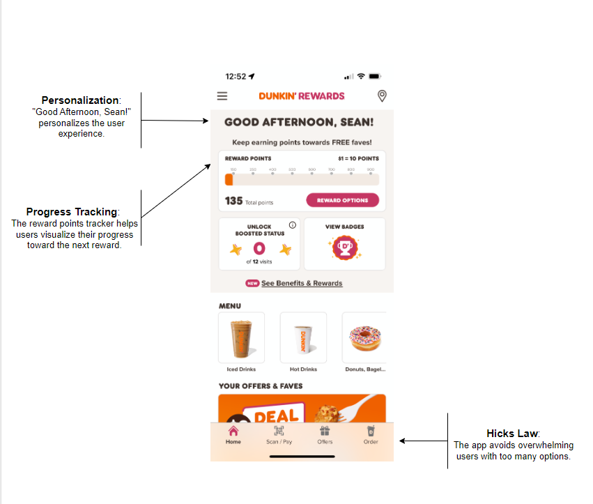
This is a screenshot of my Dunkin app, featuring reward points and a personalized greeting at the top. In the top/middle, you can track your rewards points and explore options to view badges, unlock statuses, and access the menu. The menu items are clearly listed with both text of what they are and pictures. When selected it lets you preview the items before entering the "ordering" mode. At the bottom you are the main options for quick navigation.

Fundamental Concept of UX: Gamification
Gamification involves incorporating game-like elements into non-gaming contexts to enhance user engagement, motivation, and experience. This can include features like points, badges, leaderboards, and challenges that encourage users to interact more with an app or service.
In the Dunkin' app, the reward points system uses gamification by allowing users to earn points with each purchase. The visual representation of points earned, and the clear goal of unlocking rewards motivate users to engage more frequently with the app. The concept of "unlocking boosted status" further gamifies the experience, encouraging users to complete more visits to achieve rewards.

Main Steps of UX Process
- Research: Gather insights about user preferences, behaviors, and pain points through surveys, interviews, and observation.
- Define: Analyze research findings to define user personas and create problem statements that outline user needs and goals.
- Ideate: Brainstorm various design solutions and features that address identified problems, encouraging creativity and collaboration.
- Design: Create wireframes and prototypes that visualize the proposed solutions, focusing on user flows and interaction design.
- Test: Conduct usability testing sessions with real users to gather feedback on the designs, identifying areas for improvement.
- Implement: Work closely with developers to ensure accurate execution of the designs in the final product.
- Evaluate: After the launch, monitor user interactions and satisfaction, using analytics to assess the product's performance and identify opportunities for future enhancements.

Psychology Principle: Intrinsic Motivation
Intrinsic motivation refers to engaging in an activity for its inherent satisfaction rather than for some separable consequence. When users find joy, interest, or personal fulfillment in using a product, they are more likely to engage with it regularly (Neuhaus, 2024).
The Dunkin' app uses intrinsic motivation by providing a personalized experience through greetings and visual progress tracking of reward points. The satisfaction of accumulating points and achieving rewards creates a sense of accomplishment and enjoyment. This intrinsic motivation is likely to encourage users to return to the app, which would increase overall user retention and engagement.

References
Neuhaus, M., PhD. (2024, August 5). Intrinsic motivation explained: 10 examples & Key factors. PositivePsychology.com. https://positivepsychology.com/intrinsic-motivation-examples/
Dunkin’® | America’s favorite coffee, espresso and donuts | Dunkin’®. (n.d.). https://www.dunkindonuts.com/en
Bruton, L. (2023, November 13). What is the UX design process? A step-by-step guide - UX Design Institute. UX Design Institute. https://www.uxdesigninstitute.com/blog/ux-design-process/

