User Behavior and UX Design
Sean F. Coggeshall
School of Science, Technology, Engineering & Math, APUS
ENTD120 User Experience I
Instructor Kathryn Williams
October 16, 2024

Table of Contents
User Behavior and UX Design 3
Overview of UX Design Importance 3
User Psychology and Behavior 3
Analyzing User Behavior 4
Integrating UX Design into Business Strategy 4
Keeping Up with new UX Strategies 5
Conclusion 5
References 6

User Behavior and UX Design
Successful user experiences must be understanding of user behavior. It aligns product functionality with what users expect to make the interaction easy, satisfactory, and engaging. This way, designers will be able to learn how users think and behave, constructing an interface that speaks both functionally and emotionally to users. Effective UX design bridges the gap between user behavior and digital solutions to seamless interactions, create engagement, and meet the needs of the user.

Overview of UX Design Importance
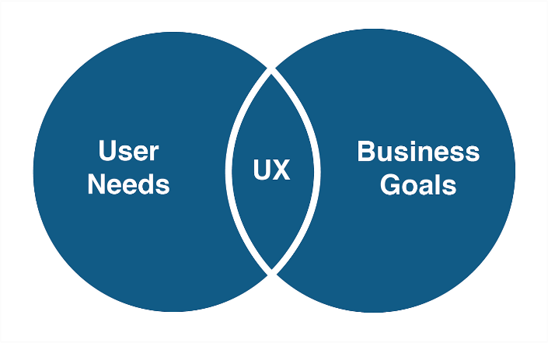
UX design is responsible for instinctive user journeys that guarantee not only the rise in satisfaction and engagement but also brand loyalty. The emphasis on UX means a higher number of conversions through building customer trust and growing your business. Beyond usability, it ensures accessibility, reduces abandoned carts, and fosters long-term loyalty. According to Doncaster (2014), businesses that implement UX into their strategy ensure better retention, performance, and competitiveness.

(Akinbade, 2019)

User Psychology and Behavior
Understanding user psychology impacts how you create the UX. By recognizing cognitive biases and behavioral patterns, designers can create user-centered designs that cater to users' needs and improve overall usability. Cognitive load, emotional responses, and behavior all show how users interact with digital products. If it takes too much of a cognitive load from users to find the information they need, they may quit a task before finishing.
An advantage of integrating psychological insights into UX design is that it minimizes cognitive load, allowing users to interact with a product with less effort. The result of this is a much more satisfying user experience, leading to higher engagement and better usability. By understanding the mental models and decision-making processes, designers can align product interfaces to exactly the way users naturally think and act.
Analyzing User Behavior Looking into users' behaviors offers insight into the motivations, preferences, and pain points of users. Examples of research methods would be usability testing, A/B testing, surveys, and cognitive mapping in which the methodologies drive design decisions about how users are engaging with products. Cognitive mapping helps one understand the user needs and mental models, for example, to make an educated set of design decisions.
Usability testing is a way to observe users with a product to understand points of friction, while A/B testing creates two versions of a design and then tests them to deduce which one performs better. The methods provide insight into making design choices based on actual data about the users rather than assumptions; it thus provides for more effective user experiences.
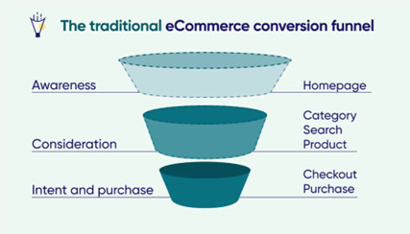
Integrating UX Design into Business Strategy By aligning UX design with the business strategy, this would not only meet the needs of the user but also the organization. For example, streamlining checkout flows in e-commerce sites reduces cart abandonment and increases sales. The companies that work on making UX support strategic objectives don't just meet customer expectations but act on meaningful successes through increased user satisfaction and retention. This funnel chart highlights how UX design can lead to more purchases.

(Contentsquare, n.d.)
Keeping Up with new UX Strategies UX design is constantly changing; to survive, designers need to stay abreast of emergent trends and technologies. As Tune and Perrin (2024) present, companies should regularly update their UX strategy if they want to outcompete others in this ever-changing digital landscape. The very trends surrounding voice interfaces, augmented reality, and personalization are shifting the goalposts of user expectations.
Continuous learning plays an important role in keeping pace with these changes. Designs should not be reactive; instead, they should proactively explore new effective methodologies and tools. If the backend technology doesn’t get updated but you continue to change the frontend, you can run into integration and compatibility issues. In Architecture Modernization, they called this ‘putting lipstick on a pig’ (Tune & Perrin, 2024). Which paints a good picture of what bad integration can look like.


(PNGKey, n.d.)
Conclusion Successful UX design, based on profound knowledge of user behavior and psychology, is important to make any digital product successful. Only a user-centric approach, analysis of user behavior, and integration of UX into the business strategy add value to customers through satisfaction, engagement, and loyalty. Constant adaptability towards new emerging trends keeps organizations competitive and relevant in the fast-changing digital environment. At the end of it all, UX design should never be just about building useful products but creating meaningful user experiences that elicit tangible business value and long-term success.

References
Canziba, E. (2018). Hands-On UX design for Developers.
Doncaster, P. (2014). The UX Five-Second Rules: Guidelines for User Experience Design’s Simplest Testing Technique. Morgan Kaufmann.
Evans, D. C. (2017). Bottlenecks: Aligning UX Design with User Psychology. Apress.
Solis, B. (2013). WTF?: What’s the Future of Business?: Changing the Way Businesses Create Experiences. John Wiley & Sons.
Taraghi, M., Armellini, F., & Imbeau, D. (2024). An exploratory investigation of cognitive mapping for analyzing needs in UX design. IEEE Transactions on Engineering Management, 71, 6581–6594. https://doi.org/10.1109/tem.2023.3277432
Tune, N., & Perrin, J. (2024). Architecture modernization: Socio-technical Alignment of Software, Strategy, and Structure. Simon and Schuster.
Buley, L., Natoli, J. (2024). The User Experience Team of One: A Research and Design Survival Guide. United States: Rosenfeld Media.
Gothelf, J. (2013). Lean UX: Applying Lean Principles to Improve User Experience. Germany: O'Reilly Media, Incorporated.
Krug, S. (2009). Don't Make Me Think: A Common Sense Approach to Web Usability. Ukraine: Pearson Education.
Free download Pig Lipstick Clipart Lipstick on a Pig - Cute Pig with Lipstick - Free transparent PNG download - PNGKey. (n.d.). PNGkey.com. https://www.pngkey.com/detail/u2q8e6a9w7i1y3w7_free-download-pig-lipstick-clipart-lipstick-on-a/
Jacklaw. (2024b, July 8). How to adapt to the changing eCommerce conversion Funnel. Contentsquare. https://contentsquare.com/blog/ecommerce-conversion-funnel-transformation/
Adenike, A. (2022, January 6). IMPACT OF UX DESIGN IN BUSINESS - Akinbade Adenike - Medium. Medium. https://medium.com/@akinbade.adenike/impact-of-ux-design-in-business-35fc0f3489d8

