Looks like this when processed
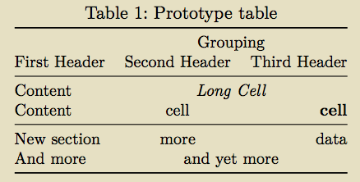

Note position in colons in line after headers
two colons -> align centre
one colon on right -> align right

