# **The Blah News Effect: Media Blah and Snurfling**

Ritsy McMeikan

Ritsumeikan University, Dept. of IR

mail-id@xx.ritsumei.ac.jp

## **Abstract**

About 200 words max here. Aenean eu leo quam. Pellentesque ornare sem lacinia quam venenatis vestibulum. Aenean eu leo quam. Pellentesque ornare sem lacinia quam venenatis vestibulum. Vivamus sagittis lacus vel augue laoreet rutrum faucibus dolor auctor. Praesent commodo cursus magna, vel scelerisque nisl consectetur et. Cum sociis natoque penatibus et magnis dis parturient montes, nascetur ridiculus mus. Aenean lacinia bibendum nulla sed consectetur. The Fox News effect could be a temporary learning effect for rational voters, or a permanent effect for voters subject to non-rational persuasion.

## **1. Introduction** (Section 1 - First-level header)

This is what my paper is about: this is where I tell you what question I'm trying to answer (maybe some explanation of how you came to think of this question as important and worth answering) and, just as importantly, why this question is interesting and why the reader should carry on reading (because it’s a relevant and interesting question!) Text lines are either aligned-left or *justified*, like these.

Also very briefly describe how you answered the question (or attempted to) - describe your methodology – and outline what you found. Explain where problems arose etc.

Explain what your research means in the larger sense; how does what you found affect how we understand the world? Or at least that little bit of it you studied.

To mark paragraphs either indent *or* leave some space (any empty line or half a line)… *don't do both (like I did for this paragraph)*! Cras justo odio, dapibus ac facilisis in, egestas eget quam. Cum sociis natoque penatibus et magnis dis parturient montes, nascetur ridiculus mus. Vivamus sagittis lacus vel augue laoreet rutrum faucibus dolor auctor. Maecenas faucibus mollis interdum.

This paper looks at the films of Stanley Kubrick which include *2001: A Space Odyssey*(1968) and *Barry Lyndon*(1972), also the little known *Titles of Things Go in Italics* (2015). Likewise, though it might be *mendo-kusai*, foreign words go in italics too. Pellentesque ornare sem lacinia quam venenatis vestibulum. Vivamus sagittis lacus vel augue laoreet rutrum faucibus dolor auctor. Praesent commodo cursus magna, vel scelerisque nisl consectetur et. Cum sociis natoque penatibus et magnis dis parturient montes. Praesent commodo cursus magna, vel scelerisque nisl consectetur et. Cum sociis natoque penatibus et magnis dis parturient montes. *Try to make paragraphs finish within the page. Having a line leaking over onto the top of the next page (a ‘hanging line’) might mean it gets missed by the reader.* Bear in mind that the ‘Introduction’ is more or less the **last** thing you write; after all, until you have finished your writing, how do you know what you’re introducing?

## **2. Literature Review** (Section 2)

Try not to have headers right at the bottom of a page, it’s better just to move it down a couple of lines to keep it with the text. I will be dealing with the following theories, ideas and terminology. This is where my ideas came from and this is what other academics have said about them.

Finally, this is why I think these ideas etc are the right ones to answer the questions I outlined in the introduction.

Remember topic, body, wrap: start your paragraphs with a sentence saying what the bit the reader is about to encounter is for, what are you going to do in this bit? Then, the next few sentences actually do what you just said you were gong to do (make claim, present evidence, explain some concept etc). Then, and this is important, finish your paragraph with a sentence that explain why it was important for the reader to understand went previously, and maybe the significance of what you just wrote about for your argument. Aenean eu leo quam. Pellentesque ornare sem lacinia quam venenatis vestibulum. Aenean eu leo quam. Pellentesque ornare sem lacinia quam venenatis vestibulum. Vivamus sagittis lacus vel augue laoreet rutrum faucibus dolor auctor. Praesent commodo cursus magna, vel scelerisque nisl consectetur et. Cum sociis natoque penatibus et magnis dis parturient montes, nascetur ridiculus mus. Aenean lacinia bibendum nulla sed consectetur.[1]

Aenean eu leo quam. Pellentesque ornare sem lacinia quam venenatis vestibulum. Aenean eu leo quam. Pellentesque ornare sem lacinia quam venenatis vestibulum. Vivamus sagittis lacus vel augue laoreet rutrum faucibus dolor auctor. I didn't actually come up with this all on my own I borrowed ideas from other scholars.(Akamatsu, 1972; Porter and Sakakibara, 2004)

Finally, remember that you are writing in English! So in your software set the language of your document to ‘English’ and make sure you use a font suitable for English! Hint, if your font has a name in *kanji* then it probably unsuitable (there may be problems with letter spacing or with punctuation marks) for writing English!

## **3. Theoretical Framework** (Section 3)

This is how I see all the bits and pieces I've talked about previously (see section 2) fitting together and how I will use them for my study – previously I told you about what other people said about these ideas, now I'm telling you what I think and why using them is a good way to approach answering the question I mentioned in section 1. Aha, all the pieces/sections are beginning to fit together and their roles are becoming clear!

As Kim(1981, p57) points out, it is ‘important to ensure that all sources are acknowledge through citations’. Cras mattis consectetur purus sit amet fermentum. Integer posuere erat a ante venenatis dapibus posuere velit aliquet. Vivamus sagittis lacus vel augue laoreet rutrum faucibus dolor auctor. Maecenas sed diam eget risus varius blandit sit amet non magna. Integer posuere erat a ante venenatis dapibus posuere velit aliquet. Integer posuere erat a ante venenatis dapibus posuere velit aliquet.

### **3.1 Theory A** (Sub-section 3.1 – second-level header)

This is the first theory that I will be using. It’s important for the following reasons and it’s the right choice because it enables us to focus on the following important things.

Important thing 1. Cras mattis consectetur purus sit amet fermentum. Cras mattis consectetur purus sit amet fermentum. Nullam quis risus eget urna mollis ornare vel eu leo. Cras mattis consectetur purus sit amet fermentum.

Important thing 2. Duis mollis, est non commodo luctus, nisi erat porttitor ligula, eget lacinia odio sem nec elit. Aenean lacinia bibendum nulla sed consectetur. These things are important, this will become especially clear when I describe my results in section X later on.

### **3.2 Concept B** (Sub-section 3.2)

This is the second theory that I will be using. It’s important for the following reasons and it’s the right choice because it enables us to focus on the following important things.

Important thing 1. Cras mattis consectetur purus sit amet fermentum. Cras mattis consectetur purus sit amet fermentum. Nullam quis risus eget urna mollis ornare vel eu leo. Cras mattis consectetur purus sit amet fermentum.

Important thing 2. Duis mollis, est non commodo luctus, nisi erat porttitor ligula, eget lacinia odio sem nec elit. Aenean lacinia bibendum nulla sed consectetur. Integer posuere erat a ante venenatis dapibus posuere velit aliquet. Nullam id dolor id nibh ultricies vehicula ut id elit. Donec sed odio dui.

As you can see these things are important, this will become especially clear when I describe my results in section Y later on.

**3.3 Summary**

So, what this section demonstrated was that these ideas are vital to this study for the reasons I described, and these ideas will be put to work in the upcoming sections I mentioned.

*3.3.1 Another thing (Sub-sub-section 3.3.1 – third-level header)*

Try to avoid the following: having a header and the following paragraph in separate pages, and, any headings lower than a sub-section. This is a relatively short piece of writing so you shouldn't need to ever go beyond the sub-sub-section level!

## **4. Methodology**

In this section I will describe the way I actually did my study. The way I went about answering my question once all the theoretical building blocks were in place.

Based on my understanding of theory I chose the following things (people, newspapers, groups of people, countries, tv shows etc) to study. From this population of ‘things’ I took a sample. This is the sample I took, this is why it's the right sample and this is how it helps me answer my question. Furthermore as Bryson(1991, p34) points out;

Quotes longer than about 40 words, or three lines, should be indented like this to make them easier to spot and read. Vivamus sagittis lacus vel augue laoreet rutrum faucibus dolor auctor. Vestibulum id ligula porta felis euismod semper. Morbi leo risus, porta ac consectetur ac, vestibulum at eros. Cras justo odio, dapibus ac facilisis in, egestas eget quam. Maecenas faucibus mollis interdum. Nullam quis risus eget urna mollis ornare vel eu leo.

Pellentesque ornare sem lacinia quam venenatis vestibulum. Vivamus sagittis lacus vel augue laoreet rutrum faucibus dolor auctor.

## **5. Results**

Describe what you found – that is, what did the activity you described above result in? What were the ‘outputs’? This section can be fairly short. Remember, it’s very likely that if your document is printed out, it will *not* be in colour, therefore all diagrams and charts have to make sense in ‘black and white’.

Figure 1: All figures need a caption!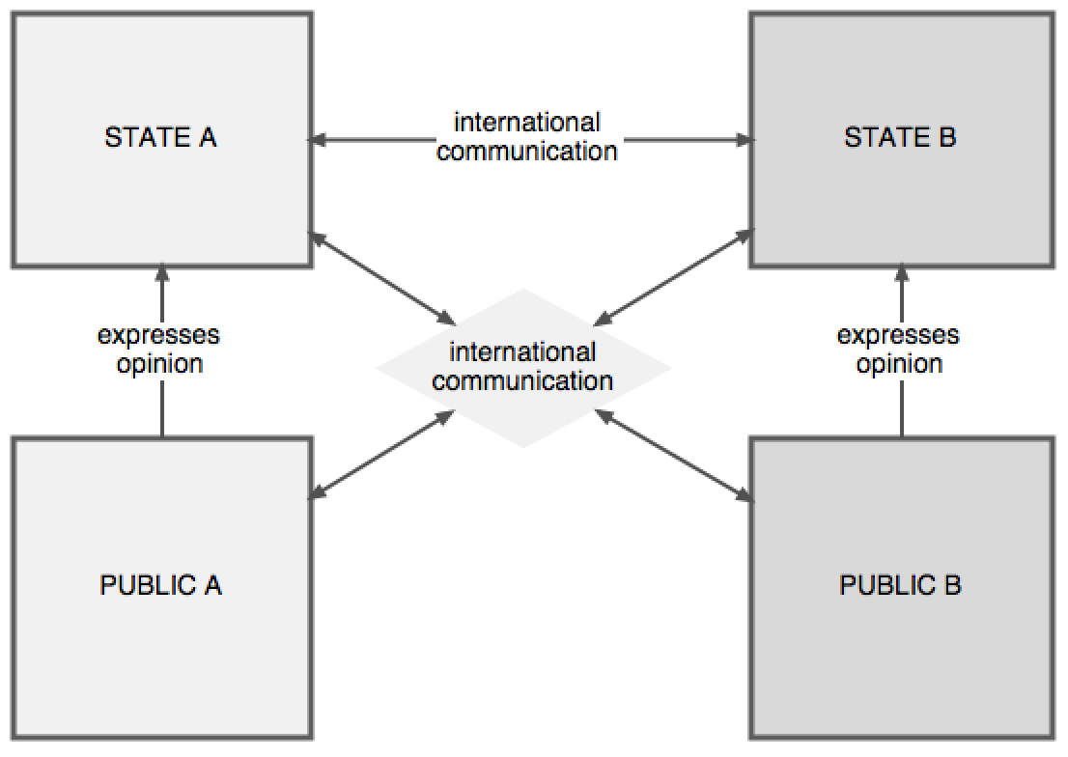

## **6. Discussion**

What do your results mean? Going back to the theoretical framework you described in section 3 - and maybe the things that other academics said in section 2 – what does your study mean? How has it answered your question? Is this what you expected? Was it perhaps surprising? Why? If the results didn't answer your question satisfactorily, what was wrong? Did your theoretical framework mean that perhaps you missed out on things that turned out to be important?

|  |  |  |
| --- | --- | --- |
| **Company name** | **Quantity (%)** | **Amount ($)** |
| Super TV | 2.2 | 3,400 |
| Duper TV | 66.0 | 12,456 |

*Table 1: Tables[2] have to have captions too! Often it's a good idea to try to put tables/figures etc either at the top or bottom of a page (if possible).*

As you can see in table 1 the things I mentioned in section three actually turned up in my results. Cool!

Final paragraph. So, looking back – this is what I said I was interested in doing, and as I have just shown you that's what I did. And if I didn't manage to do what I set out to do, I am now aware of the problems in my methodology etc and have made sure that no-one else can make the same error. I have also become aware of the restrictions and limitations imposed by my assumptions, data sources, sample size (etc) and methods and have therefore been careful when describing the meaning and wider applicability of my results. And what did I say about ‘hanging lines’!?!?

## **References**

Abed, F. (1991). Cultural influences on visual scanning patterns. *Journal of Cross-Cultural Psychology*, 22(4):525–534.

Akamatsu, P. (1972). *Meiji, 1868: Revolution and counter-revolution in Japan*. Harper & Row.

Bignell, J. (2012). *An introduction to television studies*. Routledge.

Bryson, N. (1991). Semiology and visual interpretation. In *Visual theory: Painting and interpretation. Polity*, Cambridge.

Furukawa, T. (1999). ‘Shimbun kisha’ sotsugyō (Newspaper reporter: Graduation)「新聞記者」卒業 . Daisan Shokan, Tokyo.

Heidenheimer, A. J. and Johnston, M., editors (2002). *Political corruption: Concepts and contexts.* Transaction Publishers, New Bruswick NJ.

Kim, Y. C. (1981). *Japanese journalists and their world*. University Press of Virginia, Charlottesville VA.

Kobayashi, Y. (1982). Terebi no nyūsu hōdō ni kansuru naiyō bunseki (Content analysis of television news broadcasts) テレビのニュース報道にかんする内容分析. *Hōgaku Kenkyū*, 55(9):1099–1119.

Marchionni, D. (2013). Journalism-as-a-conversation: A concept explication. *Communication Theory*, 23:131–147.

MEXT (2000). *Gendai Shakai ni okeru Kei’i Hyōgen* (Expressions of Respect in Modern Society) 現代社会における敬意表現. Kokugo Shingikai 国語審議会 National Language Advisory Committee.

Morley, D. (1995). Television: Not so much a visual medium, more a visible object. In Jenks, C., editor, *Visual Culture*. Routledge.

Porter, M. E. and Sakakibara, M. (2004). Competition in Japan. *The Journal of Economic Perspectives*, 18(1):27–50.

Satō, S. (1966). *Asahi Shimbun no Naimaku* (Inside Asahi Shimbun) 朝日新聞の内幕. Jitsugyō no Sekai-sha, Tokyo.

Shibata, R. and NaminoriSha (1987). *Yajiuma masukomi kōza. Hōsō, Rajio-hen* (‘Behind the Scenes’ Mass Media: Broadcasting and Radio) やじうまマスコミ講座: 放送・ラジオ編. Kō Shobō, Tokyo.

Taylor, P. M. (2003). *Munitions of the mind: A history of propaganda*. Manchester University Press, Manchester.

Thompson, R. (1998). *Grammar of the shot*. Focal Press, Oxford.

Watson, J. (2007). Representing realities: An overview of news framing. *Keio Communication Review*, (29):107–131.

Zhu, S. and Mumford, D. (2007). A stochastic grammar of images. *Foundations and Trends in Computer Graphics and Vision*, 2(4):259–362.

1. This is what a footnote looks like. Try to keep these to minimum! Please use footnotes (notes at the bottom of the page) rather than endnotes (notes all together after the main text has finished). Extra information that doesn't fit within the flow of the main text goes here in the footnotes. They’re also useful for things that are textually ‘ugly’, like URLs.
2. Tables generally should not have vertical lines; text should be aligned left, numbers should be aligned right, or if you want to get clever, the decimal points should be aligned to make comparison between rows easier.