

Company Name : inCity Housing Agent

User Documentation

* On how to book or check for available accommodation on our site

Manual Done by: Abdallah Nasser

Yasser El-Kabbout

Mwanjiwa Kamanga

Collette Tlhagwane

*What is InCity?*

Incity house agent is a company in North Cyprus, Lefkosa that offers its services to individuals looking for accommodation or looking to put their houses under rental.

It is a 24hours service company with a website online on the link

<http://swproject.lfcreativity.com/en/?page_id=25>

The below steps will demonstrate on how to use the website for booking for houses

After opening the link given above, you will be on the home page where you can select a house of your choice.

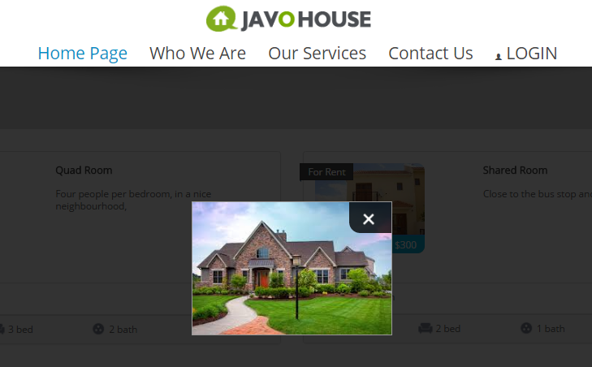You can either click on the pictures of the desired house from the home page in order to see quick snippets of the house inside like the screenshot on the right.

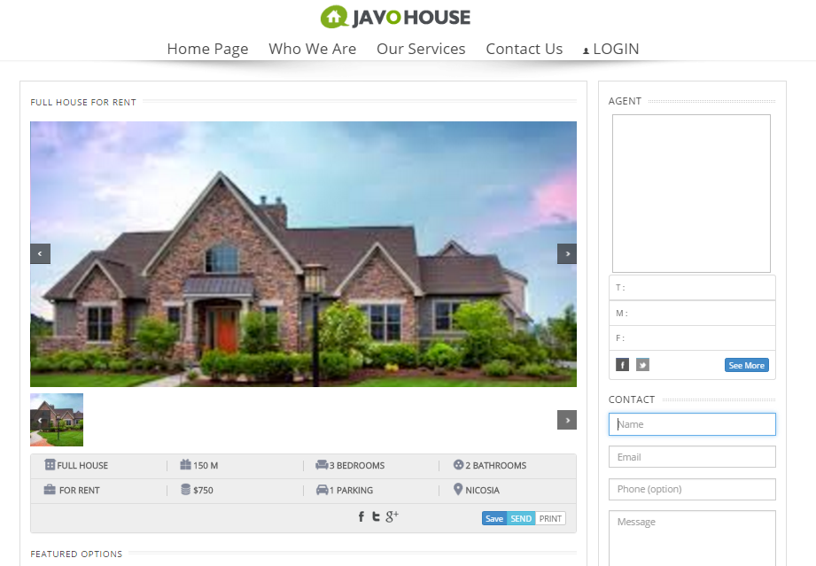When closing the above picture and clicking on the house you want, the site will take you to another page where you can see more pictures of the house and where you can fill in your details for the agency to contact you later on for further details you require

In case the customer would want to contact the agency first, clicking on the top tab where it says “contact us” would direct the individual to a page where all the companies details are written.

This is the page that will come up

