**Outcome 3**

**Stage 2 – Testing**

**Test Log**

**Database at start of testing:**

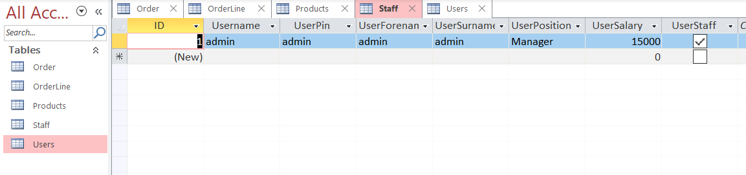

|  |  |  |  |  |  |
| --- | --- | --- | --- | --- | --- |
| **Test No.** | **Action** | **Expected Output** | **Actual Output** | **Result (Pass/Fail)** | **Screenshot** |
| 1 | Start the application. | Program should start up and launch the MainMenu frame. | As expected | Pass |  |
| 2 | Click the Customer Login button on the Main Menu | CustomerLogin frame should show and ask the user to sign in with credentials, | As expected | Pass |  |
| 3 | On Customer Login Page-Enter an invalid Username and Password for any customer:  User: testing  Pass: 1  Press Login button | With invalid credentials the system should reject the login and present an error to the user. | As expected | Pass |  |
| 4 | On Customer Login Page-Enter the Username and Password of a valid customer:  User: test  Pass: test  Press Login button | System should verify credentials and pass user to the Customer Home frame with a welcome. | As expected | Pass |  |
| 5 | Click Register button on the Customer Login Page | Customer Register frame should show and prompt the user to type in credentials. | As expected | Pass |  |
| 6 | On the Customer Registration page attempt to register while missing out key pieces of information:  Username: test6  Pass:  test6  forename:  [miss out]  Surname:  test6  address1:  test6  address2:  test6  postcode:  test6  town:  test6  telephone:  0123456  Press Submit button | System should understand a field has been left blank and reject the registration. An error message should show. | As expected | Pass |  |
| 7 | On the Customer Registration page attempt to register using the same Username as a previously registered customer.  Username: test  Pass:  test  forename:  test  Surname:  test  address1:  test  address2:  test  postcode:  test  town:  test  telephone:  0123456  Press Submit Button | System should recognise the user already exists and reject the registration. An error should be shown to the user. | As expected | Pass |  |
| 8 | On the Customer Registration page press the “Clear” button | If there is any data written in the text boxes the system will clear all of the fields. | As Expected | Pass |  |
| 9 | On the Customer Registration page attempt to register as a valid new customer with a unique username:  Username:  docs  Pass:  docs  forename:  Mr  Surname:  Docs  address1:  docs  address2:  docs  postcode:  docs  town:  docs  telephone:  0123456  Press Submit Button | System should recognise the username is unique and fields are filled. The registration should go through on the system. | As Expected | Pass |  |
| 10 | Once logged in as a Customer, on the Customer Home Page, click “Browse Products” button | System should pass the View Products frame to the user. | As Expected | Pass |  |
| 11 | On the Browse Products screen (as a Customer) click on the ‘Clothing’ item on the first list box under the ‘Categories’ header. | (IF) there are any clothing items added to the DB it should show the items of clothing. (IF NO) items of clothing are available it will not show the items. | In this case there is one clothing product available and the system should display it to the user. | Pass |  |
| 12 | On the Browse Products screen (as a Customer) click on the ‘Footwear’ item on the first list box under the ‘Categories’ header. | (IF) there are any footwear items added to the DB it should show the items of footwear. (IF NO) items of footwear are available it will not show the items. | In this case there is one footwear product available and the system should display it to the user. | Pass |  |
| 13 | On the Browse Products screen (as a Customer) click “Add to Basket” without first selecting any Product. | System should understand no product is selected and give an error to the user. | As expected | Pass |  |
| 14 | On the Browse Products screen (as a Customer) select a Category and Product.  Quantity: 11  Category: Clothing  Product:  ClothingA  Click “Add to Basket” with a Quantity you ATTEMPT to make too high/low for stock level | System should see quantity exceeds product stock level and returns error to user. | As expected | Pass |  |
| 15 | On the Browse Products screen (as a Customer) add valid products and quantities for a number of orderlines  Quantity: 4  Category: Clothing  Product:  ClothingA  Quantity 3  Category: Footwear  Product:  FootwearA | As the stock level is available for both products, the system should add it to the cart of the user. | As Expected | Pass |  |
| 16 | On the Browse Products screen (as a Customer), attempt to buy a product you already have on the basket at a quantity which should be unavailable now  Quantity: 3  Category: Clothing  Product:  ClothingA | As the products stock level has decreased (As it’s in basket) the system should return an error with unavailable stock level. | As expected | Pass. |  |
| 17 | On the Browse Products screen (as a Customer) once you have entered valid entries to your Basket click on “View Basket” button | System should pass the user to the ViewBasket frame and display current basket. | As Expected | Pass |  |
| 19 | On the View Basket page, click the “Remove Selected Product” button without first selecting a Product. | System should see no item has been selected and return an error asking the user to highlight a product. | As Expected | Pass |  |
| 20 | On the View Basket page, click on a  product and click “Remove Selected Product” button | System should remove that current product from the basket and deduct the price from the total. A message should be shown to the user to confirm this deletion. | As Expected | Pass |  |
| 21 | On the View Basket page, click on “Add More Products Button” | System should display the ViewProducts frame to the user. | As Expected | Pass |  |
| 22 | On the Browse Products screen (as a Customer) add another product which is currently already on your basket at a quantity which is still available | System should see that the quantity is still available for the product and update the current orderline with the new order line total. | As Expected | Pass |  |
| 23 | On the View Basket page click “Buy” button | Customer should be redirected to the OrderConfirmation frame and a confirmation of purchase (including order ID) should be shown to the user. | As Expected | Pass |  |
| 24 | On the Confirmation screen (as a Customer that has successfully placed an order) press the Home button | System should redirect the customer to the Customer Home frame. | As expected | Pass |  |
| 25 | Once logged in as a Customer, on the Customer Home Page, click “View My Orders” button | System should redirect user to “View previous Orders” frame and display all of their past completed orders. | As Expected | Pass |  |
| 26 | On the View My Orders page, click on “View Selected Order” button without first clicking on any order from the menu. | System should see no order has been selected and return an error to the user. | As Expected | Pass |  |
| 27 | On the View My Orders page, select an Order and then click “View Selected Order” button | System should move user to PreviousOrderLines frame and display a more in-depth overview of the specific selected order. | As Expected | Pass |  |

Appendix