

# Installation and User Guide for

**Magento 2 Advanced SEO Suite Extension**

**Table of Contents**

1. Installation 5

• Upload Package 5

• Install Extension 5

2. Configuration Settings for SEO Base 5

• General Settings 5

3. Configuration Settings for SEO Sitemap Exclusion 6

• General Settings 6

• Exclude Categories from Sitemap 6

• Exclude Products from Sitemap 6

• Exclude CMS Pages from Sitemap 7

• How to Generate Sitemap . 7

• Add new Sitemap 8

• Magento Out of the Box Functionality to set the Category Path. 8

4. Google Sitemap XML 9

• Product Link in Sitemap XML 9

• Category Link in Sitemap XML. 10

• CMS Pages Link in Sitemap XML. 10

5. Configuration Settings for Catalog URL 10

• General Settings 10

• Configuration Path to Set Up Primary Category 11

6. Front-end Site View 12

• Product Page Unique URL. 12

7. Configuration Settings for Canonical Tags 13

• General Settings 13

• Category Canonical Tag 13

• Product Canonical Tag 14

• CMS Canonical Tag 14

• No Index No Follow 14

• Product Setup for Canonical URL 15

• Category Setup for Canonical URL 16

• CMS Setup for Canonical URL 17

8. Front-end Site View 17

• Canonical Tag on the Category Page 17

• Canonical Tag on the Product Page 18

• Canonical Tag on the CMS Page 18

9. Configuration Settings for Rich Snippets 18

• General Settings 19

• Rich Snippets General Settings 19

• Twitter Card Settings 20

• Facebook Open Graph Settings 21

• Facebook Open Graph Settings 21

• Pinterest Rich Pins Settings 22

10. Structured Data / Markup Code of Front-end Page(s) in Structured Data Testing Tool 22

• Home Page Markup Code 22

• Category Page Markup Code 23

• Product Page Markup Code 24

• Twitter, Facebook Open Graph Social Sharing Code 25

o Twitter Card 25

o Facebook Open Graph 26

• Increased and Optimized Page Ranking in Search Results 26

11. Configuration Settings for Hreflang 27

• General Settings 27

• Language and Country Settings 28

12. Front-end Site view 28

• Hreflang Tag on the Home Page 28

• Hreflang Tag on the Category Page 29

• Hreflang Tag on the Product Page 29

• Hreflang Tag on the CMS Page. 30

13. Configuration Settings for Cross Linking 31

• Cross Links Grid. 33

• Add New Cross Link. 33

• Build External Link to Any Website 35

• Alert Message for Inactive Product / Category 35

14. Front-end Site View 36

• Cross Link on Category Page 36

• Category Page Cross Link Redirecting on External Link 37

• Cross Link on Product Page 38

• Product Page Cross Link Redirecting on Internal Link. 38

• Cross Link on CMS Page 39

# Installation

* Upload Package:Upload the content of the module to your root folder. This will not overwrite the existing Magento folder or files, only the new contents will be added.
* Install Extension:After the successful upload of the package, run below commands on Magento 2 root directory.

**composer require scommerce/seobase**

**php bin/magento setup:upgrade**

**php bin/magento setup:di:compile**

**php bin/magento setup:static-content:deploy**

# Configuration Settings for SEO Base

Go to **Admin > Stores > Configuration > Scommerce Configuration > SEO Base**

### **General Settings**

* **Enabled -** Select “Yes” or “No” to enable or disable the module.
* **License Key –** Please add the license for the extension which is provided in the order confirmation email. Please note license keys are site URL specific. If you require license keys are dev/staging sites then please email us at core@scommerce-mage.com

Select “Yes” to enable the module

Enter the License key for the module

# Configuration Settings for SEO Sitemap Exclusion

Go to **Admin > Stores > Configuration > Scommerce Configuration >** **SEO Sitemap**

### **General Settings**

* **Enable -** Select “Yes” or “No” to enable or disable the module.

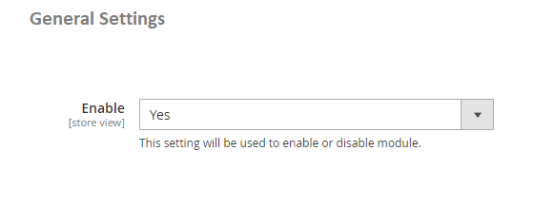

Select “Yes” to enable the module

### **Exclude Categories from Sitemap –** To include or exclude categories, go to Admin > Catalog > Manage Categories > Select category (you want to exclude from site map) > General > Exclude from Sitemap: Set to “Yes/No”

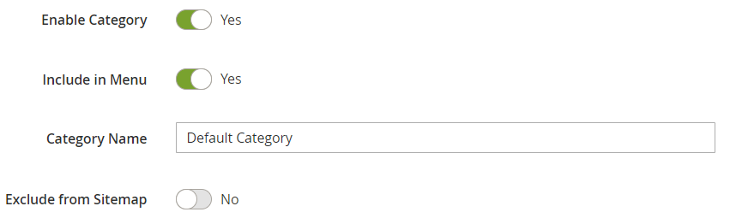

### **Exclude Products from Sitemap –** To exclude products from sitemap, go to Admin > Catalog > Manage Products > Select product (you want to exclude from sitemap) > General > Exclude from Sitemap: Set to ”Yes/No”.

|  |  |  |
| --- | --- | --- |
| **Untitled 1 (2)** **Exclude CMS Pages from Sitemap –** To exclude CMS pages from sitemap, go to Admin > CMS > Pages > Select CMS Page (you want to exclude from site map) > General > Exclude from Sitemap: Set to “Yes/No” **Untitled (2)** **How to Generate Sitemap –** To generate the site map from the admin panel go to, Admin > Marketing > Sitemap > Click ''Generate Sitemap''.  **Add new Sitemap -** You can create new site map from, Admin > Marketing > Sitemap > Click ''Add Sitemap'', it redirects to New Site Map page and by providing all the required details you can create Site Map. **Untitled (2)** **Magento Out of the Box Functionality to set the Category Path -** To include category path in product URLs in sitemap.xml, go to Admin > System > Configuration > Catalog > Catalog > Search Engine Optimizations > Use Categories Path for Product URLs: Set to "yes". **Untitled (2)** Google Sitemap XML - Google site map shows all the included Products, Categories and CMS Pages links in the sitemap.xml. |  |  |

### **Product Link in Sitemap XML -** You can see the product link in the Google Sitemap XML.

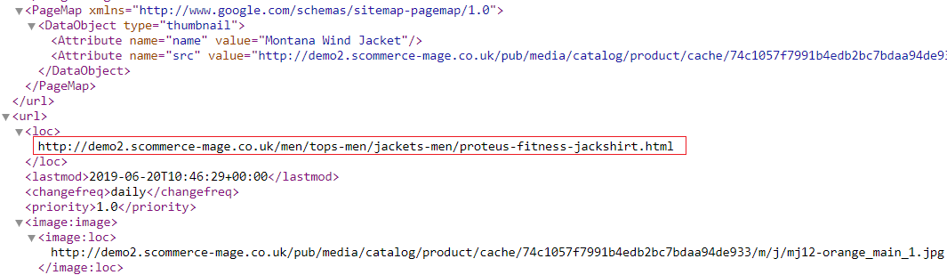

### Category Link in Sitemap XML - You can see the category link in the Google Sitemap XML.

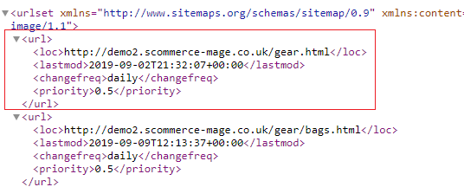

### **CMS Pages Link in Sitemap XML -** In the below screen grab you can see the about-us page link in the Google Sitemap XML.

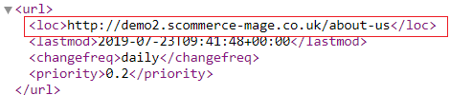

# Configuration Settings for Catalog URL

Go to **Admin > Stores > Configuration > Scommerce Configuration > Catalog URL**

### **General Settings**

* **Enabled -** Select “Yes” or **“**No**”** to enable or disable the module.
* **Exclude Root Categories –** Exclude some root categories to appear as primary category dropdown against products.

Select “Yes” to enable the module

Please select the root categories to exclude Categories

### **Configuration Path to Set Up Primary Category**

Go to **Admin > Catalog > Select Product > Search Engine Optimization > Primary Category** . The drop down will show all the categories selected for the product from where you can select the primary category of the product.

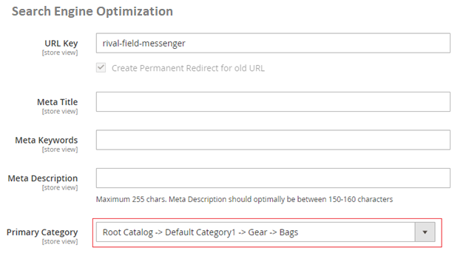

# Front-end Site View

### **Product Page Unique URL -** You can assign primary category to any product from Admin > Catalog > Select Product > Search Engine Optimization > Primary Category. In the below image you can see the assigned category of product Rival Field Messenger is "Gear->Bags" .

### 

# Configuration Settings for Canonical Tags

Go to **Admin > Stores > Configuration > Scommerce Configuration > Canonical Tags**

### **General Settings**

* **Enable -** Select “Yes” or “No” to enable or disable the module.

Select “Yes” to enable the module

### **Category Canonical Tag**

* **Category Canonical Enable –** Set it to yes, if you want canonical tag on category pages.
* **Exclude Current Category in Admin –** Set it to “Yes”, if you don’t want the same category to appear in the drop-down selection while choosing canonical category for a category.
* **Append Text with Every Category URL Path –** Set it to yes, if you want to append text with overridden canonical url as well. This setting is useful when you have pagination/filtered navigation/sorting on your site.

Select “Yes” to enable the Category Canonical

Select “Yes” to Exclude the Current Category

Select “Yes” to Append Text with Category URL

### **Product Canonical Tag**

* **Product Canonical Enable –** Set it to yes, if you want canonical tag on product pages.

Select “Yes” to enable the Product Canonical Tags

### **CMS Canonical Tag**

* **CMS Canonical Enable –** Set it to "yes", if you want canonical tag on CMS pages.

Select “Yes” to enable the CMS Canonical Tags

### **No Index No Follow**

* **No Index No Follow Enabled –** Set it to yes, if you want to add no index, no follow in the head section.
* **Action names –** Add action names here to add no index, no follow in the head section for specific page. New route name needs to be added in next line.
* **Route names –** Add route name here to add no index, no follow in the head section for list of pages.

Select “Yes” to enable the Index No Follow

Please select the Action Names

Please define the Route Names

### **Product Setup for Canonical URL**

### Go to **Admin > Catalog > Products > Select Product** **(for which you want to set Canonical URL) > Search Engine Optimization Tab**

* **Primary Category –** Select primary category to be included in the canonical URL tag.
* **Override Canonical URL –** Enter text here to be used as canonical tag URL.
* **Robot Settings –** Select the robot settings from dropdown.

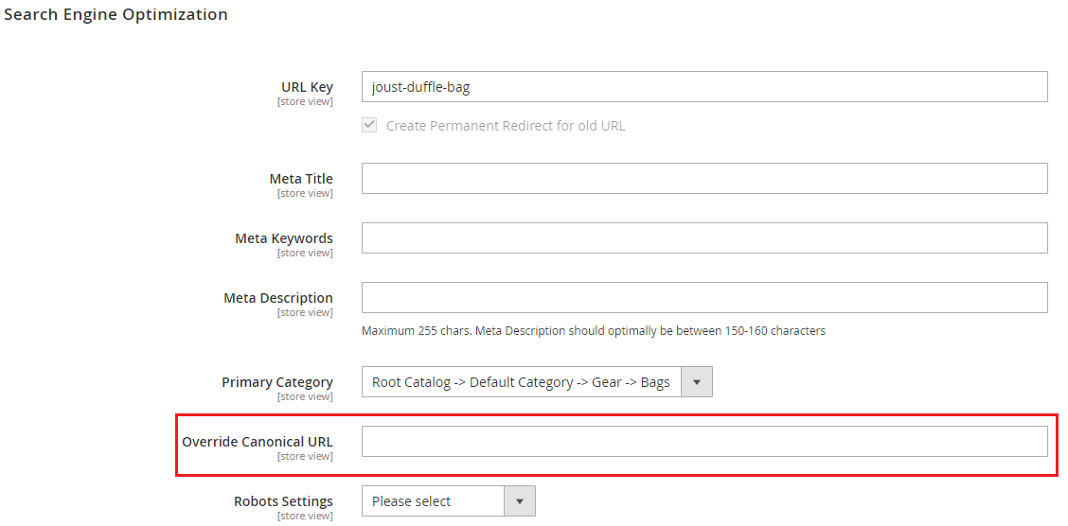

### **Category Setup for Canonical URL**

Go to **Admin > Catalog > Category > select category (for which you want to set canonical URL) > Search Engine Optimization Tab**

* **Canonical URL –** Select primary category to be included in canonical URL tag.
* **Override Canonical Tag –** Enter text here to be used as canonical tag URL.
* **Robot Settings –** Select the robot settings from dropdown.

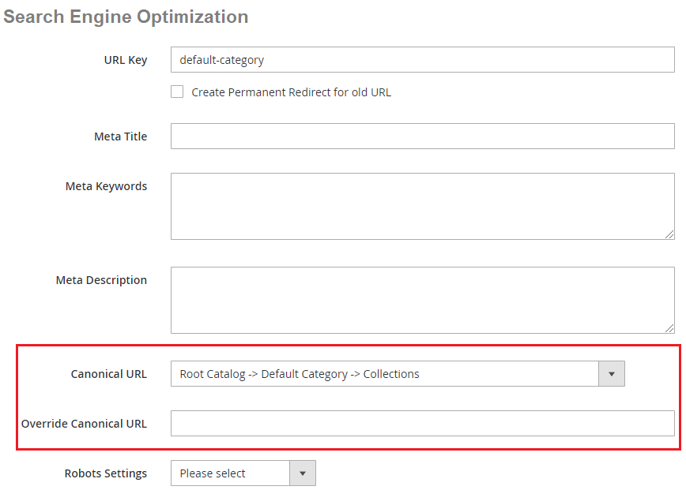

### **CMS Setup for Canonical URL**

Go to **Admin > Content > Pages > Choose page (for which you want to set canonical URL) > Search Engine Optimization Tab**

* **Override Canonical URL –** Enter text here to be used as canonical tag URL.
* **Robot Settings –** Select the robot settings from dropdown.

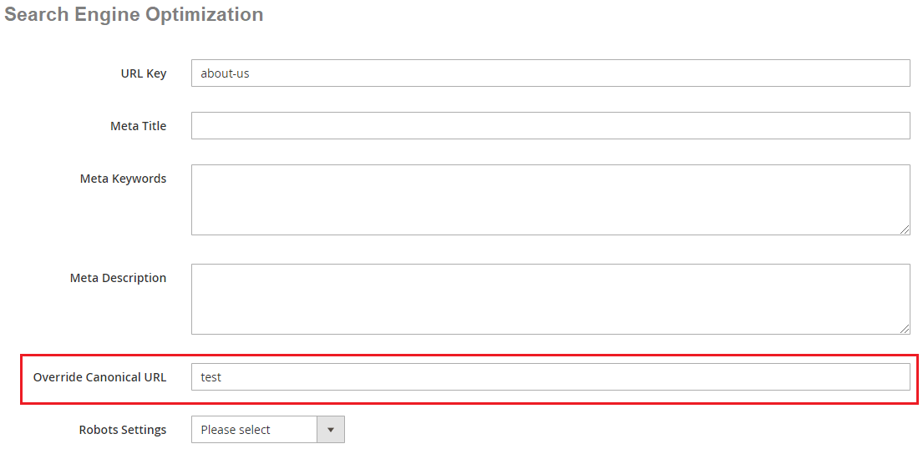

# Front-end Site View

### **Canonical Tag on the Category Page -** You can enable canonical tag on the category page from Admin > Stores > Configuration > Scommerce Configuration > Canonical Tags > Category Canonical Enable - Select "Yes".

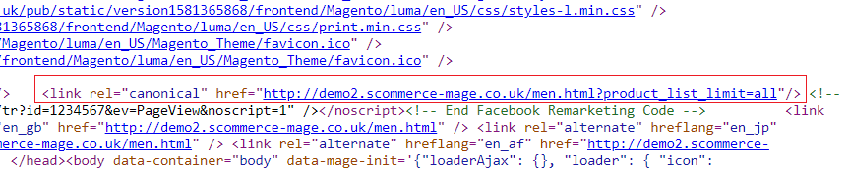

### **Canonical Tag on the Product Page -** To add canonical tag on the product page, go to Admin > Stores > Configuration > Scommerce Configuration > Canonical Tags > Product Canonical Enable - Select "Yes".

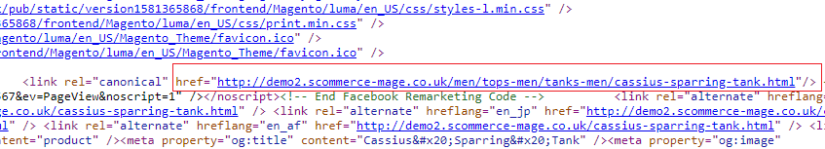

### **Canonical Tag on the CMS Page -** You can add canonical tag on the CMS page from Admin > Stores > Configuration > Scommerce Configuration > Canonical Tags > CMS Canonical Enable - Select "Yes".

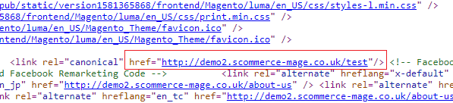

# Configuration Settings for Rich Snippets

Go to **Admin > Stores > Configuration > Scommerce Configuration > Rich Snippet**

### **General Settings**

* **Enable -** Select “Yes” or “No” to enable or disable the module.
* **Description –** Select description/short description from the drop down.
* **Price –** Select Price from the drop down. In case price is listed with tax and without tax select which price should be used.
* **Brand –** Select brand from the drop down.
* **Global Product Identifier –** Select product identifier from the drop-down list.
* **Global Identifier Type –** Select product identifier type from the drop-down list. It could be one of the following: gtin8, gtin13, gtin14, mpn.

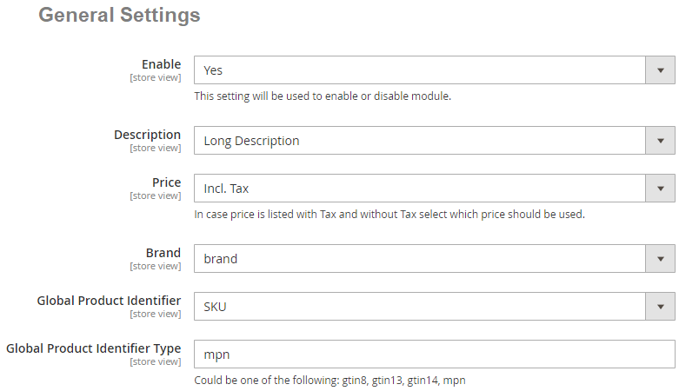

Select “Yes” to enable the module

Please select the description

Please select the price

Please select the brand

Please select the global product identifier

Please add the global product identifier type

### **Rich Snippets General Settings**

* **Enable -** Select “Yes” or “No” to enable or disable the module.
* **Description –** Select description/short description from the drop-down.
* **Price –** Select price from the drop down. In case price is listed with tax and without tax select which price should be used.
* **Wrap with div –** Select “Yes/No”. It helps prevent conflicts with SEO extensions.
* **Use JSON-LD –** Select “Yes/No” use JSON-LD format for product snippet.

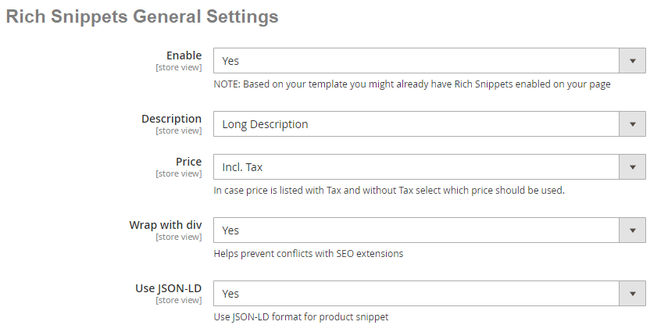

Select “Yes” to enable the Rich Snippets

Please select the description

Please select the price

Select “Yes” to enable wrap with div

Select “Yes” to use JSON-LD

### **Twitter Card Settings**

* **Enable -** Select “Yes” or “No” to enable or disable the module.
* **Card Type –** Select the card type.
* **Description -** Select description/short description from the drop down.
* **Price –** Select price from the drop down. In case price is listed with tax and without tax select which price should be used.
* **Twitter Site –** Set Twitter site name (@ username for the website used in the card footer)
* **Twitter Creator –** Set Twittercreator name (@username for the content creator / author)

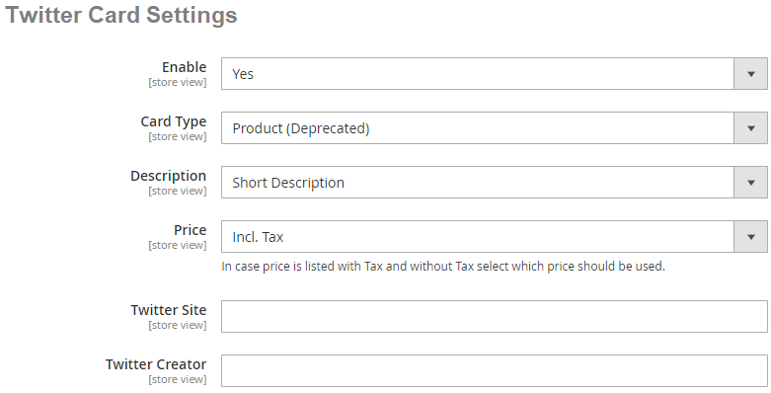

Select “Yes” to enable the Twitter Card

Please select the card type

Please select the description

Please select the price

Please add the twitter site

Please add the twitter creator

### **Facebook Open Graph Settings**

### **Facebook Open Graph Settings**

* **Enable –** Set “Yes” to enable.
* **Description –** Select description/short description from the drop down.
* **Price –** Select price from the drop down. In case price is listed with tax and without tax select which price should be used.
* **Site Name –** Set Facebook site name.
* **App ID –** Set Facebook App ID.

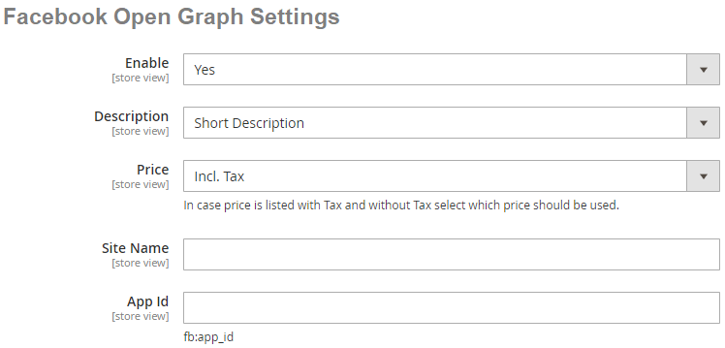

Select “Yes” to enable the Facebook Open Graph

Please select the description

Please select the price

Please add the site name

Please add the App Id

### **Pinterest Rich Pins Settings**

* **Enable –** Set “Yes” to enable Pinterest Rich Pins . It uses same tags as Facebook open graph, make sure Facebook Open graph is enabled as well.

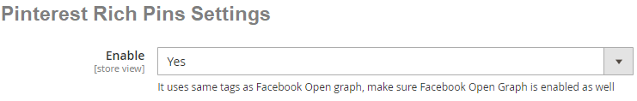

Select “Yes” to enable the pinterest rich pins

# Structured Data / Markup Code of Front-end Page(s) in Structured Data Testing Tool

### **Home Page Markup Code -** You can add structured data/markup code on home page from, **Admin > Stores > Configuration > Scommerce Configuration > Rich Snippet > Enable -** Select **"Yes**". To test structured data, go to **Structured Data Testing Tool > Provide Home Page URL >** Click **"Run Test"** button.

### 

### **Category Page Markup Code -** You can add markup code, breadcrumbs on category page from, Admin > Stores > Configuration > Scommerce Configuration > Rich Snippet > Enable - Select "Yes".

### 

### **Product Page Markup Code** - To add structured data markup code on product page, set "Enable" to "Yes" from, Admin > Stores > Configuration > Scommerce Configuration > Rich Snippet.

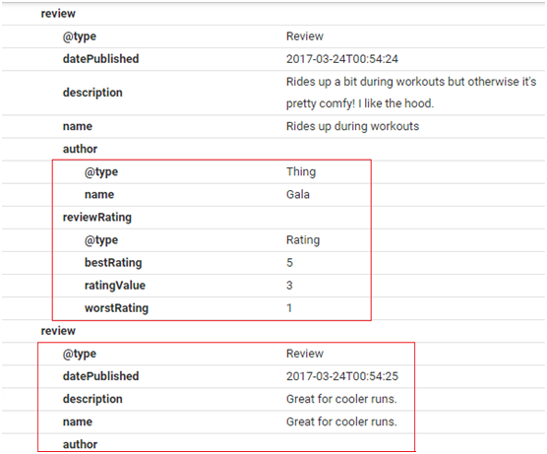

### **Twitter, Facebook Open Graph Social Sharing Code**

### Twitter Card - You can enable Twitter Card from, Admin > Stores > Configuration > Scommerce Configuration > Rich Snippet >Twitter Card Settings > Enable - "Yes".

### 

### Facebook Open Graph - Enable Facebook Open Graph from, Admin > Stores > Configuration > Scommerce Configuration > Rich Snippet >Twitter Card Settings > Enable - "Yes".

### 

### **Increased and Optimized Page Ranking in Search Results -** In the below image you can see the increased and optimized page ranking in search results.

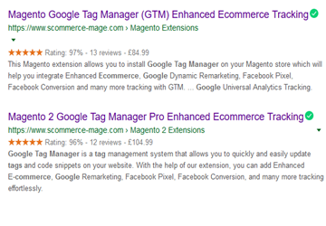

# 11. Configuration Settings for Hreflang

Go to **Admin > Stores > Configuration > Scommerce Configuration > Hreflang**

### **General Settings**

* **Enable -** Select “Yes” or “No” to enable or disable the module.
* **Href UrLS Scope –** Select options from the list.
* Website Hreflang URLs: It will work within one website.
* Global Hreflang URLs: This will work across multiple websites.
* **X-Default –** Select default store view.
* **Enable Hreflang Tags for Categories –** Select “Yes/No”. If set to “Yes” then it will enable Hreflang Tags for the categories.
* **Enable Hreflang Tags for Products –** Select “Yes/No”. If set to “Yes” then it will enable Hreflang Tags for the products.
* **Enable Hreflang Tags for CMS Pages –** Select “Yes/No”. If set to “Yes” then it will enable Hreflang Tags for the CMS Pages.

Select “Yes” to enable the module

Please select the Hreflang URLs scope

Please select the X-Default

Select “Yes” for enable Hreflang Tags Categories

Select “Yes” for enable Hreflang Tags Products

Select “Yes” for enable Hreflang tags CMS pages

### **Language and Country Settings**

* **Select Language –** Select Local or Custom languages from the drop down list.
* **Add Country –** Select “Yes/No”. If set to “Yes” then only the “Select Country” option will be visible.
* **Select Country –** Select country from the drop-down list.

Please select the language

Select “Yes” to enable the add country

Please select the country

# 12. Front-end Site view

### **Hreflang Tag on the Home Page -** You can enable hreflang on the home page by selecting "Yes" for " Hreflang Tags For CMS Pages " from **Admin > Stores > Configuration > Scommerce Configuration > Hreflang > General Settings > Enable - Select "Yes " > Enable Hreflang Tags For CMS Pages**.

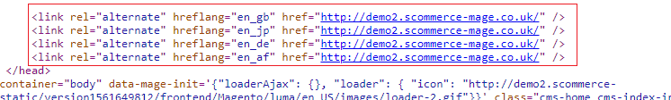

### **Hreflang Tag on the Category Page -** To enable hreflang on the category page, go to **Admin > Stores > Configuration > Scommerce Configuration > Hreflang > General Settings > Enable - Select "Yes " > Enable Hreflang Tags For Categories - "Yes"**.

### **Hreflang Tag on the Product Page -** You can enable hreflang on the product page by selecting "Yes" for " Hreflang Tags For Products " from **Admin > Stores > Configuration > Scommerce Configuration > Hreflang > General Settings > Enable - Select "Yes " > Enable Hreflang Tags For Products**.

### **Hreflang Tag on the CMS Page -** Enable hreflang on the CMS Pages From **Admin > Stores > Configuration > Scommerce Configuration > Hreflang > General Settings > Enable - Select "Yes " > Enable Hreflang Tags For CMS Pages - "Yes"**.

# 13. Configuration Settings for Cross Linking

Go to **Admin > Stores > Configuration > Scommerce Configuration > Cross Linking**

* **Enabled –** Select “Yes” or “No” to enable or disable the module.
* **Product Page Replacement Limit –** Please define the replacement limit per product page. It determines how many keywords will be replaced on the given page.
* **Category Page Replacement Limit –** Please define the replacement limit per category page. It determines how many keywords will be replaced on the given page.
* **CMS Page Replacement Limit –** Please define the CMS page replacement limit. It determines how many keywords will be replaced on the given page.
* **Product Attributes for Replacement –** Please select the product attributes where text will be replaced with link on product pages.
* **Category Attribute for Replacement –** Please select the category attributes where text will be replaced with link on category page.

Please define the product page replacement limit

Select “Yes” to enable the module

Please define the category page replacement limit

Please define the CMS page replacement limit

Please select the Product attributes for replacement

Please select the Category attributes for replacement

### **Cross Links Grid** **-** You can manage and create new cross links from **Admin > Marketing > SEO Cross Linking > Cross Links**. This grid will have ID, Title, Status, Store View, Target, Replacement Limit, Priority, Nofollow, Action.

### **Add New Cross Link -** To add new cross link, go to **Admin > Marketing > SEO Cross Linking > Cross Links** **>** Click on "**Add New Link**" button. It redirects on "Add New Cross Link" page and by providing all the general information you can create a new cross link.

### This will have following general information:-

### **Active** - Dropdown with 'YES' or 'NO' options

### **Link Title** - Title of the link

### **Link Target** - Dropdown with options self or blank

### **Keywords** - Keywords can be entered with line breaks and wildcard % anywhere with the keyword for example %phone% (iPhone7)

### **Store View** - Multi-select with options All Store Views, Default Store View

### **Reference** - Dropdown with options, Product ID, Category ID or Custom Url

### **Reference Resource** - This will show either category tree or product grid with filters or css grid with filters to choose category or product ID

### **Priority** - Priority to be given to the link which has highest priority first in case the replacement is lower number

### **Replacement limit** - Limit the number of links per page

### **No Follow** - This will add follow or nofollow with the link on frontend

### **Build External Link to Any Website -** You can set external link to any website from **Admin > Marketing > SEO Cross Linking > Cross Links >Reference - Custom Url >  Custom Url -** Provide External Link.

### 

### **Alert Message for Inactive Product / Category -** It shows an alert / warning message when you disable the category or product from **Admin > Catalog > Category / Product > Select Category / Product > Disable > Save.**

### **Alert Message for Inactive Category**

# 14. Front-end Site view

* Cross Link on Category Page - You can define the replacement limit for category page from **Admin > Stores > Configuration > Scommerce Configuration > Cross Linking** **> Category Page Replacement Limit - 1**. It determines how many keywords will be replaced on the given page and to define cross link, go to **Admin > Marketing > SEO Cross Linking > Cross Links > Select Link > Replacement Limit -1.**

* Category Page Cross Link Redirecting on External Link - Click on the cross link "Luma" will redirect to external link.

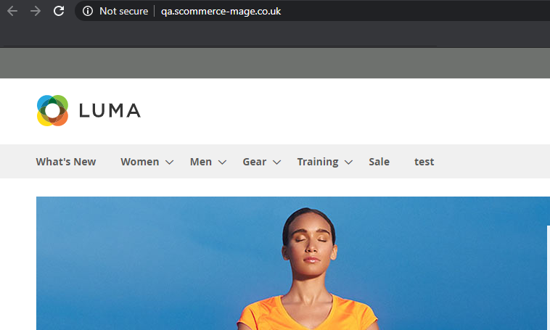

* Cross Link on Product Page - You can define replacement limit for cross link from **Admin > Marketing > SEO Cross Linking > Cross Links > Select Link > Replacement Limit - 2.** Individual Cross link limit determines how many times the link will be replaced on the given page.

* Product Page Cross Link Redirecting on Internal Link - Click on the cross link "Duffle" will redirect to defined internal link.

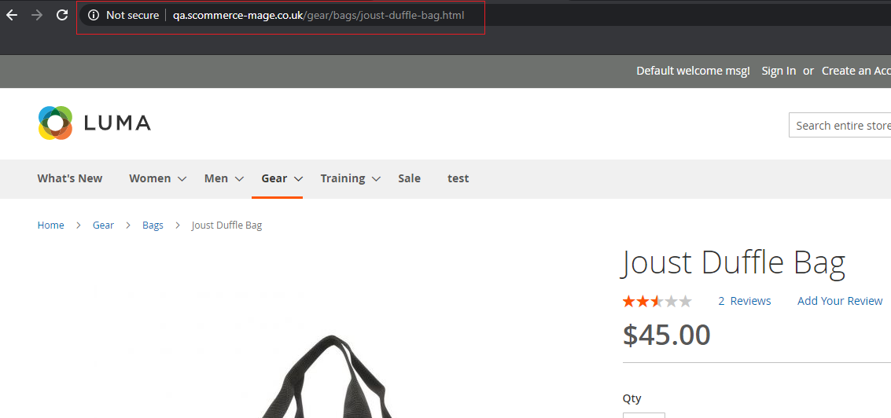

* Cross Link on CMS Page - You can set replacement limit for cross link from **Admin > Marketing > SEO Cross Linking > Cross Links > Select Link > Replacement Limit - 1.** Individual Cross link limit determines how many times the link will be replaced on the given page.

**Please contact** [**core@scommerce-mage.com**](mailto:core@scommerce-mage.co.uk) **for any queries.**