August 14, 2025

Dear Acme Corp,

**Protect Your Business with Tailored Insurance Solutions!**

Protecting your business is our priority at Jones Insurance Advisors.  
  
As an Indian River County business, you need insurance solutions tailored to your unique needs. Our experienced team specializes in crafting comprehensive coverage plans for businesses like yours, ensuring protection against risks while keeping costs competitive.  
  
Jones Insurance Advisors, a family-owned agency in Vero Beach, is here to help. Contact us for a free consultation to discuss how we can safeguard your business.  
  
We look forward to partnering with you!  
  
Best Regards,

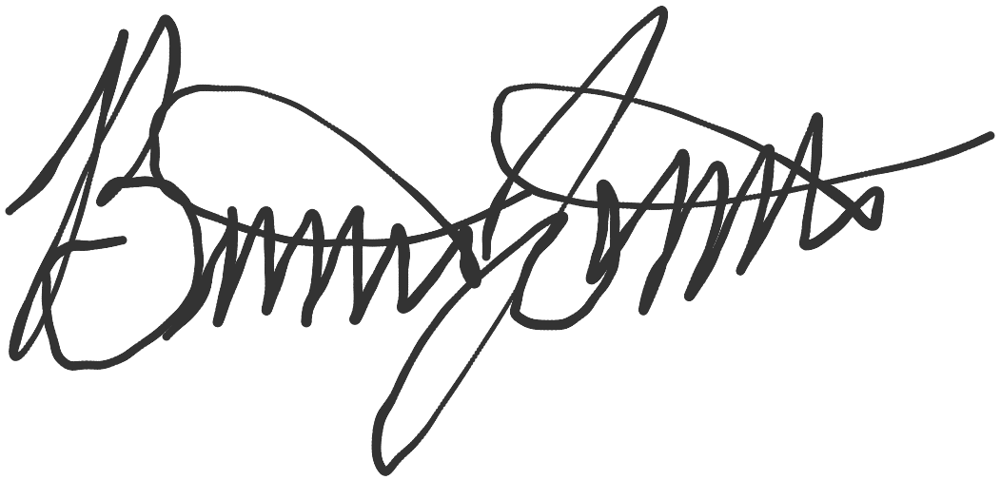

Brian Jones  
Vice President  
Brian@jonesia.com  
(772) 569-6802  
www.jonesinsuranceadvisors.com