Stephen R. Ouellette

CIP311 – Prior Art Activity

**NAME OF PRODUCT:** Yummlytm

**HOW IS THIS LIKE MY CIP:** Yummly provides its users with descriptive art-oriented recipes and has the capability to add ingredients to a shopping list. Yummly also provides the user with access to 1-hour delivery depending on user location. Users can search online databases of recipes via the app as well.

**NAME OF PRODUCT:** Tasty

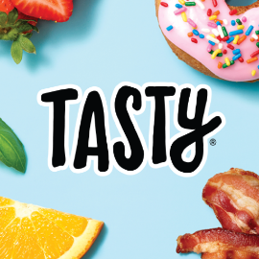

**HOW IS THIS LIKE MY CIP:** Tasty provides its users with the ability to view and favorite recipes, and export the ingredients list, but does not provide any form of shopping lists, recipe creation/deletion and sharing.

**NAME OF PRODUCT:** Allrecipes



**HOW IS THIS LIKE MY CIP:** Allrecipes is pretty like the others, however they add the unique function of allowing the user to see stores nearby that have the ingredients. This app also provides the user with the ability to create shopping lists but lacks the ability to save meal lists and create/remove recipes. This is an online database of recipes.

**BOTTOM LINE:** It seems like there are a plethora of recipe programs available in the app store, but many of them lack in different categories. Most if not all the apps that I have found to date all require some sort of network connectivity for the user to search the online databases of recipes. The functions that will set my CIP apart from other projects is to give the user the ability to create their own recipes, saving these for later, allowing the user to select recipes to create a ‘meals list’ in which generates a shopping list the user can then utilize while shopping. These simple functions may seem trivial, but I believe they will be a large selling point, as many users do not always have connectivity to the internet. I have also yet to find an app that provides QR code recipe sharing, they do have recipe sharing via usernames and emails, but a simple QR scan that can add an entire recipe to another users list could be a great selling point.