ClassMate

Installation & Deployment Guide

# Table of Contents

Table of Contents

Overview

Installation

Manually Installing ClassMate on an Android Device

Installing ClassMate from the Google Play Store

Deployment

Manual Installation

Google Play Store

# Overview

This document outlines the process of installing *ClassMate* on an Android device, as well as the process we used to deploy the app from the source to a useable *.apk* file.

# 

# 

# Installation

## Manually Installing ClassMate on an Android Device

1. Ensure ***Unknown Sources*** are allowed. You can configure this by going to *Settings > Security* and checking *Unknown Sources.*

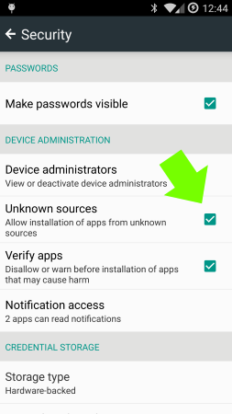

1. Download ***ClassMate.apk*** onto your device
2. Find ***ClassMate.apk*** on your device using a *Download Manager* or *File Explorer* (E.g. ES File Explorer) and tap it.
3. Click the ***Install*** *Button* and then the ***Open*** *Button*

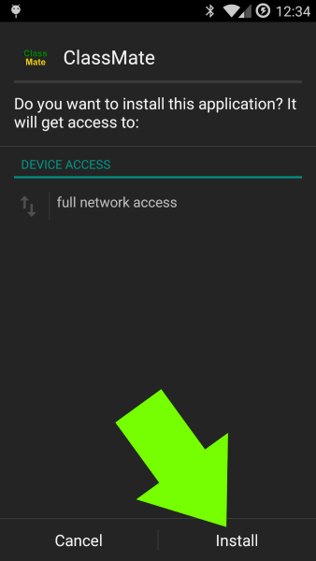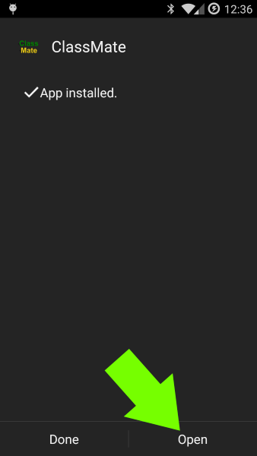

## 

## Installing ClassMate from the Google Play Store

ClassMate is currently unavailable on the Google Play Store, however we will be uploading it for the next phase of the assignment.

# Deployment

## Manual Installation

The initial deployment will be done by providing an APK file to manually install the app. It will be available for download from D2L in our Assignment Submission as well as from <http://justin.coschi.ca/ClassMate.apk>.

This APK was built on a local machine using the PhoneGap CLI (Command Line Interface). This creates a hybrid app where the website we built in jQuery Mobile is packaged into a native app that is simply a webview to display our site.

## Google Play Store

For the next phase of the assignment, we will be publishing the app to the Google Play Store. To do this we will use the same build process as in the manual installation, but also sign the file and upload it to the Google Play Store using a developer account.