Installing Microsoft Active Directory Lightweight Directory Services (AD LDS).

At the time of writing AD LDS distributives for Windows 7 can be downloaded from Microsoft web site through the following link:
http://www.microsoft.com/en-us/download/details.aspx?id=14683

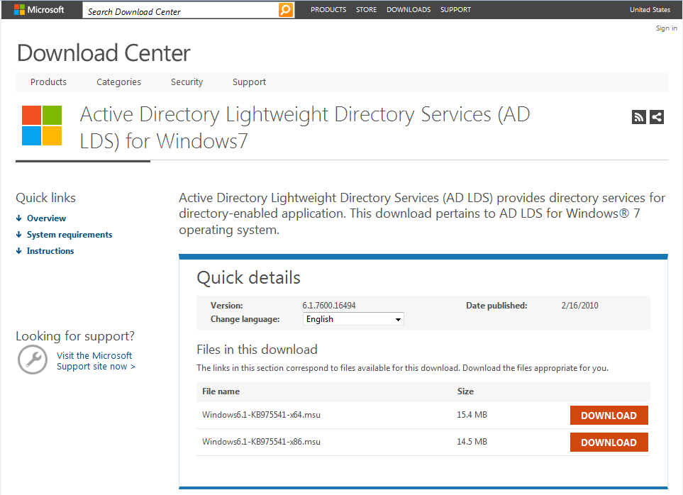

AD LDS is a standalone LDAP provider solution from Microsoft. It is not a full scale replacement for Microsoft Active Directory, but can be used for supporting directory-enabled applications. AD LDS was previously known as Active Directory Application Mode (ADAM).
After downloading, run the executable and follow the installation process. AD LDS doesn’t add any new shortcuts to the Start menu, and instead adds executables to the Windows system directory and installs a set of administrative tools (available as MMC console plugins). So, don’t be surprised if you will not see any new programs installed.
After successful installation if you go to
Control Panel > System and Security > Administrative Tools
You should be able to see the AD LDS management components. We will use them to add a directory partition and create AD users in the following steps.
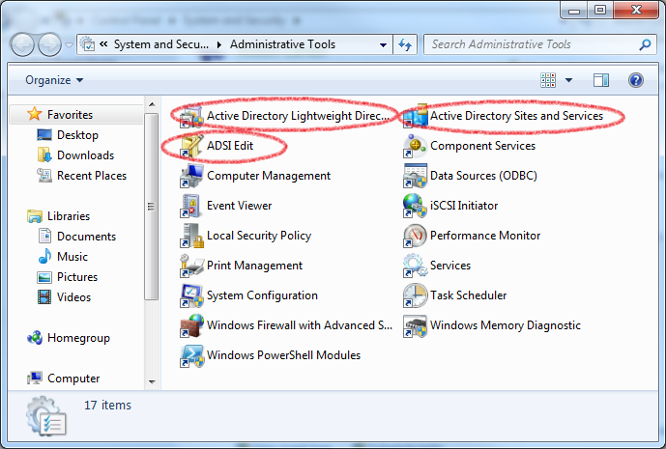

Creating directory instance

Step 1. Launching the setup wizard
Launch the AD LDS Services setup wizard by going to:
Control Panel > System and Security > Administrative Tools
It will display the dialog below:

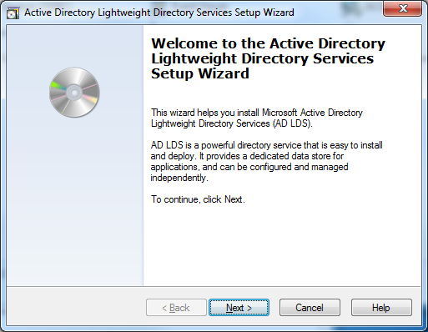
Click Next to move to the “Setup Options” view.
Step 2. Setup Options
Please make sure you select “A unique instance” option in this step
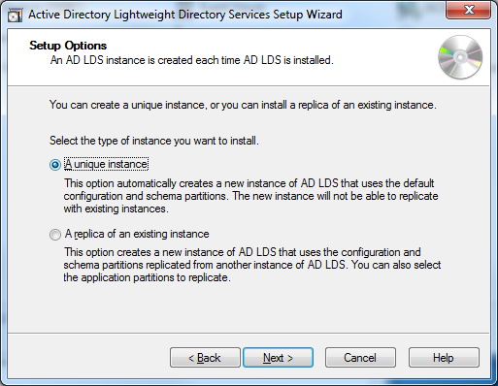

Step 3. Instance Name
Enter instance name and description. The instance name will be used as a windows service and description will show in the “Installed Programs” view. You can enter any name and description, however for this walkthrough, we will use the information below
Instance Name: OSCAR
Description: OSCAR AD LDS instance
After entering this information click Next to move to the Step 4: Ports
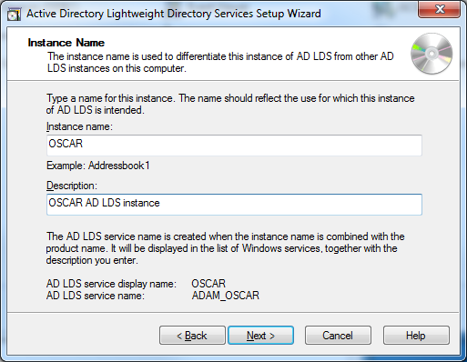

Step 4. Ports
Enter port numbers for the AD LDS installation. By default LDAP connects to ports 389 and 636 for SSL, so you can leave these values:
LDAP port number: 389
SSL port number: 636
Click “Next” to move to the Step 5: Application Directory Partition
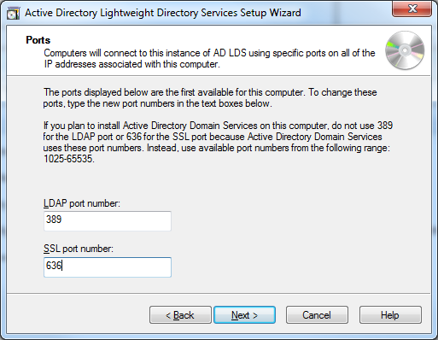

Step 5: Application Directory Partition
In real settings, the application directory will be already setup by the system administrator. For the purpose of walkthrough we will utilize partition below:
Partition Name: CN=Providers,DC=OSCAR,DC=ca
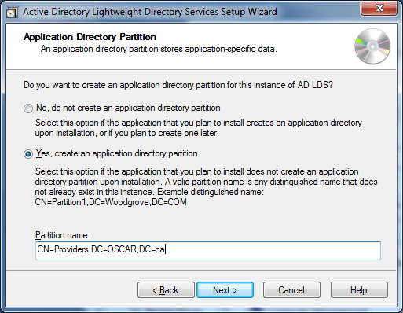
This information will be used as the base context for all DNs (Distinguished Names). Click Next to move to the Step 6: File Locations
Step 6: File Locations
Enter the location of the files where AD will keep its data. It’s fine to accept the defaults:
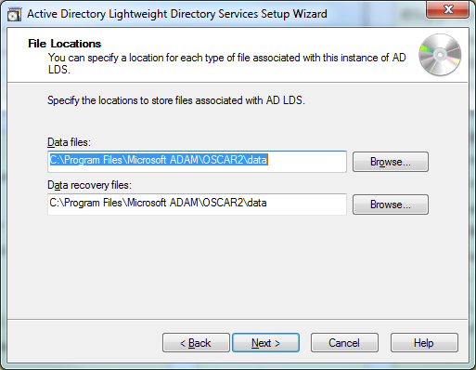
So click next to move to the next step.
Step 7: Service Account Selection
This step configures the permissions for AD LDS. It’s ok to leave the defaults:

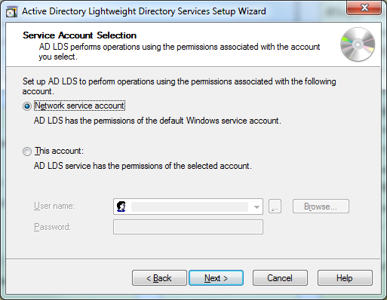
Please note that after clicking next you may see a warning message:
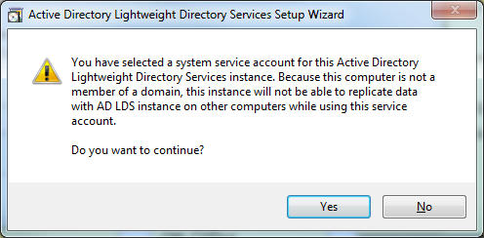
We will not be replicating data, so it’s ok to continue. Click Next to move to step 8.
Step 8: AD LDS Administrators
In this step we will configure administrative account. You can leave the defaults to enable your login to be the AD LDS instance admin
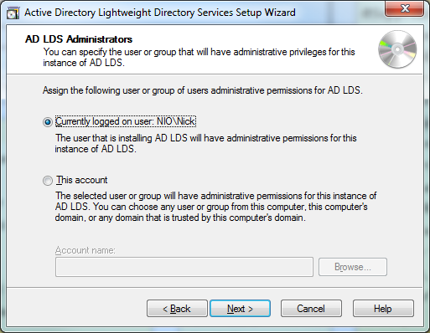
Click next to the step 9
Step 9: Importing LDIF files
Please be sure to import MS-User.LDF file in order to be able to have an active directory schema ready.
More information about schemas can be found here:
http://technet.microsoft.com/en-us/library/cc816931%28v=ws.10%29.aspx

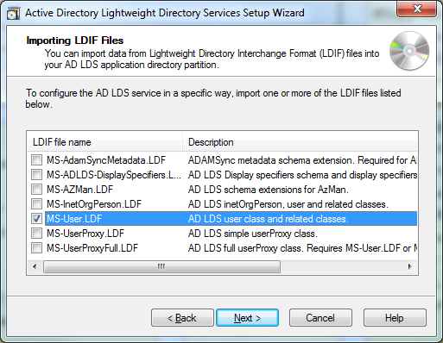
Click next.
Step 10: Ready to Install
This screen will allow reviewing all of the information specified in the previous steps. You can copy and paste it into a text file for the future reference.
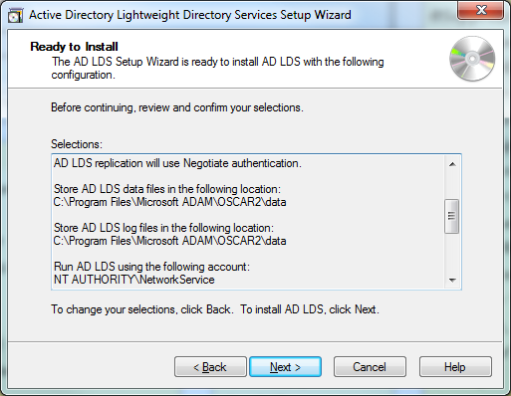
Click next to run the install.
During the install it will show this screen:

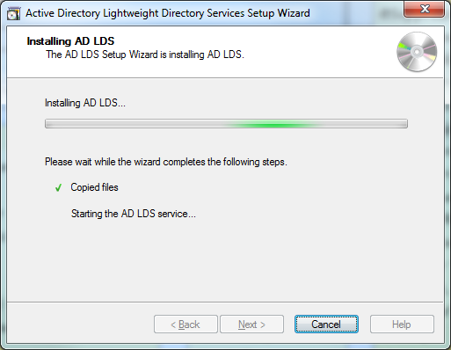

Upon the successful installation, you will see the screen below:
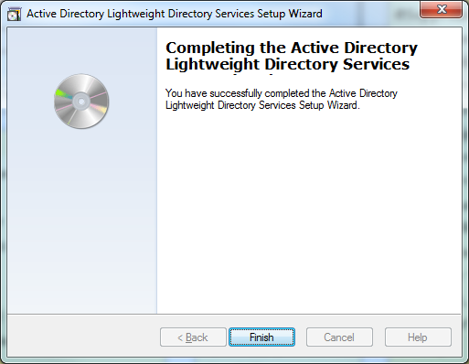

Click “Finish” to complete the installation.

Configure OSCAR for use with Active Directory Microsoft Active Directory Lightweight Directory Services.

Before AD LDS can be used with OSCAR, it’s necessary to add users. This can be accomplished through the ADSI Edit utility. Go to
Control Panel > System and Security > Administrative Tools
And double click “ADSI Edit” icon:
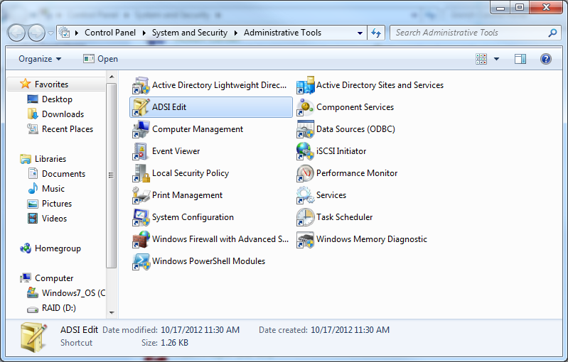
This will launch ADSI Edit console:
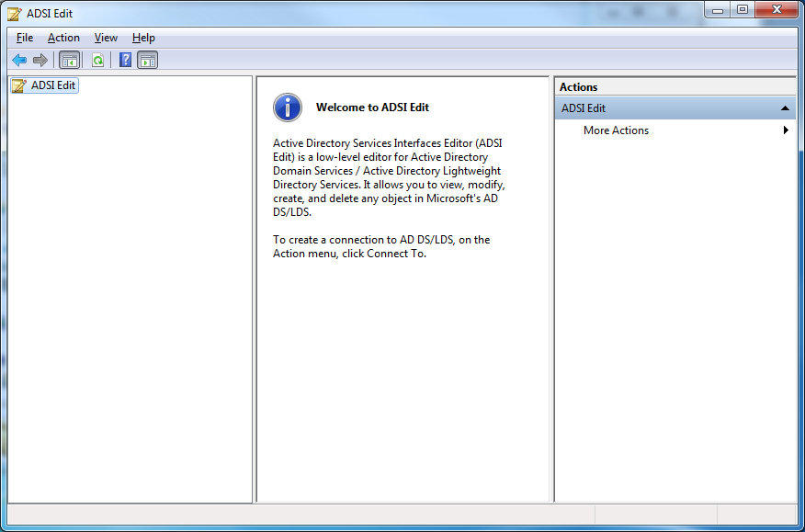
Right click “ADSI Edit” menu item and select “Connect to…”:
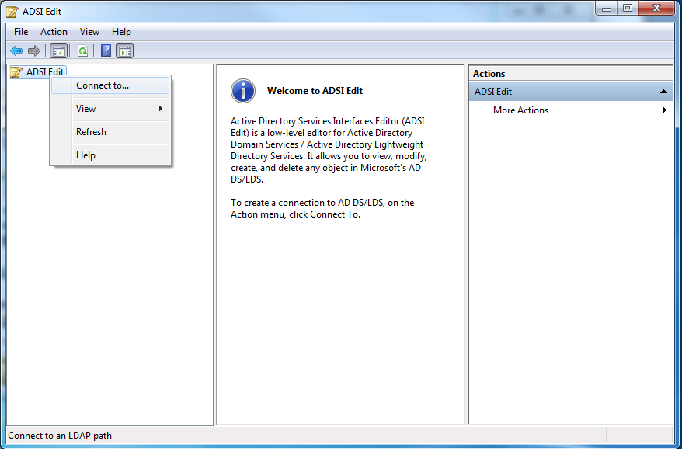
It will launch “Connection Settings” dialog
Apply the following settings:
Name: OSCAR
Connection Point: CN=Providers,DC=OSCAR,DC=ca
Computer: localhost
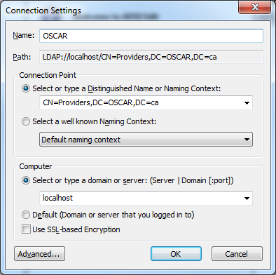
And click “OK”.
You should now have a new configuration “OSCAR [localhost]” under ADSI Edit menu:
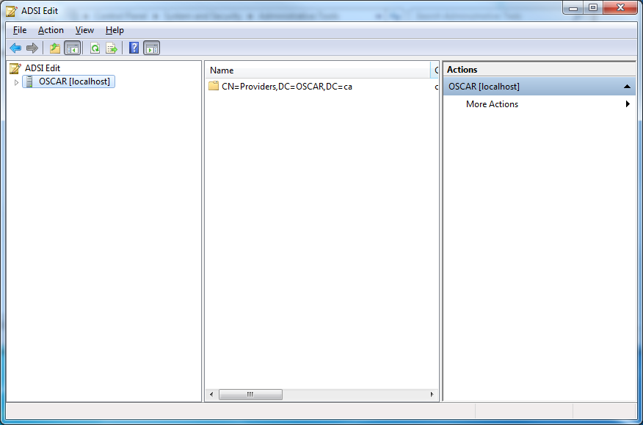
Navigate to
OSCAR [locahost] > CN=Providers,DC=OSCAR,DC=ca > CN=Roles

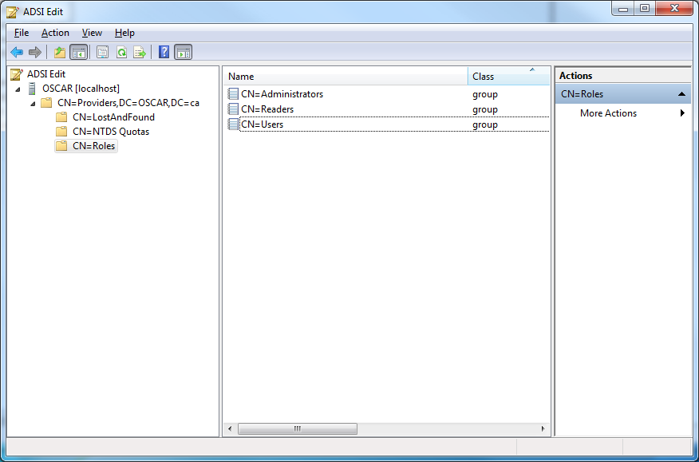

Right click “CN=Roles” and select New > Object

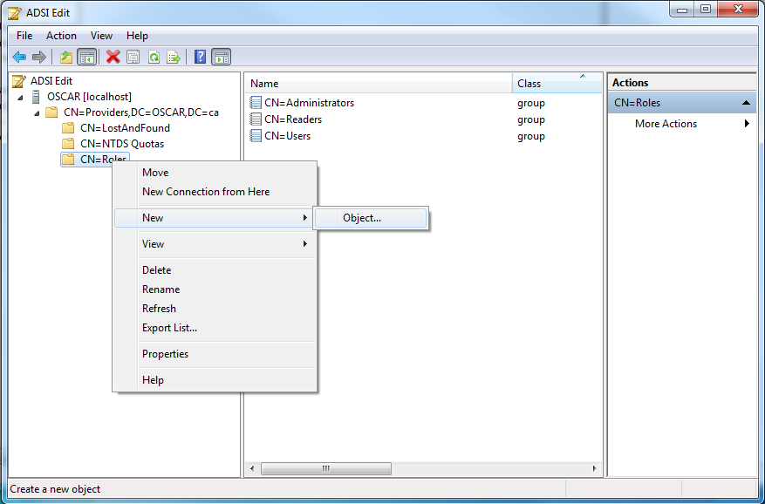
In the “Create Object” dialog select “User” and click “Next”
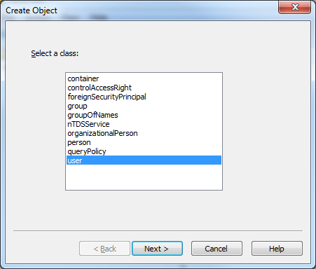
Now enter “oscardoc” and click next
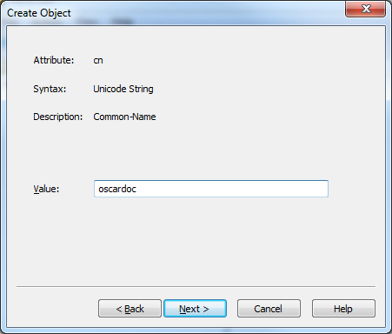
Click “Finish”
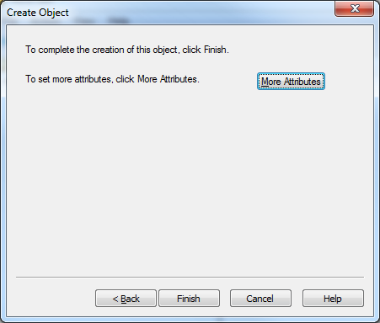
You should now see the new user in ADSI Edit:
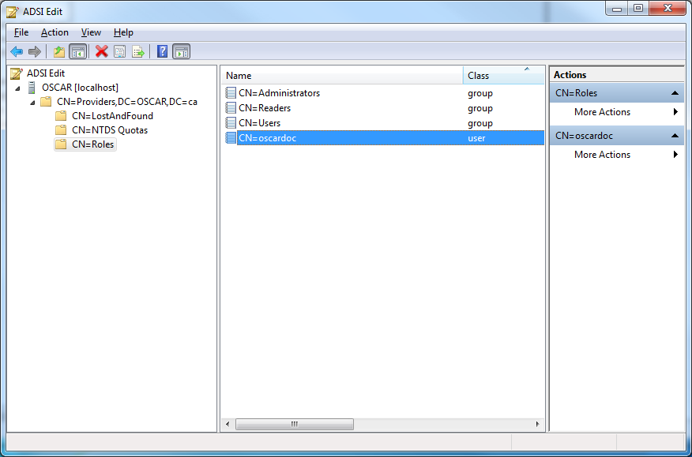
Right click oscardoc and click “Reset Password”
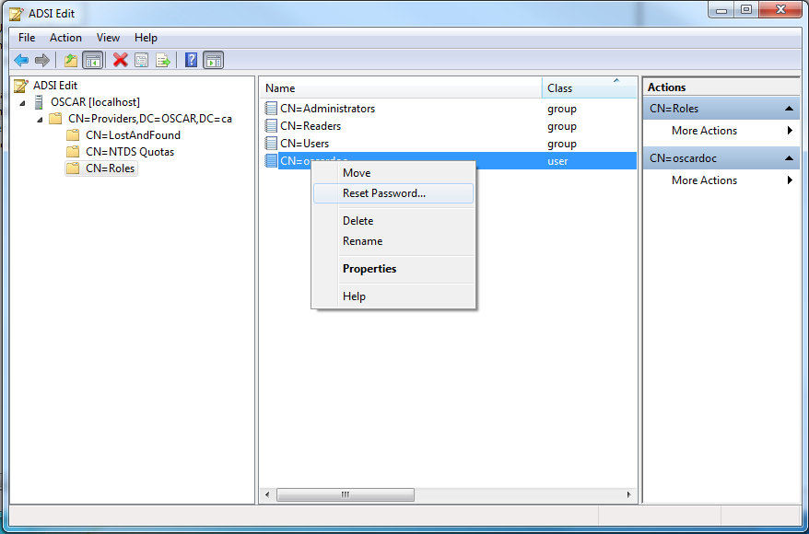
Enter mac2002 as the password
New password: mac2002
Confirm password: mac2002
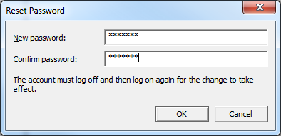

And click OK
Right click “CN=Users” and select properties

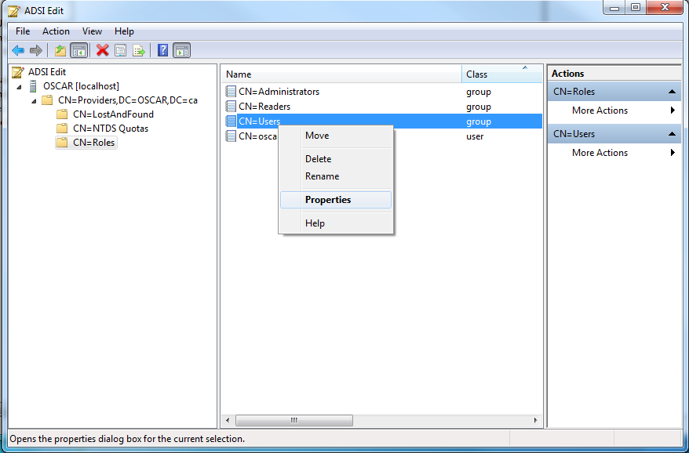

You should now see the attribute editor dialog. Locate “member” attribute and click “Edit”

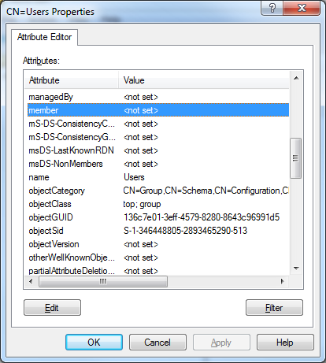

It will show the editor dialog:

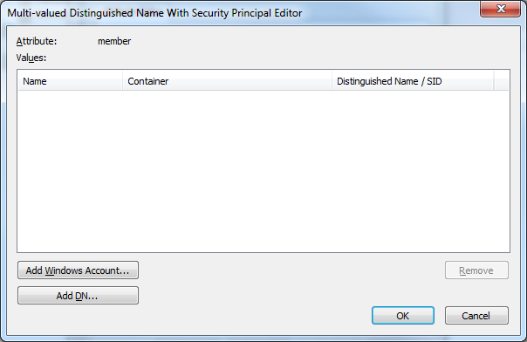

Click “Add DN…” button
Enter DN of the new user
CN=oscardoc,CN=Roles,CN=Providers,DC=OSCAR,DC=ca

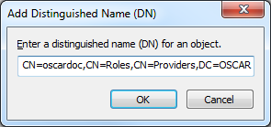

And click OK
You should now see the user in the editor:

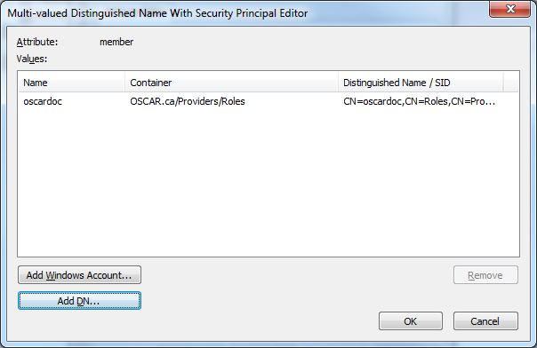

Click OK to close the dialog, and OK to close the property editor.
This completes the AD LDS setup.

Enabling LDAP authentication in OSCAR

Locate your OSACR properties file and find the LDAP configuration snippet. It should include several properties all starting with “ldap” prefix:
ldap.enabled=false
ldap.url=ldap://localhost:389
ldap.baseDn=CN=Roles,CN=Providers,DC=OSCAR,DC=ca
ldap.authorization=false
ldap.authMethod=simple

Change them as follows:
ldap.enabled=true
ldap.url=ldap://YOUR_AD_LDS_INSTALL:389
ldap.baseDn=CN=Roles,CN=Providers,DC=OSCAR,DC=ca
ldap.authorization=false
ldap.authMethod=simple

And save the properties file. Now after restarting the application, all login user name and passwords will be validated against AD.

Property Name | Description
ldap.enabled | This property enables or disables LDAP authentication. When it is set to false, only the DB authentication is used. When set to true, all user names and passwords will be validated against an LDAP provider. Valid values are “true” or “false”
ldap.url | URL of the LDAP provider. For example, “ldap://localhost:389”
ldap.baseDn | Base distinguished name (DN) containing user information. For example, “CN=Roles,CN=Providers,DC=OSCAR,DC=ca”
ldap.authorization | Boolean flag for enabling LDAP login code to retrieve user roles and groups (i.e. authorization info) and adding them to the authenticated subject. This option should be enabled only when integrated into the container. Valid values are “true” or “false”
ldap.authMethod | Method for LDAP authentication. Supported methods are "simple" or "digest-md5". For “simple” authentication passwords are sent in clear text. "digest-md5" enables a HTTP digest compatible challenge-response scheme based upon MD5

Removing the AD LDS instance

AD LDS instances are installed as Windows service and are also available in “Program and Features” view. To delete it, open “Uninstall or change a program” screen:
Control Panel > Programs > Programs and Features
Highlight the AD LDS Instance and click “Uninstall” button:

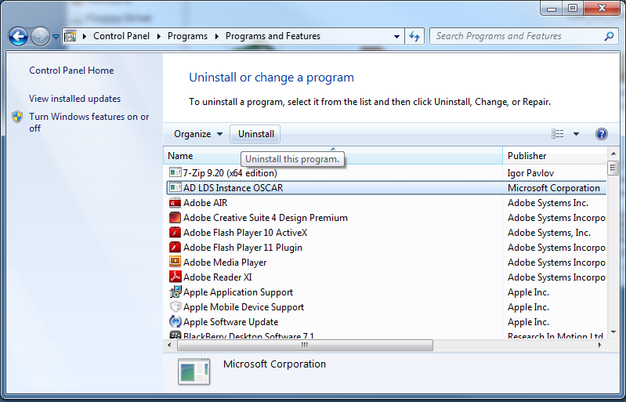

It will bring up this dialog:

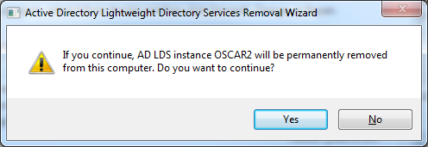

Just click “Yes”

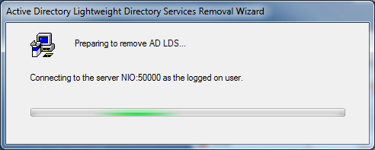

Which will resume the uninstallation process

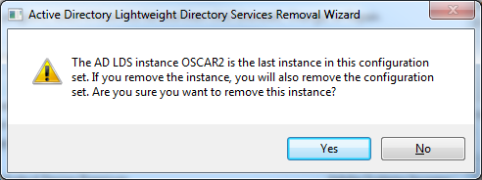

Finally confirm the uninstallation of the last instance by clicking “Yes”, and then OK.

