Continuing Care Information Management

OCAN - Ontario Common Assessment of Need

Reporting Requirements Specification

March 18, 2009
Version 1.0

SECURITY NOTICE

This material and the information contained herein are proprietary to Continuing Care Information Management and may not be used, reproduced, stored in electronic retrieval systems, or disclosed to others, in any form or by any means, except as specifically permitted in writing by creator of the document. The recipient of this information, by its retention and use, agrees to protect it from any loss, theft or compromise. Please contact the Creator of this document if you wish to share this document with organizations outside of Continuing Care Information Management.

Table of Contents

1 Purpose and Objective 3
2 Assumption 4
3 Report Definitions 5
4 Report Parameters 6
5 Parameter Details 7
6 Report Specifications 8
6.1 Individual Need Rating over Time Report 8
6.2 Need over Time (Consumer and Staff) Report 8
6.3 Summary of Actions and Comments Report 10
6.4 Staff Workload View/Report 11
7 Appendix 13
7.1 Appendix A 13
7.2 Appendix B 13
7.3 Appendix C 13
7.4 Appendix D 13
7.5 Appendix E 13

Purpose and Objective

The purpose of this document is to provide a description of the functional approach to be used for building Direct Line Worker Reports. These reports will be generated by the users of the organizations who conduct the OCAN with their individual Consumers. Most of the reports display information for an individual Consumer that is assigned to the Staff instead of a group of Consumers. Users of the system will be able to see all the information that they require depending on the parameters they choose for a specific report. More information for each report and its parameters are provided in their respective sections.

Assumption

The design and the intent of each report has gone through a rigorous process and have been reviewed by the different organizations as well as the researchers who developed the toolkit from which OCAN was derived from. Their feedback was essential in making sure the right information is being displayed in each report and the design of each report is user friendly. The look and feel of the report in the mock ups should resemble the final product delivered in the automated solution

Report Definitions

This section defines all the reports with detailed definitions of each of the reports. Once the application has been further defined and detailed design has begun, the business may discover new reporting requirements.
The following definitions will be captured for each Report:
    - Report Name: A unique name for each report as agreed by the business users. The report name will be displayed at the top of every page of the report.
    - Report Description: A brief description of the report including its purpose and use. The purpose of the report as defined in the mock ups should also be displayed on the first page of each report.
    - Report Display Fields: A list of all the fields that will be displayed on the report.
    - Report Filter Parameters: A list of user-defined report parameters which includes the parameter names and its associated values will be requested when a user selects a report to generate. More information about the parameters is in Section 4 Report Parameters.

Report Parameters

The mock up design below shows the options that the users should see when generating reports for their Consumers. When the users are ready to generate the report, the following parameters should be available to them to choose from. Details of each parameter are defined after the mock up below. The copy of the report parameters flowchart can also be found in Section 7.5 Appendix E.

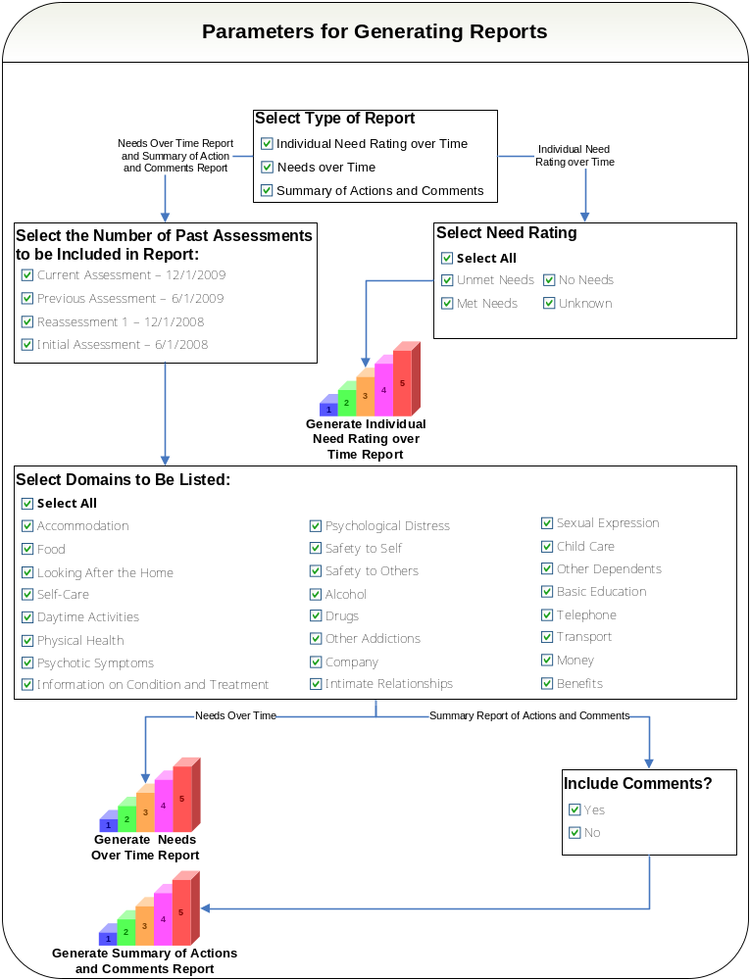

Parameter Details

Generating Individual Needs over Time Report

- The User selects to generate the “Individual Needs over Time” report.
- The User selects from a list the specific (or all) Need Ratings to be included in the report.
- The User generates the Individual Needs over Time Report.

Generating Needs over Time Report

- The User selects to generate the “Needs over Time” report.
- The User selects from a list of Assessments that were conducted with the Consumer.
  - The first Assessment should always be named as the “Initial Assessment.”
  - The latest Assessment should be listed as the “Current Assessment.”
  - The last Assessment (Assessment conducted prior to the most current Assessment) should be named as the “Previous Assessment.”
  - All Assessments conducted between the Previous and Last Assessment (if any) should just be named as Reassessment and be numbered chronologically from 1 onwards (1 being the earliest Reassessment conducted after the Initial Assessment).
  - All Assessments listed in this parameter should have a date next to it.
- The User selects the specific (or all) domains in the OCAN to be included as part of the report.
- The User generates the Needs over Time Report.

Generating Summary of Actions and Comments Report

- The User selects to generate the “Summary of Actions and Comments” report.
- The User selects from a list of Assessments that were conducted with the Consumer. Details of this step are the same as step 2 for generating “Needs over Time” report.
- The User selects the specific (or all) domains in the OCAN to be included as part of the report.
- The User selects to include or exclude Comments from the report.
- The User generates the Summary of Actions and Comments Report.

Report Specifications

Individual Need Rating over Time Report

Please refer to Section 7.1 Appendix A for the Report Mock Up

Report Name: Individual Need Rating Over Time

Report Description:

- This report will display what the purpose of the report is at the very top which is identified in the report mock up.
- It will then display the names of the Consumer and the Staff on the left and the date of when the report was ran by the Staff on the right.
- The report will display the number of needs for a particular need rating in a line graph.
- The report will display one or up to 4 line graphs in the report depending on the how many need ratings the user wants to see.
- Each need rating will be displayed in an individual line graph and will not be consolidated into one line graph.
- Each line graph on the report will show the number of need ratings for each Assessment given by both the Consumer and Staff.
- The Assessments will be listed on the x-axis and will list the Initial Assessment first going from left to the most Current Assessment on the right.
- The number of needs for a particular need rating will be listed on the y-axis.

Need over Time (Consumer and Staff) Report

Please refer to Section 7.2 Appendix B for the Report Mock Up

Report Name: Needs over Time (Consumer and Staff)

Report Description:

- This report will display what the purpose of this report is at the very top which is identified in the report mock up.
- It will then display the names of the Consumer and the Staff on the left and the date of when the report was ran by the Staff on the right.
- The report will then display a summary of the total number of Domains in each Need Rating category for each Assessment included in the report for both the Staff and Consumer descending in the following order: Unmet Needs, Met Needs, No Needs and Unknown.
- A date will be displayed under each Assessment to show when it was conducted.
- The report will also display in detail all the Domains rated by the Staff and Consumer in a table format for each Assessment that is part of the report.
- The Consumer and Staff columns where the need ratings are displayed for each domain should be different colors and consistent for the Consumer and Staff. It will show which domains are “Unmet Need”, “Met Need”, “No Need” and “Unknown” by both the Consumer and Staff.
- The grouping will be descended in the following order by agreement between the Consumer and Staff only for the most current Assessment included in the report: Unmet Need, Met Need, No Need and Unknown. The other Assessments should follow the same order as the most Current Assessment.
  - Every time “Unmet Need” is listed for a particular Domain, it should be displayed in red and bold text.
  - Agreement in Domains should be listed first for a particular Need Category. For e.g. if the Consumer and Staff agree that Physical Health is an “Unmet Need,” then it will be displayed first since there is agreement between the Consumer and Staff.
  - If there is disagreement where for e.g. the Consumer identifies that the Self Care Domain is an “Unmet Need” and the Staff identifies Self Care as a “Met Need,” then the higher rating will be taken into account which is “Unmet Need” and will be displayed after all domains where there was an agreement for “Unmet” need.
  - The grouping will then continue listing agreements between Consumer and Staff in “Met Needs” and so on until all Domains and their Need Ratings are listed for the Current Assessment.
- The Assessments are to be separated out with thick black lines.
- If there is a change in need rating from the previous Assessment when displaying the domain details table, a check mark will be displayed to denote the change in the “Change” column.
- The report will display a stacked up bar graph for both the Consumer and Staff for each Assessment included in the report.
- Each bar graph will be divided by the different need ratings for their specific Assessment and the value of each bar graph should always equal 24 which represent the number of domains.
- The Unmet Needs will be listed at the top of the bar followed by Met Needs, No Needs and Unknown.
- The value of each need rating is to be displayed within their specific bar graph for each Assessment.
- The graph will separate the Assessments by thick black lines.
- The legend of the bar graph should be listed at the bottom of the graph.
- The y-axis on the graph should display a maximum value of 24 and should be labelled “# of Domains.”
- The x-axis on the graph will list each Assessment included in the report and will be displayed under the Consumer and Staff columns for each Assessment. The x-axis will be labelled “Assessments.”
- The name of the report should be displayed at the top of the bar graph.

Report Display Fields: Purpose of Report, Summary of Needs, Assessment + <Date>, Need Ratings, Consumer, Staff, <Domains>, Change, Consumer Name, Staff Name, Report Date.

Report Filter Parameters:

# | Parameter Name | Parameter Values
1 | Assessments | List of all current and past Assessments done for the Consumer
2 | Domains | List of all Domains that are part of the OCAN

Summary of Actions and Comments Report

Please refer to Section 7.3 Appendix C for the Report Mock Up

Report Name: Summary of Actions and Comments

Report Description:

- This report will display what the purpose of the report is at the very top which is identified in the report mock up.
- It will then display the names of the Consumer and the Staff on the left and the date of when the report was ran by the Staff on the right.
- Each Assessment that is part of the Report will have the Assessment Date next to it.
- The user will have the option of wanting to see the Comments for each Domain. If they choose not to see the Comments, only the Actions for the domains will be listed.
- If there are no Comments or Actions for the Domains selected by the user, they will not show up on the report.
- The Comments will be listed for both the Consumer and Staff along with the Need Rating given by both the Consumer and Staff.
- The report will clearly identify what the Action, Consumer Comments and Staff Comments are for each Assessment.
- The Actions and Comments will be grouped by Domain first and then by Need Rating.
- Unmet Needs should be listed first followed by Met Needs, No Needs and Unknown.
- The Need Rating of the most current Assessment the user would like to view in the report will be taken into account when grouping the Actions and Comments by Need Rating.
- The Need Rating for the previous Assessments will not matter and will fall under the Current Assessment Need Rating as a history in descending order.
- When grouping current Assessment by Need Rating, the higher need rating given by either the Staff or the Consumer will be taken into Account.
  - For e.g., for the Accommodations the Consumer rates the Domain as an Unmet Need and the Staff rates it as a Met Need, then the Accommodation Domain will fall under the Unmet Need grouping since Unmet Need is a higher rating.

Report Display Fields: Purpose of Report, Assessment + <Date>, Need Ratings, Actions, Consumer Comments, Staff Comments, <Domains>, Consumer Name, Staff Name, Report Date.

Report Filter Parameters:

# | Parameter Name | Parameter Values
1 | Assessments | List of all current and past Assessments done for the Consumer
2 | Domains | List of all Domains that are part of the OCAN
3 | Comments | Yes/No

Staff Workload View/Report

This can either be a view or report depending on how the specific vendor would like to implement this within their system.

Please refer to Section 7.4 Appendix D for the View/Report Mock Up

View/Report Name: Staff Workload

View/Report Description:

- This view/report will display a list of all Assessments that are assigned to the user and show the information in each column if applicable.
- It will list the details for each Assessment that is part of the Staff workload.
- When a new Assessment is created by the user using their login information, the Assessment will show up in this view.
- Once the Staff has completed the Assessment, the Assessment record will be marked as completed.
- The view/report will be filtered by listing the Assessments that are “In Progress” first with the earliest start date and then list “Completed Assessments” with the earliest start date.
- Users should have the capability of filtering the view by all columns if implemented as a view within the specific system.
- The user will have the ability to assign the Assessments that are part of their workload to other workers within the organization by changing the value in the Worker field. The Consumer that is part of the Assessment that is being assigned a new worker will become part of the new worker’s workload as well and all past and future Assessments for the Consumer will show up on the new worker’s workload list. The Assessments will no longer be part of the original worker.

Assessment at Discharge

- If the date at Discharge is less than 3 calendar months from the current date, then the Consumer and their corresponding Assessments will remain part of the Staff’s Workload.
- If the Consumer has been discharged from the OCAN for more than 3 calendar months, the Consumer and their corresponding Assessments will no longer be part of the Staff’s Workload.

Below is a list of the columns that will be listed and a brief description of each column.

Column Name | Description
Assessment ID | This is the unique ID for each individual Assessment that is given by the system.
Consumer ID | This is the unique ID for each individual Consumer that is given by the system.
Last Name | Last Name of the Consumer for which the Assessment is being conducted.
First Name | First Name of the Consumer for which the Assessment is being conducted.
Status | This is the Status of the Assessment. There will be two different statuses:  In Progress: Assessments which are open and being worked on.  Completed: Assessments which have been marked as complete.
Start Date | Start Date of the Staff Assessment.
Completion Date | Completion Date of the Staff Assessment.
Reassessment Time Frame | This is the date range for when the Reassessments should be completed for the Assessments that are currently In Progress.  - Like all Assessments, Reassessments also have a 30 day completion window.  - Reassessment time frames will only be displayed for Assessments where the Reason for Assessment is either “Initial Assessment” or “Reassessment at 6 months.” All other assessments will not show a Reassessment timeframe.  - The start date of the Reassessment Time Frame will be 6 calendar months from the start date of the Initial Assessment that is “In Progress” and end date will be 30 calendar days from the start date of the Reassessment Time Frame.  - Once the first 6 month Reassessment is started by the user, this new Reassessment will become part of the Staff Workload and a new Reassessment time frame will be created for the recently “In Progress” Reassessment.  - The timeframe will always follow a 6 month “heartbeat” from the start date of the Initial Assessment until discharge.  For e.g. if the Initial Assessment that is part of the Staff work load has a start date of “1/24/2009,” the Reassessment Time Frame will be “07/24/2009 – 08/22/2009” for the 1st Reassessment. For the 2nd Reassessment once the 1st Reassessment has been started and becomes part of the Staff Workload, the 2nd Reassessment Time Frame will be 6 months out from the 1st Reassessment Time Frame start date and will be 01/24/2010 – 02/22/2010. This will continue on for the next 6 Month Reassessments.
Consumer Assessment Start Date | This is the Start Date of when then Consumer started their Self Assessment.
Consumer Assessment Completion Date | This is the Completion Date of when then Consumer completed their Self Assessment.
Worker | This is the Staff Member/Worker who is assigned to the Assessment/Consumer.

Report Display Fields: Assessment ID, Consumer ID, Last Name, First Name, Status, Start Date, Completion Date, Reassessment Time Frame, Consumer Assessment Start Date, Consumer Assessment Completion Date and Worker.

Report Filter Parameters:

# | Parameter Name | Parameter Values
 | None | None

Appendix

Appendix A


Appendix B

Appendix C

Appendix D

Appendix E

