EAAPS - The Electronic Asthma Action Plan System for Implementation in Primary Care

1. Statement of objectives and specific aims of the project in the form of hypothesis (1 page maximum)
Objectives
We hypothesize that our electronic asthma action plan system will increase the frequency of asthma action plan (AAP) delivery to patients by primary care physicians.

The objectives of the proposed study are:

1) to determine the impact of an electronic asthma action plan system on asthma action plan delivery by primary care physicians (as measured by chart review and patient questionnaires) (primary outcome measure)

2) to determine the impact of an electronic asthma action plan system on patient-relevant outcomes including hospitalisations, emergency room visits, unscheduled visits to the doctor, total visits to the doctor, days off work or school, nocturnal asthma symptoms, daytime asthma symptoms, daytime rescue bronchodilator use, and quality of life (as measured by patient questionnaires and health administrative databases) (secondary outcome measure)

3) to measure physicians’ perceived utility and adoption of the system and satisfaction with the system, as well as barriers and facilitators to use of the system (as measured by physician questionnaires and interviews) (secondary outcome measure)

2. Background, rationale and present state of knowledge (6 pages maximum)

Background
Asthma is a chronic and potentially fatal disease characterized by episodic or persistent shortness of breath, chest tightness, and cough¹, affecting 8.3% of Canadians aged 12 and over and increasing in prevalence². The annual economic burden of asthma was estimated at $10.7 billion in the United States in 1994³ and $504 million in Canada in 1990⁴.

Although effective therapies for asthma exist and well-controlled asthma is achievable in most patients, studies have demonstrated that the majority of patients with asthma remain poorly controlled, with frequent daytime asthma attacks, asthma-related nocturnal arousals, missed school or work, and recurrent need for urgent medical care⁵⁻⁷. This poor control has been shown to be largely attributable to undertreatment⁵⁻⁷. Reasons for undertreatment are likely multifactorial, including patient aversion to inhaled steroid medications due to a lack of appropriate education⁶, and confusion between the roles of controller and reliever medications among both patients and physicians^{5, 6}. Furthermore, patients appear to have low expectations for disease control; in one study⁸, 85% of patients who regarded their disease as either “adequately” or “very well” controlled actually had poor control according to the Canadian Asthma Consensus Guidelines. A similar discrepancy exists in physician assessment of asthma control, with physicians significantly overestimating control among their patients^{5, 6}, reflecting a failure of patient-physician communication, a lack of physician knowledge of achievable asthma control targets, or a combination of these two factors.

An asthma action plan (AAP) is an important potential solution to these challenges. It is an individualized written plan produced by a health care professional for a patient with asthma, for the purpose of providing education and guidelines for self-management of worsening asthma symptoms, including when and how to modify medications and access the medical system⁹. A systematic review of 18 randomized controlled trials (RCTs) demonstrated that the use of a written AAP in conjunction with education and regular clinical review significantly reduces hospitalizations [relative risk (RR) 0.64], emergency room visits (RR 0.82), unscheduled visits to the doctor (RR 0.68), number of days off work or school (RR 0.79), and nocturnal asthma symptoms (RR 0.67), and significantly improves quality of life (standard mean difference 0.29)⁹. Furthermore, in a study of predictors of asthma mortality, the use of an AAP was associated with a 70% reduction in the risk of death¹⁰.

Current Practice Gaps and Study Rationale
In accordance with this strong evidence, the most recent Canadian Asthma Consensus Guidelines recommend that all patients receive a written AAP¹. However, in a recent Canadian survey, only 22% of physicians reported providing a written AAP, and only 11% of patients with asthma reported receiving one⁶. This evidence-to-practice gap highlights the need for an effective knowledge translation strategy to address AAP delivery in primary care, where the vast majority of asthma patients are seen¹¹. This is the rationale for the proposed study.

Our Knowledge Translation Framework
Graham and colleagues termed the process of systematically bridging care gaps the “knowledge-to-action” (KTA) process and developed a framework describing its key elements, based on a review of planned-action theories and models¹². The process begins with identification of the particular clinical problem, which in this case is suboptimal asthma control. One then consults existing literature to identify, review, and select appropriate knowledge to address this problem. In this case, there is a well-established body of evidence to suggest that provision of a written AAP improves asthma control, as described above. After defining a simple message which is appropriate to the local context - in this case, primary care in Ontario - one identifies the existing barriers to use of this knowledge in that environment. Identifying these barriers to local knowledge uptake is a key prerequisite for designing successful interventions. Interventions are then selected, tailored, and implemented accordingly. Once these are in place, one measures instrumental knowledge use (the concrete application of new knowledge), which in this case, is the frequency of AAP delivery¹³. Finally, one evaluates the effects of this knowledge on patients, providers, and/or the health care system and makes plans to ensure the sustainability of any observed improvement.

Barriers to AAP Delivery
In accordance with the KTA process, we sought to identify barriers to AAP delivery by primary care physicians in order to target our intervention appropriately. Barriers may occur at many levels, including at the level of the care providers themselves, the practice environment, the patients, and the overall health care system¹⁴. Qualitative studies evaluating barriers to AAP delivery in primary care indicate that a majority of physicians consider AAPs important, but fail to provide them due to a lack of time^{6, 15, 16}. In addition, physicians are limited by a lack of experience and confidence in generating appropriate AAP recommendations, and a lack of availability of AAPs at the point of care^{6, 15-19}. In one study, 30% of physicians attending an asthma skills workshop were unable to prepare an adequate AAP¹⁹. Some physicians also believe that their patients would be unlikely to adhere to an AAP if provided^{15, 16}. This may be the case if patients are not engaged in their care, if the AAP is presented as a generic tool with no personalization, or if concurrent communication in the form of asthma education is not provided^{15, 20, 21}. However, studies have shown that most patients who receive education about AAPs view them favorably²². Also, the majority of patients across a wide range of educational and social backgrounds prefer an active or collaborative role in their asthma management and are less involved in their care than they would like to be²³, particularly when making decisions about initiating changes in medications during an exacerbation²⁴. Thus, existing barriers are multi-faceted, including provider-level barriers such as insufficient time and a lack of knowledge and self-efficacy, environmental factors such as limited AAP availability, and potential patient level factors such as poor adherence to AAPs under certain circumstances¹⁴.

A Proposed Solution
Few previous asthma care intervention studies have targeted and measured changes in AAP delivery by physicians²¹. The majority of these have employed simple tactics such as physician education and reminders, failing to address all of the above-identified barriers, and particularly time constraints. Although some previous system-wide interventions such as physician incentive programs²⁵ and specialized asthma clinics with asthma educators²⁶ have had some success, these resource-intensive interventions are not broadly applicable in our own primary health-care environment²¹.

Barriers at the health care provider level including time constraints as well as knowledge and self-efficacy barriers to AAP delivery may be addressed by a point-of-care clinical decision support system (CDSS). CDSSs work by generating patient-specific assessments or recommendations for clinicians through the input of patient data into a computer, with use of software algorithms that match pieces of information from a knowledge database^{27, 28}. In a systematic review of 100 controlled trials of CDSSs used in various settings and for various diseases, these systems improved provider performance in 64% of cases²⁷. A CDSS tool could employ a computerized algorithm to process responses to specific asthma-related input parameters to produce a personalized AAP, which could then be incorporated into an existing electronic medical record (EMR). Such a tool could diminish both uncertainty surrounding decision-making and the time required to create an AAP. The CDSS could also be used to ensure regular clinical review by prompting the clinician to arrange an appropriate follow-up appointment. Finally, considering patient level barriers, patients could concurrently be offered access to a self-directed web-based asthma educational program, increasing the likelihood of patient adherence to the AAP^{11, 21} while further minimizing clinical time requirements for physicians. A recent review found that most computer-based asthma education programs successfully improve patients’ asthma knowledge, and some may in themselves improve clinical outcomes²⁹.

A CDSS for general asthma care has been studied previously. Researchers in the United Kingdom attempted to improve asthma care by employing a CDSS which triggered tailored guideline recommendations in response to physician-initiated entries. However, both the number of times that the CDSS was triggered and physician interaction beyond the first information screen were low, and quality of care was unchanged³⁰. This suggests that clinical time constraints may limit the effectiveness of CDSS’s that require significant physician engagement, and systems that require activation by physicians may be less likely to be used²⁷. In order to address these concerns, relevant asthma-related parameters could be collected directly from individual patients. This can be done through a patient’s home computer or a portable computing device in the physician’s waiting room. Tablet computers with touch-screen capability have demonstrated high usability and uptake scores across age groups, and implementation in physician waiting rooms has been shown to be feasible^{31, 32}. This would have the added advantage of enhancing patients’ involvement in their own care and increasing personalization of the AAP, thereby addressing these patient-level barriers to AAP adherence²⁰. Patient responses could then be transmitted electronically from the home computer or portable computer interface to the CDSS on the physician’s desktop computer, which would then produce an electronic version of the AAP (eAAP) and send this to the physician EMR for review, printing and delivery to the patient by the physician. Although the content of the eAAP would still be alterable by physicians before printing, this process would eliminate the need for the physician to activate the system or to enter data directly. Furthermore, physicians could be offered an option to automatically email a copy of the eAAP to a consenting patient, providing another avenue for patient access to the information in the AAP.

An embedded message in the patient interface could also be used to encourage patients to prompt their physicians to provide them with the AAP. This adjunctive patient-mediated KT strategy may be particularly effective in influencing practice³³. A website designed to improve asthma care by suggesting patient questions for physicians resulted in improved patient-physician communication and interaction, and garnered favorable reviews and high acceptance rates from patients, suggesting that patients can play a role in overcoming the clinical inertia of providers³⁴. A prior study has also shown that a directed patient-to-physician prompt for guideline-recommended asthma care can improve quality-of-care³⁵. The patient-to-physician prompt would be an automated component of the multifaceted electronic asthma action plan system (eAAPS) that we have outlined above.

Previous experience suggests that a participatory approach through the use of electronic technologies is likely to be acceptable to patients with asthma. As noted, qualitative studies suggest that most patients with asthma prefer to take on an active or collaborative role in their care²³. Furthermore, these patients are willing to use the internet to access asthma and other health-related information, and this tendency is not associated with a particular gender, age, education level, or socio-economic class³⁶. Portable communication devices such as a pocket personal computer or personal digital assistant have also been shown to be well accepted by both adolescents and adults of all ages with asthma^{37, 38}. The benefits of using electronic communications technology in this population may include greater adherence and a greater feeling of control and mastery through patient empowerment³⁷.

Progress To Date
This proposed study is the second phase of a three-phase study that has been planned (please see project design, methodology and analysis section for details). The first phase of the project was the AAP development phase, which was supported by a grant from the Physicians’ Services Incorporated Foundation. This phase is now complete, and its components are detailed below.

A Systematic Review of Existing Asthma Action Plans
As a first step to developing our electronic asthma action plan system (eAAPS), we sought to identify an existing AAP which could be adapted and integrated for use in our system. However, analysis of a convenience sample of 5 locally available AAPs revealed significant variability in both content and format across these different AAPs (examples are included in Appendix 1). Previous authors have also noted the presence of important differences in the structure and content of AAPs recommended by different authorities^{20, 39, 40}. A systematic review comparing major features of 17 different written AAPs evaluated in RCTs found that the following components were common to most AAPs: 1) when to increase treatment (an “action point”), 2) how to increase treatment, 3) for how long to increase treatment, and 4) when to seek medical help³⁹. However, the content and format of each component varied. For example, the number of action points varied between two and four, and thresholds for increased treatment advice were based either on peak expiratory flow values, symptoms, or a combination thereof, with threshold values differing between plans. In terms of format, action points were occasionally but not consistently presented in a green, yellow and red “traffic light” configuration³⁹. As demonstrated in the three distinct AAPs in Appendix 1, other potentially variable AAP format features include use of an “asthma quiz”, use of “happy face” symbols to indicate level of control, integration of a valid prescription in the AAP, use of coloured text and background, bolded or italicized text, various organizational logos, and landscape document orientation.

Given these findings, we sought to formally characterize the variability between existing AAPs and to thereby develop a comprehensive catalogue of content and format elements for possible inclusion in the AAP to be used in our system. We undertook a systematic search for currently used, recommended, or previously studied adult AAPs, or specific published recommendations regarding AAP format and/or content from the following sources: the internet (GoogleTM keyword: “asthma action plan”), Canadian asthma experts, Canadian pulmonary and/or asthma associations, the most recent asthma guidelines from Canada, the United States, the Global Initiative for Asthma (GINA), Australia, and the United Kingdom, and published randomized trials as identified through a systematic search strategy. We inductively developed analytic criteria for both format and content analyses as well as categories for each of these criteria based on serial examination of AAPs. We analyzed plans using principles of content analysis⁴¹. The format features of each AAP were analyzed by a specialist in human factors’ engineering and the content features were analyzed by a respirologist. Analytic criteria for format and content are included in Appendix 2.

Briefly, we recovered a total of 98 AAPs, of which 20 were exact duplicates, leaving 78 unique AAPs. Of these, 22 (28%) were pediatric-specific, 1 (1.3%) was ER-specific, 1 (1.3%) was ER and pediatric-specific, 2 (2.6%) were in Spanish and 1 (1.3%) was in Cantonese, leaving 51 (65%) unique English or French-language adult out-patient AAPs suitable for content and format analysis. We found published appendices or tables containing details regarding an additional 16 AAPs used in studies, one of which was a duplicate of a previously acquired AAP, leaving 15 additional AAPs. We also included 3 additional sets of published specific recommendations for AAP format and/or content - two received from an asthma expert and one found in the Global Initiative for Asthma Guideline. In total, this represented 18 additional unique AAPs for which we had format and/or content information, yielding a total of 69 AAPs for analysis.

Of these 69 AAPs, twenty-four (35%) originated in Canada, 19 (28%) in the United States, 10 (14%) in the United Kingdom, 7 (10%) in Australia, 1 (1.4%) in each of New Zealand, the Netherlands, Spain, Italy, Norway, and France; 1 (1.4%) was by an international group and 2 (2.9%) were of unknown origin. Of the 53 AAPs in which language could be ascertained, 50 (94%) were in English and 3 (5.7%) were in French.

There were important content and format differences between AAPs. Major features are summarized in Appendix 2, Tables 1 and 2.

Development of a Stakeholder Preference-Based Asthma Action Plan
Given the variability between existing AAPs noted in the above study, before undertaking an implementation study of our electronic AAP system (eAAPS), we believed that it was necessary to establish the “best possible” content and format for the AAP to be used in this system.

We reviewed current asthma literature for evidence supporting content elements, and noted that many important questions remain unanswered. Systematic reviews comparing peak expiratory flow (PEF)-based and symptom-based AAPs have found these two approaches to be equivalent for most outcomes, with the exception of preventing unscheduled doctor visits, for which symptom-based plans are superior^{42, 43}. Overall, these data suggest that symptom-based action points should be included in any AAP, but any additional benefit of including PEF-based thresholds remains unproven. For asthma exacerbations requiring an emergency room (ER) visit without admission, a systematic review has demonstrated that outpatient systemic corticosteroid therapy decreases future requirement for urgent care, hospitalizations, and reliever medication requirements⁴⁴. However, it remains unclear if an identical approach is warranted for the milder exacerbations - also known as “asthma worsenings”⁴⁵ - that are targeted by an AAP. Also, corticosteroid dose, need for a tapering regimen, and exact duration of therapy remain unclear ⁴⁴. Studies have also addressed whether an increase in inhaled corticosteroid (ICS) dose alone can avert “full-blown” exacerbations in patients with asthma worsenings, but data are limited. Early quadrupling of the ICS dose in response to a drop in PEF significantly decreased the number of exacerbations compared to placebo in a study by Foresi, et al.⁴⁶, and reduced the relative risk of requiring oral steroids in a study by Oborne, et al.⁴⁷. Other studies have failed to show an effect with a doubling in ICS dose^{48, 49}. Other authors suggest that patients should be instructed to use a combination ICS/long-acting beta-agonist puffer as needed in response to increasing asthma symptoms, in which case the increase in ICS dose in the context of an asthma worsening would be individualized⁴⁵.

We reviewed human factors and graphical design literature for evidence supporting format elements. Although no studies have examined which particular format elements of an AAP render it a more effective tool for adult patients with asthma, a growing body of work has examined the role of typological features such as font size and type, and paragraph and page layout on the effectiveness of written educational materials in general⁵⁰. Given that medical decision aids are designed to transmit medical information and complex risk/benefit ratios to patients, the literature surrounding their appearance and format may also be relevant to the design of AAPs. These researchers have used "information architecture" to lay out information in such a way as to invite the patient into the content and guide him or her through the document. Important features influencing use include the density of information on the page and the length and "feel" of the tool itself⁵¹. Finally, literature on health consumer communication has stressed the importance of “reader-friendly” design elements, including 12 to 14-point serif type, lower case letters in the body of the text, and ample margins⁵². Written elements must require a “low grade-level” of literacy, and special attention must be paid to “document” literacy (readability of graphs and tables) and “quantitative” literacy (ability to process numbers and perform calculations)⁵²; these concepts are particularly relevant given that AAPs often list medications in a table format, and stipulate numerical changes to both frequency and doses of medications. Studies have also suggested that symbols can be used as visual cues to make data more readily evaluable and to reduce the reader’s cognitive load⁵³. Unfortunately, there is a paucity of analytical research addressing aspects such as page size, distribution of margins, and choice of page and font colour, and these are routinely based on design experience.

In developing the AAP for use in our system, we used the following four sources: 1) the above-described current evidence regarding content and format; 2) the catalogue of previously used content and format elements developed in the above-described study; 3) asthma expert opinion for content elements; and 4) human factors’ design expert opinion for format elements. This approach was supported by previous studies that have demonstrated the advantage of incorporating basic human factors design elements in the design of visual media intended for health care interventions⁵⁴. Although the vast majority of existing AAPs have been developed predominantly from a medical rather than from a patient perspective^{22, 55}, we also believed that it was important to consider the needs and preferences of all key stakeholder groups in our design process: asthma expert respirologists (content experts), primary care physicians and asthma educators (professionals that interact directly with the patients), and patients with asthma.

In order to both capture the user preferences of these various stakeholder groups³⁹ and arrive at a collaboratively designed and agreed upon AAP, we employed a unique wiki-based approach. A wiki is a hypertext-based collaborative software that not only allows users to add content, but also to edit and alter existing content according to their preferences. We began by creating a web-based “AAP template” which contained entry fields with drop-down menus containing multiple choices for AAP content and/or format, based on the four sources outlined above (Appendix 3, Figure 1). This enabled users to “construct” an AAP by choosing a series of options in these various menus while visualizing the evolving AAP on the same screen. We refined both the usability of this tool and the various options presented in the drop down-menus based on analysis of field notes and audio transcriptions from a series of structured, moderated focus group sessions held with each stakeholder group (please see Appendix 3, Tables 3 and 4 for participant demographics). Focus group participant responses to an exit questionnaire regarding the usability of the tool are summarized in Appendix 3, Figure 2. After several iterative rounds of tool improvements based on this feedback, we presented the improved tool to three groups of new users (each comprised of 3 respirologists, 2 primary care physicians, 2 asthma educators, and 7 patients with asthma) in a wiki environment (please see Appendix 3, Tables 3 and 4 for participant demographics). Each group was then given a one-week period during which members collaboratively authored a single, printable AAP by making multiple selections in the online tool (http://knowledgetranslation.ca/octapus_i/login.php?access=guest). During this period, the tool functioned as a wiki, whereby any member could log on at any time and alter the choices that had previously been made by other members, such that the AAP gradually evolved based on user preferences. Over time, individual preferences were influenced by those of others until the process yielded a group consensus. This process was supported by a web-log for online discussions between members and comment fields attached to particular choices, allowing members to offer supporting arguments for each of their choices (statistics describing participant usage of the tool are reported in Appendix 3, Table 5). Overall, users considered this an effective process to generate consensus around a complex and multifaceted product. Also, users reported higher system usability scores compared to focus group stage users, and a high level of satisfaction with the final AAP that was produced by their group (please see Appendix 3, Figures 3 and 4, respectively). Subsequent to this wiki process, a small group of study investigators analyzed all three groups’ AAPs using document analysis methods and developed a single common AAP by incorporating as many group preferences as possible. Finally, this AAP underwent face validation in two successive, moderated, 4-participant focus groups with representation from all stakeholder groups, and a resulting final version of the AAP was thereby created (Appendix 3, Figure 5).

In summary, based on the evaluation and development process carried out in the first phase of this study, we now have a valid model AAP which will be used in our electronic AAP system (eAAPS). In addition, given that the electronic AAP that will be generated by the CDSS will have a similar functionality to that of the wiki tool (e.g. drop-down options for clinicians who wish to override certain AAP features), development of this part of the system is largely complete.

References (For Background)
4. Project design, methodology and analysis (7 pages maximum)
We propose to bridge the gap in AAP delivery by implementing a multifaceted electronic AAP system (eAAPS). This project will employ an interrupted time series study design to measure the effect of this eAAPS on AAP delivery and patient outcomes. This study will inform the next study phase, a cluster randomized controlled trial testing the effects of the eAAPS on asthma patient outcomes across a large number of primary care practices in Ontario.

Study Design
We will evaluate the eAAPS using the quasi-experimental interrupted time series (ITS) design. This analytic design was chosen because it is more robust than a simple before-and-after study design in that it can detect and account for important potential biases⁵⁶. Although RCTs are widely accepted as the most reliable method of determining effectiveness⁵⁷, complex interventions benefit from designs such as the ITS in order to establish the acceptability and feasibility of the intervention, estimates of effect sizes and their variances, and the feasibility of measuring desired outcomes⁵⁷. We believe that a large, cluster-randomized RCT of this intervention would be inappropriate at this stage, given that feasibility and any potential barriers and facilitators to successful implementation of the eAAPS have not yet been determined.

This phase of the study will take place in the McMaster Family Health Team (FHT) in Hamilton, Ontario, which comprises 28 physicians and approximately 30 000 patients over two sites. This group uses the latest OntarioMD-certified EMR system (“OSCAR”) (http://oscarcanada.org), into which we will be able to directly incorporate the functionality required for the eAAPS system. Our co-investigators from the FHT (DC and GA) will identify potential physician and nurse practitioner participants, and all physicians and nurse practitioners will be given access to the eAAPS in their office environment.

This will be a two-year study, and each of the baseline assessment and intervention assessment periods will consist of 26 2-week assessment points (52 weeks each). The study’s primary outcome will be AAP delivery as measured by a review of electronic charts. The long duration of this study should also allow AAP provision to result in downstream changes in patient-level outcomes. These will be collected directly from consenting patients through an existing web-based patient health record (PHR) called “MyOSCAR” (http://myoscar.org). Twenty-eight hundred patients are currently enrolled in the MyOSCAR system, through which they can view their electronic health record and send personal data to the physician EMR from any computer, using a standard Internet browser (through a secure server). Accordingly, study-related electronic questionnaires will be embedded directly within consenting patients’ PHRs. Patients who are not already using the MyOSCAR system will be offered a MyOscar account through a practice-wide initiative of the McMaster Family Health Practice. In accordance with existing clinic procedures to encourage patients to use the MyOSCAR system, patients who are not using the system will also be called to encourage use of the system. During the intervention period, patients who are not already on this system will also be directly enrolled into MyOSCAR through the portable computer interface which forms part of the intervention.

Intervention
During the baseline phase (the first year of the study), we will encourage patients with asthma to use the web-based MyOSCAR interface from home (through the various measures described above) and offer access to a web-based asthma education program both through MyOSCAR and independently. During the intervention phase, the eAAPS will be offered, including: 1) the MyOSCAR interface at home or through a portable waiting room computer (a touch-screen tablet device), which will now allow patients to enter relevant asthma-related parameters, will explain the purpose of an AAP and the web-based asthma educational program, will offer direct access to the web-based educational program (from the home computer interface) or offer to email a link for the program (from the portable waiting room computer), and will ask patients to prompt their physicians for the AAP at the time of the clinical visit; 2) a CDSS which will process information provided by patients through MyOSCAR to produce an electronic AAP, will allow physicians to alter this AAP as necessary before printing and/or emailing it to patients, and will provide physicians with a reminder to arrange appropriate follow-up and to provide patients with a pre-printed sticky-note reminding them to visit the web-based asthma education program; and 3) the web-based asthma education program. This web-based program was developed through a collaboration between a study co-investigator (AL) and the Asthma Society of Canada, using best-practices in evidence-based multimedia learning, and subjected to rigorous formative evaluation (www.takingcontrolofyourasthma.ca).

Population
Eligible health care practitioners will include all primary care physicians and nurse practitioners at the McMaster FHT. Eligible patients will include patients currently on a controller medication for asthma, aged ≥ 16 years with physician-diagnosed asthma as listed in their current diagnoses in the electronic chart, regardless of which particular complaint they are being seen for on the day of the clinical assessment. Patients who received an AAP within the last 6 months (from their primary care physician, a respirologist, or any other source) will be excluded, as these patients would not be expected to receive a new AAP, but simply review and possible updating of their previous AAP (this will be ascertained directly from patients through the home or portable computer interface, and through the physician chart for patients who chose not to use the computer interface). Pregnant patients will be excluded given that conventional AAP recommendations may not be appropriate in this population. Patients with no computer and/or internet access at home will be unable to enroll and participate from home or to provide patient-level outcome data, but can still use the portable device in the waiting room and therefore will be counted in the primary outcome analysis.

Outcomes
The primary outcome will be the percentage of eligible patients to whom an AAP was delivered by the physician during the intervention period (52 weeks) compared to the baseline period (52 weeks). AAP delivery will be defined as delivery by hand or email of a new AAP to a patient by a physician. Previous studies have used patient report^{5, 6} and/or physician report⁶ to determine AAP delivery rates, however given that these sources are of uncertain accuracy⁵⁸, we will base our primary outcome on a chart review. During the baseline assessment phase (pre-intervention), this percentage will be determined by reviewing all eligible electronic patient charts in search of documentation of AAP delivery. Eligible charts will be identified through an automated search of the EMR system for all patients with a diagnosis of asthma. During the intervention phase, for eligible patients in whom physicians used the CDSS, this percentage will be determined by counting each time the physician printed or emailed the AAP as a delivery event (this will be recorded automatically through the EMR); for eligible patients in whom physicians did not use the CDSS, we will review electronic charts in search of documentation of AAP delivery (in case physicians chose to bypass the CDSS in certain cases).

Our unit of experimentation will be based on multiple temporal assessments rather than a single group of participants being tested both before and after introduction of the intervention. Each assessment period will be 2-weeks in duration, and the data set in each period will consist of all eligible patients seen within that time. The primary outcome will be recorded on a chart review form which will be tested on a random sample of patient charts prior to data collection. For calibration of reliability, we plan to apply several different algorithms by combining different sets of variables, and test these combinations for sensitivity and specificity by performing a chart review. We have designed this part of the study in accordance with a similar recent study conducted at the Institute for Clinical Evaluative Sciences (AS Gershon, et al. Identifying patients with physician-diagnosed asthma in health administrative databases. Can Respir J 2009;16(6):183-188.)
Population-based samples of individuals are often used to validate diseases in the population; however, to evaluate the ability of our algorithm to distinguish between asthma and COPD, and other related respiratory conditions, a more conservative cohort that includes higher proportions of these patients will be created. Therefore, the study population will consist of equal numbers of patients who have asthma, COPD, asthma-related conditions and other conditions according to the their PCP’s electronic billing system. Patients with asthma will be included to ensure that the algorithm definition can truly identify individuals with asthma. Patients with asthma-related conditions and COPD will be included to ensure that the algorithm can distinguish between asthma and clinically similar conditions. Patients not specifically identified as having ‘other’ conditions not included in any of the other categories will be included as respiratory healthy controls. To simplify subject selection and ensure that these patients do not have respiratory disease, this final category will be limited to patients with hypertension or musculoskeletal problems. It will be possible for an individual to be eligible for inclusion in an asthma and a non-asthma category; these patients will be included in the most recent category that they were identified to be in by their PCP’s billing code.

We will divide each consenting physician’s practice roster into these 4 diagnostic categories, and randomly analyze a fixed number of charts from each category, for each physician, for a total of approximately 50-100 charts per category (we will include charts from each of the recruited physicians’ practices, to ensure that our algorithm’s operating characteristics are not biased by any one particular physician’s charting style). Chart analysis will be performed by 2 physicians who are residents in family practice. Each physician will review and abstract all charts, and determine whether or not physician-diagnosed asthma is present, and whether or not patients with asthma are being treated with controller asthma medications. A determination of a physician-diagnosis of asthma will be based on a mention of an asthma diagnosis in the chart and /or if a patient is receiving treatment consistent with asthma treatment, even in the absence of a formal diagnosis of asthma).

Most patients will not have had a formal and objective diagnosis made by pulmonary function testing, but we will record this when it does exist. Given that our purpose is to be able to identify cases of physician-diagnosed asthma in primary care, and that most primary care physicians do not employ objective testing routinely in the diagnosis of asthma, it would be unreasonable to require objective testing as a criterion for diagnosis.

Agreement between abstractors will be calculated, and a study investigator will act as a tie-breaker for charts over which there is disagreement.

We will then use this set of charts to test the operating characteristics of several different algorithms for identification of patients with asthma.

These algorithms will consist of combinations of the following main chart variables:

1) Patient medications
2) Patient diagnoses in the electronic disease registry
3) Billing codes used by physicians
4) Use of an asthma flow sheet
5) Use of the word search for “asthma” anywhere in the chart
6) Use of the word “asthma” in the electronic cumulative patient profile

A database will be developed to capture appropriate data for both the pre- and post-intervention phases of the study and to log all chart review sessions. A subset of the primary outcome data will also be verified by matching data extracted from charts with corresponding questionnaire responses from patients enrolled in the study. This comparison will serve to verify the validity of the chart review data.

Secondary outcomes that we will collect directly from patients will include the following: hospitalisations, emergency room visits, unscheduled visits to the doctor, days off work or school, nocturnal asthma symptoms, daytime asthma symptoms, daytime rescue bronchodilator use, and quality of life (through the validated Mini Asthma Quality of Life Questionnaire)⁵⁹. For these outcomes, the data set at each time point will consist of patient responses to an electronic questionnaire administered at the end of every 2-week assessment period. Patients will be emailed a unique link which opens their MyOSCAR webpage containing the questionnaire, which will consist of a series of questions with radio button and fillable form fields ending with a “click-to-submit” button. In addition, we will measure hospitalisations, emergency room visits, and total outpatient visits to primary care physicians and respirologists using health administrative databases. Other secondary outcomes will include questionnaire and interview-based assessments of physicians’ perceived utility of, adoption of, and satisfaction with the system (including the System Usability Scale - a validated 10-item Likert scale designed to assess the subjective usability of a system)⁶⁰, as well as barriers and facilitators to use of the system¹³. The use of asthma educational website will be evaluated by measuring whether people clicked on the link, which website people came from to arrive at our website, aggregate data on how much time all users spent on each section of the website, pageview numbers, unique pageview numbers, average time on each page, bounce rate (percentage of visitors who etner the site and “bounce” (leave the site) rather than continue viewing other pages within the same site.

Study Phases (please see timeline, Appendix 4)
Baseline Phase (12 months)
The baseline phase will consist of the first 12 months of the study, during which we will develop the intervention and debug it in the actual practice environment. At the same time, we will collect 12 months of baseline data.

a) Intervention Development (6 months)
During the first six months of the Baseline Phase, we will develop the two main components of the eAAPS intervention. The first component is the questionnaire to be incorporated in the web-based MyOSCAR interface that will enable patients to input relevant asthma-related parameters while at home, or on a portable computer in the physician’s waiting room. Given their low cost and user-friendly interface, we will use AppleTM iPad tablets with touch screen capability⁶¹ (or a comparable portable computing interface if these are not available). A series of simple questions will be used to collect the information required to generate a personalized AAP (a list of these variables is provided in Appendix 5). A simple explanation of the nature and purpose of an AAP and a prompt encouraging patients to ask their physicians for their AAP will also be included.

Our design will draw on our previous successful experience developing a similar portable computer-based questionnaire for patients with osteoporosis⁶², and previously published recommendations and usability testing data^{31, 63}. After initial development, we will test the device and questionnaire in a moderated 2-hour focus group with 5 patients with asthma, targeting a wide age range, as has previously been shown to be effective³¹. Participants will be asked to complete the questionnaire using the portable device while being observed by the moderator and a study investigator, who will record any difficulties in an event-log. The moderator will then debrief the users as a group, eliciting opinions on the information architecture, graphic design, animation, color, font and screen size preferences, interactivity functions for data entry, as well as ergonomic features³¹. A study investigator will take field notes during the session, and these will be supplemented by transcriptions of audio-recordings of each session. Based on these qualitative data, investigators will make recommended changes to improve the clarity of the questionnaire and/or the usability of the portable computer interface. If substantial changes are made to the questionnaire as a result of feedback received, we will assemble a new focus group and conduct an identical second session with the updated version. Participants for this stage will be recruited among the 26 patients with asthma who recently participated in our wiki-based AAP development study. Should we require additional participants we will recruit patients with asthma through the respirology clinic at St. Michael’s.

The second component of the eAAPS is the clinical decision support system (CDSS) with the electronic AAP (eAAP). The CDSS will employ a computer algorithm to generate a personalized AAP based on patient responses to the questionnaire in MyOSCAR (described above). The eAAP will be developed using the computer code written for our previously described wiki-based AAP development tool. Although the goal of the CDSS is to generate a readily printable and usable AAP, physicians will be given an option to edit the eAAP before finalizing. After entering the appropriate electronic patient chart, physicians will be given the following options: “View eAAP,” “Ignore eAAP (patient already has up-to-date AAP produced within 6 months)”, or “Defer viewing eAAP Until Next Visit”. Upon viewing the eAAP, they will be allowed to make any desired changes before printing and/or emailing the plan to the patient. Before exiting the system, physicians will be reminded to book a regular follow-up for AAP review and to provide patients with the pre-printed sticky-note reminding them to visit the web-based asthma education program. We will test this system in a similar fashion to that described above for the portable device and electronic questionnaire, using a 2-hour moderated focus group with 3 to 5 primary care physicians. Participants will be recruited among the 10 primary care physicians who recently participated in our wiki-based AAP development study. Although we will exclude physicians from the McMaster FHT to avoid bias during the baseline phase, we will also solicit feedback on this system from the clinic managers at both FHT sites and make suggested changes.

b) Intervention Debugging (6 months)
During the next 6 months of the Baseline Phase, we will assess clinical practice workflow and adapt and debug the intervention for later incorporation into each of the two the participating sites. A computer programmer and the research coordinator will work with personnel from each site to integrate the system within each practitioner’s setting without impeding workflow. Practical considerations will include where to locate and how to secure iPads, where to locate pre-printed sticky-note pads, how to target patients with asthma to use the iPad (e.g. signs in the clinic waiting room and reminders from clinic staff), enabling appropriate and secure data transfer between the MyOSCAR interface, the CDSS, and the physician’s OSCAR EMR, installing the CDSS on all desktop computers, and establishing connections to accessible network printers for physicians to conveniently print and deliver AAPs to patients (if local printers are not available). Most of these factors will depend on existing local resources and will require customization to each practice environment.

Near the end of this period, we will organize individual or group sessions in order to educate clinic staff and consenting physicians about the goals of the study (depending on the needs of each practice). These sessions will present the evidence for AAPs and address possible physician concerns that patients would be unlikely to use an AAP if provided (which has previously been identified as a barrier to AAP delivery, detailed above). Consenting physicians at each site will be trained on how to use the system in brief training sessions led by the research assistant and a clinician. They will receive a short instructional pamphlet which will be available electronically and in print format. An information technologist will also be available during these educational sessions.

c) Baseline Outcome Assessment (12 months)
Baseline data for the primary outcome (AAP delivery by physicians) will be based on 26 2-week assessment-points. We will collect the data for these assessment points through an electronic chart review conducted during the last week of each month for 12 months. Because we will not be seeking patient level consent for this chart review, each chart will be assigned a unique identification number and data entered into a database in aggregate form only. For the subset of patients who agreed to enrolled in the study for patient-level outcomes (through MyOSCAR at home or in the waiting room), we will also verify individual charts to confirm that they have a physician diagnosis of asthma (consent for access to these particular charts will be acquired directly from patients at the time of the electronic study consent). We will target collection of all episodes of care at each time point, in accordance with Ramsay, et al’s quality control criteria for ITS designs⁵⁶. AAP ownership may not be documented in the charts of patients who received an AAP from a respirologist. We will not be able to exclude these patients unless there is clear documentation that they received an AAP within the last 6 months (an exclusion criterion). However, because primary care physicians may expect patients who are under the concurrent care of a respirologist to receive an AAP from their respirologist, the chart review will document whether a respirologist has seen the patient within the last 6 months, and whether a respirology follow-up is planned (according to the last respirology consult letter).

Patient-level secondary outcomes will be collected directly from patients through online questionnaires in MyOSCAR. Upon accessing the website from home or in the waiting room, they will be recruited to the study electronically in accordance with recognized principles for ethical internet research⁶⁴ (a screen shot of a prior electronic consent that we have developed is included in Appendix 6). Although all recruitment will take place through a novel application which will be offered in patients’ MyOSCAR portals, because there is no formal method for alerting patients of new applications, we will notify patients of the presence of the new application relating to this study by a secure message within the MyOSCAR system. In cases where patients are not using the MyOSCAR secure messaging system, we will e-mail them directly to notify them about the application. Alternatively, we will telephone them (if an e-mail address is not available, or if there is no response to e-mail after 1 week). We will also send out a general information message relating to the application and the study in a biannual newsletter received by all patients (this is not formulated yet, as it will be sent out close to the start of the 2nd year of the study). Participants recruited over the first 6 months of the Baseline Phase will answer a baseline electronic questionnaire and a simple follow-up questionnaire sent to their personal emails at 2-week intervals for a total of 6 months, assessing their level of asthma control over the previous 2 weeks⁶⁵; these data will be analyzed as 13 2-week assessment points. Questionnaires will also record whether patients received an AAP from their primary care physician at the first visit and at any visits thereafter, or from any other sources such as a respirologist. These data will be analyzed independently and responses will also be compared to findings from the review of the corresponding visit’s electronic health record to ascertain the accuracy of the primary outcome assessment. We will also use health administrative databases to ascertain hospitalisations, emergency room visits, and total outpatient visits to primary care physicians or respirologists. This will be ascertained for all consenting patients with a physician-diagnosis of asthma seen during the baseline outcome assessment period. We will use patient health insurance numbers to generate unique anonymous identifiers which will then be used to match each patient to health-administrative databases (procedures will be in compliance with current privacy legislation). We will not collect secondary outcome data from participants enrolled during the latter 6 months of the Baseline Phase due to the fact that they will have less than 6-months follow-up before the intervention is implemented. However, these patients will still be asked to report whether they received an AAP (assessed as above, through electronic questionnaires sent every 2 weeks). It should be noted that after responding to the initial electronic recruitment-related web pages on MyOSCAR, both consenting and non-consenting patients will be advised to visit the web-based asthma education program and provided with the corresponding link.

Study materials required for the Baseline Phase, including the web pages that will be used for patient recruitment and consent, consent forms (a sample is provided in Appendix 7), questions for the web-based outcome assessment questionnaires, and the pre-printed pads of sticky-notes are currently being finalized.

Intervention Phase (12 months)
By the end of the 12-month Baseline Outcome Assessment, the system will have been fully developed and debugged, and the Intervention Phase will begin. Throughout the intervention period, physicians will continue to have access to an information technologist (via email or phone) to address any problems or questions regarding the system.

Data collection will proceed in a similar fashion to that described above for the Baseline Outcome Assessment. Briefly, eligible charts will be reviewed during the last week of each month for 12 months. To minimize the possibility of biased data ascertainment, all data collection techniques, procedures, and data collection forms will be identical to those used during the Baseline Phase. For evaluation of secondary outcomes, new patients will be recruited at each clinical visit through an identical process to that outlined above and followed with questionnaires, as above. Patients who participated in the Baseline Phase will be allowed to enroll again for this phase. In the ITS analysis, their questionnaire responses will not be compared to their own previous results, but will simply inform the event rate for the corresponding assessment period. Consenting patients seen during the Intervention Phase will also be linked to health administrative databases (as described above for the Baseline Phase).

Feedback Phase
In the last month of the 12-month intervention phase, an electronic questionnaire will be sent to all physicians using the eAAPS. This questionnaire will collect demographic information, probe physicians’ perceived utility of the system, readiness to adopt the system, and satisfaction, using Likert scale-type questions and the System Usability Scale⁶⁰ (an example of this questionnaire is shown in Appendix 8). A research assistant will also conduct 30-minute telephone interviews with 3-5 physicians at each site, using open-ended questions to probe their experiences with the tool and perceived barriers and facilitators to its use. To evaluate for the possibility of “history” (a threat to internal validity in ITS designs whereby some influential event occurring just before or during the intervention period influences the outcomes of interest), questionnaires will also capture all clinical practice-related activities completed by physicians (e.g. continuing medical education activities), exposure to any new publications or recommendations (e.g. new asthma guidelines), and any new government incentives or initiatives relating to asthma care during the study period (24 months), and the influences of these factors on practice. Interviews will be recorded and transcribed verbatim.

Sampling and Population
In ITS studies, sample size calculations are based on an estimation of the number of observations or time points at which data will be collected. Recommendations for a rigorous ITS design indicate that at least 10 pre- and 10 post-data points would be needed to achieve at least 80% power to detect a change (if the autocorrelation is > 0.4)⁶⁶. As this is a novel intervention, there is no data on what the autocorrelation might be or what effect size the intervention is likely to produce. Therefore, we will divide data into 26 2-week time points both before and after the intervention. This should be sufficient to detect any trend and to suggest seasonal patterns. Although we expect high first-order autocorrelation, we do not expect to encounter a complicated error structure (such as a higher-order autoregressive process integrated with a higher-order moving average of error). Estimating a baseline AAP delivery rate of 11%⁶, we would require only 15 time points in each phase for a power of 80% to detect a doubling in this rate to 22% with the intervention (a conservative estimate of effect size). Estimating a physician recruitment of 8 physicians across both FHT sites, an average active practice size of 1000 patients per physician, a physician-diagnosed asthma prevalence of 8.3%⁶⁷, and at least one eligible patient visit per year, we estimate that 664 patients with asthma will be seen each year (approximately 25 visits per 2-week time period). Assuming that 50% of these patients will also consent for and provide secondary (patient-related) outcomes for the first 6-months of each phases, we will analyze patient-related outcomes in approximately 330 patients over the 2-year study.

ITS Analysis
Most outcome data will be analyzed cumulatively for all patients at all sites. For the primary outcome, 26 consecutive 2-week time points will be used to create a pre-intervention model. To evaluate whether this pre-intervention model adequately describes the baseline, time series models will also be estimated for the entire 52 time points (pre- and post-intervention). The impact of the intervention will be examined using interrupted time series modeling for both FHT sites cumulatively, for each site independently, and for individual physicians. Time series analysis of aggregated patient data will allow a rigorous analysis of model error structure, facilitating an understanding of the impact of the intervention on the time series. The autoregressive integrated moving average (ARIMA) model will be used for this analysis. Residual partial, inverse and extended autocorrelations, as well as goodness-of-fit Chi-squared statistics will be used as diagnostic checks in the ARIMA model⁶⁸. Similar time series analytic strategies will be used for most patient-level secondary outcomes. For outcomes pertaining to asthma control, a seasonal trend for worsening in the fall and winter and improvement in the summer⁶⁹ will be considered in the ARIMA model. If one or more outcomes has an event rate that is too low to allow for a precise estimate of a baseline rate within each 2-week time point, we will aggregate and compare pre- and post- intervention data for this outcome in a multilevel model, to account for correlations between patients nested within the same physician. Ordinary multilevel regression will be used for continuous outcomes (such as daytime rescue bronchodilator use), Poisson or negative binomial models for counts (such as number of emergency room visits), and logistic regression for dichotomous outcomes (such as presence of nocturnal asthma symptoms). We will also include high level predictors such as physician demographics (e.g. gender, years in practice) in these models. An exploratory analysis will address differences between patients who are under the concurrent care of a respirologist and those who are not. Finally, physician-related secondary outcomes (based on questionnaires and interviews) will be analyzed using descriptive and inferential statistics for quantitative data, and content analysis through a grounded theory approach for qualitative data. For example, analysis of questionnaire data (eg. Likert-type questions) will be summarized with means and standard deviations, and qualitative variables (eg. open-ended questions and interview transcripts) will be analyzed using content analysis.
The Research Team and Established Collaborations
Our research team has distinct skills and expertise which favour the success of this project, particularly representation from key stakeholders, decision makers, and several experts in study design and knowledge translation methodology. A list of the research team and their expertise and roles in the research project can be found in Appendix 9.
Study Limitations
Our study has several potential limitations. Although we designed our study in accordance with the highest recommended quality standards for ITS methodology⁵⁶, it remains susceptible to several potential threats to internal validity. As noted, “history” occurs when some practice-changing event occurs just before or during the intervention period and influences the outcomes of interest. Although we cannot control the occurrence of history, we will attempt to measure for it closely in order to assess for any potential impact on our results. Rather than requiring an objective diagnosis of asthma, our inclusion criteria are based on physician-diagnosis, whereby some patients may be erroneously labelled as asthmatics⁷⁰. Although secondary outcomes would be biased toward the null with inclusion of non-asthmatic patients, the effect of our intervention on physician AAP delivery behaviour (the primary outcome) should not be importantly impacted by this. Another potential threat is contamination, whereby the Intervention Debugging Phase, which occurs concurrently with the last six months of the Baseline Phase, may influence physician behaviour. Although physicians will have increased awareness of and receive passive education about AAPs during this phase, we will ensure that clinical use of the eAAPS is not allowed until the actual Intervention Phase begins. Previous literature suggests that education alone does not specifically address known barriers to AAP delivery and is unlikely to significantly alter practice in isolation⁷¹. Also, we will be able to detect any secular trends related to the Debugging phase or the implementation process itself in the ITS analysis, which will test for the sustainability of any observed changes.
Significance of the Study and Implications for Practice
Asthma action plans (AAPs) have an important beneficial effect on health outcomes in patients with asthma^{9, 10}, yet they are seldom offered to these patients⁶. This study attempts to bridge this important care gap.
The findings of this study may be generalizable to diverse primary care settings within Ontario. As priority programs, electronic medical records (EMRs) and physician use of electronic interfaces at the site of patient interaction will become ubiquitous in Ontario and Canada⁷². A system such as the eAAPS could be integrated into various EMR systems, increasing the frequency of AAP delivery and having a major impact on the health of the close to 1 million chronic asthma sufferers in Ontario⁶⁷. With the introduction of the Primary Care Asthma Program (PCAP), the Ontario Ministry of Health has prioritized the management of asthma, aiming to improve asthma care at the level of primary care. The goals and components of our system are in line with those of PCAP, and this rapidly growing provincial program presents an excellent opportunity for dissemination and implementation of our results⁷³ (please see letter of support from Nancy Garvey of the Ontario Ministry of Health). If the results of this study are promising, we plan to undertake a multi-center cluster randomized controlled trial of this intervention, and have secured the support of a number of collaborators who are keen to facilitate both this study and downstream implementation activities. Finally, our proposed technology may be applicable to many different chronic diseases such as chronic obstructive airways disease, diabetes, and cardiovascular disease, where self-monitoring is a common requirement. This patient-driven model of care empowers patients to manage their own diseases and may improve health care efficiency.

Full List of References
Appendix 1: Examples of Asthma Action Plans (AAPs)

Appendix 2: Analysis of Existing Asthma Action Plans (AAPs)
Analytic Criteria for AAPs
Analytic criteria for format included plan orientation, page size, number of pages, use of colours, use of graphical images, font style and size, font emphasis, number of zones or action points (defined as a described level of symptoms and/or lung function that indicates the need to activate the action, with a corresponding clinical recommendation), information format (use of a table format versus a flow diagram), zone orientation (in columns versus rows), use of a guided-prescription format (defined as a pre-written prescription for medication and/or action requiring completion of one or more blank spaces), use of a blank box for free text, use of arrows, and person in which the plan was written (first, second, or third). We also qualitatively described several miscellaneous format differences between AAPs.
Analytic criteria for content were divided into 1) descriptive criteria for each zone, including: specific symptoms, specific cut-offs for frequency of symptoms and/or puffer use, generic descriptive statements, and inclusion of peak flow parameters and their specific numerical cut-offs; 2) instructions within each zone, including: inhaled medication dose changes, duration of inhaled medication dose changes, recommendations to seek medical assistance, reminders to continue with regular medications, instructions to proceed to other zones, use of a 2-part zone instruction format (defined an instruction followed by an “if, then” statement and a second instruction, within a single zone), and recommendations for oral corticosteroids; and 3) features located anywhere within the AAP, including mention of pre- exercise medication use and asthma triggers. We also qualitatively described several miscellaneous content differences between AAPs.

Table 1. Format Analysis of Collected Asthma Action Plans

 | Format Features (%)
Orientation | Portrait (62) | Landscape (26) | Pamphlet (8) | Credit Card (4)
Number of Action Points┼ | 3 (49) | 2 (46) | Other (5)
Configuration | Traffic light (79) | Other (21)
Use of Images | Yes(30) | No(70)
Use of Colour | Yes(63) | No(37)
Font Style | Arial (52) | Times New Roman (22) | Verdana (17) | Other (9)
Font Size | 10 point (43) | 12 point (28) | Mixed* (28)
Use of Capitalized Text | Yes (38) | No (62)
Narrative Format | 1st person(15) | 2nd person(83) | Not applicable^{ǂ} (2)
┼ An action point describes a level of symptoms and/or lung function that indicates the need to activate the action plan³⁹, with a corresponding clinical recommendation
* Mixed font sizes included sizes ranging from 10 to12, 10 to 14, or 12 to 14 in the same asthma action plan
^{ǂ} This asthma action plan consisted of blank lines only

Table 2. Content Analysis of Collected Asthma Action Plans
 |  | Content Features (%)
Peak Flow Inclusion |  | Yes (81) |  |  | No (19)
Peak Flow Cutoffs |  | % of personal best (66) |  |  | % of predicted best (5) |  |  | Blank fields (29)
 | Yellow Zone Descriptors*
Symptom Criteria |  | Shortness of breath (36) |  | Cough (46) |  |  | Wheeze (43) |  |  | Chest Tightness (28)
Control Criteria |  | Number of symptom episodes per week (9) |  | Number of nights with symptoms per week (10) |  |  | Symptoms with activity or exercise (42) |  |  | Absenteeism (3)
 | Yellow Zone Instructions*
Reliever Change Recommendation |  | Specific dose increase (31) | Dose change in blank fields (24) |  |  | Reliever change not mentioned (23) |  |  | No space for reliever change (23)
Controller Change Recommendation |  | Specific dose increase (29) | Dose change in blank fields (32) |  |  | Controller change not mentioned (32) |  |  | No space for controller change (6)
* refers to descriptors and instructions included in the first action point in the asthma action plan
Appendix 3: Wiki-Based Asthma Action Plan Development Study
Figure 1: Screenshot of Wiki-Based AAP Development Tool
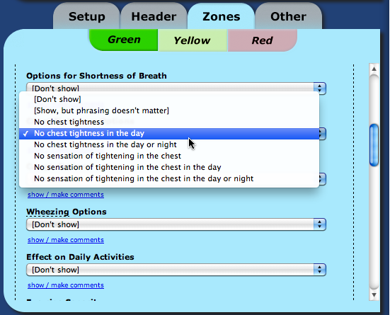

Table 3. Characteristics of all Health Care Practitioner Participants
 | Focus Group Stage (11)* | Wiki Stage (18)^{ǂ}
Male | 7 (64) | 11 (61)
Age (years)
<30 | 0 | 0
30-39 | 7 (64) | 4 (22)
40-49 | 3 (27) | 10 (56)
50-59 | 1 (9) | 4 (22)
>60 | 0 | 0
Years in Practice (SD) | 8 (9) | 16 (8)
Practice Setting
Suburban | 1 (9) | 1 (6)
Urban | 10 (91) | 16 (89)
Mixed | 0 | 1 (6)
Practice Type
Group | 9 (82) | 14 (78)
Solo | 2 (18) | 4 (22)
Number of patients with asthma seen each month (SD) | 20 (23) | 51 (32)
Prior experience preparing an AAP | 5 (46) | 16 (89)
Numbers in parentheses are percentages unless indicated otherwise
* Health care practitioners included certified asthma educators (3), primary care physicians (4), and respirologists (4)
^{ǂ} Health care practitioners included certified asthma educators (5), primary care physicians (5), and respirologists (8)
AAP denotes asthma action plan

Table 4. Table of Characteristics of all Patient Participants
 | Focus Group Stage (5) | Wiki Stage (21)
Male | 2 (40) | 3 (14)
Age (years)
<30 | 0 | 3 (14)
30-39 | 0 | 6 (29)
40-49 | 1 (20) | 4 (19)
50-59 | 3 (60) | 5 (24)
>60 | 1 (20) | 3 (14)
Level of Education
High School | 1 (20) | 2 (10)
College/Trade school | 1 (20) | 10 (48)
University | 3 (60) | 9 (43)
Current Asthma Follow-Up
No regular follow-up | 1 (20) | 10 (48)
Primary care physician | 2 (40) | 9 (82)
Respirologist | 1 (20) | 1 (9)
Both | 1 (20) | 1 (9)
Current Asthma Medications
Short-acting bronchodilator | 5 (20) | 18 (86)
Inhaled corticosteroid alone | 0 | 4 (19)
Long-acting bronchodilator and inhaled corticosteroid | 5 (20) | 8 (38)
Leukotriene receptor antagonist | 1 (20) | 1 (5)
Current asthma control*
Had exercise limitation due to asthma | 2 (40) | 12 (57)
Had work absenteeism due to asthma | 1 (20) | 4 (22)^{ǂ}
Average weekly rescue short-acting bronchodilator use > 3/week | 1 (20) | 10 (48)
Average number of days with asthma symptoms per week > 3/week | 1 (20) | 11 (52)
Average number of nights with asthma symptoms per week ≥ 1/week | 1 (20) | 13 (62)
Had an ER visit for asthma  (in the last 1 year) | 1 (20) | 3 (14)
Ever received an AAP | 2 (40) | 1 (5)
* in the last 1 month unless indicated otherwise
^{ǂ} 3 patients were not working at the time, therefore the denominator used for this percentage calculation was 18
ER denotes emergency room; AAP denotes asthma action plan
Figure 2. Mean System Usability Scale Results for all Participants* in the Focus Group Stage
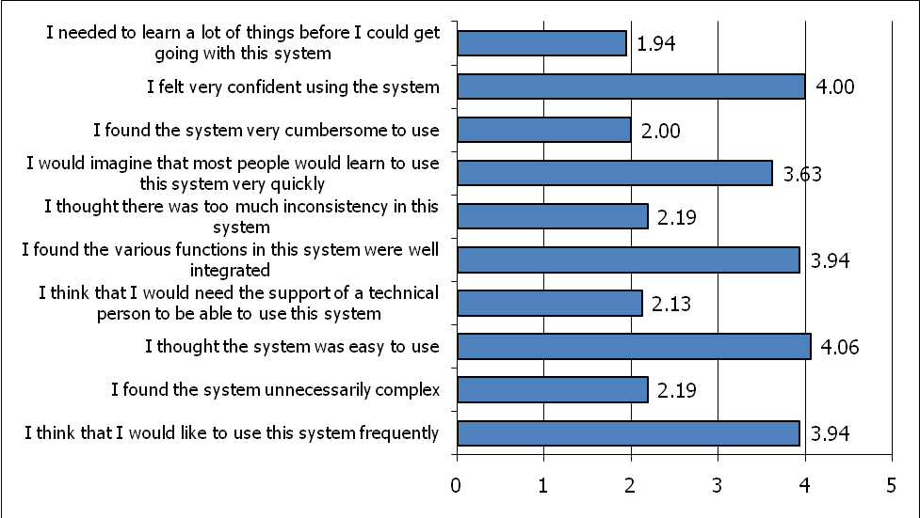
The System Usability Scale is a Likert scale ranging from 1 to 5 where 1 =Strongly Disagree, 3=Neutral, and 5 = Strongly Agree⁶⁰
* includes 16 participants (3 certified asthma educators, 4 primary care physicians, 4 respirologists, and 5 patients with asthma)
Table 5. Table of Participant use of the Wiki System
 | Participant Type
 | Respirologists | Primary Care Physicians | Certified Asthma Educators | Patients with Asthma
Mean logged-in time/day (minutes) | 11 | 13 | 31 | 23
Mean number of changes made/day | 5.5 | 5.0 | 6.2 | 8.3
Mean number of changes made/login | 9.9 | 7.7 | 8.0 | 9.3
Mean number of comments posted (over 1 week) | 3.0 | 1.7 | 4.5 | 0.8
Mean number of blog entries (over 1 week) | 3.3 | 4.7 | 7.3 | 3.6
Figure 3. Mean System Usability Scale Results for all Participants* in the Wiki Stage
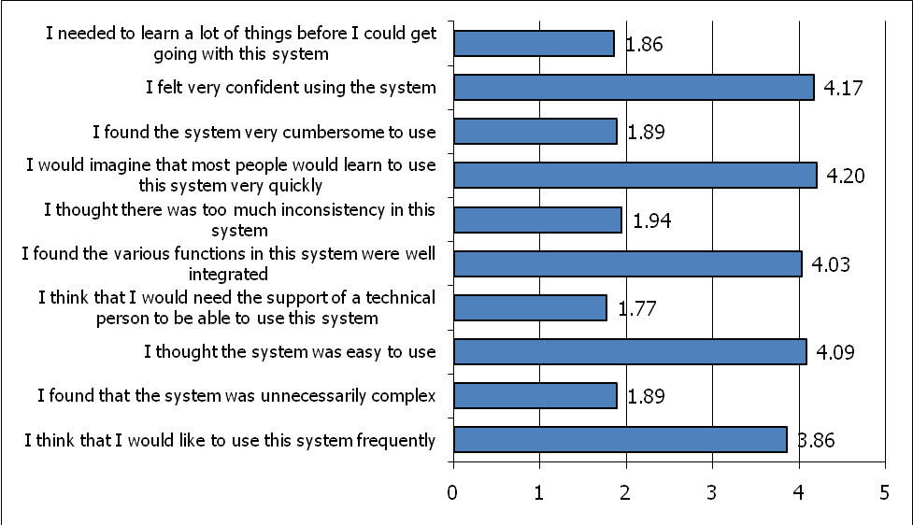
The System Usability Scale is a Likert scale ranging from 1 to 5 where 1 =Strongly Disagree, 3=Neutral, and 5 = Strongly Agree⁶⁰
* includes 35 participants (5 certified asthma educators, 5 primary care physicians, 6 respirologists, and 19 patients with asthma)

Figure 4. Mean Satisfaction Scale Results for all Participants* in the Wiki Stage
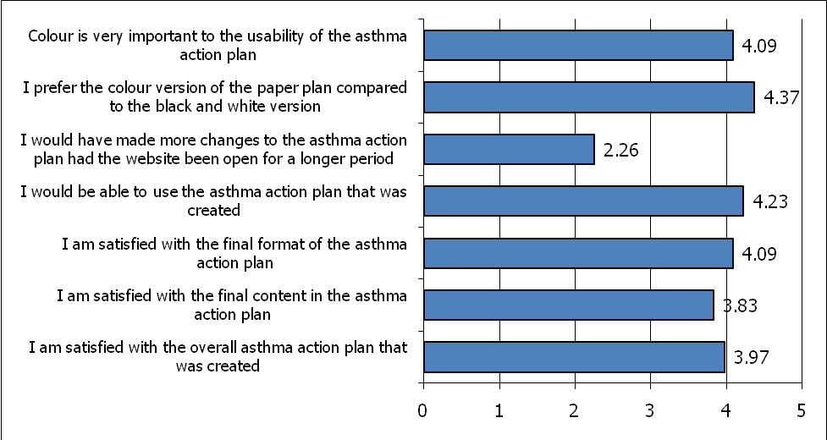
This Satisfaction Scale employed a Likert scale ranging from 1 to 5 where 1 =Strongly Disagree, 3=Neutral, and 5 = Strongly Agree.
* includes 35 participants (5 certified asthma educators, 5 primary care physicians, 6 respirologists, and 19 patients with asthma)

Figure 5: Final AAP Created Through the Wiki Process

Appendix 4: Study Timelines

Task | Month
Task | Baseline Phase |  |  |  |  |  |  |  |  |  |  |  | Intervention Phase
Task | 1 | 2 | 3 | 4 | 5 | 6 | 7 | 8 | 9 | 10 | 11 | 12 |  | 13 | 14 | 15 | 16 | 17 | 18 | 19 | 20 | 21 | 22 | 23 | 24
Intervention Development (Development of eAAPS components)
Intervention Debugging (pre-eAAPS implementation in the practice setting)
Baseline Outcome Assessment (prospective data collection)
Intervention Phase (prospective data collection)
Feedback Phase (physician interviews and electronic questionnaires)

Appendix 5: Variables to be Collected Through the Home or Portable Computer MyOSCAR Interface

1) Basic demographics

2) Home access to the internet (yes/no, connection speed)

3) Whether the patient has received an AAP in the last 6 months and from which source

4) Whether the patient is followed concurrently by a respirologist and corresponding follow-up plans

5) Whether the patient would like the AAP itself and/or the URL for the web-based asthma education program emailed to him/her (in addition to having home access through MyOSCAR)

6) Questions related to asthma:
- current medications
- asthma triggers the patient can identify
- physical activities and or sports that the patient regularly engages in (if any)
- whether the patient has exercise symptoms which may require a pre-exercise dose of a fast-acting bronchodilator medication
- what the patient’s most prominent asthma symptoms are
- whether the patient has a peak flow meter and knows his/her personal best peak flow
- the name and contact information of an emergency contact
- whether the patient is in school and/or is currently working
- the patient’s personal asthma goals

Appendix 6 - Screen Shot of a Previously Developed Electronic Consent Form
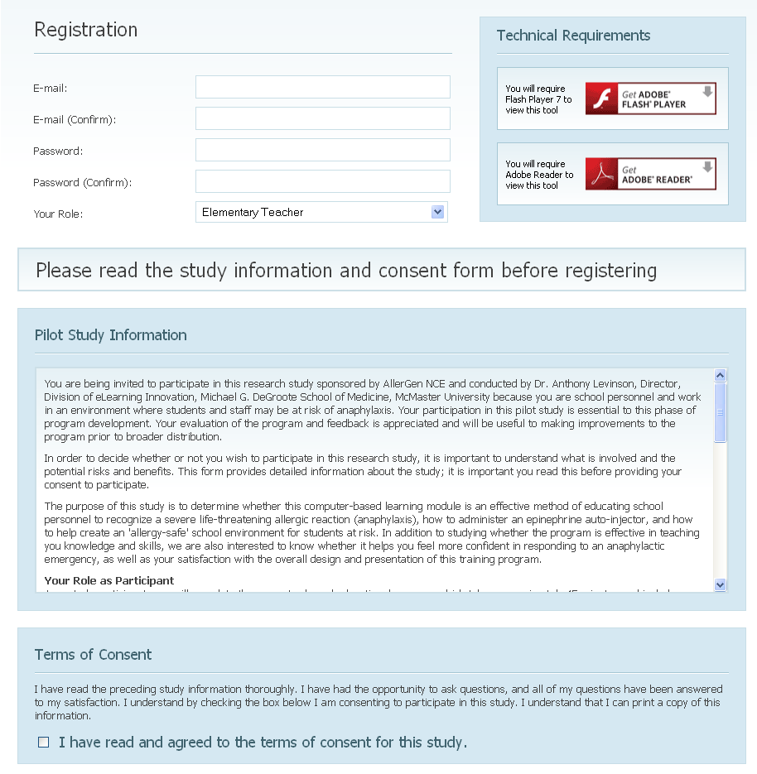

Appendix 8 - Sample Physician Questionnaire
1. Age: _____
2 Year of graduation: ____________________________________________
3. % of time spent in clinical practice: ________________________________
4. Practice setting:
- Urban
- Rural

- What medical school did you graduate from? ______________________

- How would you rate your experience with using the Internet?
Not very experienced |  |  |  | Very experienced
1 | 2 | 3 | 4 | 5

- How would you rate your experience with evidence-based medicine/practice?
Not very experienced |  |  |  | Very experienced
1 | 2 | 3 | 4 | 5

- Approximately how many hours did you spend doing continuing medical education (CME) activities in the past 24 months? _______________

- What type of CME activities did you participate in in the last 24 months? _________________________________________________________________________________________________________________________________________________________________________________________________________________________________

- Did you participate in any CME activity related specifically to asthma in the last 24 months?
- Yes
- No

- Did you participate in any CME activity specifically addressing asthma action plans in the last 24 months?
- Yes
- No

- Did you read any published literature (including guidelines) about asthma action plans in last 24 months?
- Yes
- No

- Did you participate in any Ontario Ministry of Health incentive or primary care support programs related to asthma care for the first time at some point in the last 24 months?
- Yes
- No

- Do you believe that your practice relating to asthma action plan delivery has been influenced by factors other than the EAAPS study tool during the last 24 months?

- If so, please indicate which factors influenced your practice:
_________________________________________________________________________________________________________________________________________________________________________________________________________________________________

System Usability Scale⁶⁰

Please click on the button that indicates your level of agreement about the usability of the
EAAPS System. If you don’t know how to answer a question, please choose a neutral response.
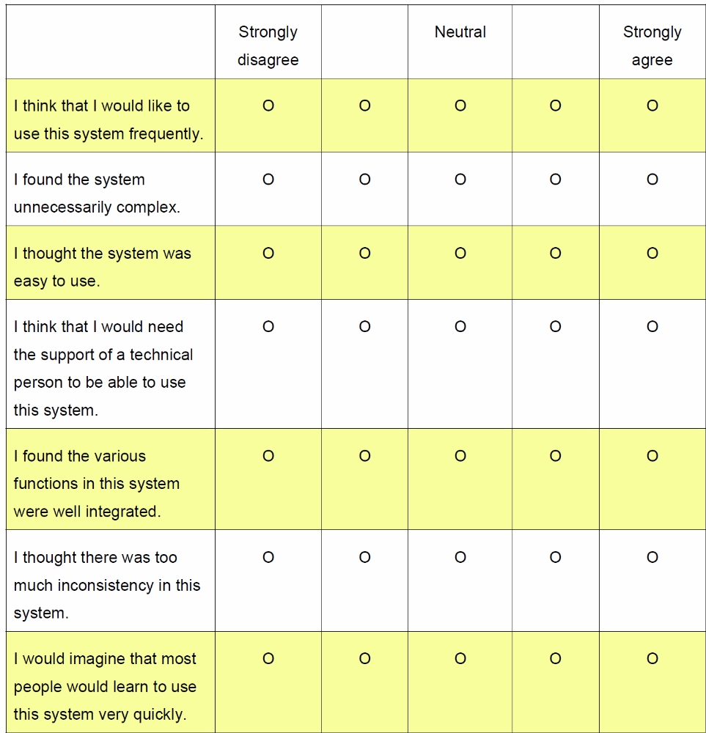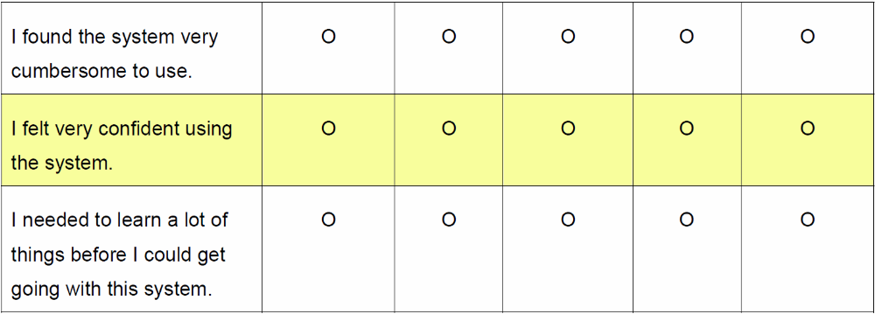
Appendix 9: Research Team
Co-Investigators
Name | Designation | Expertise | Role in Grant
Samir Gupta | Co-Principal applicant | KT, respirology, asthma action plans, clinical trials | Oversee physician recruitment, develop study forms and tools, design intervention (develop asthma-related content), develop and maintain databases, extract and collect data, analyze data, prepare manuscripts
Sharon Straus | Co-Principal applicant | KT, clinical decision support tools, general internal medicine | Oversee the project and provide guidance in all aspects of the study. Provide experience in qualitative research methods and analysis
Louis-Philippe Boulet | Co-applicant | KT, asthma, action plans, patient education | Provide expertise in intervention design (development of asthma-related content) and overall study conduct
Alan Kaplan | Co-applicant | KT, clinical decision, primary care usability and utility | Provide expertise in primary care practice, expertise in intervention design (development of asthma-related content and usability in a primary care setting)
Anthony Levinson | Co-applicant | KT, e-learning, educational research, Internet-based tools and methods | Provide expertise in development and maintenance of electronic recruitment, consent, and questionnaire materials, and web-based asthma education program
Depeng Jiang | Co-applicant | Study design, biostatistics, quantitative modeling, program evaluation | Provide expertise in study methodology, mode selection, statistical analyses, as well as the interpretation of statistical results
Monika Kastner | Co-applicant | KT, health research methodology, clinical decision support systems (CDSSs) | Provide expertise in intervention design, practical aspects of implementation in a primary care setting, outcome assessment, and qualitative research methods and analysis
Muhammad Mamdani | Co-applicant | Health Services research, pharmacoepidemiology, epidemiology, health economics, decision analysis, cost effectiveness, pharmacotherapy | Provide expertise in linking and analyzing secondary outcome data from health administrative databases
David Chan | Co-applicant | Web-based CDSS, health research methodology | Provide expertise in “OSCAR” and “MyOSCAR” software and chronic disease self-management using Patient Health Record
Gina Agarwal | Co-applicant | Health research in primary care, chronic disease management, e-health | Provide expertise and assist in project design, particularly e-health innovation delivery, analysis of results and manuscript preparation; knowledge dissemination
Collaborators
Name | Designation | Expertise | Role in Grant
Nancy Garvey Senior Program Consultant, Ontario Ministry of Health and Long-term Care | Collaborator | Asthma program implementation in primary care, knowledge translation, asthma quality indicators | Help to align the study with the goal of the Primary Care Asthma Program, to facilitate recruitment for a larger RCT and implementation across Ontario
Carole Madeley Director, Respiratory Health Programs, Ontario Lung Association | Collaborator | Asthma-related educational initiatives and health promotion with Ontario public health officials, hospitals, universities and community groups | Help to effectively and efficiently transfer the results of this study to individuals and organizations in the field of respiratory health care across Ontario
Christine Hampson President and CEO of the Asthma Society of Canada | Collaborator | Patient-centered asthma education and resources | Provide access to the Asthma Society of Canada’s existing web-based educational module, help to recruit for a multi-center study of EAAPS, and help to implement EAAPS across Ontario and Canada if the results of the study are promising
David Price Lead of the McMaster Family Health Team (FHT) | Collaborator | OSCAR EMR-based research, McMaster FHT logistics | Provide advice and support for integration and testing of EAAPS in the McMaster FHT environment
Anne Van Dam Director, Research & Knowledge Translation, Canadian Thoracic Society | Collaborator | Knowledge Translation, multi-stakeholder and decision-maker linkages across Canada | Help to disseminate and implement the results of the current study, and help to organize a broad-based multi-center follow-up study
Mark Chignell Lab Director of the Interactive Media Lab, University of Toronto | Collaborator | KT, usability, software engineering | Provide expertise in the usability testing and maintenance of the handheld computer and CDSS interfaces
Lisa Dolovich | Collaborator | Primary Healthcare Research, e-Health research, OSCAR EMR-based research, knowledge translation | Provide expertise in primary healthcare research, intervention implementation, research with my OSCAR software

