Q1. Create a hierarchy of person, employee and developers.

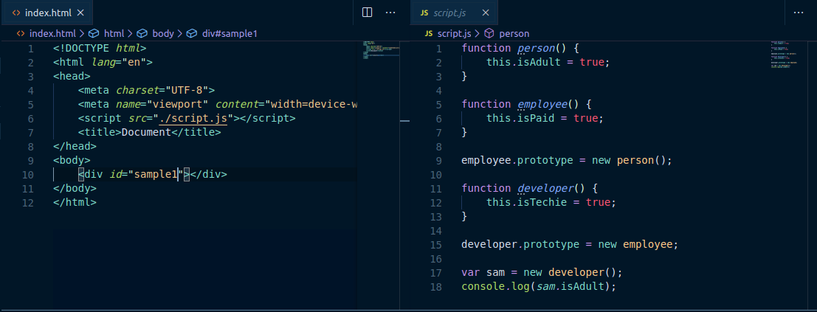

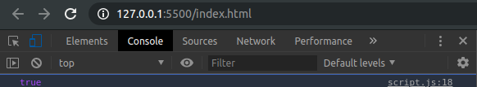

Q2. Given an array, say [1,2,3,4,5]. Print each element of an array after 3 secs.

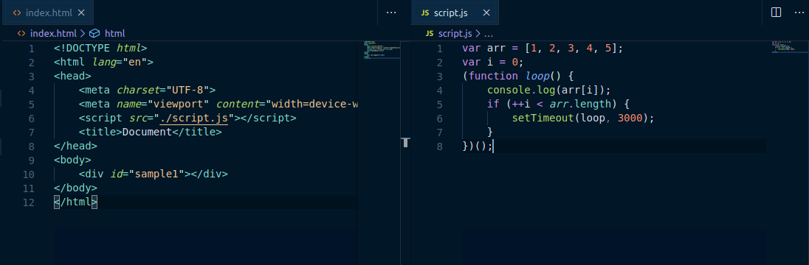
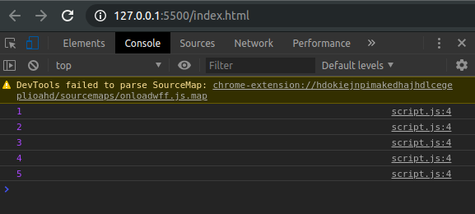

Q3. Explain difference between Bind and Call (example).
A. Call attaches this into function and executes the function immediately
For example : -
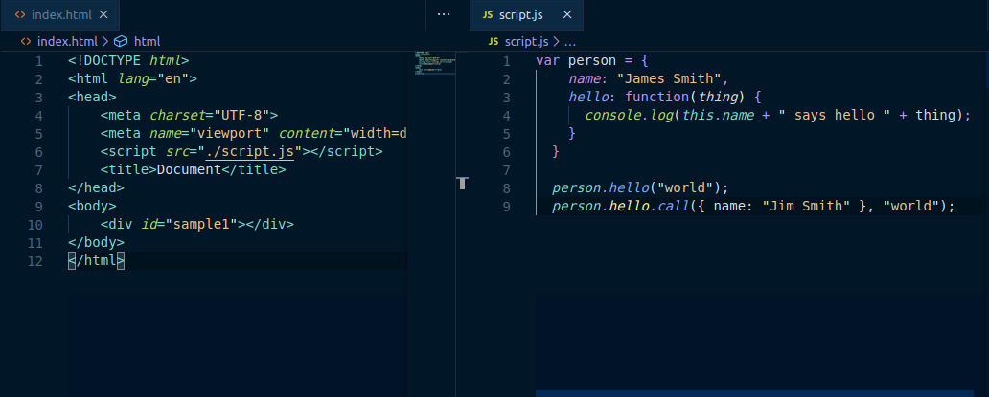
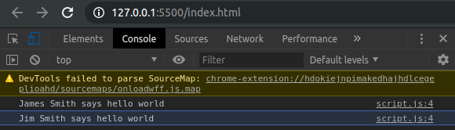

Bind attaches this into function and it needs to be invoked separately.
For example :-

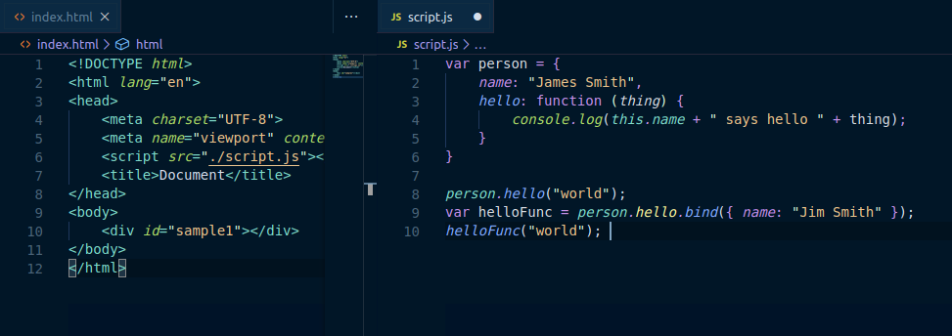
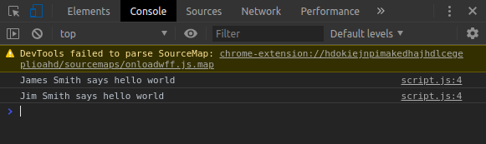
Q4. Explain 3 properties of argument object.

A.Property of argument object :

1. argument.callee

Callee is a property of the arguments object. It can be used to refer to the currently executing function inside the function body of that function. This is useful when the name of the function is unknown, such as within a function expression with no name (also called "anonymous functions").

2 .argument.length

The arguments.length property provides the number of arguments actually passed to a function. This can be more or less than the defined parameter's count.
3. arguments[@@iterator]()

The initial value of the @@iterator property is the same function object as the initial value of the Array.prototype.values property.
====
Q5. Create a counter using closures.

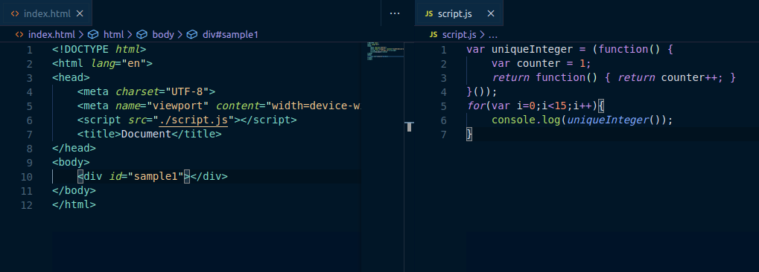

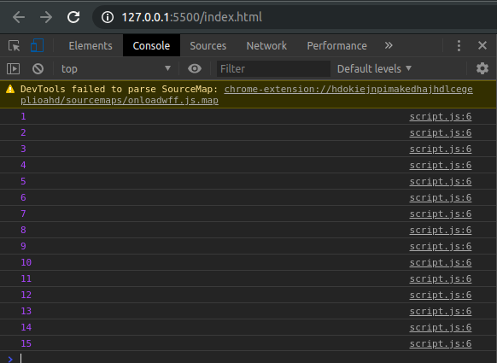

Q6. Explain 5 array methods with example.

A.

1. forEach()

The forEach() method calls a function once for each element in an array, in order.

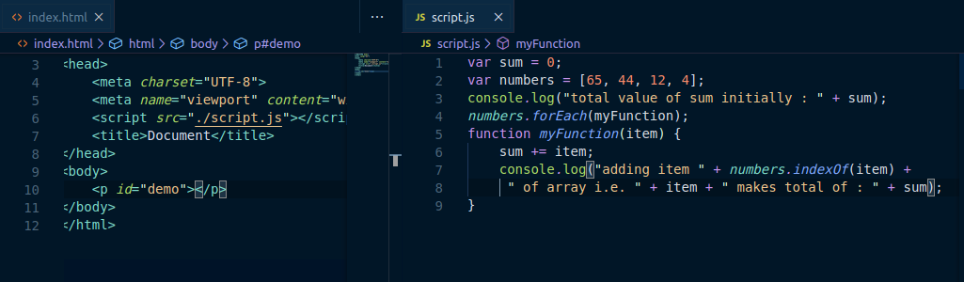
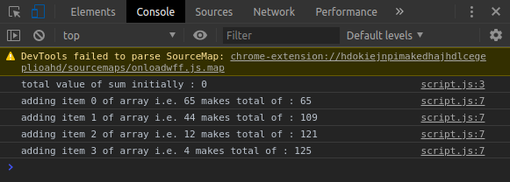

2. indexOf()

The indexOf() method searches the array for the specified item, and returns its position.

The search will start at the specified position, or at the beginning if no start position is specified, and end the search at the end of the array.

Returns -1 if the item is not found.

If the item is present more than once, the indexOf method returns the position of the first occurence.

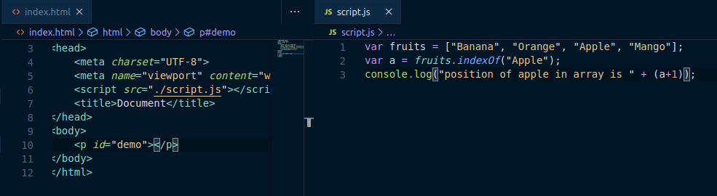

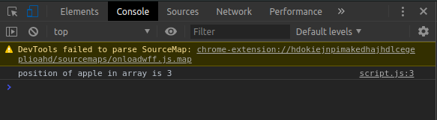

3. isArray()

The isArray() method determines whether an object is an array.

This function returns true if the object is an array, and false if not.

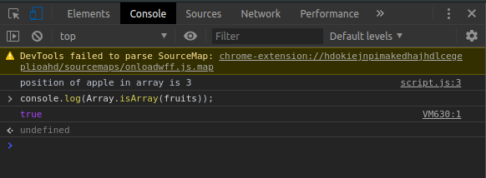

4. join()

The join() method returns the array as a string.

The elements will be separated by a specified separator. The default separator is comma (,).

5. keys()

The keys() method returns an Array Iterator object with the keys of an array.

