Q1.Filter unique array members using Set.

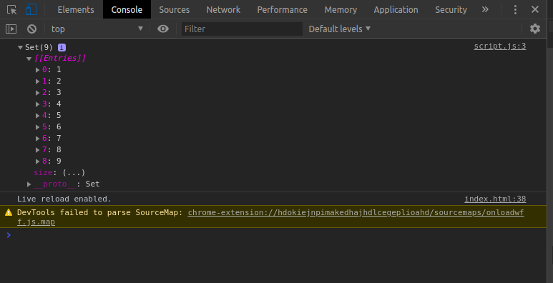
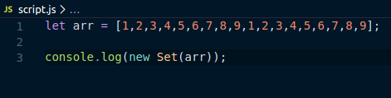

Q2. Find the possible combinations of a string and store them in a MAP?

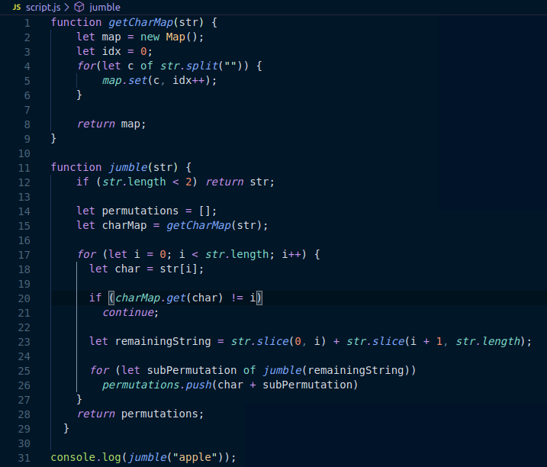

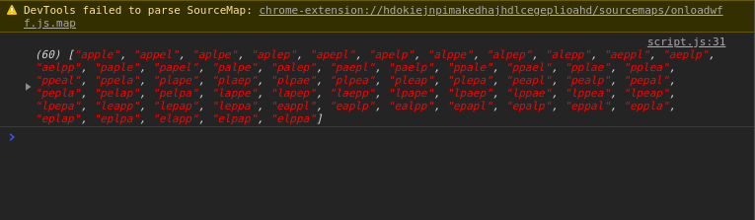

Q3. Write a program to implement inheritance upto 3 classes.The Class must public variables and static functions.

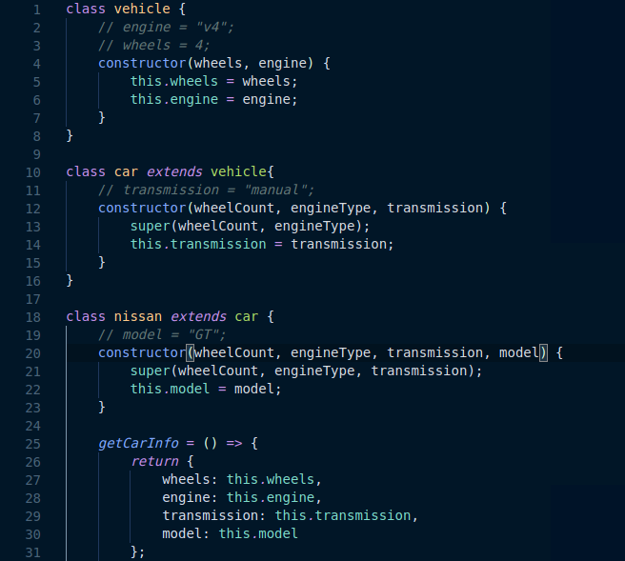

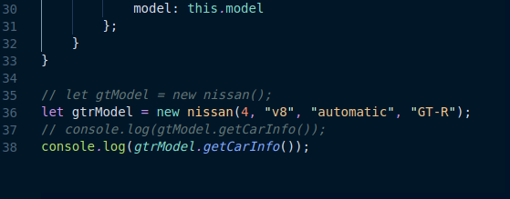
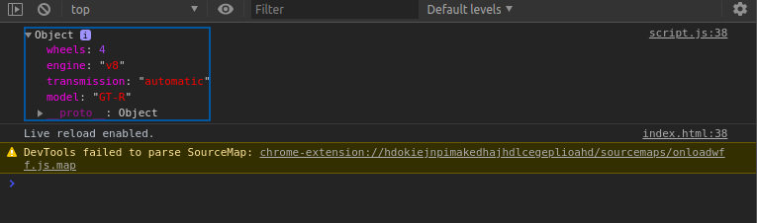

Q4. Write a program to implement a class having static functions.

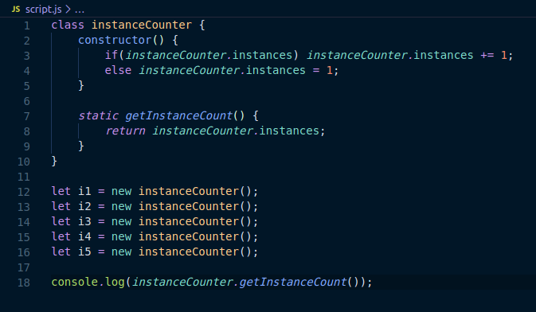
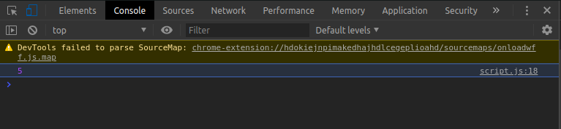

Q7. Write a program to flatten a nested array to single level using arrow functions.

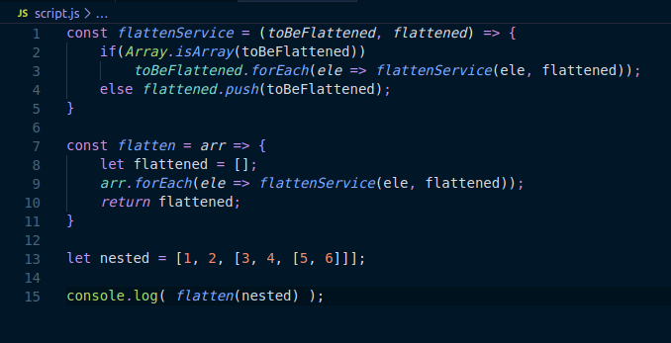
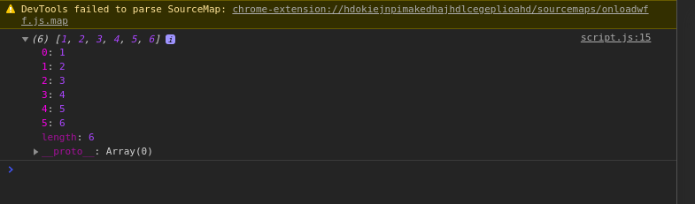

Q8. Implement a singly linked list in es6 and implement addFirst() addLast(), length(), getFirst(), getLast(). (without using array)

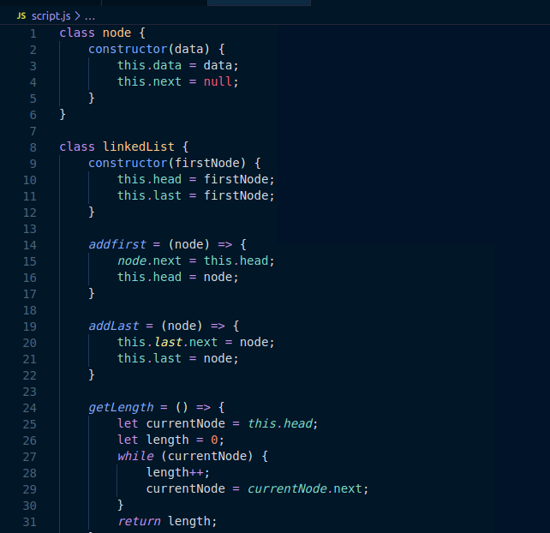

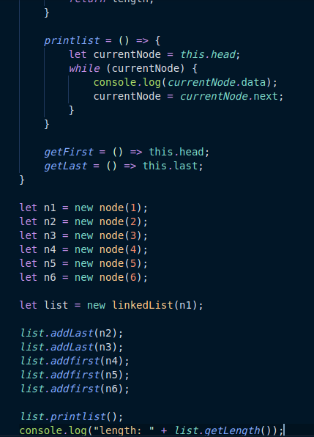

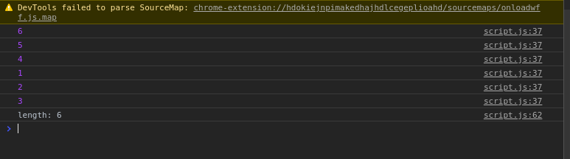

Q9. Implement Map and Set using Es6?

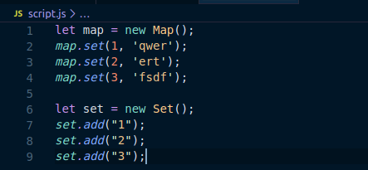

Q10. Implementation of stack (using linked list) ?

