Q1. Given this array: `[3,62,234,7,23,74,23,76,92]`, Using arrow function, create an array of the numbers greater than `70`.

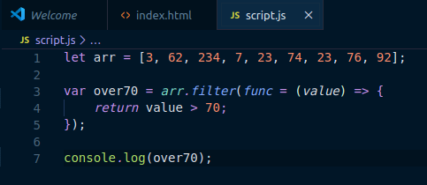

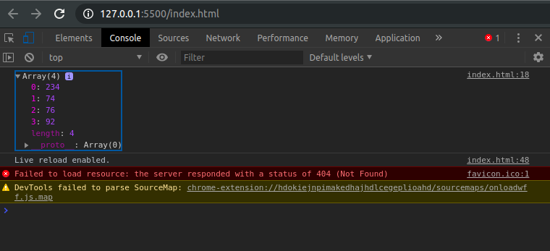

Q2.

1) Select all the list items on the page and convert to array.

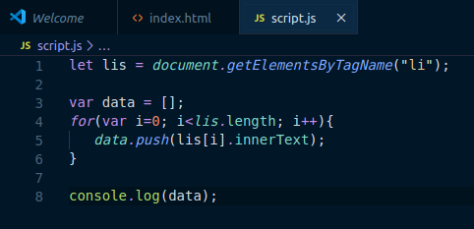

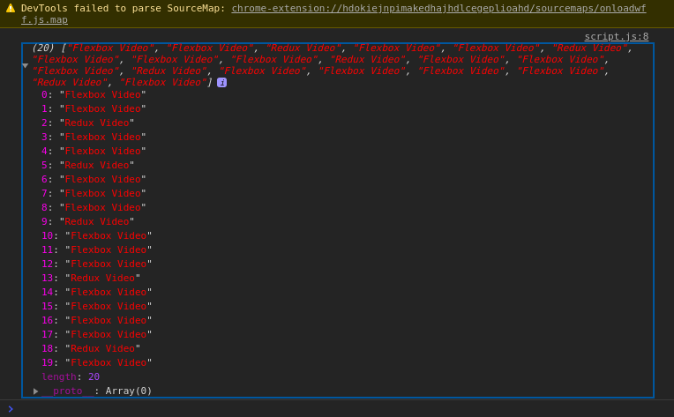

2) Filter for only the elements that contain the word 'flexbox'

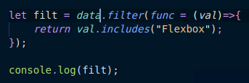

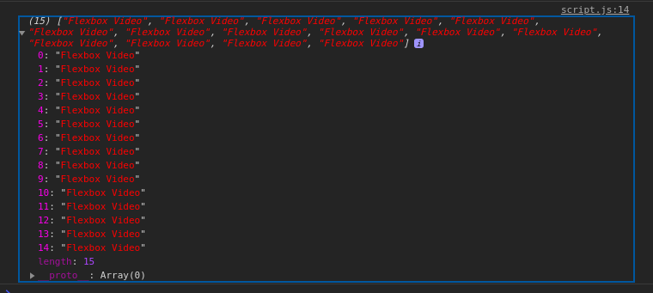

3) map down to a list of time strings

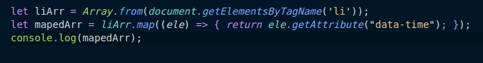
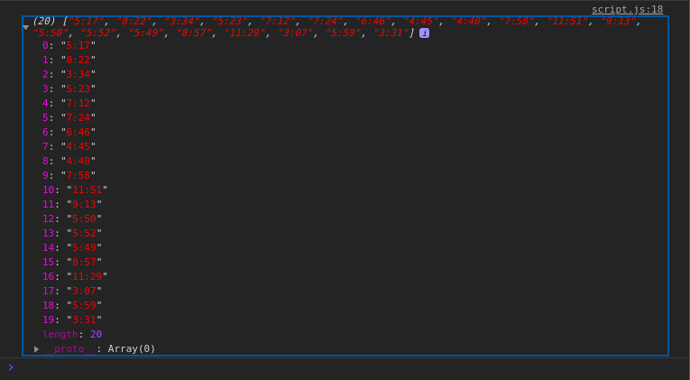

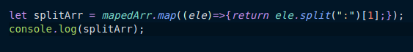
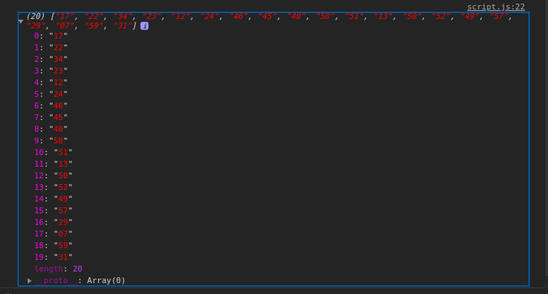
4)map to an array of seconds

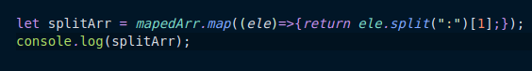
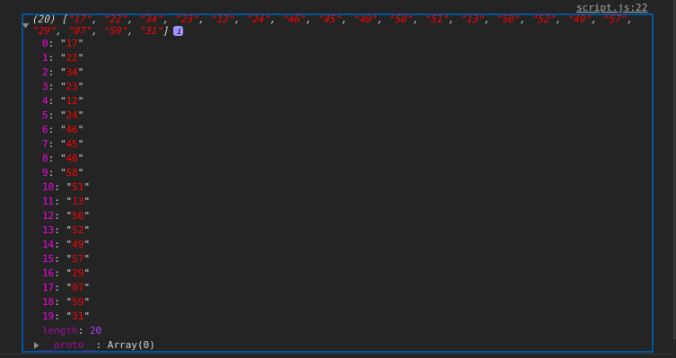

5) reduce to get total using .filter and .map
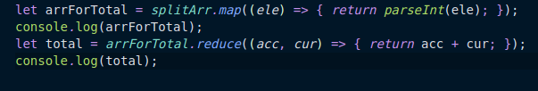

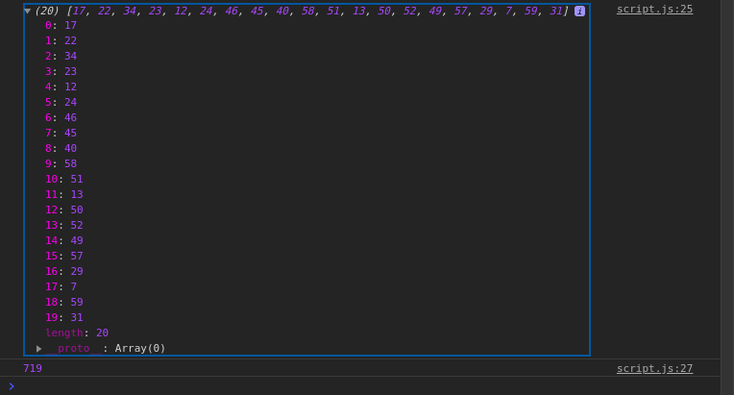

Q3. Create a markup template using string literal
const song = {
name: 'Dying to live',
artist: 'Tupac',
featuring: 'Biggie Smalls'
};

Result:
"<div class="song">
<p>
Dying to live — Tupac
(Featuring Biggie Smalls)
</p>
</div>
“

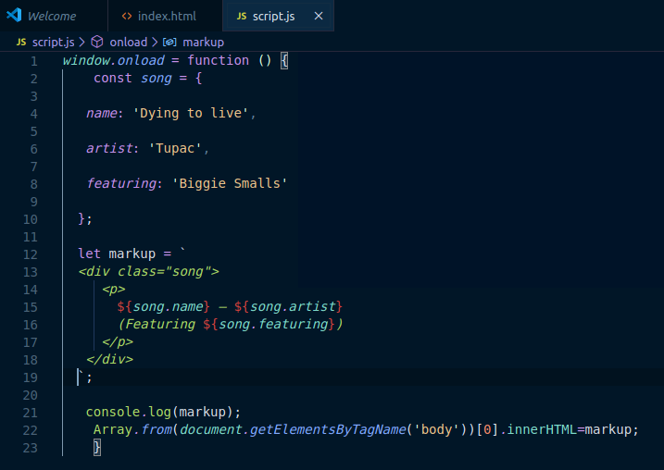
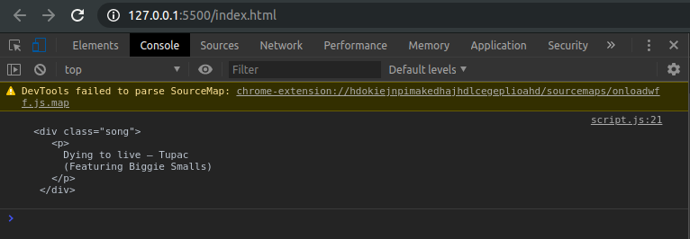

Q4. Extract all keys inside address object from user object using destructuring ?
const user = {
firstName: ‘Sahil’,
lastName: ‘Dua’,
Address: {
Line1: ‘address line 1’,
Line2: ‘address line 2’,
State: ‘Delhi’,
Pin: 110085,
Country: ‘India’,
City: ‘New Delhi’,
},
phoneNo: 9999999999
}

