Welcome Message
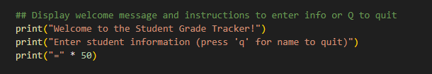
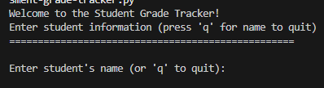

Here we display our welcome message and give the user a basic instruction to input the data when prompted or to quit with q

While Loop

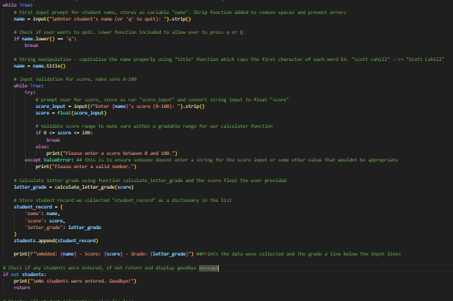

This is the while loop that allows our user to enter multiple students and append each entry to the students list we created earlier in the main() function. User presses q to quit

Student name Input
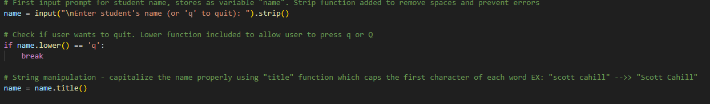
]

user is prompted and uses an input function to store the output as name variable. Output is stripped and capitalized appropriately using the title() function I looked up.

Decison (User wants to quit)

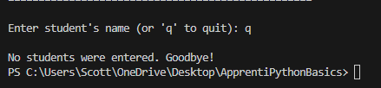

user is given the option to type the letter q which will break the function and print the results or return a goodbye message if no data entered

Input score
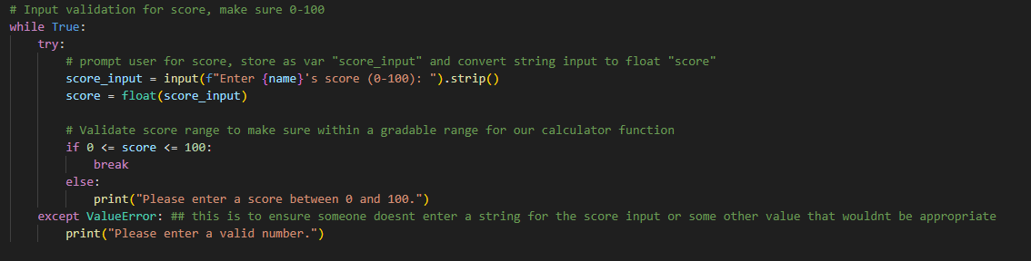

This loop prompts the user to enter a score between 0 or 100 and includes some exception handling if the user enters a number outside of 0-100 or an incorrect value. Input is stored as a float called ‘score’

Calculate Letter Grade


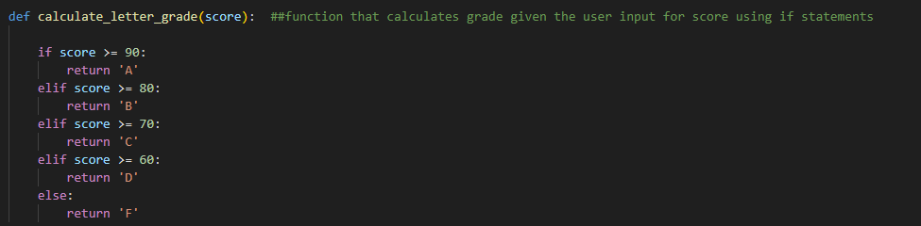

in our main function we call the calculate letter score function that determines what letter corresponds to the score provided

Add Student to list
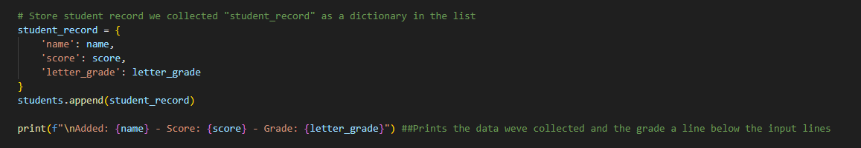

This uses the append function to store the score, name, and letter grade we calculated into the students list we created earlier

Display All students and calculate class average

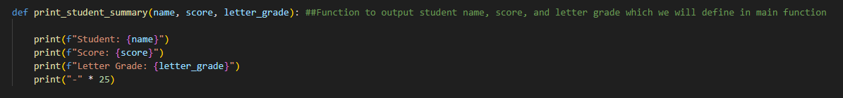
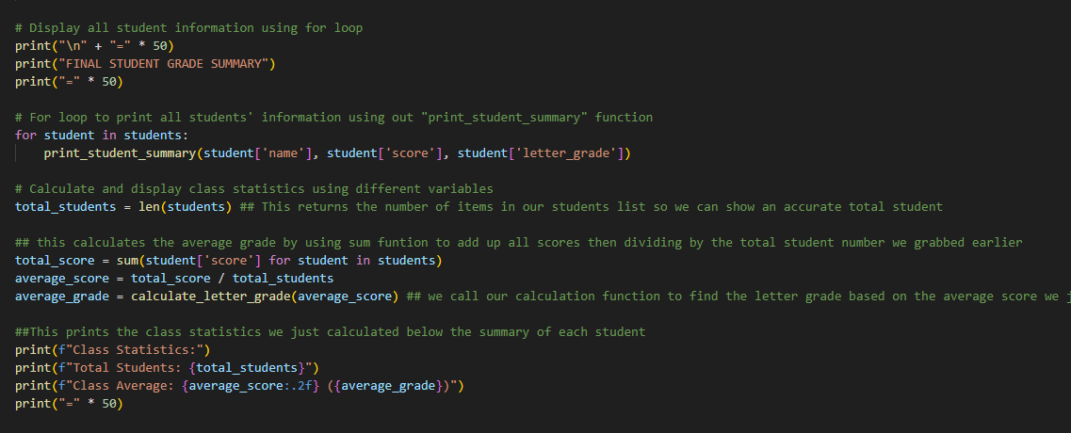
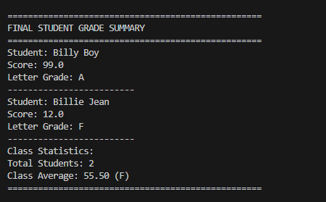

This prints out a final summary page and uses a for loop to print each student record in the student list we created. To print each student we call a print_student_summary function we defined earlier

Save to txt file using file I/O

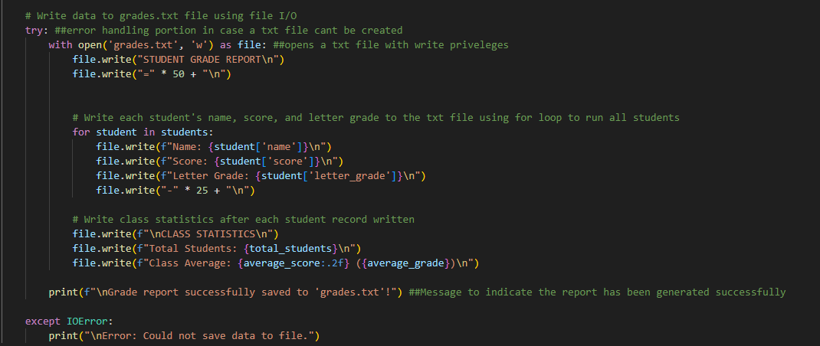
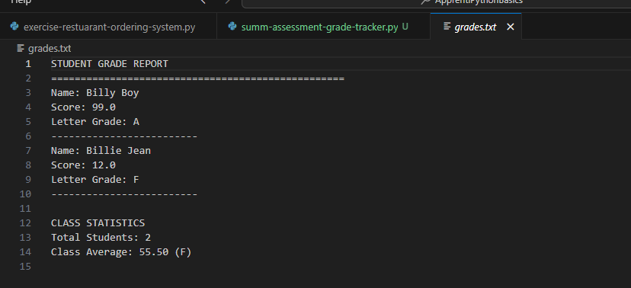
Here write the data in each student record using file i/o and we make sure each student is written by using a while loop. We also write the final class statistics we calculated earlier

