Bloom Filter Implementation for two remote machine (Java)

Structure
Master Node : Table1(Id, ZipCode)
Client Node : Table2(Id, PhoneNumber)

Sample Case of Presentation
For Sample Case with 50000 Records in Table1 and Table 2 each and performing a join operation.

Amount of Data Transmitted (using bloom filter)
[Master->Client] : 31251 bytes (Size of BloomFilter)
[Client -> Master] : 5132 Records

Amount of extra data transmitted based on false positive
[Client->Master] : (5132-5013) = 119 Records

Final Join Size
[Master] : 5013 Records

Runtime
On Master Node

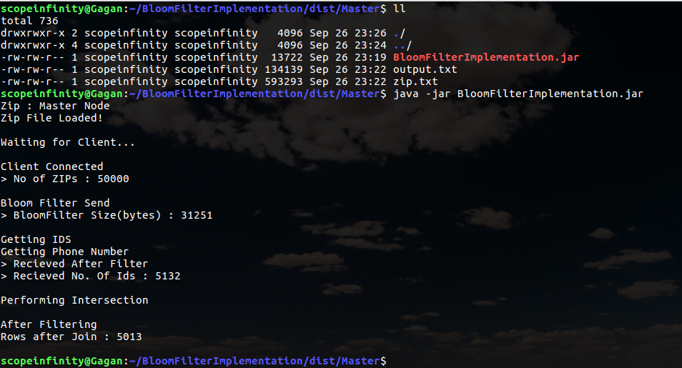

Client Side

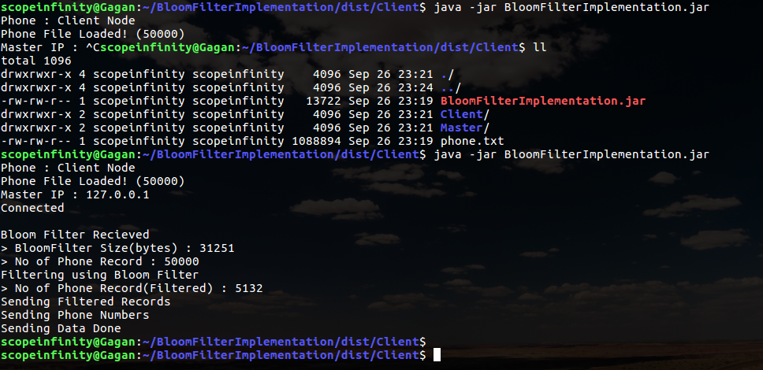
Data (Top Few Records)
Final Join in Master
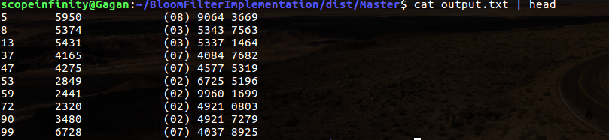
Zip List in Master
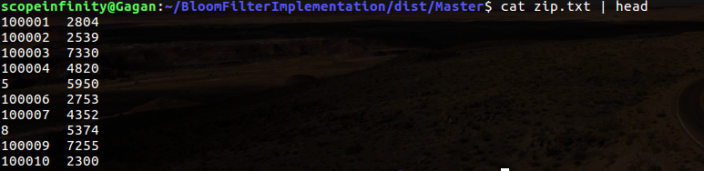
Phone list in Client
