CS242

Lab

Name : Gagan Kumar
Roll : 1401CS15

Answers For Starter

- The configuration file, by default is read by LILO. The configuration file tells LILO where it should place its boot loader. In general, you can either specify the master boot record (MBR) on the first physical disk (/dev/hda) or the root partition of your Linux installation (/dev/hda1 or /dev/hda2).

If you have another operating system installed in your hard drive, it is better to install Lilo to the root partition instead of the MBR. In this case, you must mark the partition as `bootable` using the `a` command of fdisk or the `b` command of cfdisk . If you don't overwrite the master boot sector you'll find it easier to uninstall Linux and Lilo if needed.

- Configuration file for Grub2 /boot/grub/grub.cfg
And for Grub Legacy is
/boot/grub/menu.lst

- We can see default run level using
cat /etc/init/rc-sysinit.conf
It's specified by
env DEFAULT_RUNLEVEL=2
in that file. Later using
telinit "${DEFAULT_RUNLEVEL}"
run level is changed by the same file.

- init can be used to change runlevel.
Example. init 6 (superuser)

- We need to change password using
sudo passwd root
and unlock root user by
sudo passwd -u root

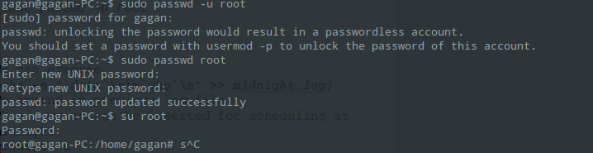

- We can execute
echo -e "`date`\n\n`who`\n" >> midnight.log;
To append in previous log file.
This command can be inserted for scheduling at midnight.
crontab -e
Then Appending to it
0 0 * * * echo -e "`date`\n\n`who`\n" >> midnight.log
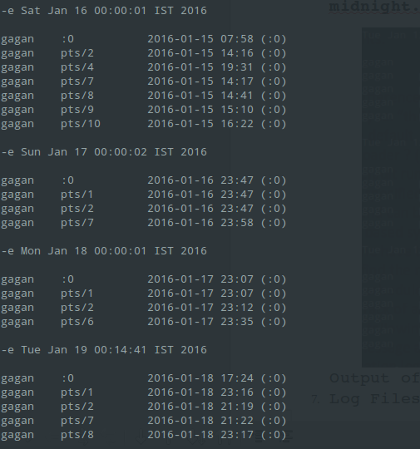
Output of cat midnight.log For Sample times.
- Log Files
  - /var/log/dmesg – General Message Stuff
  - /var/log/auth.log – Authentication Log
  - This can be used to find only CRON log.
cat /var/log/syslog | grep CRON
  - /var/log/boot.log and /var/log/dmesgBoot Info for boot log
  - /var/log/wtmp

Sample Output of C Program
