CS242

Lab 10

Name : Gagan Kumar
Roll : 1401CS15

Motion Simulation using Make

Make [For Compilation]

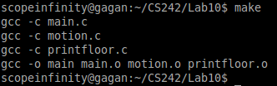

Make Again [No changes]

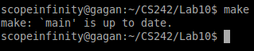

[Simulation]

Iteration 0

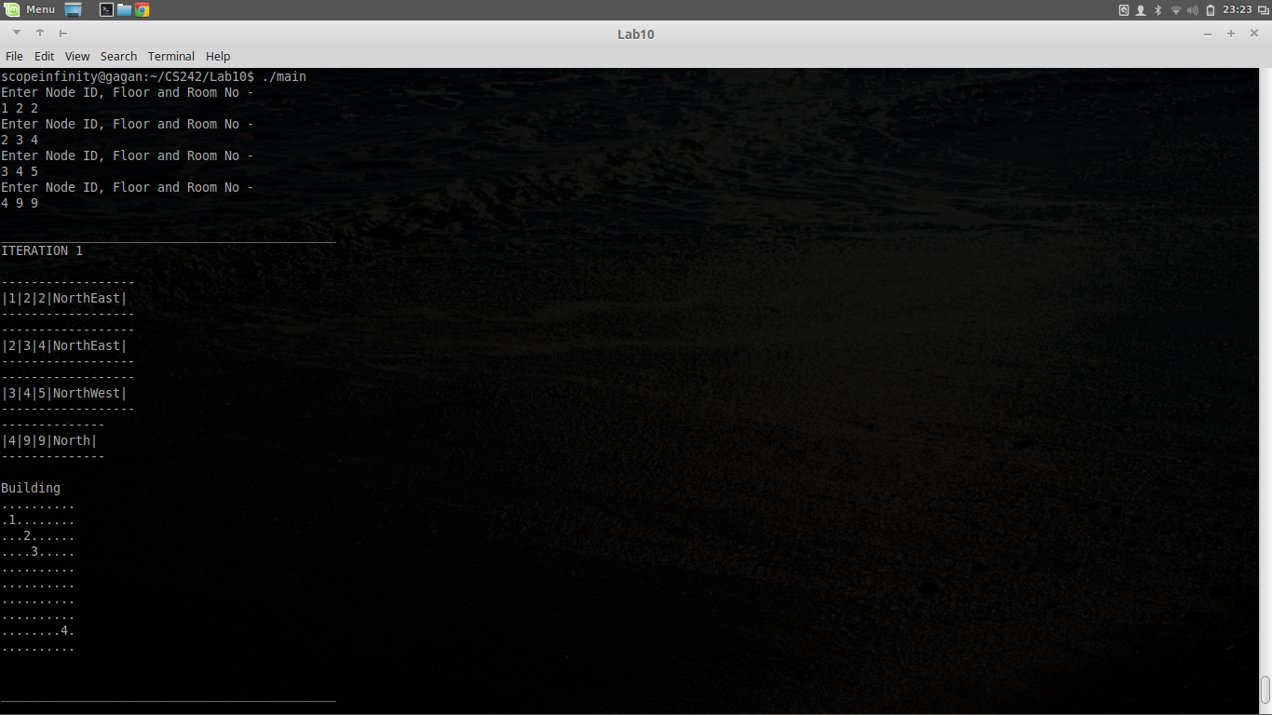

Iteration 1
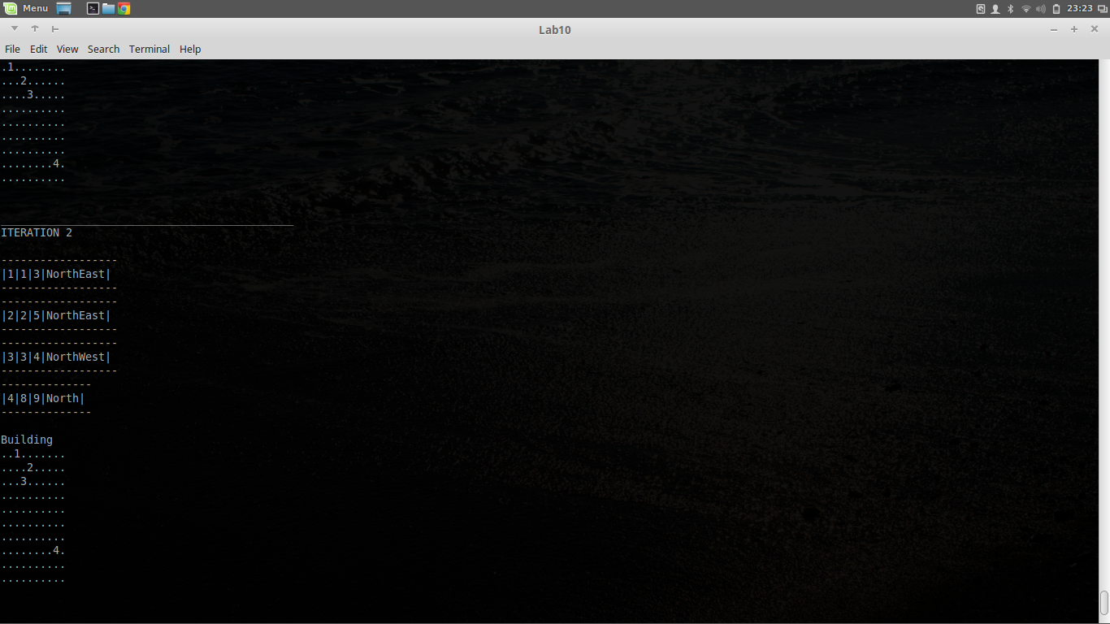
Iteration 2
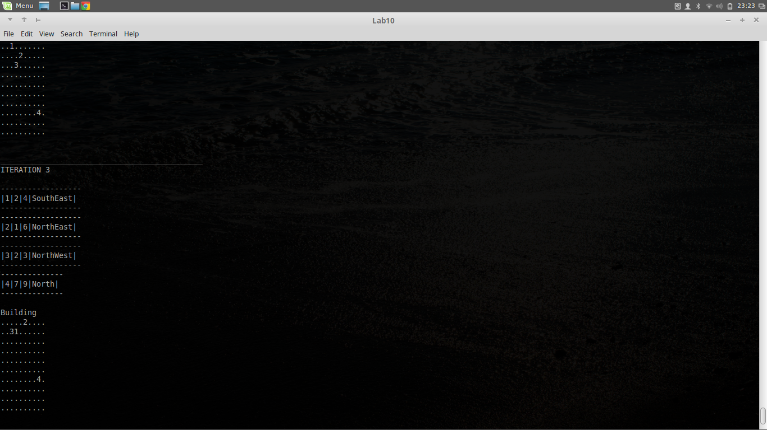

Iteration 3
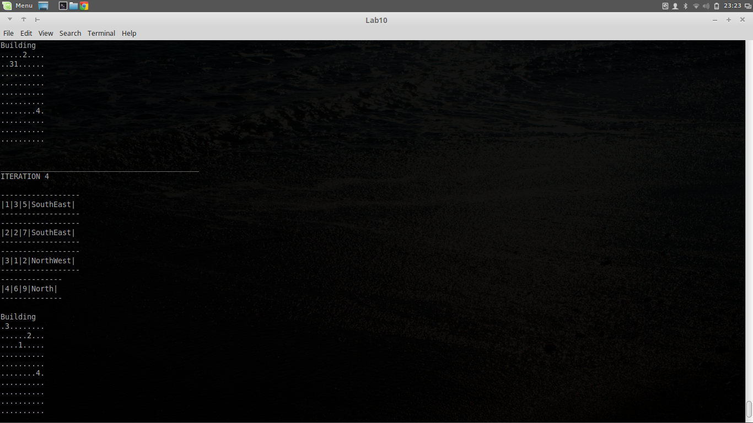
Iteration 4
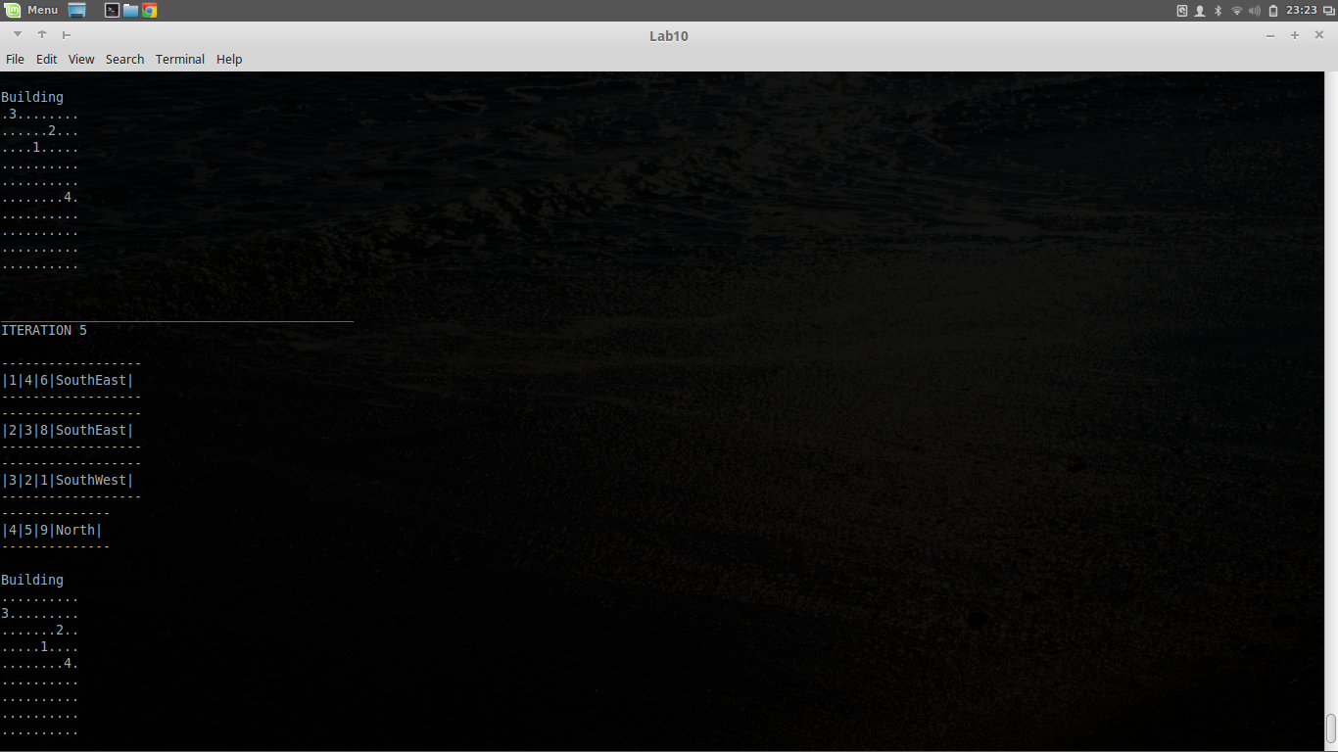

Iteration 5
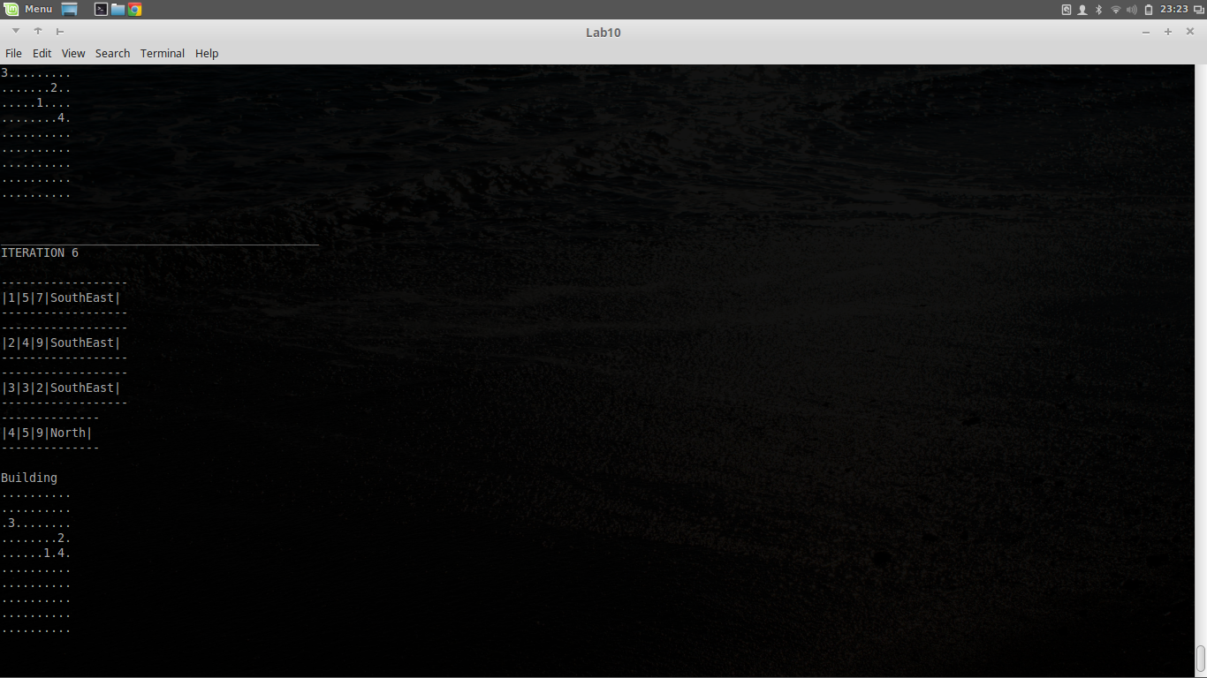
Iteration 6
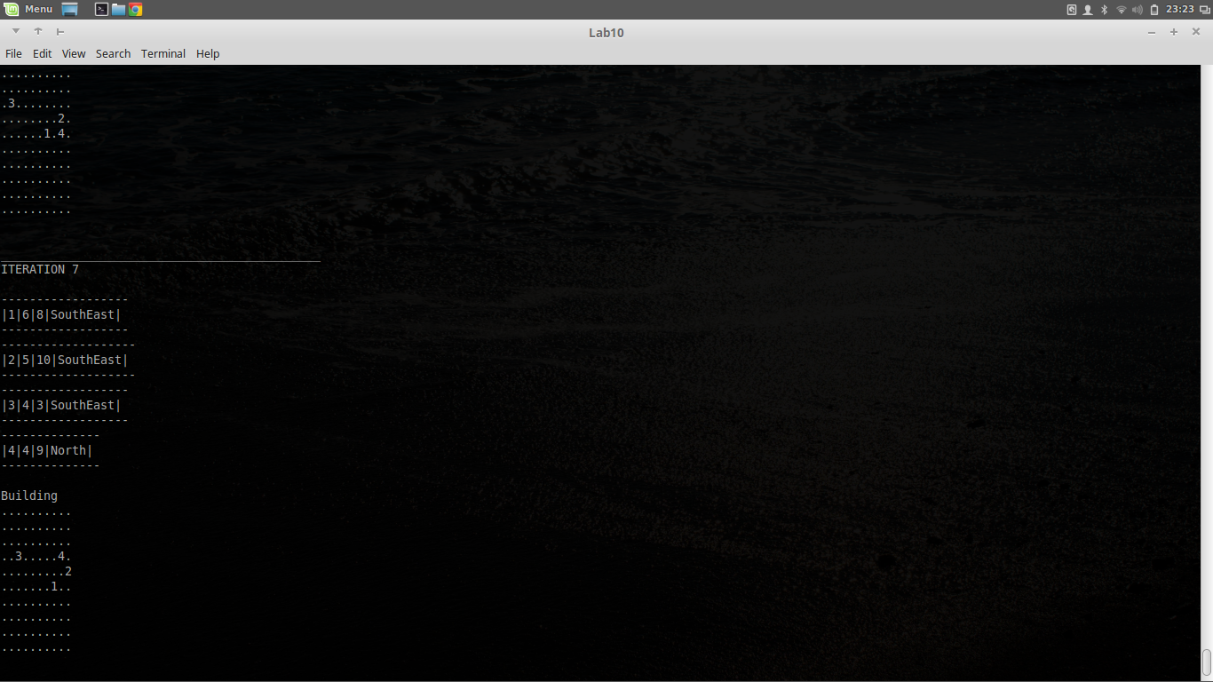

Iteration 7
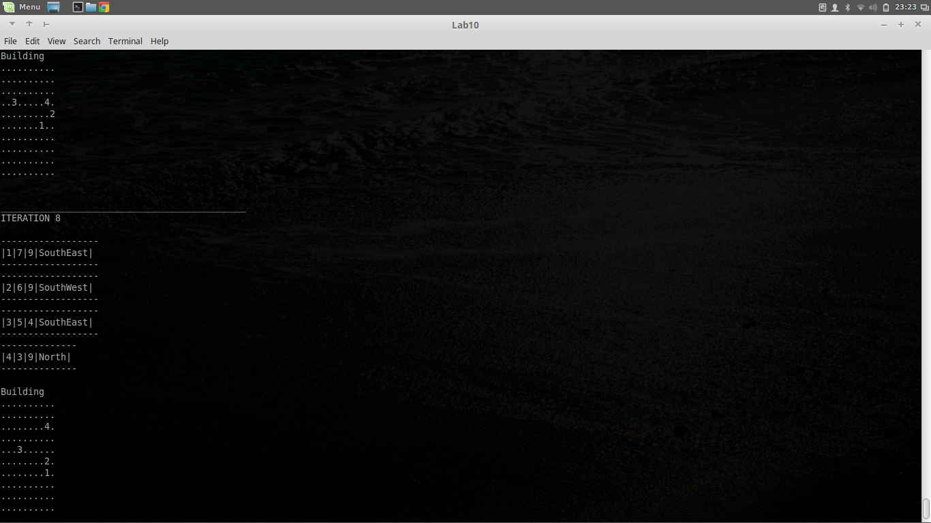
Iteration 8
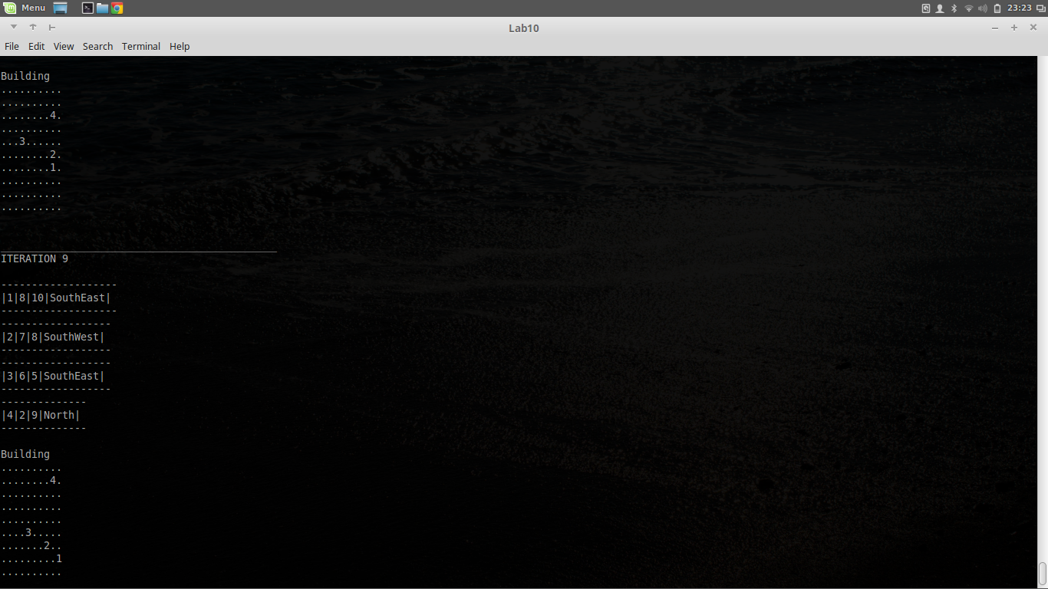

Iteration 9


