CS242

Lab

Name : Gagan Kumar
Roll : 1401CS15

Q1.
Across
2. passwd
7. root
8. rmdir
9. mounting
11. relative
Down
1. cp
3. absolute
4. whoami
5. uname
6. terminal
10. less
11. rm

Q2. Sample Output
> Using my program
./ls

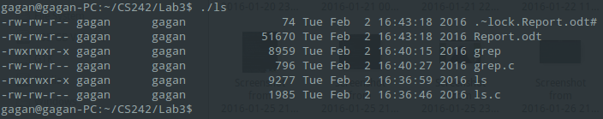
> Using Linux Command
ls -l
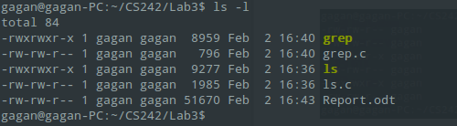

Q3. Sample Output

> Using my program
./grep ls.c “if”
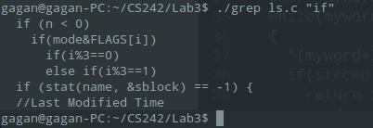

> Using Linux grep command
grep “if” ls.c
