CS242

Lab

Name : Gagan Kumar
Roll : 1401CS15

Custom Shell
Screen Shots
> Basic Commands
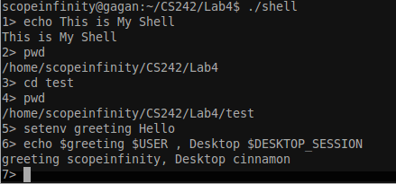
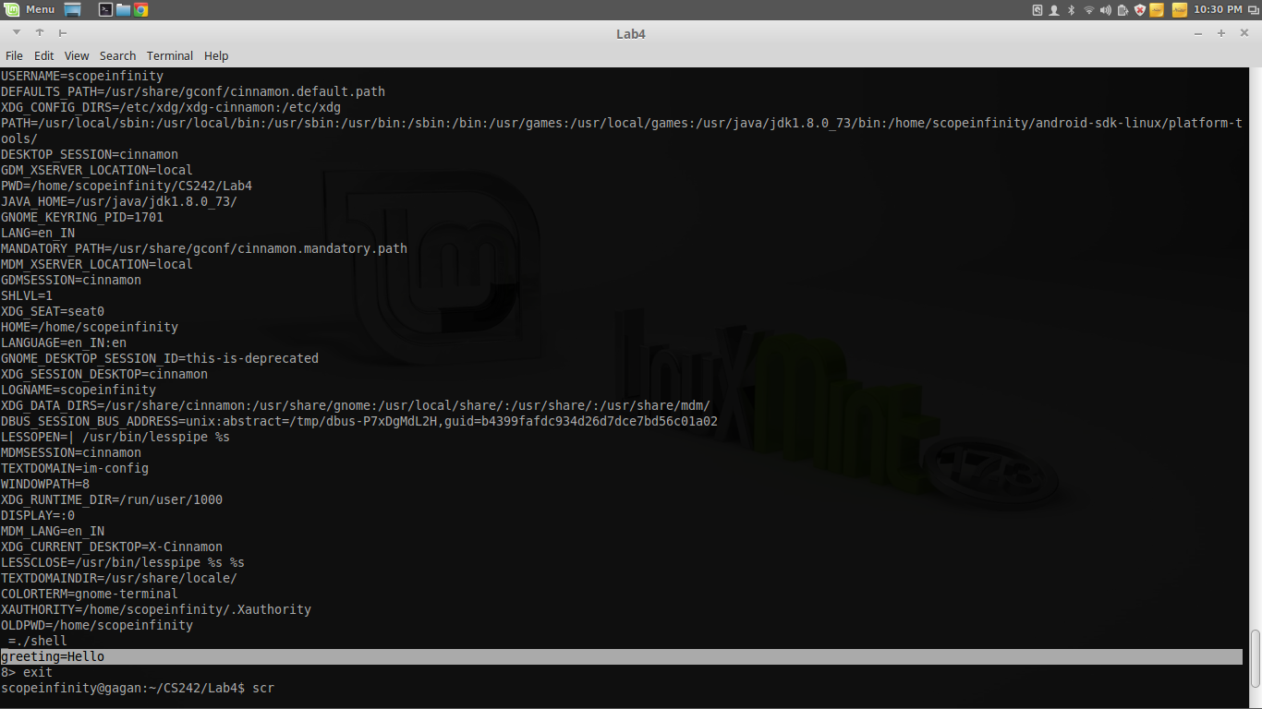

>Environment Variable List using `env` in my shell

