CS242

Lab 6

Name : Gagan Kumar
Roll : 1401CS15

CSV Search Name
Screen Shots

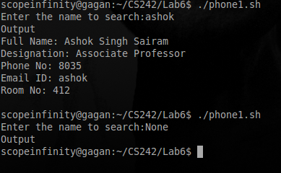

CSV Search (Extended)
With multiple flags
Screen Shots

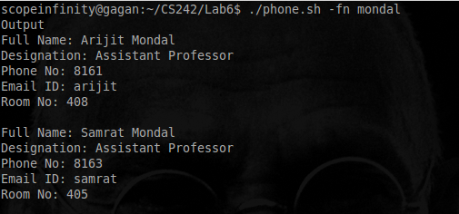
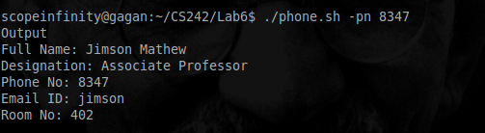
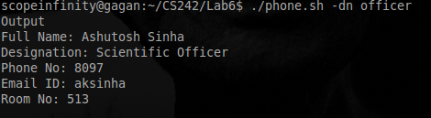

Print file permission
Screen Shots

