CS242

Lab 7

Name : Gagan Kumar
Roll : 1401CS15

Simple Spell Checker

Screen Shot

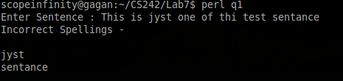

Spell Checker with Suggestions

Screen Shot

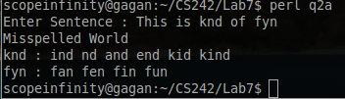

Screen Shot with Time Taken

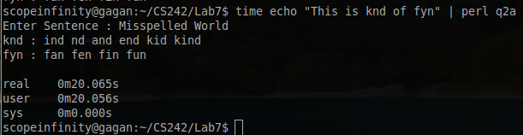

Fast Spell Checker with Suggestions
Screen Shot
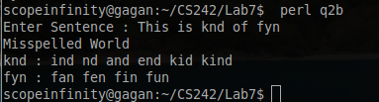

Screen Shot with Time Taken
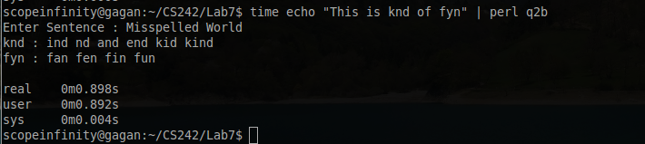

Time is Dropped from 20 sec to 0.89 sec for the same sentance.

