**RAY KURZWEIL- robots can simulate humans and can act like humans.**

Jorge Echvarria – works at Boeing Corp. been there for 24 years.

Going for his PH.D

Read book after lecture. Professor will try to teach us information we need to know. Its ok to skim through the book and keep it high level.

Discussion

Topic1 – Friday-Monday - 1 answer 2 response

Topic2 – Tuesday-Friday – 1 answer 2 response.

How to respond: Opinion, facts, post a link to the facts. – take something from someone elses post and run with it.

Starting next week - professor will go over the homework.

Project - Think about working with someone else. (Mariam and me =))

* + Next week we will go over the topics.
* Homework is from Friday-Friday. If the date changes please notify the professor.
* Data Warehousing is a huuuuge industry.
* **(SBO) Strategic Business Objectives**
* Why Information System is important:
* 1. Operational Excellence
* 2. New Products
* 3. Customer Service.
* 4. Improved Decision Making
* 5. Competitive Advantage
* 6. Survival
* There is no difference b/w Company, Firm, Business, Organization. All synonimus
* IT : Hw/Network/Sw
* IS : Is IT, people, data, process itself
* **Organizational dimension of information systems (cont.)**
* Separation of business functions
  + Sales and marketing
  + Human resources
  + Finance and accounting
  + Manufacturing and production
* Unique business processes
* Unique business culture
* Organizational politics
* Chapter2:
  + TPS – Transaction Processing System
  + MIS – Management Support Systems
  + DSS – Decision Support Systems
  + ESS – Executive Support Systems
* **CHAP 3**
* Organizational Politics
* Organizational Culture
* Organizational Structure
  + Entrepreneurial
  + Machine bureaucracy
  + Divisionalized bureaucracy
  + Professional bureaucracy
* Other Organizational features
  + Goals
  + Constituencies
  + Leadership styles
  + Tasks
  + Surrounding environments.
* They key to IT is to reduce Transaction cost.
  + Transaction Cost Theory
    - Figure out ways how to reduce production cost.
      * Find ways to reduce transactions on the internet.
  + Agency Theory
    - Because of Technology we can have supervisor now manage many people more than before.
* Resistance to change
  + Politics
  + Structure
  + Culture
* The internet and organizations
  + Access
  + Storage
  + Distance
  + Speed
* Why do some firms become leaders within their industry?
* Michael Porter’s competitive forces model
  + Provides general view of firm, its competitors, and environment
  + Five competitive forces
    - New Market Entrants
    - Substitute Products
      * Itunes substitutes for CD
    - Customers
      * Can customers switch competitors easily
    - Suppliers
    - Traditional Competitors
* **INFORMATION SYSTEM STRATEGIES FOR DEALING WITH COMPETITIVE FORCES**
* (*Management Information Systems: Managing the Digital Firm, 11th Edition*. Pearson Learning Solutions p. 96).
  + Low cost of leadership
  + Product differentiation
  + Focus on market niche
    - spple, Mac for graphic designers)
  + Strengthen customer and supplier intimacy
    - Use data to develop strong ties and loyalty with customers. (ex. Zappos)
* **THE BUSINESS VALUE CHAIN MODEL**
* (*Management Information Systems: Managing the Digital Firm, 11th Edition*. Pearson Learning Solutions p. 102).
  + Primary – Production Shippin, Sales, Marketing
  + Secondary - HR, Finance, Acct, IT
  + Benchmarking
  + Best Practices
* Value Web
  + Collection of independent firms using IT to coordinate chains to produce a product or service collectively. (ex. HTC and Android of Google)
* **network economics**. In traditional economics—the economics of factories and agriculture—production experiences diminishing returns.
* (*Management Information Systems: Managing the Digital Firm, 11th Edition*. Pearson Learning Solutions p. 106).
* **Traditional Economics**: Adding more people to a project, wont necessarily make the project finish faster, cause there is learening curve, more noise.

**Network Economics:**  marginal cost of adding new participants. (adding more users to a network, adding more players to a fantasy game, gaining more viewers from a tv show.

Research:

Which technology you want to do your paper on and which company you want to represent

Paper:

* + Abstract
  + Desired Technology
    - Define your terms
  + Brief background of the company.
  + Business Issues (Facts)
  + Proposed solution
    - Address each of the business issues defined
  + Recommendation.
  + Bibliography
* **CHAP 10**
* **E-commerce unique features**
* **WHY E-COMMERCE IS DIFFERENT**
* (*Management Information Systems: Managing the Digital Firm, 11th Edition*. Pearson Learning Solutions p. 376).
  + **Ubiquity**
    - Internet technology available everywhere
  + **Global reach**
    - Technology reaches across national boundries. Around earth.
  + **Universal standards**
    - Open standard
  + **Richness**
  + **Interactivity**
  + **Information Density**
  + **Personalization/Customization**
  + **Social Technology**
* **KEY CONCEPTS IN E-COMMERCE: DIGITAL MARKETS AND DIGITAL GOODS IN A GLOBAL MARKETPLACE**
* (*Management Information Systems: Managing the Digital Firm, 11th Edition*. Pearson Learning Solutions p. 380).
  + Digital Markets reduce
    - Info asymmetry
    - Search cost
    - Transaction costs
    - Menu costs
  + Digital markets enable
    - Price discrimination
    - Dynamic pricing
    - Disintermediation
* **Digital Goods**
* (*Management Information Systems: Managing the Digital Firm, 11th Edition*. Pearson Learning Solutions p. 383).
* **Interactive Marketing and Personalization**
* (*Management Information Systems: Managing the Digital Firm, 11th Edition*. Pearson Learning Solutions p. 391).
* **Clickstream tracking**
* (*Management Information Systems: Managing the Digital Firm, 11th Edition*. Pearson Learning Solutions p. 391).
* <vbk:9781256084365#outline(16.5.2.1)>
* **Electronic data interchange (EDI)**
* (*Management Information Systems: Managing the Digital Firm, 11th Edition*. Pearson Learning Solutions p. 394).
* <vbk:9781256084365#outline(16.5.3)>
* **CHAP 12**
* **TYPES OF DECISIONS**
* **(*Management Information Systems: Managing the Digital Firm, 11th Edition*. Pearson Learning Solutions p. 451).**
* **<vbk:9781256084365#outline(18.4.2)>**
* Unstructured: Decision maker mush provide judgement, evalutions
* Structured: Definite procedure for handeling each situation.
* SemiStructured: only part of problem is clear.
* **Senior executives**
* (*Management Information Systems: Managing the Digital Firm, 11th Edition*. Pearson Learning Solutions p. 452).
* <vbk:9781256084365#outline(18.4.2)>
* **Middle management**
* (*Management Information Systems: Managing the Digital Firm, 11th Edition*. Pearson Learning Solutions p. 452).
* <vbk:9781256084365#outline(18.4.2)>
* **Operational management**
* (*Management Information Systems: Managing the Digital Firm, 11th Edition*. Pearson Learning Solutions p. 453).
* <vbk:9781256084365#outline(18.4.2)>
* Four stages of decision making:
* **THE DECISION-MAKING PROCESS**
* (*Management Information Systems: Managing the Digital Firm, 11th Edition*. Pearson Learning Solutions p. 453).
* <vbk:9781256084365#outline(18.4.3)>
  + Intelligence
  + Design
  + Choice
  + Impelementation.
* **Real-World Decision Making**
* (*Management Information Systems: Managing the Digital Firm, 11th Edition*. Pearson Learning Solutions p. 456).
* <vbk:9781256084365#outline(18.4.4.2)>
  + Information Quality
  + Management Filters
  + Organizational Culture
* FOUR kind of systems for decision support
  + Management Infromation systems (MIS)
  + Decision Suppor Systems (DSS)
    - Is fed by MIS and TPS
  + Group Decision supper system (GDSS)
  + Executive support systems (ESS)
    - Use external and internal data . unstructured
* **Components of DSS**
* (*Management Information Systems: Managing the Digital Firm, 11th Edition*. Pearson Learning Solutions p. 458).
* <vbk:9781256084365#outline(18.5.2.1)>Database
  + Used for query and analsys
  + User Interface
  + Software systems.
* **Data redundancy** is the presence of duplicate data in multiple data files so that the same data are stored in more than place or location.
* (*Management Information Systems: Managing the Digital Firm, 11th Edition*. Pearson Learning Solutions p. 211).
* **data inconsistency**, where the same attribute may have different values
* (*Management Information Systems: Managing the Digital Firm, 11th Edition*. Pearson Learning Solutions p. 211).
* **PROBLEMS WITH THE TRADITIONAL FILE ENVIRONMENT**
* (*Management Information Systems: Managing the Digital Firm, 11th Edition*. Pearson Learning Solutions p. 210).
  + Data Redundancy and Inconsistency
  + Program-Data Dependence
  + Lack of Flexibility
  + Poor Security
  + Lack of Data Sharing and Availability
* **database** is a collection of data organized to serve many applications efficiently by centralizing the data and controlling redundant data.
* (*Management Information Systems: Managing the Digital Firm, 11th Edition*. Pearson Learning Solutions p. 212).
* A **database management system (DBMS)** is software that permits an organization to centralize data, manage them efficiently, and provide access to the stored data by application programs.
* (*Management Information Systems: Managing the Digital Firm, 11th Edition*. Pearson Learning Solutions p. 212).
* **Relational databases** represent data as two-dimensional tables (called relations).
* (*Management Information Systems: Managing the Digital Firm, 11th Edition*. Pearson Learning Solutions p. 213).
* Chapter 7
* **Telecommunications, the Internet, and Wireless Technology**
  + internet
  + wirless
  + networking
* **NETWORKING AND COMMUNICATION TRENDS**
* (*Management Information Systems: Managing the Digital Firm, 11th Edition*. Pearson Learning Solutions p. 249).
  + Convergence – telephone networks and computer networks converging into single digital network using internet standards
    - Cable companies providing voice service
  + Broadband – More than 60% of US internet have broadband access
    - Broadband – wide band of frequency available to transmit information. Ex. Like lanes of a high way. More lanes less conjestion
* **WHAT IS A COMPUTER NETWORK?**
* (*Management Information Systems: Managing the Digital Firm, 11th Edition*. Pearson Learning Solutions p. 249).
  + Two or more connected compuetrs
  + Major components in simple network
    - Client computer
    - Server computer
    - Network interface card (NIC)
    - Connection medium
    - **Network operating system** – routes and manages communications on the network and coordinates network resources.
    - **Hub** – devices that connect network components
    - **Switch** - smarter than hub.can filter and forward data to a destination in the network
    - **Router** – communication processor used to route packes of data through different networks.
    - **Server** - is a computer designed to process requests and deliver data to other computers over a local network or the Internet
* **KEY DIGITAL NETWORKING TECHNOLOGIES**
* (*Management Information Systems: Managing the Digital Firm, 11th Edition*. Pearson Learning Solutions p. 252).
* **\*Client/Server Computing**
  + (*Management Information Systems: Managing the Digital Firm, 11th Edition*. Pearson Learning Solutions p. 252).
    - 2tier technology of bunch of small powerful clients linked to one another through a network controlled by a network server.
    - It has replaced the centralized mainfraime where all computer takes place.
* **\*Packet switching** is a method of slicing digital messages into parcels called packets, sending the packets along different communication paths as they become available, and then reassembling the packets once they arrive at their destinations
* (*Management Information Systems: Managing the Digital Firm, 11th Edition*. Pearson Learning Solutions p. 252).
* **\*TCP/IP and Connectivity**
* (*Management Information Systems: Managing the Digital Firm, 11th Edition*. Pearson Learning Solutions p. 253).
  + Helps transmit data among different types of computers over long distances
  + A set of standards and rules for relaying of information from computer to another.
  + Application Layer – enables client application programs to access the other layers and defines the protocols that application use to exchange data.
  + Transport layer – provides the applications layer with communication and packet services.
  + Internet Layer – responsible for addressing and routing the packets called IP.
  + Network Interface – responsible for placing packets on and receiving them from computer network medium.
* A **local-area network (LAN)** is designed to connect personal computers and other digital devices within a half-mile or 500-meter radius.
* (*Management Information Systems: Managing the Digital Firm, 11th Edition*. Pearson Learning Solutions p. 255).
* Modem – Modulator/Demodulator – converts digital-analog-digital
* **Twisted wire** consists of strands of copper wire twisted in pairs and is an older type of transmission medium
* (*Management Information Systems: Managing the Digital Firm, 11th Edition*. Pearson Learning Solutions p. 257).
* **Coaxial cable**, similar to that used for cable television, consists of thickly insulated copper wire, which can transmit a larger volume of data than twisted wire
* (*Management Information Systems: Managing the Digital Firm, 11th Edition*. Pearson Learning Solutions p. 257).
* **Fiber-optic cable** consists of bound strands of clear glass fiber, each the thickness of a human hair. Data are transformed into pulses of light, which are sent through the fiber-optic cable by a laser device at rates varying from 500 kilobits to several trillion bits per second in experimental settings.
* (*Management Information Systems: Managing the Digital Firm, 11th Edition*. Pearson Learning Solutions p. 257).
  + Cant steal information and there is no EMI(electro magnetic interference)
* Internet Architecture
  + Trunk Lines (backbone networks)
  + Regional networks
  + ISPs
* Internet Governance
  + Not formala management
  + Policies established by profession, governemtn organizations
    - IAB, ICANN, W3C
* No one “owns” the Internet, and it has no formal management. However, worldwide Internet policies are established by a number of professional organizations and government bodies, including the Internet Architecture Board (IAB), which helps define the overall structure of the Internet; the Internet Corporation for Assigned Names and Numbers (ICANN), which assigns IP addresses; and the World Wide Web Consortium (W3C), which sets Hypertext Markup Language (HTML) and other programming standards for the Web.
* (*Management Information Systems: Managing the Digital Firm, 11th Edition*. Pearson Learning Solutions p. 262).
* Time Berner Lee – original developer of the internet and world wide web software
* How google works
  + Pagerank – developed by larry page.
* TCP/IP
* Client Server
* Packet switching
* Are key technologies that we can use to access the internet.
* **Radio frequency identification (RFID)** systems provide a powerful technology for tracking the movement of goods throughout the supply chain
* (*Management Information Systems: Managing the Digital Firm, 11th Edition*. Pearson Learning Solutions p. 282).
  + RFID Active – tags have batteries, data can be rewritten, ranges hundred of feed and more expensive.
  + RFID Passive – Range is shorter, also smaller, less expensieve, powered by raido frequency. (credit cards)
* Chapter 13
* Four Kinds of structural organization change enabled by IT.
  + Automation
  + Rationalization
  + Business Process reengineering (BPR)
    - Be prepared for layoffs as companies are trying to be more efficient.
  + Paradigm shifts
    - 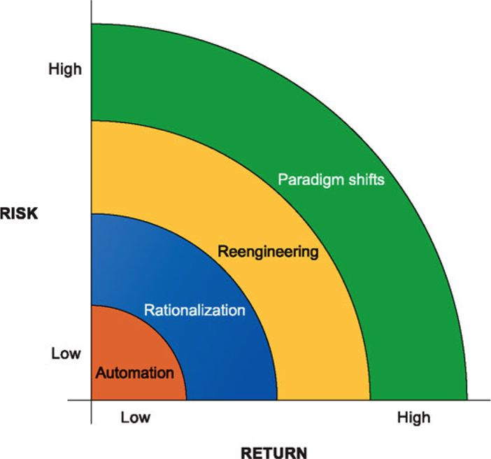
  + 70% of business process fail for reeingeneering projects.
    - buy-in
    - lack of planning
    - lack of understanding of the complexity.
    - Always takes longer than expected
* Overview of systems Development
* **Overview of Systems Development**
* (*Management Information Systems: Managing the Digital Firm, 11th Edition*. Pearson Learning Solutions p. 489).
  + **Systems Analysis**
  + **System Design**
  + **Programming (outsourcing is done)**
  + **Testing**
    - Unit Testing
    - System Testing
    - Acceptance Testing ( based on requirements)
    - Test plan
  + **Conversion**
    - Process of changing from old system to new system
    - Fourn main strategies
      * Parallel strategy
      * Direct cutover
      * Pilot study
      * Phased approached
    - Requires user end testing.
    - Training and documentation of how the system works.
  + **Production and Maintenance**
  + 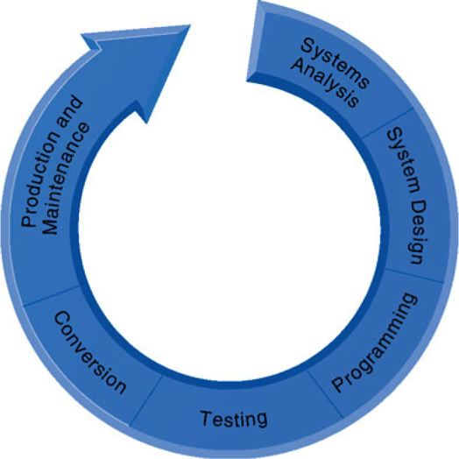
* Business Process Management - Continuous - BPM
* PERT – review a projects task and their interrelationships
* Major variables of project managements
* Scope
* Time
* Cost
* Quality
* Risk
* RAD - developing software in a really short time
* JAD – developing software in a really intense level.