# High Level Design (HLD)

# Mushroom Classification

Revision Number 1.0

Last Date of revision :

# Document Version Control

|  |  |  |  |
| --- | --- | --- | --- |
| Date Issued | Version | Description | Author |
|  | 1 | Initial HLD -V1.0 | Varun Ingle  Abhishek Doifode |
|  |  |  |  |
|  |  |  |  |
|  |  |  |  |
|  |  |  |  |
|  |  |  |  |
|  |  |  |  |

# Content

Document Version Control

Abstract

1. Introduction………………………………………………………………………………….5
   1. Why this High-Level Design Document?.......................................................................5
   2. Scope…………………………………………………………………………………...5
2. General Description…………………………………………………………………………6
   1. Product Perspective…………………………………………………………………….6
   2. Problem Statement……………………………………………………………………...6
   3. Proposed Solution………………………………………………………………………6
   4. Further Improvements…………………………………………………………………..6
   5. Technical Requirements………………………………………………………………...6
   6. Data Requirements………………………………………………………………………7
   7. Tools Used………………………………………………………………………………7
   8. Constraints………………………………………………………………………………8
3. Design Details………………………………………………………………………………..9
   1. Process Flow……………………………………………………………………………9
      1. Model Training and Evaluation…………………………………………………10
      2. Deployment Process…………………………………………………………….11
4. Performance………………………………………………………………………………….12
   1. Reusability………………………………………………………………………………12
   2. Application Compatibility………………………………………………………………12
   3. Resource Utilization…………………………………………………………………….12
   4. Deployment……………………………………………………………………………..12

5 Conclusion……………………………………………………………………………………13

# ABSTRACT

This is the age of the internet where the amount of data being generated is so huge that man alone is not able to process through the data. Many machine learning techniques hence have been discovered for this purpose. We are trying to classify the mushrooms in edible or poisonous category using different machine learning techniques and trying to determine the best algorithm suited to our particular problem statement.

# 

# 1 Introduction

# Why this High-Level Design Document?

The purpose of this High-level Design(HLD) document is to add the necessary detail to the current project description to represent a suitable model for coding. This document is also intended to help detect contradictions prior to coding and can be used as a reference manual for how the modules interact at a high level.

The HLD will :

* Present all of the design aspects and define them in detail
* Describe the user interface being implemented
* Describe the performance requirements
* Include design features and the architecture of the project
* List and describe the non-functional attributes like :
  + - Security
    - Relatability
    - Maintainability
    - Portability
    - Reusability
    - Application Compatability
    - Resource utilization
    - Serviceablility

# Scope

The HLD documentation presents the structure of the system, such as the database architecture, application architecture (layers), application flow (navigation), and technology architecture. The HLD uses non-technical to mildly-technical terms which should be understandable to the administrators of the system.

# General Description

# 2.1 Product Perspective

Mushroom Classification is a solution which is able to predict which mushroom is poisonous & which is edible.

# 2.2 Problem Statement

The Audubon Society Field Guide to North American Mushrooms contains descriptions of hypothetical samples corresponding to 23 species of gilled mushrooms in theAgaricus and Lepiota Family Mushroom (1981). Each species is labelled as eitherdefinitely edible, definitely poisonous, or maybe edible but not recommended. This lastcategory was merged with the toxic category. The Guide asserts unequivocally that there is no simple rule for judging a mushroom's edibility, such as "leaflets three, leave itbe" for Poisonous Oak and Ivy.

The main goal is to predict which mushroom is poisonous & which is edible..

# 2.3 Proposed Solution

We have built a solution which is able to predict which mushroom is poisonous & which is edible according to the provided dataset. We have done classical machine learning tasks like Data Exploration, Data Cleaning, Feature Engineering, Model Building and Model Testing and have used best fit ML algorithm for the above case.

# 2.4 Further Improvements

We can save User’s History of Classification.

# 2.5 Technical Requirements

Any Device with Internet Access.

# 2.6 Data requirements

Data requirement completely depend on our problem statement.

# 2.7 Tools Used

Python Programming language and frameworks such as Numpy, Pandas,

Scikit-learn, Django are used to build the whole model. 



* Pycharm and Jupyter Notebook is used as IDE.
* For visualization of the plots Autoviz, Matplotlib, Seaborn are used.
* Heroku is used for deployment of the model.
* Front end Development is done using HTML/CSS.
* Python Django is used for backend development.
* Github is used as version control system.

# 2.8 Constraints

The Mushroom Classification system must be user friendly, as automated as possible and users should not be required to know any of the workings.

# Design Details

# Process Flow

For Identifying the different types of anomalies, we will use a machine learning model. Below is the process flow diagram is as shown below.

Proposed Methodology

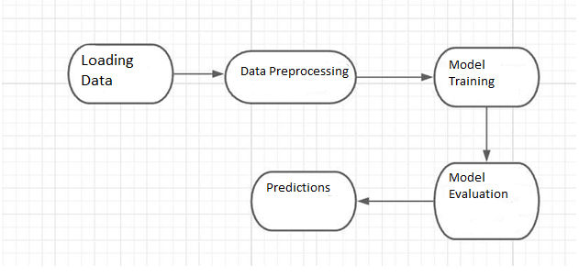

# Model Training and Evaluation

# 

# Deployment Process

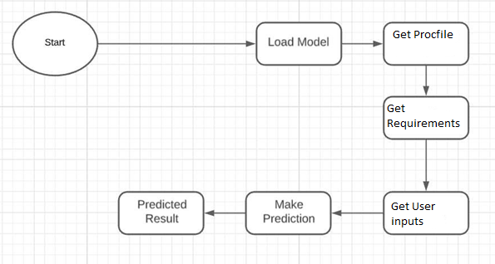

# 4 Performance

The Performance of model depends on dataset. We have done indepth preprocessing of dataset for greater accuracy and much closer prediction with less error.

# Reusability

The code written have the ability to be reused with no problems

# Application Compatibility

This Project will be using Python as an interface between them. Each Component will have its own task to perform, and it is the job of the python to ensure proper transfer of information.

# Resource Utilization

When any task is performed, it will likely use all the processing power available until that function is finished

# 4.4 Deployment



# 5 Conclusion

Model is able to classify the mushrooms which is edible or poisonous according to the provided dataset.