Mushroom Classification

Wireframe Documentation

Mushroom Classification

Mushroom Classification is of Three Pages :

1) Home Page

2) Input Page

3) Result Page

After accessing the [URL](https://mushclassify.herokuapp.com/), user will get directed to the Home Page.

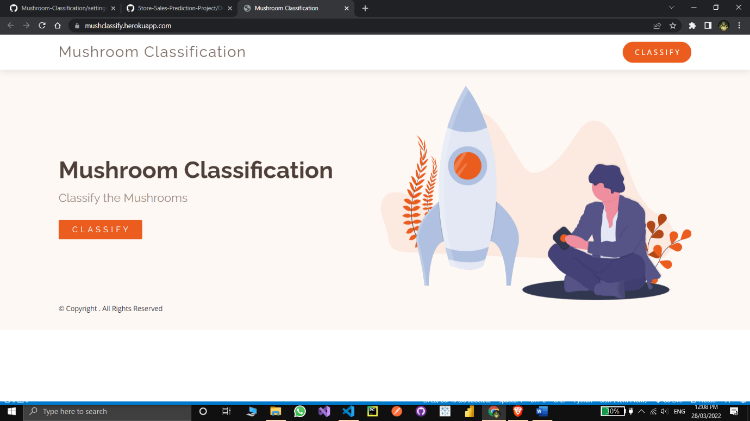

After pressing the CLASSIFY button, User will get directed to the Input Page, where user have to fill the input fields

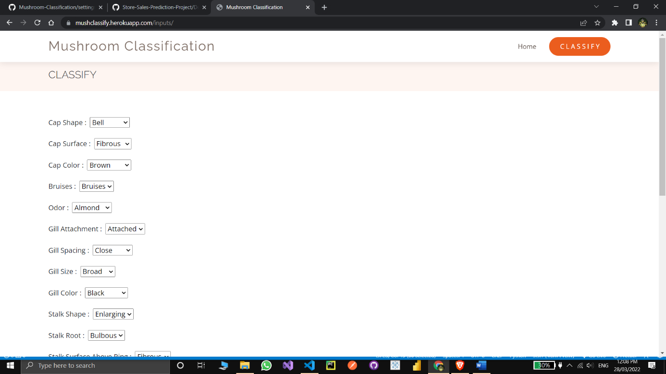Based on User Inputs, mushroom classification will classify the mushroom in edible and poisonous category 