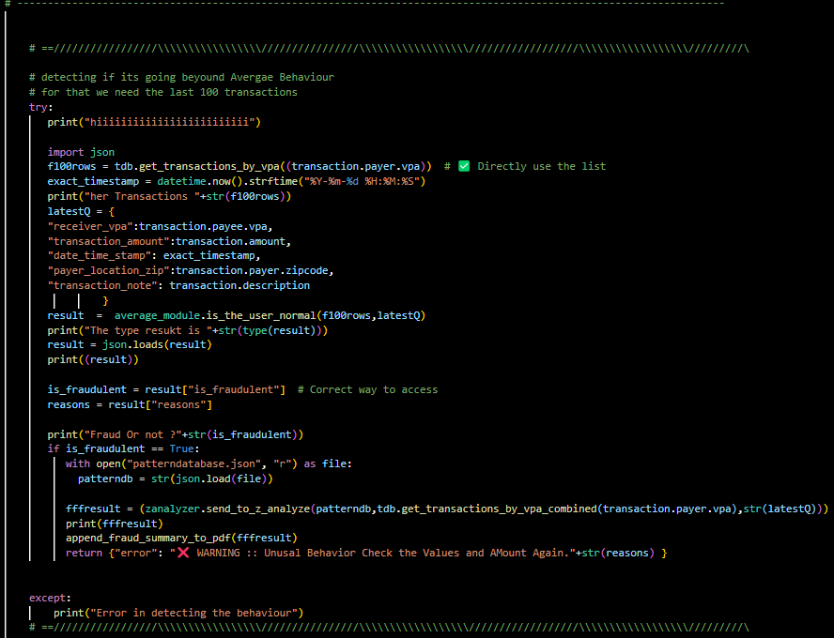

Above where the actual processing Happnens.

And below os the Message Displayed after the Detetction

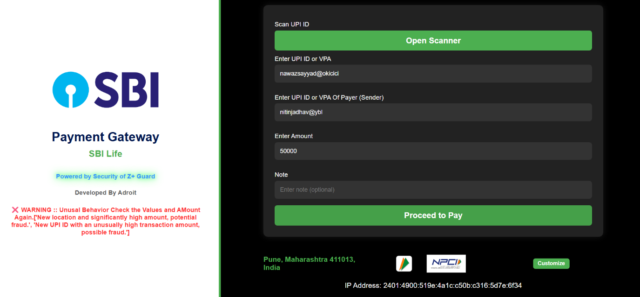

And for cyber Security Depatment   
this pdf is generated   
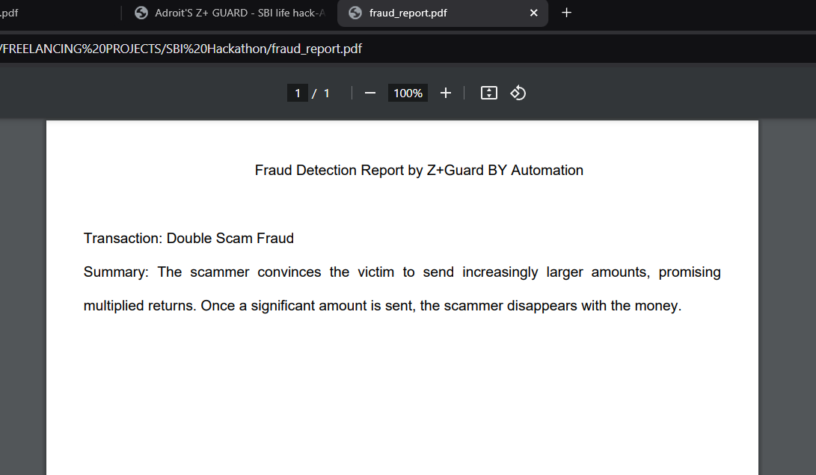  
  
  
Ml models are used .  
Due to Time limitations ill be adding details in the readme File,  
  
  
Please visit that .  
and   
I am really sorry.  
Thank you  
  
  
  
  
  
Nawaz Sayyad  
Team Adroit  
project Z+ Guad