Steps of the approach:

1. Getting sentences out of the review
2. Tokenizing the given input file after basic NLP pre-processing (spell correction, stop word removal, lemmatization etc.)
3. Parts of Speech tagging using Standard NLP parser (from python NLTK) and extracting all words only with pos tag 'NN','NNP','NNS','NNPS'

Based on research, it is found that product aspects tend to be nouns or/and noun phrases

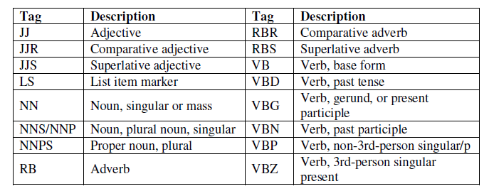

1. Focusing on extracting Nouns and Noun phrases as relevant aspect words
2. Mapping of the extracted words using likeness scores\*

* Couldn’t complete this due to time constraint.

References:

* <https://eprints.qut.edu.au/97562/8/Amani%2520Khalaf_Samha_Thesis.pdf>
* <http://sentic.net/aspect-parser.pdf>