|  |  |
| --- | --- |
|  | **316-318 Delsea Drive North Glassboro, NJ 08028**  **856.881.7575 856.881.8477 fax Mon-Fri 10am-5pm & 6:30pm-9pm Saturdays 10am-5pm**  www.bobslittlesportshop.com  www.facebook.com/BobsLittleSportShop |

|  |  |
| --- | --- |
|  |  |
| **ATTN: JAY REED** |  |
| **LAWMEN SUPPLY** |  |
| **RE: FFL TRANSFER FOR JOE TODARO** |  |
| **SIG P229R** |  |
| **Date: 4/2/19** |  |

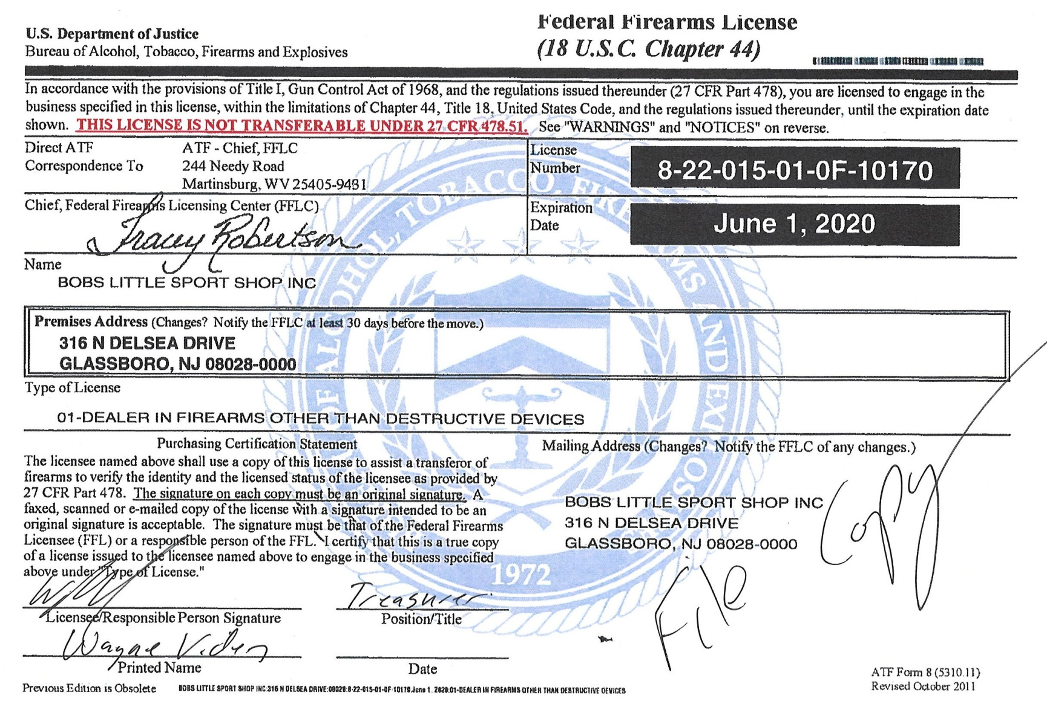

05/30/17