This license is provided as a “File Copy Only” for lawful transfer or purchase of firearms between Second Amendment Sports, Inc. and other lawfully licensed Federal Firearms Licensees. Federal Law and Second Amendment Sports, Inc. prohibit its use for any other purpose.

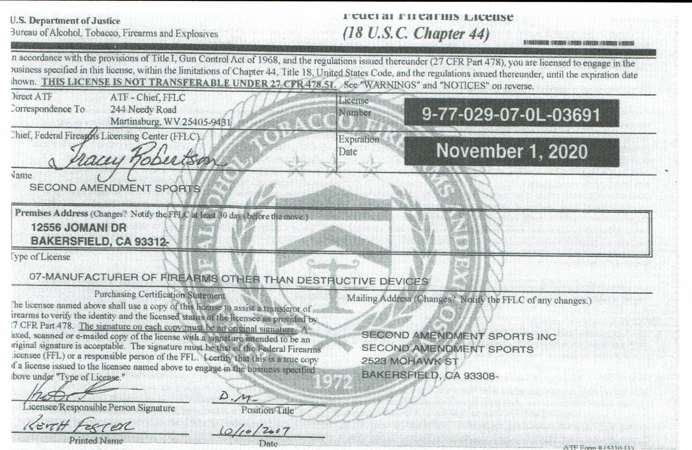

**CFD# 22566**