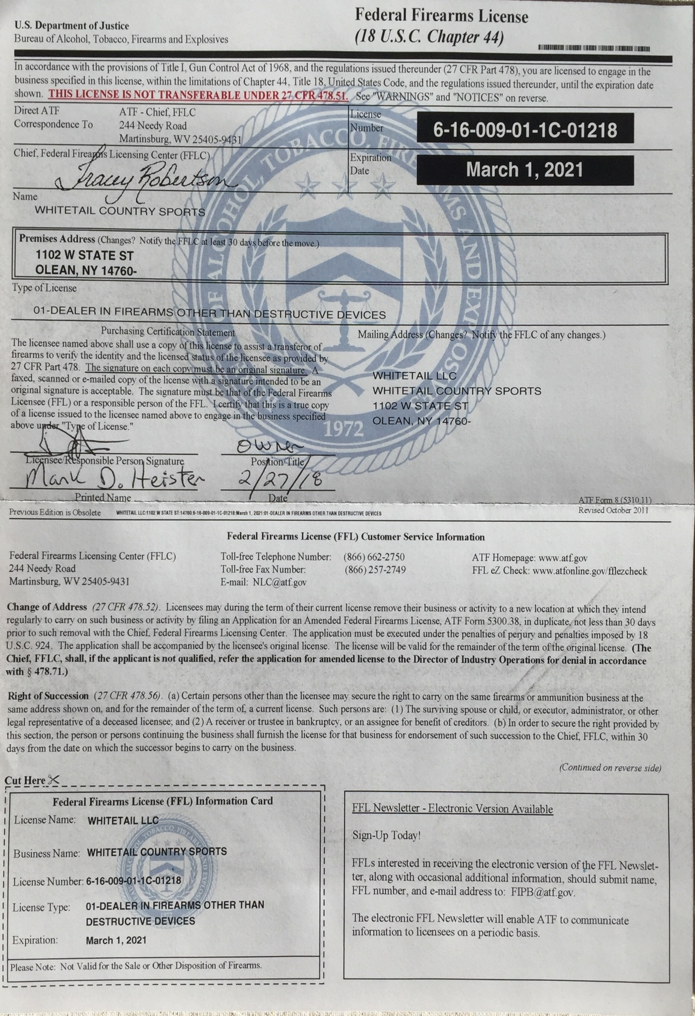

**FILE COPY ONLY!**

**Not for in person transfer**

Whitetail Country Sports

1102 West State St

Olean, NY 14760

716-373-2144

Make ___________________________________________________________

Model ___________________________________________________________

Serial # ___________________________________________________________

Caliber ___________________________________________________________

Transferee _________________________________________________________

Phone ____________________________________________________________