**DO IT YOURSELF FRACTALS: CONNECTING GEOMETRY, MEASUREMENT, AND ALGEBRA**

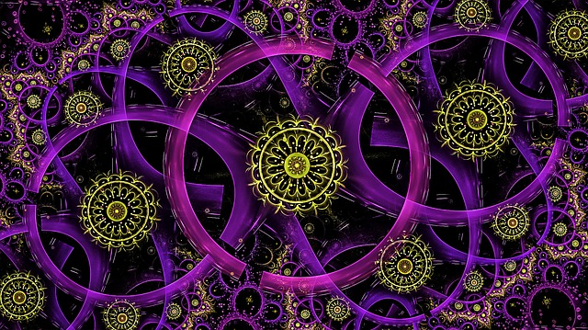

**Mandy McDaniel**

**Boise State University**

**Teri Willard**

**Retired (Central Washington University)**

**November 10, 2018**

**Boise State University**

**Workshop Agenda**

**• Introduction**

**• Make three personal fractal cards.**

**• Discuss vocabulary strategy.**

**• Explore distinct patterns exhibited in the cards and represent them with expressions and equations.**

**• Examine ratio patterns in fractal cards and simplify algebraic expressions related to the ratios.**

**• Ask ourselves: Who can “do” the activity?**

**• Ask ourselves: Where’s the math?**

**• Wrap–up, comments, questions**

**Bonus Activity, if time permits!**