My first

Service Landscape

Diagram

Like a Service Blueprint

BUT

10 times easier and useful for longer

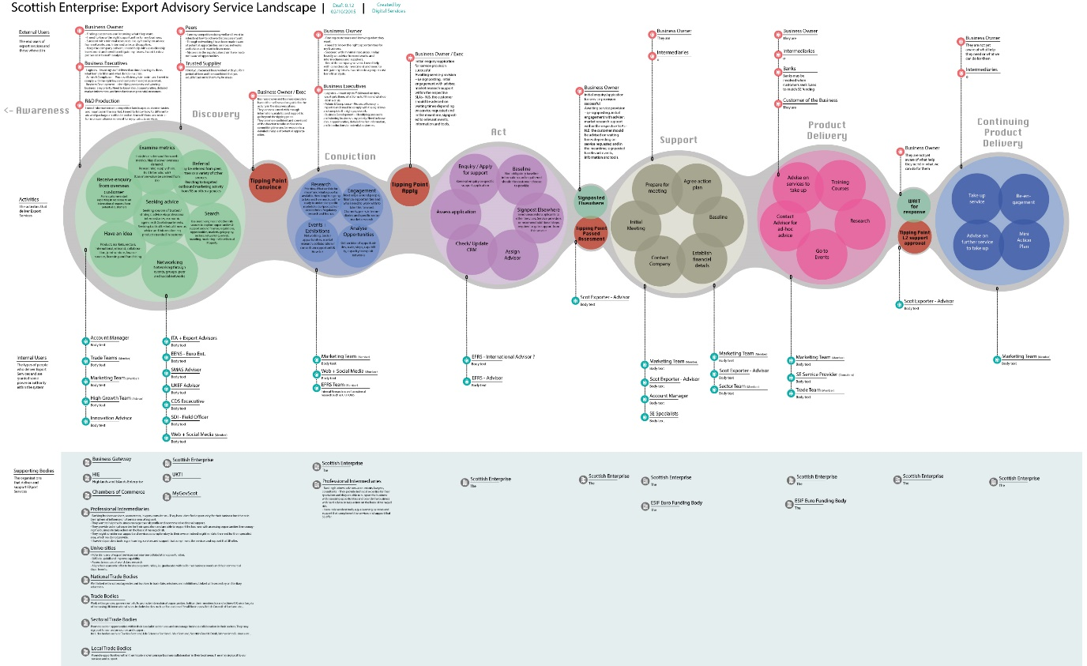

HowTo
- Run a workshop (2 hours max)
- Use the templates at the end of this document
- Populate a table with bits of paper that describe your service/area/problem so that it looks like this (* Pic1)
- Put stuff in the 4 rows
  - External Users
  - Activities (Post-It Notes)
  - Internal Users
  - Supporting Bodies
- Put RED post-it notes in the Activities row to show blockers,delays or other major waste
- Take Pictures (* Pic1)
- Get an Illustrator or Sketch wizard to make a lovely diagram (* Pic2)

Pic1. The Workshop Table
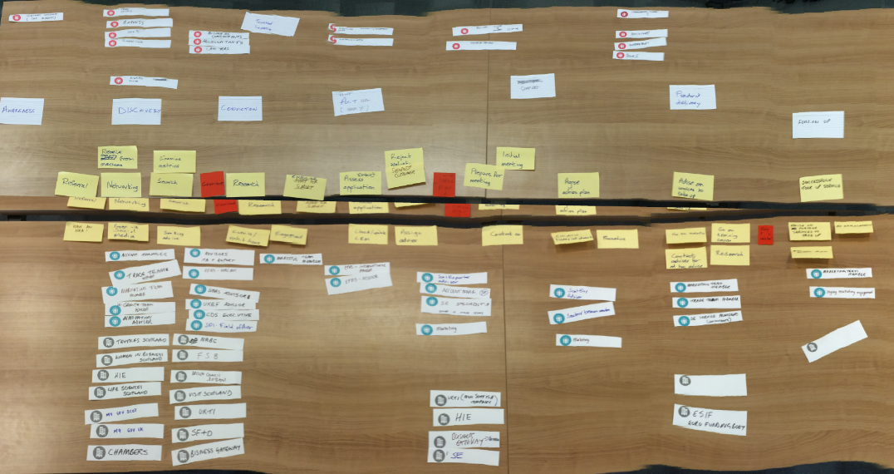

Pic2. The finished Diagram



Templates

External Users









Internal Users









Supporting Bodies









