My first

Service Landscape

Diagram

# Like a Service Blueprint

# BUT

# 10 times easier and useful for longer

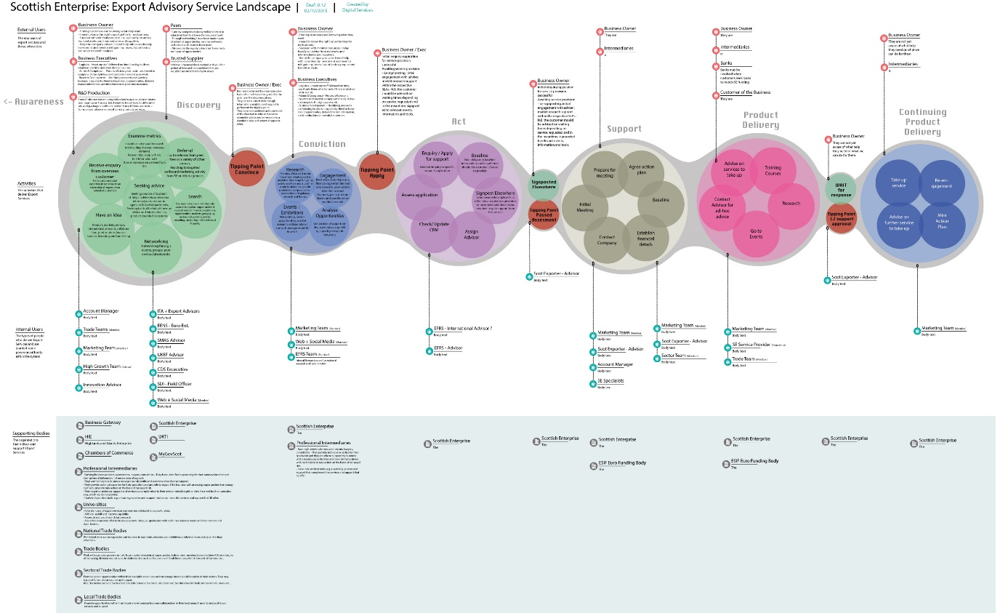

# HowTo

* Run a workshop (2 hours max)
* Use the templates at the end of this document
* Populate a table with bits of paper that describe your service/area/problem so that it looks like this (* Pic1)
* Put stuff in the 4 rows
  + External Users
  + Activities (Post-It Notes)
  + Internal Users
  + Supporting Bodies
* Put RED post-it notes in the Activities row to show blockers,delays or other major waste
* Take Pictures (* Pic1)
* Get an Illustrator or Sketch wizard to make a lovely diagram (* Pic2)

Pic1. The Workshop Table

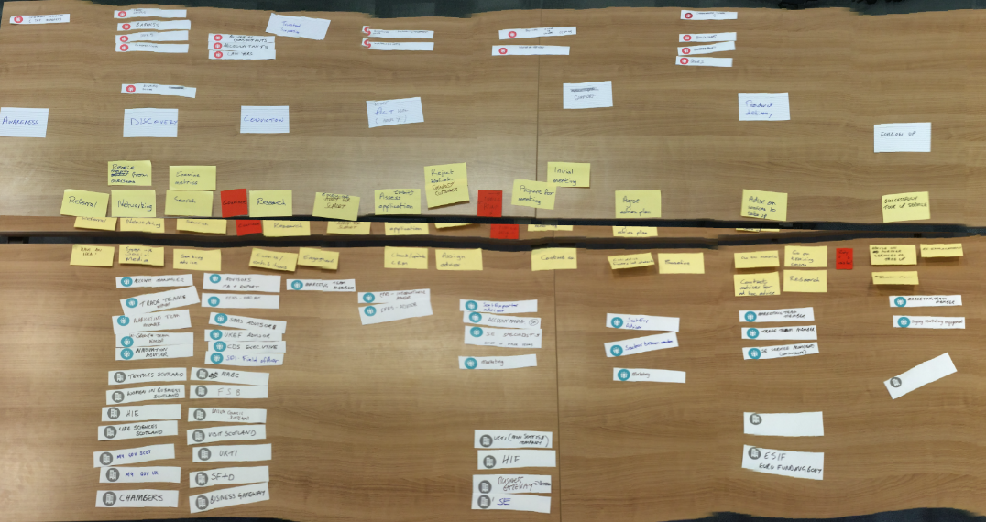

Pic2. The finished Diagram

# 

# Templates

## External Users

|  |  |
| --- | --- |
|  |  |
|  |  |
|  |  |
|  |  |
|  |  |
|  |  |
|  |  |
|  |  |
|  |  |
|  |  |
|  |  |
|  |  |
|  |  |

## Internal Users

|  |  |
| --- | --- |
|  |  |
|  |  |
|  |  |
|  |  |
|  |  |
|  |  |
|  |  |
|  |  |
|  |  |
|  |  |
|  |  |
|  |  |
|  |  |

## Supporting Bodies

|  |  |
| --- | --- |
|  |  |
|  |  |
|  |  |
|  |  |
|  |  |
|  |  |
|  |  |
|  |  |
|  |  |
|  |  |
|  |  |
|  |  |
|  |  |