The Nature of Languages
And Their Programmatic Constructs
February 2, 2016

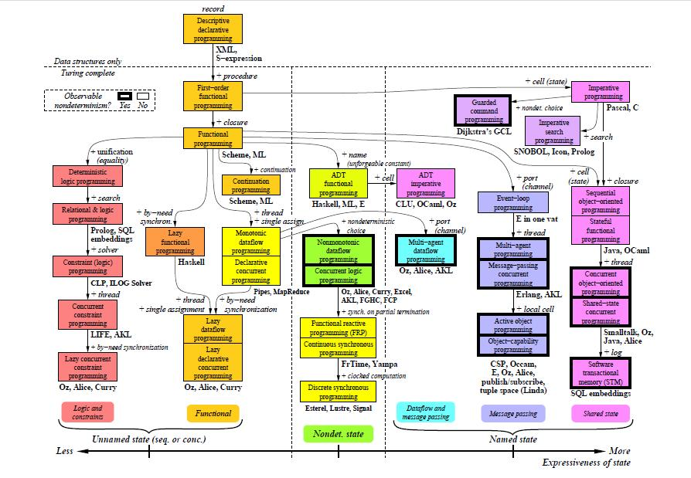
“The purpose of programming languages is to enable the communication from man to machine of problems and their general means of solution.”

- Robert Kowalski, Univeristy of Edinburgh
Department of Computational Logic

A Modeling of Languages
A programming paradigm is a structured model used to convey information in a decisive manner. Whereas the goal of language is to provide an accessible route of information transaction. Whether it be programmatic or spoken, a paradigm exists to provide an efficient structural foundation for the transport and interpretation of messages. Consider the application of linguistics, languages vary greatly throughout the world and often incorporate a variety of bodily gesticulations, vocal cadences, and facial expressions. This natural geographical evolution of languages tends to serve as a survival mechanism, each language distinctly serving a finite role (i.e., emotional expressiveness, dominance, secrecy, haste, etc…). Furthermore languages have artificially evolved overtime to provide a construct of reason to disciplines in fields of science, engineering, and mathematics. Computationally when we speak of paradigms, we are equally interested in not just the languages themselves but more so how they serve to fulfill a specific role.

Paradigms often emerge as a byproduct of a newly formed language. We can refer to the origin language of a paradigm as the ‘Kernel Language’. These Kernel Languages may occur as a natural evolution of computation, seen in such languages as Machine Code, Assembly, and C, or may have been designed specifically to fulfill a role, such as MatLab for matrices and numerical analysis, or PHP for server-side web scripting. An important differentiation must be made though that languages do not manifest purely to support new paradigms, the latter in this case were developed to fulfill a market need while the former have strong ties to the lineage of imperative and procedural programming. One goal of language development however has been the desire to generate a platform agnostic implementation that runs not only efficiently but is human-readable. Unfortunately a human-readable form, aka, a high-level language, often trades efficiency for reduced complexity. As we’ll discuss, many of the paradigms which have presented over the last century were a direct result of this relationship.

The Von Neumann Era
Jon Von Neumann, a name often referenced when speaking of imperative programming (Anthony A. Aaby, 2004 ) was a Hungarian mathematician credited for having contributed one of the first known digital design architectures for an electronic digital computer, appropriately coined the Von Neumann Architecture. The Von Neumann Architecture is a design principle rooted in the development of early computers which establishes the relationships between an arithmetic logic unit, control unit, processor register, program counter, instruction register, and memory.
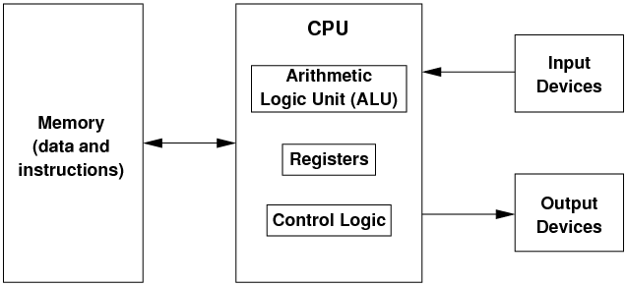
Understanding the basic principles of the Von Neumann architecture will shed some light on not only imperative programming, but also the last 50 years of hardware development and programming paradigms. In this model, computer programs and associated data were stored together in memory. An operative cycle beings when a data is fetched from the memory address in the program counter. The length of the instruction is then added to the program counter and begins to be decoded via the control unit. Any additional commands carried out (e.g., arithmetic and logic) are ordered by the control unit and upon completion of this step the cycle begins again. This process is carried out routinely as a streamlined electronic data pipeline. Sequences of information continue to be fetched, decoded, executed, and stored again – one instruction at a time.

Imperative programming is the digital manifestation of this hardware architecture. Predating assembly language, this model may be most fully appreciated in its pure form as Machine Code. Machine Code is comprised of a two character alphabet, 0 and 1. Words are formulated as strings of 0’s and 1’s and are stored in memory. Upon application execution these strings are sequentially fetched and processed. Similar to completing a recipe or a process checklist, order must be maintained. For larger units of data this has the downside of creating bottlenecks in an application. Fortunately in the early days of computing the exponential growth of hardware capabilities quickly overcame the bottlenecks of serial processing. The bigger issue was the difficulty of working with a language whose alphabet was comprised as Boolean representations of a digital circuit. Driven by a need for accessibility and productivity, Machine Code was used to develop assembly languages and disassemblers which would unwrap assembly language back into Machine Code. Assembly language gave way to many of the defining features characteristic of the imperative model of programming, such as looping, branching, and complex expressions. Further more, it paved the way for the procedural programming paradigm which is a yet another extension of imperative programming.

The Bifurcation of Programmatic Paradigms
“Solving a programming problem requires choosing the right concepts. All but the smallest toy problems require different sets of concepts for different parts. This is why programming languages should support many paradigms.“

- Peter Van Roy, Programming Paradigms For Dummies
What Every Programmer Should Know

An early principle of development, lovingly referred to as DRY, or Don’t Repeat Yourself, has been the mantra for many-a-lazy programmer. For practicality’s sake it is an incredibly succinct concept which embodies the idea of code reuse through the use of collecting related constituent rules into a singular scoped entity. This was one of the greatest contribution of the procedural paradigm and paved the way for an explosive outgrowth of new ways of thinking about structuring data. In procedural programming, procedures, or functions if they return data, greatly improve the readability of code while diminishing the amount of code one actually must write by repeatedly ‘calling’ these procedures to perform routine tasks. Procedures introduce the concept of scoped variables, arguments, return values, and the practice of developing modular code blocks in which multiple procedures may work together to perform a single task and often times will be grouped together to form a standard library.

Earlier it was stated that one of the many goals of language developers was to maintain a level of efficiency while attempting to achieve a more human-readable syntax. While the imperative languages were a step in the right direction, it was the procedural paradigm and its functional blocks that would take the first step towards what is known as the declarative programming paradigm. As a stark contrast to imperative programming and its many branches, the declarative model presents an entirely new root structure from which others paradigms would be built upon. Declarative languages tend towards a high degree of abstraction in which code is more logical and deviates away from the classical models of control flow. We say declarative languages are descriptive in nature and allow the programmer to focus on what they want to accomplish and not so much how to go about accomplishing it, which are all qualities highlighted by languages such as SQL and Prolog. Simplification and clarity is a primary goal of this initiative. When discussing paradigms we can often refer to imperative and declarative as being foundational models which have established an intricate hierarchy of other paradigms as new concepts are developed. “With n concepts, it is theoretically possible to construct 2^{n} paradigms.” (Van Roy, 2004). While it would not be conducive to address the exponential number of paradigms in existance, it is worthwhile to explore three notable examples which have had been in continual use over the last few decades - functional, logical, and object-oriented.

The functional paradigm is the golden boy of the declarative hierarchy as the procedural paradigm is to imperative. Whereas the declarative model merely introduces abstraction and control, functional languages heavily enforce the idea. First and foremost, everything is a function and data is immutable. The intent of these two decrees is to eliminate the possibility of conflicting name spaces and to reduce data ambiguity. Every function is written with intent, and so no return types are allowed; in essence, no code is wasted.

Functional Logical→Object-Oriented

There Can Be Only One, Paradigm
“Since most programs have to solve more than one problem, it follows that they are best written in different paradigms.”

“The likelihood that continued advance in programming will require the continuing invention, elaboration, and communication of new paradigms.”
- Robert W. Floyd
The Paradigms of Programming

Works Cited
- Kowalski, R., 1974, August. Predicate logic as programming language. InIFIP congress (Vol. 74, pp. 569-544).
- Van-Roy, P. and Haridi, S., 2004. Concepts, techniques, and models of computer programming. MIT press.
- Seibert, S 2001, Imperative Programming. Available from: <http://everything2.com/title/Imperative+Programming>
- Roth, A., 1993. The practical application of prolog. AI EXPERT, 8, pp.24-24.
- Vujoševic-Janicic, M. and Tošic, D., 2008. The role of programming paradigms in the first programming courses. The Teaching of Mathematics, XI, 2, pp.63-83.
- Hewitt, C., 2006, March. The Repeated Demise of Logic Programming and Why It Will Be Reincarnated. In AAAI Spring Symposium: What Went Wrong and Why: Lessons from AI Research and Applications (pp. 2-9).
- Floyd, R. W., 1979. The paradigms of programming. Communications of the ACM, 22(8), pp.455-460.
- Aaby, A. A., 1996. Introduction to programming languages. Walla Walla College, Computer Science Department.
- Louden, K, Lambert, K 1993, Programming Languages, Course Technology.
- Levy, S., 2001. Hackers: Heroes of the computer revolution (Vol. 4). New York: Penguin Books.
- Floyd, R.W., 2005. The paradigms of programming. Resonance, 10(5), pp.86-98.

