Project 2

Title
Fatal Trajectory
Ballistic trajectory game

Course
CSC-5

Section
47981

Due Date
December 10, 2013

Author
Scott Nevin

Introduction:

In this ballistic trajectory game, imaginary tanks are generated at random points in a field. The user must enter the angle for the projectile to be fired at, and the speed at which to fire it. This game is essentially the same as the one pictured below, just without any sort if graphics.
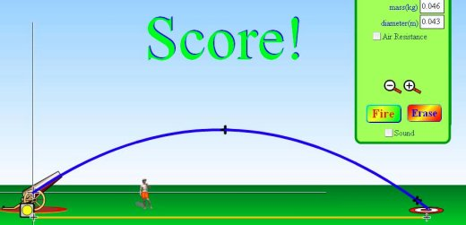
http://www.sjogy.nu/images/200.282470cf126ab885cf88000584/Projectile+motion.jpg

Summary:
Statistics
Code Length: 309 Lines
Variables used: About 30
Number of Functions: 8

Rules and Gameplay
In this version of this game, the user has 15 shots to destroy as many tanks as possible. Every time a tank is destroyed, a new one spawns at a random location. The user must enter the angle (0-90) the gun should be aimed, and the power (0-100m/s) it should be fired at. The program will tell the user when he has hit a target and will offer feed back on if a missed shot was too close or too far. The user has a choice between two difficulties, easy and hard. In the easy difficulty, the blast radius of the projectile being fired is 70 meters , and in the hard difficulty, the blast radius is only 30 meters. Also. if the user manages ti destroy a target on the first attempt, he will be awarded an extra shot. The user’s score will be recorded, and written to a high scores file for each difficulty if it is large enough to replace one of the existing scores.

Logic:
This game uses several functions to pass values during play. First a function uses a random number generator to randomly place the tank, then functions for user input collect the difficulty at which the user would like to play, and later the firing instructions for each turn. A function is used to calculate where the projectile will land based on the user’s input, and another will test if the shot was considered a hit or a miss. A for loop is used to carry out the 15 consecutive turns, with functions that pass the user’s score by reference to keep a running total. At the end of the game, the appropriate high score file is opened, and all of the data read in. The high score system uses a structure titled “highscores” to keep names of users and scores parallel. The user’s score is then compared to the values of the high score table using if statements, then, the array is rearranged, and rewritten to the high score file.

Constructs used:

- Primitive data types
- Global variables
- Reading/writing to/from files
- if statements
- Loops
- functions
- Arrays
- Passing values by reference
- Abstract data types (structures)

References:

- Gaddis “Starting out with C++”
- http://www.cplusplus.com
- http://www.dreamincode.net

