

|  |
| --- |
| **Activity 1.1.4 Pulley Drives and Sprockets** |

|  |  |
| --- | --- |
| [Image:Keilriemen-V-Belt.png](http://upload.wikimedia.org/wikipedia/commons/4/42/Keilriemen-V-Belt.png) | j0289741[1] |

Introduction

Pulleys and sprockets achieve the same tasks as gears by transferring power through rotary motion. Depending on how pulleys and sprockets are applied, speed, direction, and torque can be modified within the system. Pulleys and sprockets are both used in everyday machines ranging from industrial applications to moving printer heads within a desktop printer. Typically, belts and pulleys are easier to manufacture, lighter weight, and less expensive to purchase than sprockets and chains. Although chains and sprockets are more difficult to manufacture and often noisier, they have the advantage of not slipping as easily and tend to be more durable then a belt and pulley system.

Procedure

In this activity you will learn about belt and pulley systems and sprocket and chain systems. You will calculate ratios of examples of both systems in a lab environment.

Belt and Pulley Systems

A driver pulley (input) powers one or more driven pulleys (output). The pulleys are connected by belts. The ratios are based on the relationship between the different pulleys. As seen in Figure 1, pulleys manipulate torque and speed.

|  |  |
| --- | --- |
|  |  |

Figure 1

The ratios of pulley and belt systems are the same as for gears. The exception is that there are no teeth on a pulley to count, so you must rely on the diameter of each pulley.



It is common for multiple pulleys to be used with a single belt as seen in Figure 2.

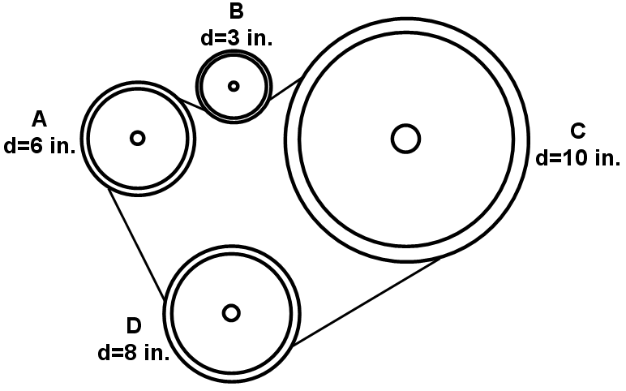

Figure 2

1. Assuming that Pulley A is the power source or input and that it is moving clockwise (CW), which way would the other pulleys rotate, clockwise or counterclockwise (CCW)? Complete the table below.

|  |  |
| --- | --- |
| Pulley | CW or CCW |
| A | CW |
| B |  |
| C |  |
| D |  |

1. Using the diameter of each pulley, what is the ratio between pulley A and the other three pulleys? Complete the table below.

|  |  |  |  |
| --- | --- | --- | --- |
|  | Formula | Substitute & Solve | Final Answer |
| B:A |  |  |  |
| C:A |  |  |  |
| D:A |  |  |  |

1. If the torque force provided at pulley A is 120. ft·lb, then what are the corresponding torque values at pulleys B, C, and D? Complete the table below.

|  |  |  |  |
| --- | --- | --- | --- |
| t | Formula | Substitute & Solve | Final Answer |
| B |  |  |  |
| C |  |  |  |
| D |  |  |  |

Sprockets and Chain Systems

It is not unusual to hear sprockets referred to as gears. However, a difference does exist between the two. Remember that with gears the teeth of one gear are meshed with the teeth of another gear. When chains are used, they are joined with sprockets. This means that a bicycle actually uses sprockets and chains to transfer power between the pedals and back wheel. Fundamentally the operation, formulas, and selection of sprockets are no different than with pulleys. One advantage is that you can count teeth to determine ratios. Below are the relationships of the ratios.



Conclusion

1. Automotive engineers design many car engines with timing belts. The timing belts provide vital function to the engine in order to maintain the combustion cycle. What is the specific purpose of a timing belt? Is a timing belt more like a belt and pulley system or more like a chain and sprocket system? Defend your answer.
2. Based on what you know about wheel and axle simple machines, how might you manipulate the size of the axle powering the input pulley or sprocket to harness more speed from the output?
3. When you are climbing a hill on a bike with different speeds, why does it seem like you are pedaling a lot to cover a short distance? What happens if you switch to a higher gear in hopes of not having to pedal as much?