An Analysis of Burt Rutan's AGW Presentation

Scott Nevin

Riverside City College

Abstract

This paper gives a brief discussion and analysis of engineer Burt Rutan's presentation entitled "An Engineer's Critique of Global warming 'Science' Questioning the CAGW theory". Catastrophic Anthropogenic Global Warming(CAGW), is a term referring to the global climate destruction caused by human emissions of greenhouse gasses. This paper will first give a discussion of Rutan's entire report, summarizing his main points and the methods that he used to make his conclusions. The next section will contain my opinion on the issues covered in Rutan's presentation and if this information altered my opinion in any way. Three graphs will be selected from the presentation and their curves will be analyzed with an explanation of the data they represent and the conclusions that can be derived from these findings.

*keywords*: CAGW

An Analysis of Burt Rutan's AGW Presentation

Burt Rutan is one of the most well respected and accomplished engineers of our time, and one of his side interests includes being an avid environmentalist. He often researches ways to reduce his emissions to our environment and event constructed his home to have a minimal environmental impact. In 2011, Rutan published a presentation outlining his research on the topic of CAGW, starting with five questions regarding the issue and providing data findings to answer those questions. Rutan's presentation has a simple purpose, to collect and consolidate data about this subject and display it in a way that allows us to get an engineer's perspective about this topic. Rutan is even interested in this data being used to spark readers' curiosity and come to their own conclusions. This report about global warming is very easy to understand and helpful in informing the public about the facts and evidence behind this incredibly controversial topic.

This report by Rutan was designed to be very straight forward and easy to read, the first point being our understanding of CO2. The main argument for those who believe in global warming is that we humans are adding dangerous amounts of CO2 to the atmosphere and subsequently forcing it to heat up, but as Rutan clearly states, CO2 is a fertilizer for the vegetation on our planet and without it, all life on Earth would perish. He even explains how the concentration of CO2 in the atmosphere when the dinosaurs were alive is 3 to five times what it is today and that the earth was green all the way around during this period. Already, Rutan has stated outright that we need to have a higher concentration of CO2 in the atmosphere if we want a healthy environment, going against the popular belief of it destroying life on Earth.

What Rutan sets out to do next is answer the five questions he feels are most relevant to understanding the truth about CAGW. He questions these five theories: 1. The recent burning of fossil fuels by humans dangerously increased CO2 levels. 2. Human CO2 emissions cause greenhouse warming. 3. Dangerous warming has occurred over the past 50 years. 4. The current temperature is already too hot and further warming is bad. And 5. It would be more difficult to adapt to climate change, rather than attempt to control it. The first question is easily dealt with by realizing that for the alarmist to prove the CAGW theory, he must prove that CO2 is a pollutant, which Rutan clearly stated isn't true on the first page of his report. He even goes so far as to say that calling CO2 a pollutant is an "uninformed joke".

Over the next several pages of his report, Rutan displays several graphs regarding CO2 levels in our recent history that all point to the conclusion that CO2 has not risen, nor will it rise in the near future, to dangerous levels that we cannot survive. His graphs also show that predictions of the supposed dangerous climb of CO2 levels are nowhere near reality and that even if those predictions were true, our atmosphere would still be well below an unlivable concentration of CO2. Most of his research regarding the first question show how alarmist have used outlandish predictions of rapid greenhouse gas increase to scare people into believing their views and distort the public's understanding of what is actually happening. In the first 25 pages of his report, Rutan shows that we are in fact adding CO2 to our atmosphere, but the idea that we are adding a dangerous amount is an absolute fallacy.

The next point that Rutan questions is the correlation between rising CO2 levels and rising temperature of the planet, answering his second question about CAGW. What he finds from the data on this portion of the topic is that CO2 changes, in relation to heat, happen between 500 - 800 years after a climate's temperature changes. Rutan shows several graphs after this point, showing how computer models designed to predict temperature change based on this correlation predicted far higher than what our temperature turned out to be. Next, he examines the research of NASA's James Hanson, who claimed that computer models were "evidence", predicting a leveling of climate change by 2006 if significant reductions were made in emissions. Rutan shows data proving that not only were those computer models wrong, but our climate would turn out cooler without the cuts proposed by Hanson. With all of these figures, Rutan concludes that greenhouse warming from emissions is not supported by data whatsoever.

Over the rest of his report, Rutan provides dozens of graphs showing data completely contrary to claims made by global warming alarmists. With the research compiled, he shows us that not only are we not adding dangerous levels of CO2 to the environment, but that CO2 isn't concerning in the first place. This report is a comprehensive look at all the data that we haven't taken the time to find and the tactics that alarmists use to further their claims. It is even proven in the report, that even if the temperature were theoretically sky rocketing, it would be more cost effective to adapt to the change rather than attempt to control something that is much larger than the human race. Rutan shows us the importance of approaching problems like an engineer would, by researching and testing the data, rather than predicting and blind guessing. Rather than listen to alarmists making claims based on guesses, engineers look at the data to show what is reality as opposed to theory. He uses airline public safety as an analogy by saying that problems like this can't just be predicted, rather, "we must do extensive testing under real conditions and pay attention to all the results". Rutan has not only given a great insight to the issue of global warming, he has also made the very important distinction between scientist and engineer. Where scientists do anything to replicate the results to prove their theories, engineers listen to reality, and throw out a theory if reality proves it wrong. The main point we need to take away from this report is not to allow an issue like this to become settled science, and to follow Rutan's policy for aircraft safety reviews, and words to live by as an observer, "Question, never defend".

My Opinion

This report was very interesting to read with the opinions I currently have, it strengthened and confirmed my beliefs in many areas. When it came to the topic of global warming, I believed that yes, we were contributing to the polluting of the Earth, but this was in no way going to cause its downfall. I believe that the human race is like a virus and that when the planet cannot stand us anymore, it will simply wipe us out and start over. It makes sense to me that, like many things, the planet has a cycle and would experience drastic changes as a part of this cycle. Burt Rutan helped confirm and give meaning to these beliefs.

It did come as a surprise to me that the average temperature of the planet hasn't changed in over 18 years, yet makes absolute sense. I have grown up being fed the idea of global warming and man being a monster by destroying the Earth all the way back since elementary school. Starting with the idea of recycling and energy conservation, and eventually leading to the idea of reducing our "carbon footprint" by reducing our burning of fossil fuels. Now I do still believe that some of these things are to our benefit with respect to things like air quality, but quickly learned that most of these programs dealing with environmentalism were related to scare tactics and politics. Rutan's research gave me an entirely new perspective on the subject with the simple concept that CO2 is not a pollutant. It seems so absurd that I could miss such a fact when learning about biology and how plants thrive, yet media and government did a sufficient job of creating a monster out of a nearly harmless substance.

After a lifetime of a belief contrary to the popular understanding of global warming, it was very refreshing to see factual data making sense of the concepts. It may seem hypocritical to say that we need to stop believing everything we are told, yet support every word of Rutan's report, but Rutan is very clear that his report is supposed to inspire readers to go and research their own opinions. The added fact that Rutan is himself is an environmentalist makes me respect his ability to come to conclusions based on the data, even if it contradicts what he may have previously thought to be true. This presentation made clear that looking at a problem like an engineer is the best way to find the answer closest to the truth.

Curve One

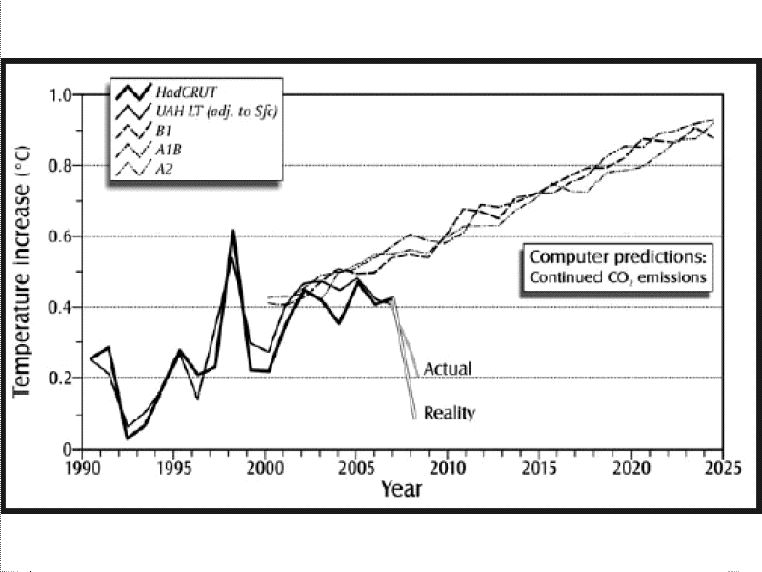

This curve is found on page 34 of Rutan's report and is a representation of computer predictions of temperature increase versus the actual trend. The curves represent temperature increase from year to year, rather than a straight representation of temperature itself. The blue curve shows computer models based on the idea that CO2 emissions cause the increase of temperature, and the red curve is what has actually been observed through time. Based on this curve, not only did the computer models predict the temperature rising, but in fact predicted an exponential rise in temperature from year to year. This graph is one of the most important curves to observe when trying to show what we've learned from global warming research, because, based on past theories, our change of temperature every should have been much higher. The graph shows the factual information, proving that those past computer models, as well as the theories and concepts that went into designing them, were completely incorrect.

Curve Two

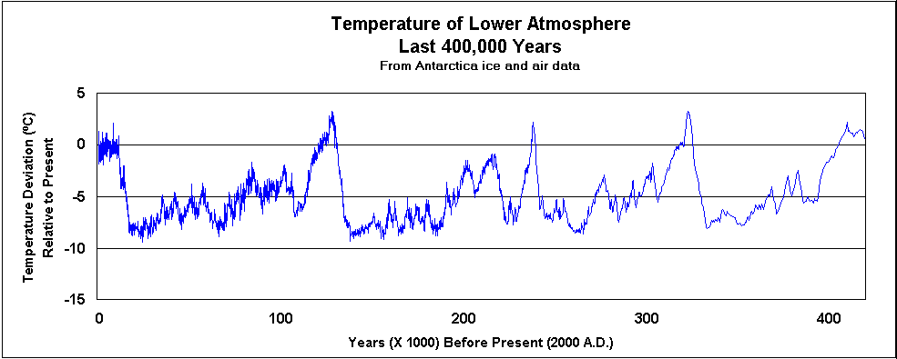

This graph is a bit more historical than some of the other graphs in Rutan's report and can be found on page 51. It shows the trend of global warming and cooling periods in the history of our planet. The red circle at the leftmost peak of this graph shows the peak of temperature we are currently living in and experiencing. What we can conclude from this curve is that there have been warming periods since long before we were around and there will be more long after we are gone. The belief that our planet has gone from a steady temperature and is now suddenly sky rocketing is a completely unsupported claim. This graph shows the cycle that our planet has gone through over the past 400,000 years and the average temperature for those time periods. What we can see on this graph is that we are not currently experiencing the warmest period in our planet's history. There have been hundreds of years where the Earth was significantly warmer, yet life thrived even more than it does today. This simply proves that warming is not anything that the planet hasn't experienced before and life can absolutely adapt to the changing climate of the atmosphere.

Curve Three

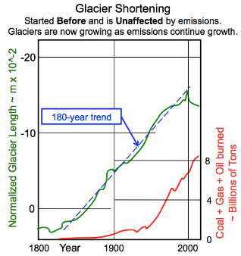

This curve can be found on page 74 of Rutan's report and shows the changing size of glaciers and how those figures relate to increased emissions. One of the most powerful tool of the environmental alarmist is shaming us with images of ice caps melting and polar bears struggling to find land because of our outrageous emissions. As it is clearly stated in the graph above, glacier shortening started long before we started putting pollutants into the atmosphere and has simply increased in a curve parallel to that of our increased emissions. This further goes to disprove the claim that human emissions are ruining the planet, this is a cycle that began before we did anything, and will continue when our race ceases to exist. Now the polar bears and other species of that region may be going extinct due to a change in the terrain, but that is also the natural order of the Earth. Species die off and glaciers shorten and melt, these are steps in the cycle of our planet, and putting the blame on humans is unfounded and unrealistic.

References

Rutan, B. (2011, January 1). Movie - The Great Global Warming Swindle (2007). Retrieved March 1, 2015, from http://rps3.com/Pages/Burt_Rutan_on_Climate_Change.htm