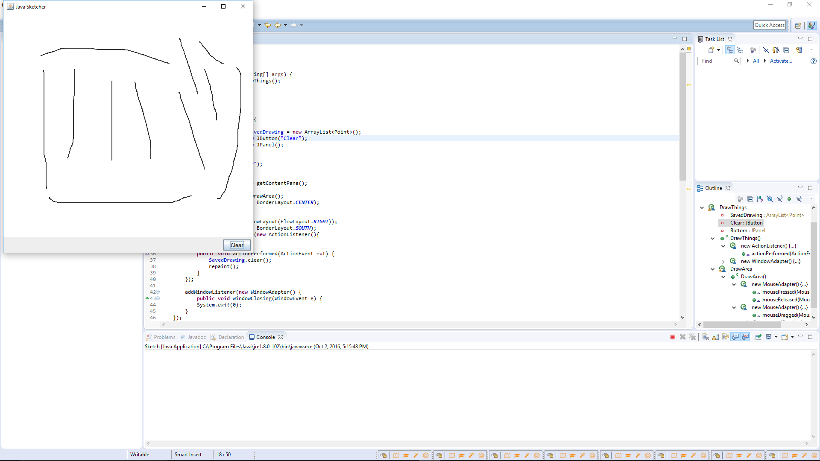

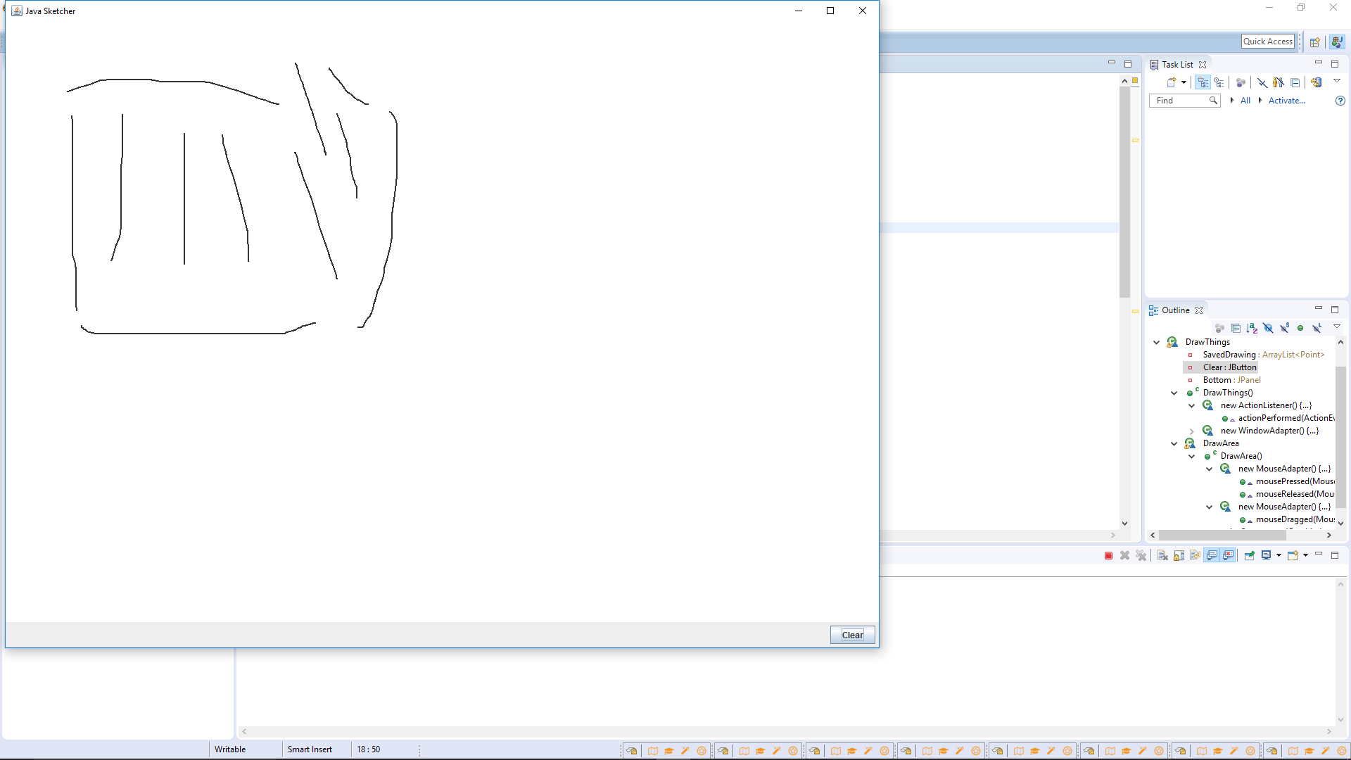

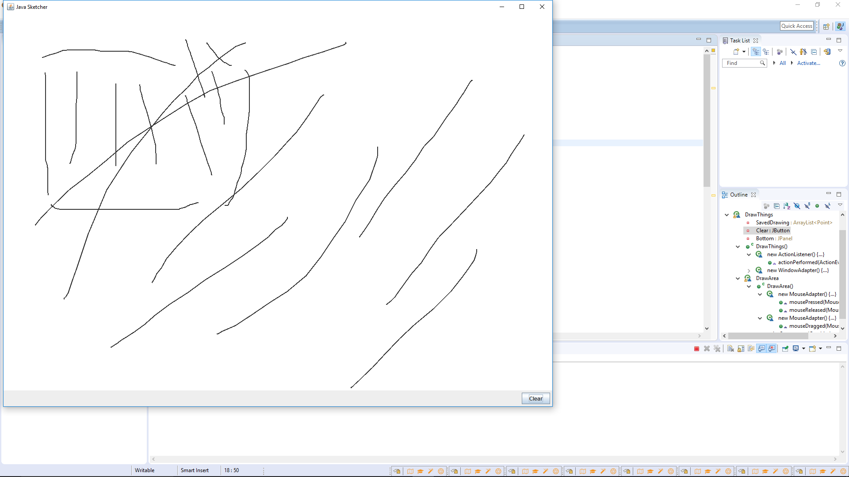

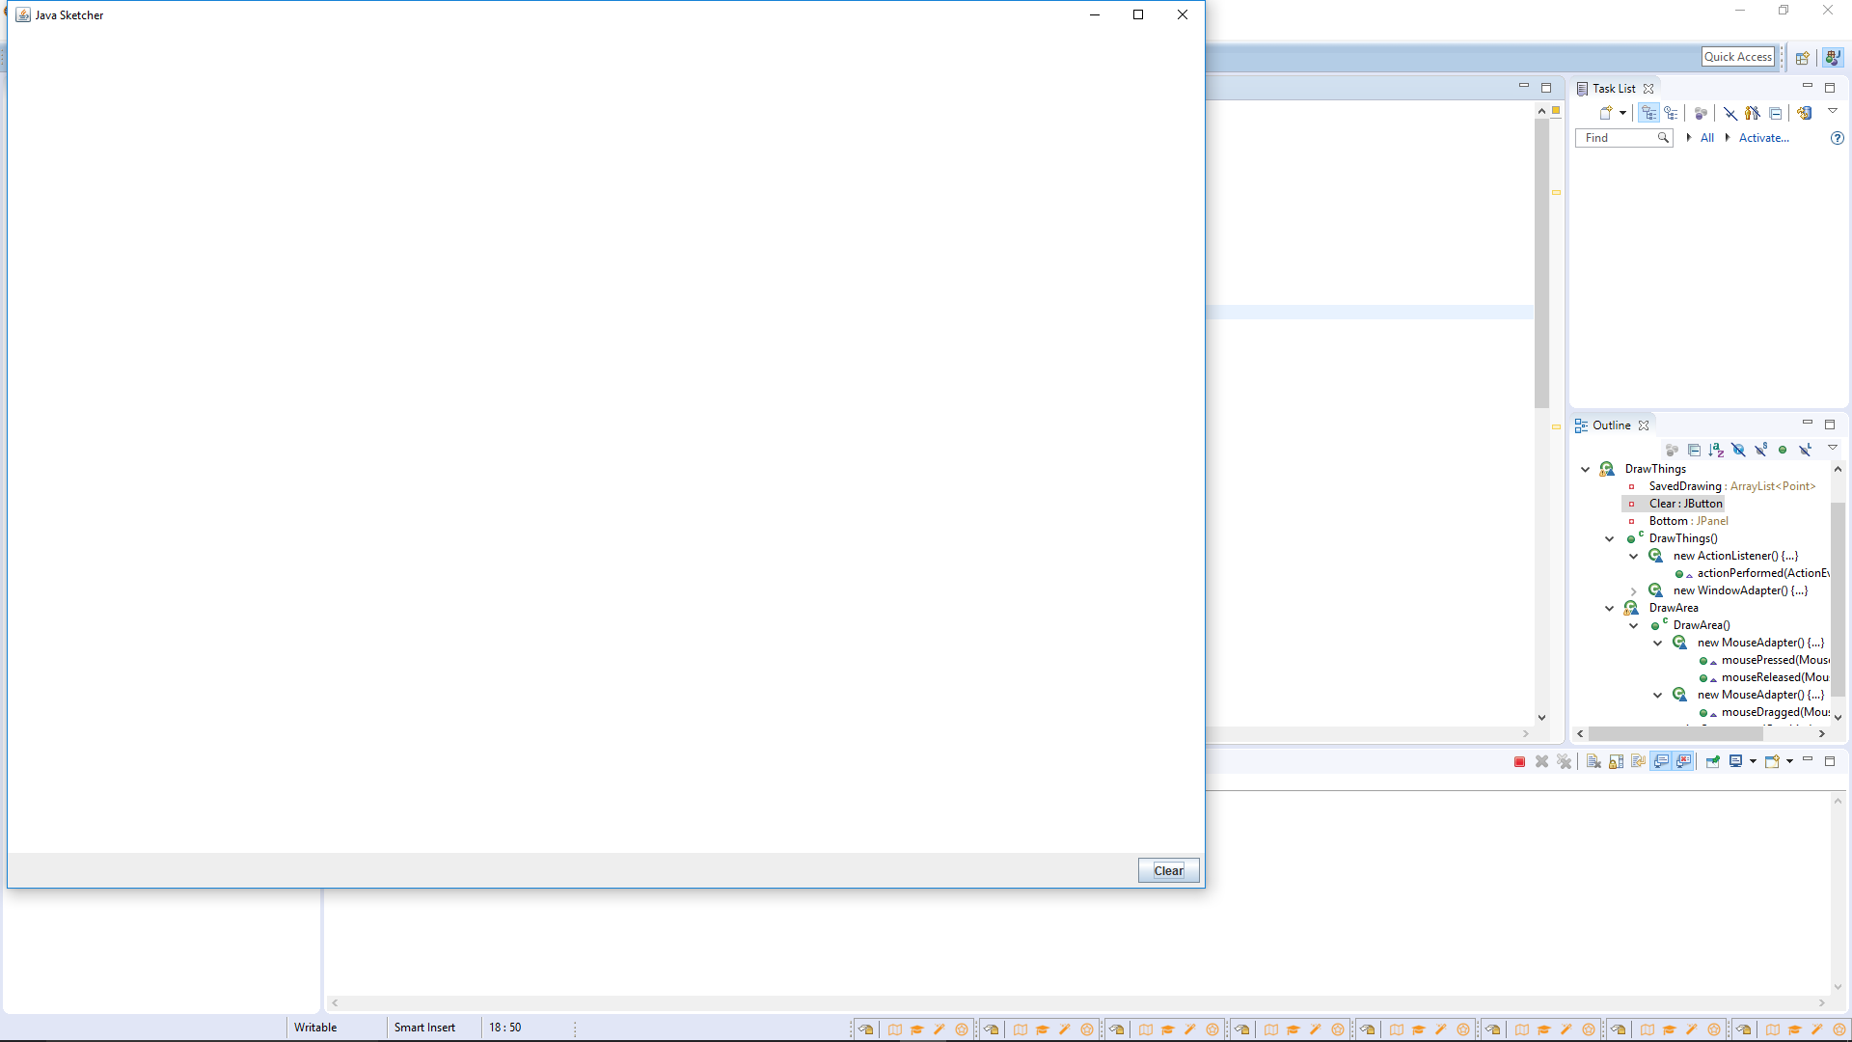

Part B:

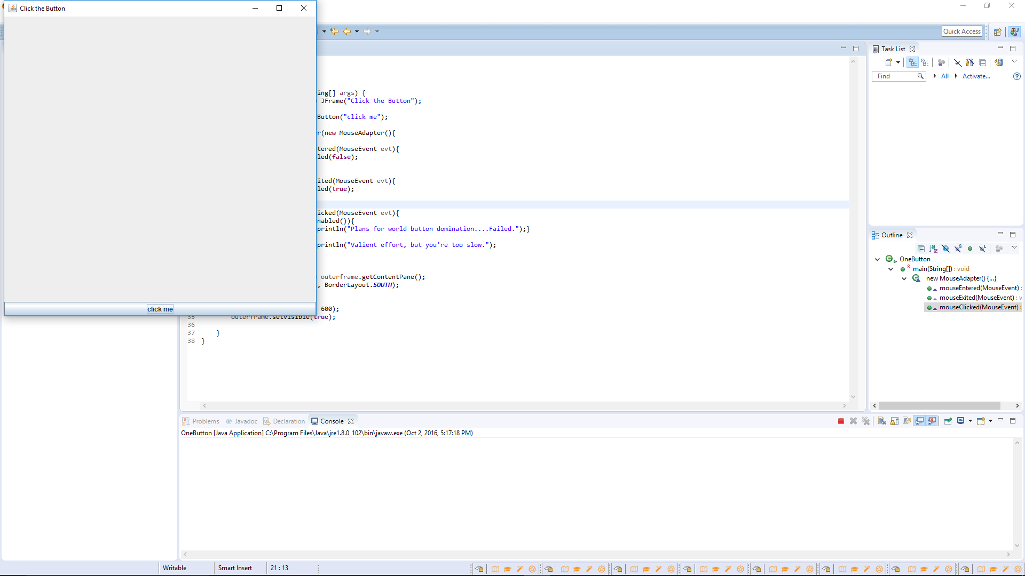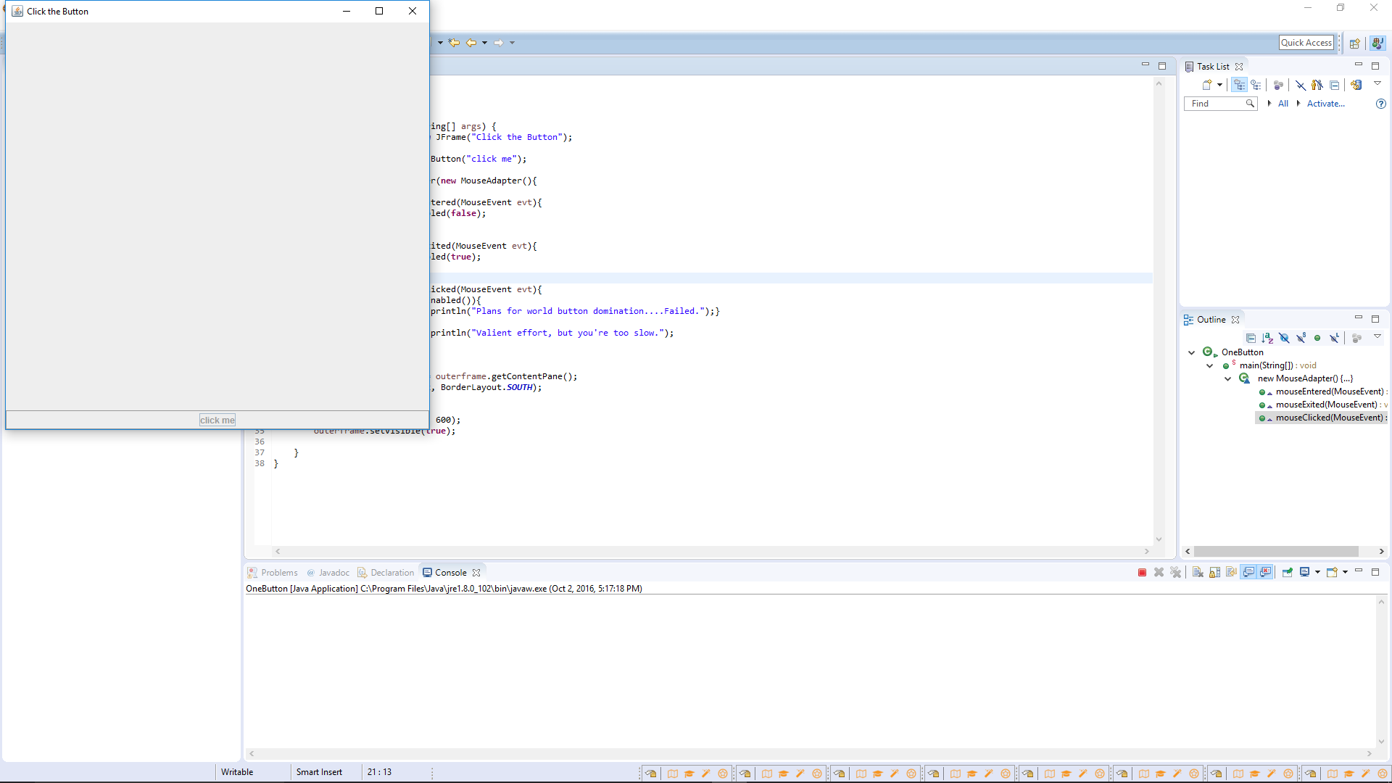

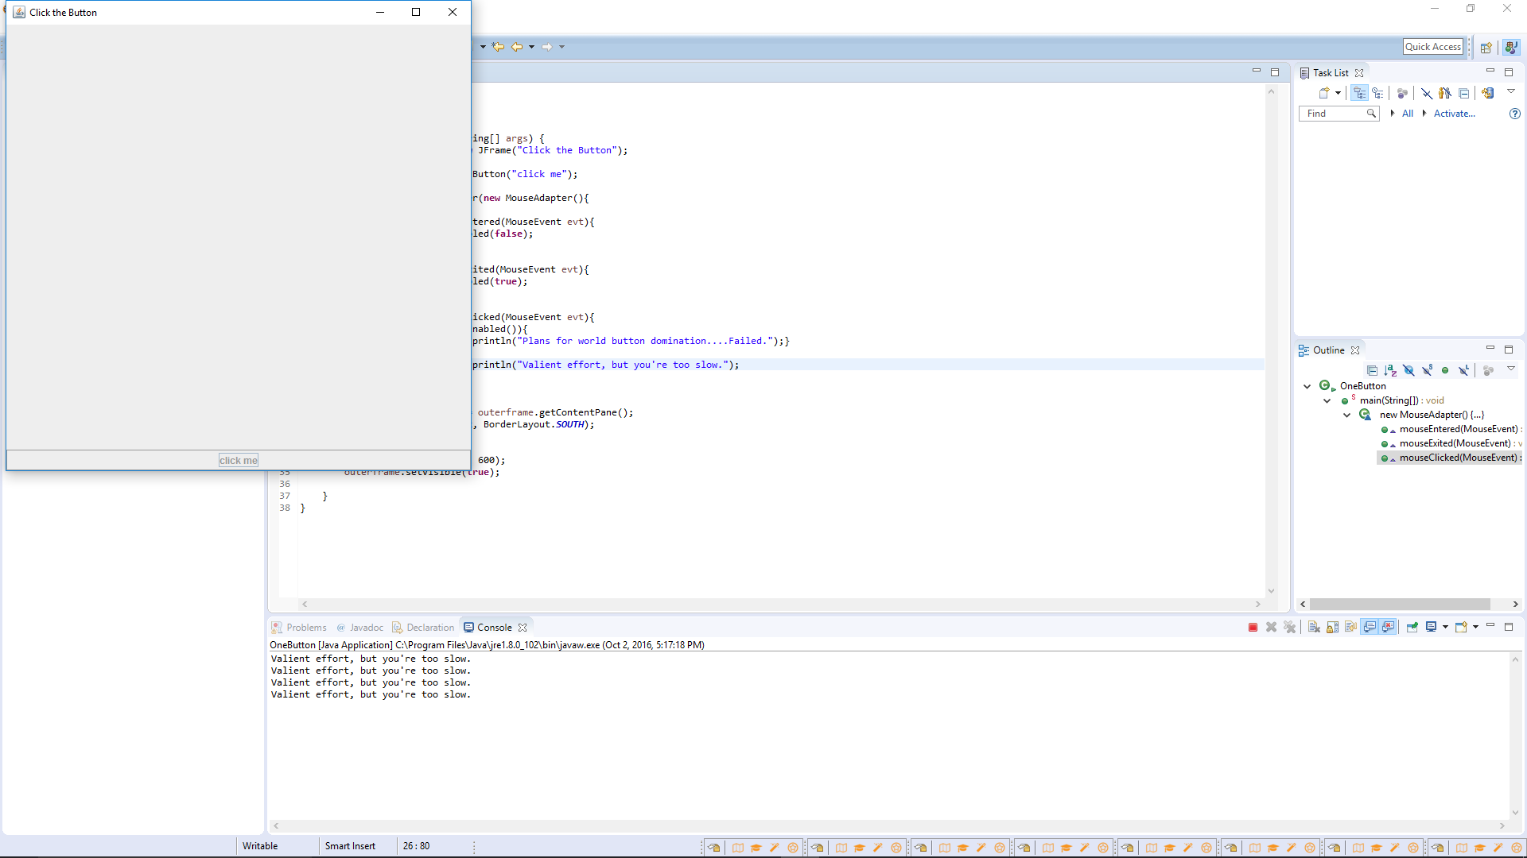

Answer:

Yes, you can still “press” the button even though it is disabled and Java will record the click event (if you use mouselistener) as a normal/valid click. You can work around this lazily like I did with an if statement asking if the button is enabled inside the click method, or by simply using an actionlistener instead. As well, if a mnemonic is set that could press the button while it is enabled without need of the mouse. And tabbing to the button and pressing space visually presses the button but doesn’t, of course, activate mouselistener clicked code.