Scott Tuschl
Homework Chapter 15
Due 3/6/2026 at 11:59 pm
A000834342

3. For the inductive element of Fig. 15.79:

- Write the current in phasor form.
$I_{L}$= 7.071 mA∠50˚
- Calculate the voltage across the inductor in phasor form.
$V_{L}$= 14.142∠40˚ V
- Sketch the phasor diagram of the voltage and current.

- Write the voltage in the sinusoidal format.
$V_{L}(t)$ = 20sin(250t + 130˚)
- Sketch the waveform of the voltage and current.

Fig. 15.79

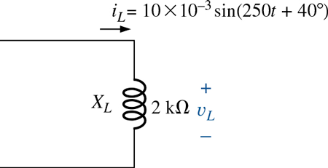

5. For the inductive element of Fig. 15.81:

- Write the voltage and current in phasor form.
Current: $I_{L}$= 4.243 mA∠-70˚ Voltage: $V_{L}$= 11.314∠20˚ V

- Calculate the impedance of the inductor.
j2666.7Ω
- Find the inductance of the coil.
L = 2.22 H
- Sketch the phasor diagram of the voltage and current.

- Sketch the waveform of the voltage and current.

Fig. 15.81

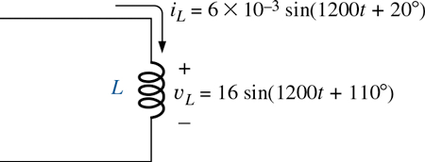

7. For the capacitive element of Fig. 15.83:

- Calculate the reactance of the capacitor
$$X_{C}=5kΩ$$
- Write the current in phasor form.
$I_{C}$= 3.536 µA∠ -170˚
- Calculate the voltage across the capacitor in phasor form.
$V_{C}$= 17.68 mV∠100˚
- Sketch the phasor diagram of the voltage and current.

- Write the voltage in the sinusoidal format.
$V_{C}(t)$ = 25 mV sin(20,000t - 170˚)

- Sketch the waveform of the voltage and current.

Fig.15.83
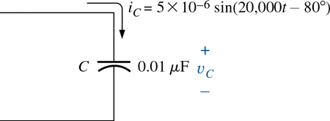

13. Calculate the total impedance of the circuits in Fig. 15.86. Express your answer in rectangular and polar forms, and draw the impedance diagram.

- $Z_{T}$= 3 – j1 Ω = 3.162 ∠ - 18.43˚Ω
- $Z_{T}$= 1000 – j4000 Ω = 4.123 kΩ∠75.96˚
- $Z_{T}$= 470 – j39.60 Ω = 471.67∠- 4.82˚ Ω

Fig. 15.86
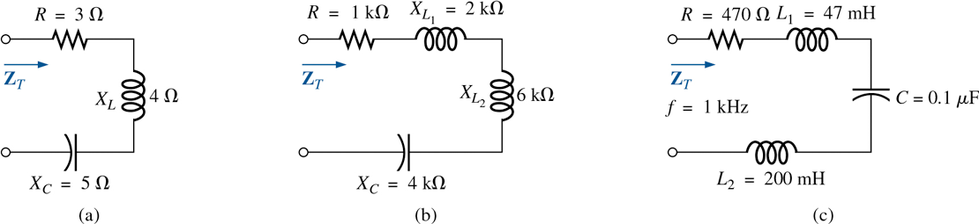

17. For the circuit in Fig. 15.90:

- Find the total impedance $Z_{T}$in polar form.
$$Z_{T}=5.657 ∠ 45˚Ω$$
- Draw the impedance diagram.

- Find the value of C in microfarads and L in henries.
L = 15.9 mH C = 265.3 µF
- Find the current I and the voltages $V_{R}$, $V_{L},$and $V_{C}$in phasor form.
I = 8.839∠- 45˚ V $V_{R}$ = 35.36∠- 45˚ V $V_{L}$I = 53.03∠ 45˚ V $V_{C}$I = 88.39∠- 135˚ V
- Draw the phasor diagram of the voltages E, $V_{R},V_{L} ,$ and $V_{C}$and the current I.

- Verify Kirchhoff’s voltage law around the closed loop.
$V_{R}$+$V_{L}+V_{C}=E$
- Find the average power delivered to the circuit.
P = 312.5 W
- Find the power factor of the circuit, and indicate whether it is leading or lagging.
Pf = 0.707 leading
- Find the sinusoidal expressions for the voltages and current.
i(t) = 12.5 sin(377t + 45˚) V, $V_{R}\left(t\right)=50\sin\left(377t+45˚\right)V$, $V_{L}\left(t\right)=75\sin\left(377t-45˚\right)V$
$V_{C}\left(t\right)=125 sin⁡(377t-45$˚) V
- Plot the waveforms for the voltages and current on the same set of axes.

Fig. 15.90
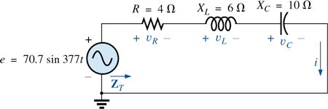

21. For the circuit of Fig. 15.94:

- Find the current $I_{L_{1}}$
$I_{L_{1}}$= 5 mA ∠ 30˚
- Find the voltage $V_{8}$
$V_{8}$ = 47.17 ∠ 88˚ V
- Calculate the voltage $V_{R_{1}}$
$V_{R_{1}}$= 8.660 + j5.000 V

Fig. 15.86
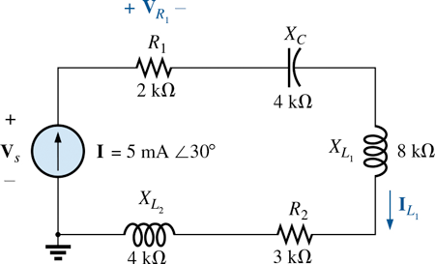

28. Calculate the voltages $V_{1}$ and $V_{2}$ for the circuits in Fig. 15.100 in phasor form using the voltage divider rule.
a. $V_{1}$= 14.14 ∠ - 155˚ V, $V_{2}$= 28.28 ∠ 25˚ V
b. $V_{1}$= 112.92 ∠12.43˚ V, $V_{2}$= 58.66 ∠ - 139.94˚ V
Fig. 15.100
