Scott Tuschl
HW 7
Due March 20 by 11:59 pm
A000834342

3. For the network in Fig. 17.31:

Find the total impedance $Z_{T}$

Find the current $I_{S}$

Calculate $I_{2}$ using the current divider rule.
Calculate $V_{C}$ using the voltage divider rule.

Calculate the average power delivered to the network.

Fig 17.31
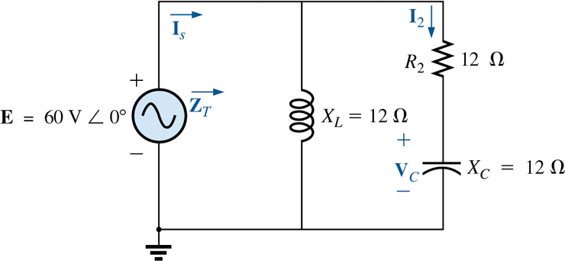

5. For the network in Fig. 17.33:

- Find the current I.

- Find the voltage $V_{C}$

- Find the average power delivered to the network.

Fig 17.33
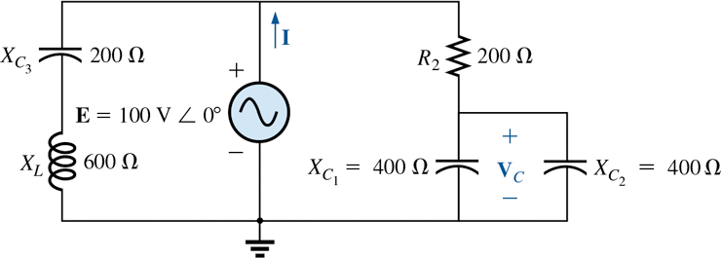

7. For the network in Fig. 17.35:

- Find the current $I_{1}$ and current $I_{2}$

- Find the voltage $V_{1}$

- Calculate the average power delivered to the network.

Fig 17.35

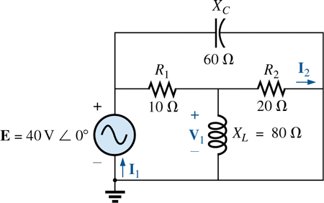

16. For the ladder network of Fig. 17.44:

- Find the total impedance $Z_{T}$

- Find the voltage across the resistor $R_{3}$

Fig. 17.44
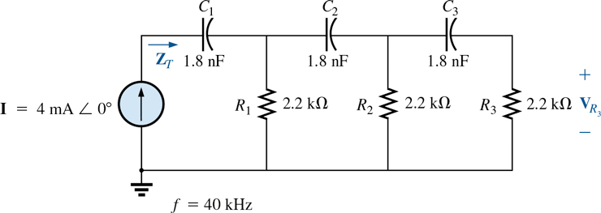

17. Find the current $I_{1}$ for the network in Fig. 17.45.
