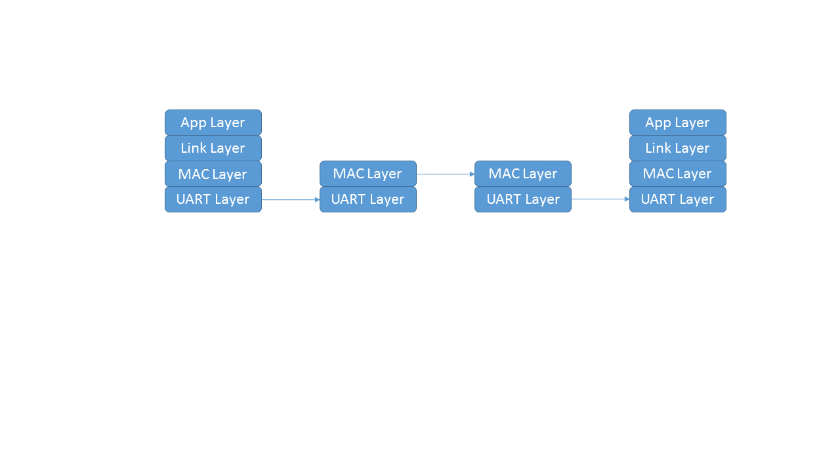

MAC frame format:

|  |  |  |  |  |
| --- | --- | --- | --- | --- |
| Field: | SOF | Payload | Parity | EOF |
| Size: | 1 byte | 1~63bytes | 1 byte | 1 byte |
| Content: | 0x3e | 1~63bytes | Odd parity | 0x3f |

Use bit stuffing to avoid 5 consecutive 1s